Smart Home Automation System Using Bluetooth and Wifi

Submitted by:
Team: ADMIN007
K.Harish Reddy
M.Giridhar
K.Snehith Reddy

Abstract:
Home Automation System is becoming very popular day by all-over the world because of making life smoother and minimizing the work load. As technology is advancing so house are also getting smarter. Modern house are gradually shifting from conventional switches to centralized control system, A Bluetooth Module is interfaced to the Arduino board at the receiver end while on the transmitter end, a GUI application on the cell phone sends ON/OFF command to the receiver where loads are connected.

Introduction
Nowadays, we have remote controls for our television sets and other systems, which have made our lives real easy. Have you ever wondered about home automation which give the facility of controlling tube lights, fans and other electrical appliances at home using a remote control? Arduino based home automation using Bluetooth. This system is super-cost effective and can give the user, the ability to control any electronic device without even spending for a remote control.
Time is a very valuable thing. Everybody wants to save time as much as they can. New Technologies are being introduced to save our time. To save people’s time we are introducing Home Automation system using Bluetooth. With the help of this system you can control your mobile phone. You can turn on/off your home appliances within the range of Bluetooth. The government and some organization are trying to develop our country in high technology. Now high technology is not bound within few features. The thing that take high technology to next level is automatic system. That is way the demanding automatic electronic device is increasing. To accomplish that, home automation is necessary.

Proposed System Of Home Automation system using Bluetooth and android phone

A). BLOCK DIAGRAM:
Mobile Device

Wi-fi / Bluetooth

Server

USB to serial Bridge

Microcontroller

Relay System

Show Block diagram of home automation system using Bluetooth and android phone digital I/O pins are interfaced with relay module. External Home appliance interfaces with NO/NC of Relay module. External 5v power supply provided for Arduino and relay module and 12v power supply for GSM module.

. Circuit Diagram
.
Circuit diagram of Home automation system using Bluetooth, GSM and android app this system can be operated in two ways.

a)Automated ,b) Conventional
- Automated
This Home Automation System uses Bluetooth, Relay channel and Android App To control Appliance are controlled With click son Android Application. Instruction are sent to Arduino through relay channel and Bluetooth Module.

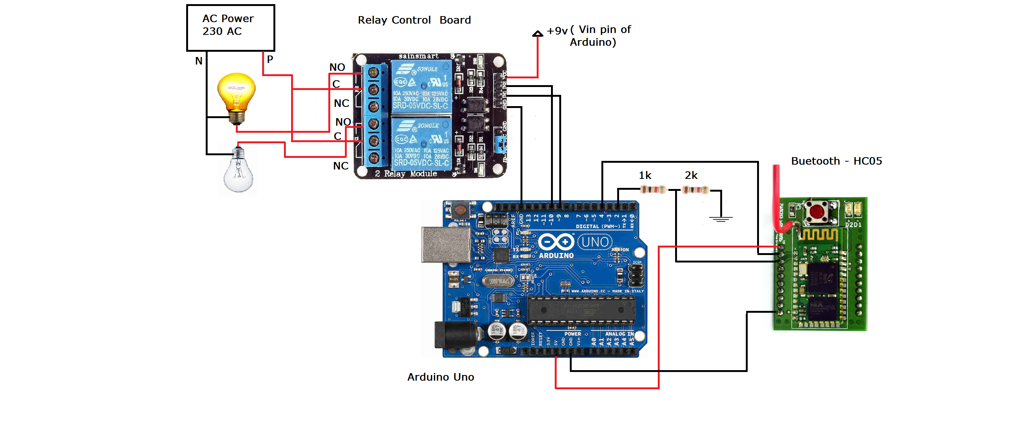
Fig 1: Circuit Diagram of Home Automation System
b).Conventional
Conventional way means normally all the electrical appliance are controlled using “switches” through Switch board. Any Person who wishes to make device “ON/OFF” without using has can use specific switch board attached to device to integrate this relays are connected.

Material and Methodology:
- Bluetooth Module
Bluetooth module used in this project is HC-05. It is easy to use serial port module.it is design transparent serial Wireless connection setup. The Module requires 3.3V to 5V power supply when a specific button is pressed on Bluetooth screen of android application data is sent serially using Bluetooth of smart phone to Bluetooth interfaced with Arduino. Further Arduino decodes this data and takes Action based on data sent. At the same time Arduino send back the data of current status of device to smart phone Bluetooth.
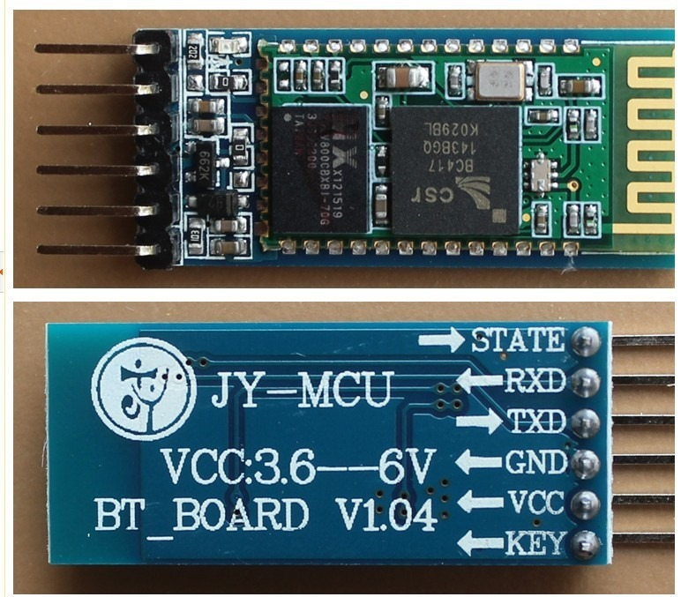
Fig 3: Bluetooth Module HC-05

- Android Application:
The App on the smart phone sends and data and SMS When we click on buttons via Bluetooth from the mobile to Bluetooth module HC-05 Connected with Arduino board. Microcontroller board process the receive data controls the relay board accordingly.

A). Components of this project:

The Components we are using are as follows.
1)Nodemcu(esp8266)
2)Basic Shield
3)Bluetooth module

B) Softwares Used:

1)Arudino
2)Nodered
3)MIT App Inventor

CONCLUSION
Home automation market is very auspicious sector which is developing rapidly. It requires extensive range of developments that can be made in the idea of smart homes. Modeling and execution of home automation system using Bluetooth Module and GSM through android application has been discussed in this paper. The proposed system is practical, economical and simple. While using Bluetooth the motive of the system is to use mobile phone integral feature for automating the Home. The key advantage of system is if control circuit fails then manual switching option of traditional method is available.

Future Works
In future home automation system can make home even more intelligent. This System can be used for building automation, industrial automation, hospital automation for patients and agricultural automation for farmers. Different sensor can interfaced with the system such as motion sensor, light sensor, flame sensor, temperature sensor etc. Automation toggling of device based on certain situation can also be implemented WI-fi and Ethernet based home automation systems can be developed.

