Capital: Hanoi, Vietnam

Primary Descriptions

* Vietnam or the Socialist Republic of Vietnam
* It is the is the easternmost country on the Southeast Asian Indochinese Peninsula
* Its capital city is Hanoi, while its most populous city is Ho Chi Minh City, also known by its former name of Saigon
* Vietnam is known for having a long, narrow nation shaped liked letter “s”

Political environment

The most profound "changing external circumstances" that affected Vietnamese literature in their political situation in the past two decades are the so-called literary Renovation movement, which began in 1986 and reached its peak in 1988-89 and had no official ending, and the post-Renovation period, from the mid-1990s to today.

Literature and art were allowed a certain "space of freedom”. The task for the post-Renovation era is to determine precisely the parameters of this space for freedom and literature and to determine the circumstances in which the government maintains a right to interfere with literature.

The parameters today are clear. You can do whatever you want as long as you avoid politics.

In Vietnam, the practice of segregating literature from politics has a stature to the separation of church and state. Since mixing literature and politics remains taboo, the writer's horizon is still constrained. But, as narrow as the post-Renovation may be, it still represents a new and fresh horizon that no one had seen before.

Vietnam Economic Environment

Walking around in Ha Noi, Viet Nam’s capital, you can feel boundless energy everywhere. People whiz by on scooters, buy and sell everything from phones to food in the countless small shops, and run to and fro to get to school or work.

Viet Nam is young, growing, and anything feels possible.

Vietnam’s economic freedom score is 58.8, making its economy the 105th freest in the 2020 Index. Its overall score has increased by 3.5 points due to a dramatic gain in fiscal health. Vietnam is ranked 21st among 42 countries in the Asia–Pacific region, and its overall score is slightly below the regional and world averages.

Facts about Economy of Vietnam

* The Socialist Republic of Vietnam remains a Communist dictatorship characterized by repression of dissenting political views and the absence of civil liberties.
* Economic liberalization, began in 1986 with doi moi reforms aimed at transitioning to a more industrial and market-based economy.
* Vietnam’s economic growth, based on tourism and manufactured exports, was among the world’s fastest during the decade-long tenure of former Prime Minister Nguyen Tan Dung. In 2016, Dung was forced out after losing election as General Secretary of the Communist Party, but state-managed economic liberalization has continued under General Secretary Nguyen Phu Trong.
* Vietnam joined the World Trade Organization in 2007 and signed the Comprehensive and Progressive Agreement for Trans-Pacific Partnership in 2018.

Unemployment 1.9%

Population 94.6 Million

Inflation 3.5%

Many cultural economic contents/ productions as films, television series, animations, video games, radio plays, musicals, songs etc. were created by using this memory or heritage as the main source. This literary heritage is considered as the main attraction of cultural tourism.

Socio-Cultural Environment

Vietnam has a vibrant literary social and cultural tradition dating back many centuries that affects their literature. Many poem from earlier eras such as Nguyen Du’s The tale of Kieu or Nguyen Tien are regarded as literary masterpiece

Important cultural symbols include dragons, turtles, lotuses and bamboo. Along with these tradition, the Vietnamese also maintained a rich oral legacy of songs, poems and morality tales that people still recite today

Historical Development of the Literature of   
Vietnam

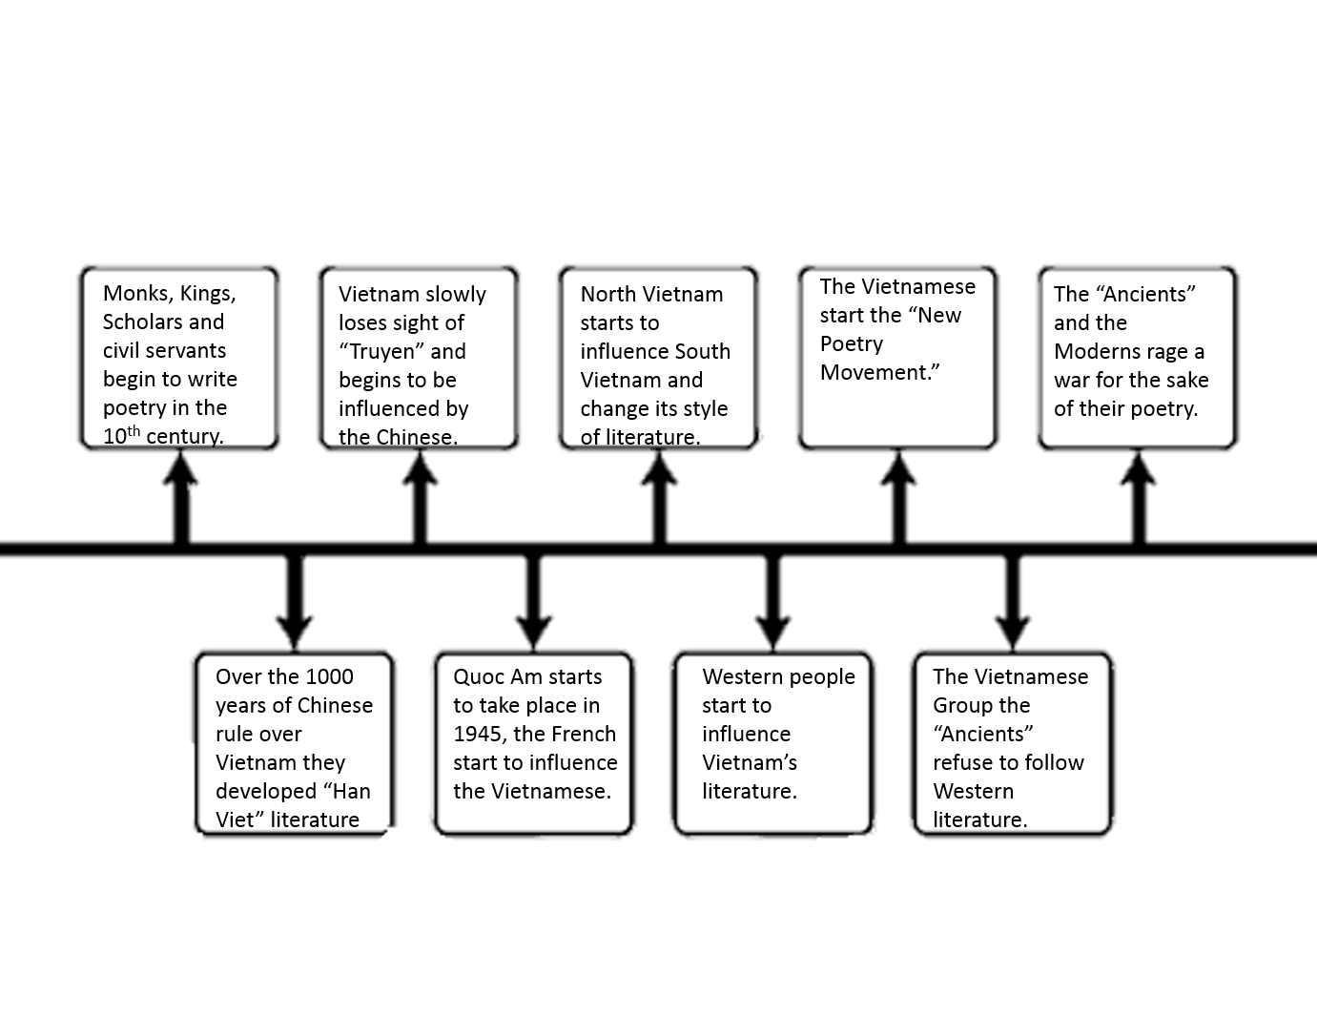

Forms of Literature

Truyen - (traditional oral literature) works of folkoric intention and their authors themselves have meant them for retelling, for existence in the oral tradition

Han Viet- (Chinese-Vietnamese literature) gives individual authors a wide range of formal and thematic possibilities, including the luc-bat (“six-eight,” referring to a basic couplet of six syllables in the first line and eight in the second) prosody of the oral tradition.

Quoc Am- (modern literature, or anything written in the romanticized quoc ngu alphabet) written with the Roman alphabet, like English and French, not Chinese characters (like China) or a distinct alphabet (as is the case in Thailand and Myanmar).

Significant Literature ( Vietnam )

Types of Poetry:

Lyrin Poetry- usually written in first person point of view and expresses personal thought and feelings

- expresses an emotion or an idea or describes a scene

- is often used in musical

Narrative Poetry - - tells a story

- they can be long and short

- Some use rhyme, some do not.

Example: The Greedy Dog

There was once a dog filled with greed

Who wanted much more than he's need

When he saw his reflection

Upon further inspection

He ended with nothing, indeed.

Descriptive Poetry -- Poetry that, through memorable descriptions that appeal to our senses, engages our minds, our hearts, and our imaginations.

- Gives the reader a sense of an experience/place/person

Subtypes:

Sonnet (Shakespearean or English Petrarchan or Italian) - 14 lines

Haiku - japanese poem of 17 syllables, 5,7,5

Elegy - lament for the dead

Limerick - 5 line poem that consist of 1 stanza

Ballad - form opf verse, narrative set to music

Ode - lyrical stanza; used to glorify

Epic - long narrative poem about heroic acts

Sound Devices:

Alliteration

Assonance

Consonance

Onomatopoeia

Rhyme

Rhythm

**The Cherished Daughter**

Mother, I am eighteen this year

and still without a husband.

What, Mother, is your plan?

The magpie brought two matchmakers

and you threw them the challenge:

not less than five full quan,

five thousand areca nuts,

five fat pigs,

and five suits of clothes.

Mother, I am twenty-three this year

and still without a husband.

What, Mother, dear, is your plan?

The magpie brought two matchmakers

and you threw them the challenge:

not less than three full quan,

three thousand areca nuts,

three fat pigs, and three suits of clothes.

Mother, I am thirty-two this year

and still without a husband.

What, Mother, darling, is your plan?

The magpie brought two matchmakers

and you threw them the challenge:

not less than one full quan,

one thousand areca nuts,

one fat dog this time,

and one suit of clothes.

Mother, I am forty-three this year.

Still without a husband.

Mother, look, Mother,

will you please just give me away?

-- Anonymous (c. 1700 AD)--

trans. Nguyen Ngoc Bich

from World Poetry: An Anthology of Verse from Antiquity