Choose one popular website.
- Website Name
- Instagram
- Is it responsive
- Yes
- What change on mobile?
- On mobile, the menu is smaller and the posts fit the screen.
- What change on desktop?
- On desktop, the screen is bigger and shows more content.
- What do you like about the design?
- I like the design because it is simple and easy to use.
- Screenshot desktop
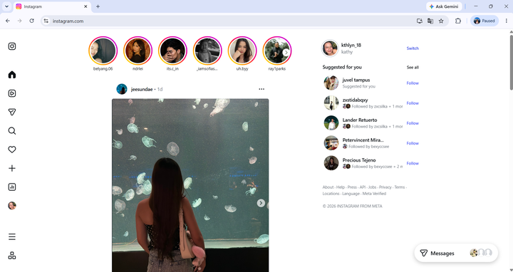
- Screenshot mobile
