Kathleen Williams
ECE471-A Power Electronics
November 15th, 2002
“I have neither given nor received nor have I tolerated any others’ use of unauthorized aid”

ECE 471 Design Project

The objective of the project was to design and build a buck dc-dc converter with a varying input voltage (Vs) in the range of 10 V < Vs < 14 V with a regulated dc output voltage of 6.1 ± 0.2 V for a 10 ohm load resistance (Figure 1). The design for the buck converter used calculated values of the duty cycles (0.44 < D < 0.61), switching frequency (f = 20kHz), minimum inductance value (L = 175 μH), capacitance value (C = 1000 μF), and maximum and rms values of the inductor currents (Imax = 1.62A). Also, the IRFZ14 N-Channel Power MOSFET was chosen to drive the circuit because of its low cost ($1.11), low average power (196 μW), current and voltage characteristics (Maximum Current = 10 Amps, Maximum Voltage = 60V), and high switching speed (50 ns rise time from data sheet). The MOSFET’s characteristics were simulated in PSpice to determine the average power dissipation (196 μW) and the rise and fall times (13.76 ns). The MOSFET was then successfully tested with a function generated square wave. The rise time of the IRFZ14 was experimentally determined to be approximately 13.0ns and the fall time to be 156.0ns. The maximum allowable switching frequency was observed to be 1.1Mhz. The voltage across the load varied between Vs,12.01 V, and 0 V as expected. The load in the high-side driver was then replaced with the complete buck converter circuit design. The output voltage was observed to increase as the duty cycle across the diode increased. The inductor current was observed to become discontinuous at a frequency of 748 Hz. An audible noise from the switching frequency was heard at 13kHz.

The next step was to use the 3425 IC to generate the switching frequency and to regulate the output voltage. The actual switching frequency was approximated to be 21kHz (not exactly 20kHz from the design) from the resistor and capacitor values of Rt = 1k and Ct = 0.047μF.. The best choice for the compensation network was an RC series circuit with R = 1k and C = 33uF (I lacked the needed variable resistor in my lab kit). These values made the control loop very stable.

The input voltage (Vs) was varied from 10 to 14 volts and the output voltage was measured to be a constant 6.125 V which is within specification of the required regulated 6.1 ± 0.2 V output voltage needed across the load. The diode voltage was observed and then verified that the duty cycle changed automatically to compensate for variations in input. The efficiency of the device was determined by Efficiency = Pout/Pin. If the input voltage (Vs) was 14 V, the observed current was 0.34 A, Pin= 4.76 Watts. The current needed to power the circuit for 10 V was 0.44 A, Pin = 4.4 Watts. The output power was held constant and determined to be (6.125 V)^2 / 10 = 3.7515 Watts. Thus the total efficiency of the circuit varied from 78.81% to 85.26%. Using the worst case estimate of efficiency, the total efficiency is 78.81%. The circuit completed its required regulation of 6.1 ± 0.2 V output voltage when the input voltage ranged from 10 to 14 Volts with a high efficiency of 78.81% using standard lab resistors, capacitors, and inductor values and a low-cost, but high performance power MOSFET assembled in a controlled stable circuit.

Figure 1 – Circuit Diagram of DC-DC Buck Converter
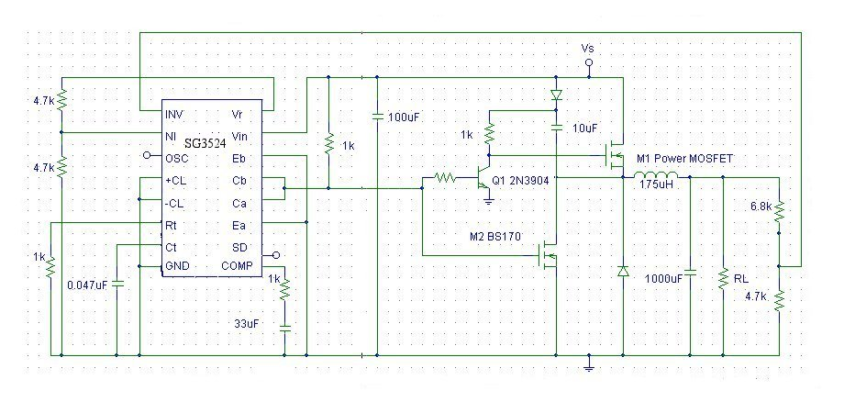
I. Specifications

The objective was to design a buck dc-dc converter with the input dc voltage which can vary from 10 to 14 V. The circuit should work for the entire range of input voltages. The output voltage must be a dc voltage, regulated at 6.1 ± 0.2 V with a load resistance of 10 ohms.

II. Design

Calculations for a Buck Converter

The duty cycle range is calculated from:
Vo = Vs*D 10 < Vs < 14 Vo = 6.1

Where Vo is the output voltage, Vs is the source or input voltage, and D is the duty cycle

For 10 V input D = 0.61
For 14 V input D = 0.44

Therefore, 0.44 < D < 0.61

The minimum inductance value is determined from:
Lmin = [(1-D)R]/(2f) R is load resistance and f is the switching frequency

D | R (Ohms) | Frequency (Hz) | Lmin (microHenrys)
0.61 | 10 | 20k | 97.5
0.44 | 10 | 20k | 140

The minimum inductor value was calculated to be 140uH, however, the value should be at least 25% of this value to allow for deviation. Thus, I chose an inductor value of 175 uH in this design. However, the inductor size was later changed to comply with standard inductor values in the lab. This did not significantly effect the regulated voltage. The PSpice simulation results are for the 140uH value.

The capacitor value was specified to be 1000uF, sufficient to decrease output voltage ripple.

The maximum current can be found from the formula:

Imax = Vo[(1/R) + (1-D)/(2*L*f)] f = 20kHz

Vo (Volts) | R (Ohms) | D | L (microHenrys) | Imax (Amps)
10 | 10 | 0.61 | 140uH | 1.7 A
14 | 10 | 0.44 | 140uH | 2.8 A

Imax = 2.8A

The change in current will determine the maximum and output rms current values of the inductor.

Δi = [(Vo/L)(1-D)T]

I_{L,RMS} = √[(I_{L})^2 + ((Δi_{L}/2)/√3)^2]

Where I_{L} = Vo/R

Vo (Volts) | D | L (uHenrys) | T = 1/f | R (Ohms) | Δi_{L}/2 | I_{L} (A) | I_{L,RMS} (A)
10 | 0.61 | 140 | 1/20000 | 10 | 0.6964 | 1 | 1.078
14 | 0.44 | 140 | 1/20000 | 10 | 1.4 | 1.4 | 1.617

I_{L,RMS MAX} = 1.617 A

MOSFET Selection

The IRFZ14 N-Channel MOSFET was chosen because of its low cost, low power dissipation, current and voltage characteristics, and high switching speed. The IRFZ14 supplier and technical information is available in Appendix A.

III. PSpice Simulation and Switch Performance

See Appendix B for PSpice Simulation and switch performance including the average power dissipation.

IV. Building and Testing the Circuit

Testing the MOSFET

It was necessary to test the n-channel IRFZ14 MOSFET before building the actual regulator circuit. The test MOSFET is shown in Figure 2. Firstly, the resistor value was varied with a 5V (2-amp) power supply and the function generator set to a square wave of 10 Vpp 61% duty cycle and a frequency of 50kHz. In addition, a large capacitor was placed on the protoboard where the power supply was attached. The output voltage Vo for the 1k resistor was 2.188V and with the 10 ohm resistor, the output voltage was 5.125 V. The rise time was determined to be approximately 13.0ns and the fall time to be 156.0ns. The switching frequency was increased to a large value until it reached a maximum of 1.1Mhz because the output did not resemble a square wave after this frequency.

Figure 2 - Test Circuit for IRFZ14 MOSFET
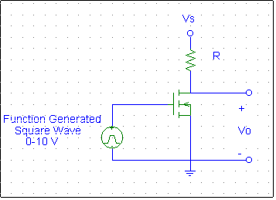

Testing the High-Side Driver

The high side driver (Figure 3) was constructed starting with RL = 1k for testing. After the circuit was working properly, the load resistance was changed to 10 ohms. The voltage supply Vs was 12V DC and the input signal Vi was generated using a function generator at 10 Vpp and at 20kHz. The voltage across the load varied between 12.01 V and 0 V as expected.

Figure 3 – High-Side MOSFET Driver
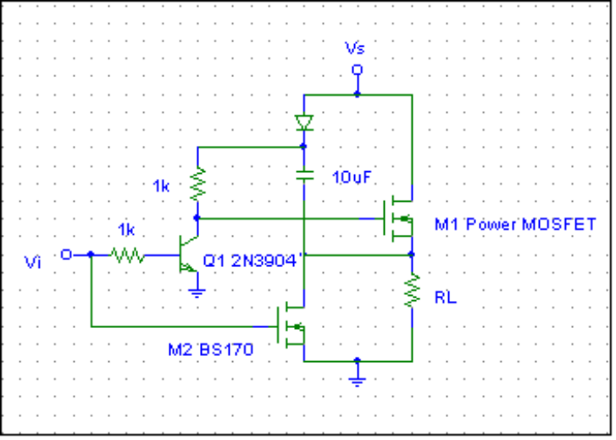

Testing the High-Side Driver with the Low-Pass Filter Attached

The load in the high-side driver of Figure 3 was replaced with the complete buck converter circuit: diode inductors, 1000uF capacitor, and a load resistor (Figure 4). The function generator again established the switching frequency at 10 Vpp and 20kHz. The power supply Vs source was again 12 V. The voltage across the switching diode when on was determined to be 11.88 V and -0.63 V when off. The duty cycle of the switch was changed to observe the relationship between the duty cycle and the output voltage. The duty cycle was measured from the voltage across the diode. The results are listed below in Table 1. The result is that the output voltage increases as the duty cycle increases.

Table 1 – Switching Diode Output Voltage and Duty Cycle Measurements
Duty Cycle (Measured Across Diode) | Output Voltage
44.98% | 4.92 V
77.6% | 8.79 V
79.2% | 9.03 V

The switching frequency was then reduced to 748 Hz to test the frequency at which the inductor current becomes discontinuous. This was determined from examining the voltage waveform across the diode. The switching frequency was then reduced to 13 kHz to test the frequency at which the circuit becomes audible.

Figure 4 – High-Side Driver with the Low-Pass Filter Attached
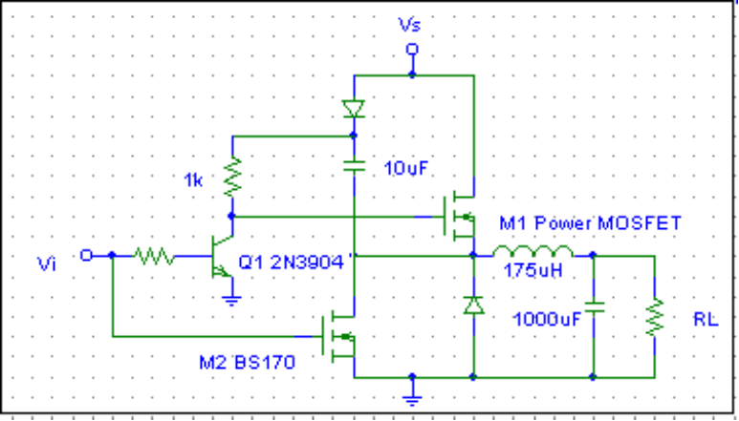

Connecting the Control Loop

The final step (Figure 5) was to disconnect the function generator and use the 3425 IC to generate the switching frequency and to regulate the output voltage at the specified value. A voltage divider in parallel with the load resistance was designed to output 2.5 V to INV pin of the SG3524 when the output voltage is regulated at the specified value of 6.1 V. The SG3524 contains an oscillator for the switching frequency. The frequency was determined in the original design to be 20kHz. However, in order to use a standard resistor Rt and a capacitor value Ct in the formula for frequency of the oscillator, f = 1/(Rt*Ct), the actual frequency was approximated to be 21kHz from the resistor and capacitor values shown in Figure 5. Control stability is determined by an external RC compensation network. The compensation network was determined from testing different capacitor and resistor values (I lacked the needed variable resistor in my lab kit) and observing the voltage across the switching diode. The voltage across this diode should be a periodic waveform, otherwise the control loop is not stable. The best choice was an RC series circuit with R = 1k and C = 33uF. These values made the control loop very stable.

The last step was to test the output voltage regulation over the specified range of 10 to 14 volts. The input voltage (Vs) was varied from 10 to 14 volts and the output voltage was measured to be a constant 6.125 V which is within specification of the required 6.1 ± 0.2 V output voltage needed across the load. The diode voltage was observed to verify that the duty cycle changed automatically to compensate for variations in input. The efficiency of the device was determined by observing the current supplied by the power source with each boundary input voltage, finding the input power, and comparing that value to the output power, Efficiency = Pout/Pin. For example, if the input voltage (Vs) was 14 V, the observed current was 0.34 A, Pin= 4.76 Watts. The current needed to power the circuit for 10 V was 0.44 A, Pin = 4.4 Watts. The output power was held constant and determined to be (6.125 V)^2 / 10 = 3.7515 Watts. Thus the total efficiency of the circuit varied from 78.81% to 85.26%. Using the worst case estimate of efficiency, the total efficiency is 78.81%.

Figure 5 – Final Circuit with Control Loop

