Restaurant Online Ordering & Table Reservation System
Progress Documentation - Activities 3, 4, 5 and 6
COMP 018 - Database Administration · Prof. John Kenneth Timblaco · Group Binary Sisters · Group no. __ [TO COMPLETE]
How to use this document. Everything that is design or code in the repository is already written here. Items marked [TO COMPLETE] need real evidence that only the group can produce (screenshots, dates, commit hashes, results of testing other groups’ projects). Do not invent results. Delete these notes before submitting, and check every screenshot for passwords.

1. Cover and team
Item | Value
Project title | Restaurant Online Ordering & Table Reservation System
Group | Binary Sisters (Group no. __ [TO COMPLETE])
Repository URL (access type) | <REPOSITORY_URL> (public / private with all groups invited) [TO COMPLETE]
Class tracker link | <TRACKER_URL> [TO COMPLETE]
User roles document | docs/user-roles.md in the repository (link in tracker) [TO COMPLETE]
Approved design | Activity 2 - submitted 2026 September 26

Member | Role in the project | Main contribution [TO COMPLETE]
Sandoval, Cellyn S. | [TO COMPLETE]
Callos, Kathlen Mae L. | [TO COMPLETE]
Romingquit, Arika E. | [TO COMPLETE]
Tambio, Jenny Mae N. | [TO COMPLETE]
Tungol, Jaimie N. | [TO COMPLETE]
Gordonas, John Benedick | [TO COMPLETE]

2. System overview (Activity 3)
Purpose. Restaurants that take orders and reservations by phone, message or paper suffer wrong orders, double bookings and slow status updates (Activity 2, Part 2). The system lets customers view the menu, order online, reserve a table and track both, while staff manage the operation. Scope follows Activity 2: payroll, suppliers, accounting and inventory are excluded.
# | Approved feature (Activity 2, Part 2B) | Where implemented
1 | Customer registration and login | /register, /login, /profile
2-3 | View menu, search and item details | /menu, /menu/item
4-5 | Place orders with multiple items | /cart, /checkout (one transaction: orders + order_item + payment)
6-7 | Make reservation, check availability | /reservations/new (availability query + database no-overlap constraint)
8 | View order and reservation status | /orders, /reservations
9-10 | Manage menu items and tables | /admin/menu, /admin/tables
11 | Manage customer orders | /admin/orders
12 | Record and manage payments | /admin/payments
Architecture (unchanged from Activity 2): Users → HTML/CSS → PHP 8 application → PostgreSQL 18.6 via PDO.
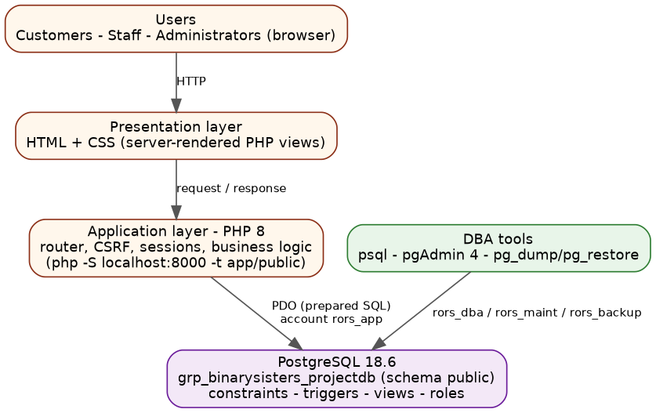
System architecture

3. User roles
Full text: docs/user-roles.md and docs/user-role-setup.md.
Application role | Functions and data access | Database role / account
Customer | register, edit own profile, order, reserve, view/cancel own pending orders and reservations | via application runtime rors_app ∈ rors_runtime_grp
Staff | read operations; update order, reservation, payment status; record payments; toggle menu availability | via rors_app (restrictions enforced in the application)
Administrator | staff functions + create/edit/delete menu items and tables, delete reservations, customers list, staff accounts | via rors_app; DBA tasks use a separate account
Application runtime | only the DML the code needs; no DDL, no DELETE on orders/payments/order lines | rors_app ∈ rors_runtime_grp
Viewer / auditor | read-only on approved tables and views; no access to password hashes | rors_report ∈ rors_readonly_grp
DBA - maintenance | VACUUM/ANALYZE, monitoring | rors_maint ∈ rors_maint_grp (pg_maintain, pg_monitor)
DBA - backup | pg_dump | rors_backup ∈ rors_backup_grp (pg_read_all_data)
DBA - administrator | day-to-day administration, not a superuser | rors_dba ∈ rors_admin_grp

4. Development progress log
Date | Milestone / work done | Who | Key commits
2026-09-26 | Activity 2 design submitted: requirements, 12 business rules, ERD, schema, architecture | all | -
[date] | Repository created, members added as collaborators | [name] | [hash]
[date] | Migrations 001-004 created and run on PostgreSQL 18.6 | [name] | [hash]
[date] | Seed data loaded | [name] | [hash]
[date] | PHP application: authentication and menu | [name] | [hash]
[date] | Orders, cart, checkout transaction | [name] | [hash]
[date] | Reservations and availability | [name] | [hash]
[date] | Staff/admin pages | [name] | [hash]
[date] | Roles and privileges (database/roles) | [name] | [hash]
[date] | Documentation, tracker registration, cross-group testing | all | [hash]
[TO COMPLETE - dates, names and commit hashes must come from git log --oneline --author=...; every member should appear.]

5. Database implementation
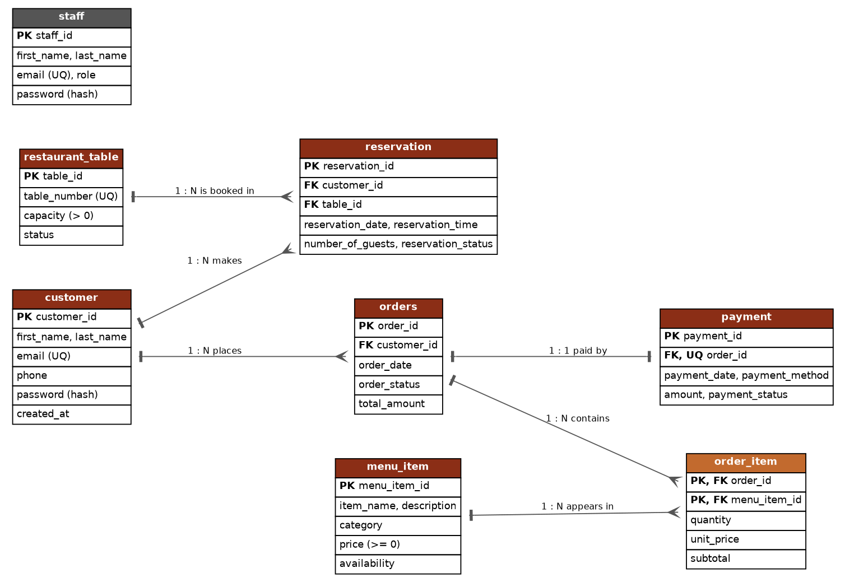
ERD
Item | Value
Database / schema / version / owner | grp_binarysisters_projectdb / public / PostgreSQL 18.6 / postgres
Tables (8) | customer, menu_item, restaurant_table, staff, orders, order_item, reservation, payment
Scripts | database/migrations/000-004, database/seeds/001_seed_data.sql, database/roles/01-04, database/setup.ps1
Seed volume | 2 staff, 5 customers, 10 menu items, 8 tables, 6 orders (14 lines), 5 payments, 7 reservations
Extra database logic | deferred triggers (order needs ≥ 1 item), total trigger, capacity trigger, exclusion constraint (no double booking), 4 views, 6 indexes
Changes from the approved Activity 2 design (details in docs/changes-from-activity2.md)
Change | Reason
Singular names menu_item, order_item | Activity 2 mixed singular/plural; the pgAdmin-generated ERD used singular
price >= 0 and no UNIQUE(item_name) | Part 6 schema is authoritative; the Part 11 sample differed
CHECK constraints on status/role/method columns | prevent typos that break the application
Order total and subtotal consistency (trigger + CHECK) | the total must always match the lines
BR9 “order has at least one item” via deferred trigger | cannot be expressed as a column constraint
Exclusion constraint and capacity trigger | the problem statement names double bookings
Views and indexes added | planned “other objects” in Activity 2; needed for read-only access (Activity 4)

6. Application evidence (Activity 3)
Database-level test: tests/crud_tests.sql (runs inside a transaction that is rolled back).
Operation | Test | Expected | Actual [TO COMPLETE] | Screenshot
Create | register a customer; place an order with 2 items; reserve a table | rows created; order total = sum of lines |  | [Figure]
Retrieve | menu search “adobo”; “My orders”; admin order list | correct rows only |  | [Figure]
Update | staff sets order confirmed; admin edits a menu price | status/price changed; old order lines keep old price |  | [Figure]
Delete | admin deletes an unused menu item; deletes an item used in orders | first succeeds; second refused (foreign key) |  | [Figure]
Rules | book same table twice; 5 guests at a 2-seat table; negative price | all rejected |  | [Figure]
[SCREENSHOT REQUIRED] home/menu page · cart and order confirmation · reservation availability page · admin dashboard · crud_tests.sql output (all PASS).

7. Setup and configuration
- git clone \<REPOSITORY_URL\>; PostgreSQL 18 + PHP 8.1+ (pdo_pgsql) + psql on PATH.
- .\database\setup.ps1 -WithRoles (hidden password prompts; nothing stored).
- copy .env.example .env → set DB_USER=rors_app and its password locally.
- php -S localhost:8000 -t app/public.
Environment variable | Placeholder value
DB_HOST / DB_PORT / DB_NAME | localhost / 5432 / grp_binarysisters_projectdb
DB_USER / DB_PASSWORD | rors_app / CHANGE_ME
APP_DEBUG / APP_TIMEZONE / DB_SSLMODE | false / Asia/Manila / prefer
Database users and roles: see section 3 and docs/user-role-setup.md.

8. Issues and resolutions
# | Problem met | Cause | How it was solved | Who
1 | [TO COMPLETE - real problems only]
Known design-level issues found while implementing the Activity 2 design are listed in section 5 (changes).

9. Cross-group verification (Activity 3 Part D)
Project tested (group, repo) | Setup result | Roles exercised | Issues found | Feedback sent
Group __ - [TO COMPLETE]
Feedback received on our project and fixes made: [TO COMPLETE]

10. Activity 4 - Database users, roles, privileges and access control

10.1 Projects set up
Group / project | Repository @ branch | Database | Objects (tables / views / sequences) | Setup result
Group __ | [TO COMPLETE]

10.2 Access-control plan
Reference plan, already implemented for our own project (database/roles/), which the group used as a model:
Login | Group role | Application role served | Responsibility | Privileges
rors_app | rors_runtime_grp | Application runtime | normal operations | S/I/U on customer, orders, payment; S/I/U/D on menu_item, restaurant_table, reservation, staff; S/I on order_item; sequences
rors_report | rors_readonly_grp | Viewer / auditor | reports | SELECT on non-credential tables and 4 views
rors_maint | rors_maint_grp | DBA - maintenance | VACUUM, ANALYZE, monitoring | pg_maintain, pg_monitor
rors_backup | rors_backup_grp | DBA - backup | pg_dump | pg_read_all_data
rors_dba | rors_admin_grp | DBA - administrator | administration | ALL on public tables/sequences, CREATE on schema
Per other project: one table like this in db-access-control/group-XX/access-control-plan.md [TO COMPLETE - copy the key rows here].

10.3 SQL scripts summary
db-access-control/_template/00-05*.sql (inventory, roles and grants, passwords by prompt, tuning, test matrix, privilege review) and run-activity4.ps1. Roles are prefixed per project (g03_...) because roles are cluster-wide. Folder link: [TO COMPLETE].

10.4 Verification results
Project | Account | Statement | Expected | Actual | Evidence
Group __ | g__app | SELECT on authorised table | Allowed | [TO COMPLETE]
Group __ | g__report | UPDATE | Denied
Group __ | g__app | CREATE DATABASE | Denied
Group __ | g__app | connect to an unrelated database | Denied
Reference result on our own database (04_verify_privileges.sql): [TO COMPLETE - paste PASS/FAIL summary].

10.5 Issues and fixes · 10.6 Feedback to owners
Project | Unexpected result | Cause | Fix / feedback sent (date)
Group __ | [TO COMPLETE]

11. Activity 5 - Database maintenance and monitoring

11.1 Projects monitored
Project | Repository | Database | Accounts and application roles used
Group __ | [TO COMPLETE] |  | g__maint (DBA-maintenance), g__report (viewer)

11.2 Health and activity evidence · 11.3 Log findings
Per project: output of 01_health_checks.sql with interpretation, and log-findings.md (evidence, explanation, impact, next step; or what was checked if nothing was found). [TO COMPLETE]

11.4 Maintenance performed
Project | Command | Why chosen | Account / date | Result
Group __ | ANALYZE; and VACUUM (VERBOSE, ANALYZE) public.<table>; | refresh planner statistics; reclaim dead tuples; no VACUUM FULL (exclusive lock) | g__maint | [TO COMPLETE]

11.5 Query performance
Project | Query (application role) | Scan type | Est. vs actual rows / time | Recommendation
Group __ | [TO COMPLETE]

11.6 Recommendations, limitations, feedback
Project | Priority | Recommendation | Limitation (permissions/logging) | Feedback sent
Group __ | Immediate / Follow-up / None | [TO COMPLETE]

12. Activity 6 - Backup, restoration and recovery

12.1 Projects covered and backup plan
Project | Database | Account | Method | Storage | Schedule / retention | RPO / RTO
Group __ | [TO COMPLETE] | g__backup | pg_dump -Fc | protected folder outside the repository | nightly / 7 daily, 4 weekly, 3 monthly | e.g. 24 h / 2 h
Roles after restore: pg_dump of one database does not contain cluster-wide roles or the database-level CONNECT grant, so the Activity 4 script is re-run for the restored database and one permitted and one denied operation are tested.

12.2 Backup creation and inspection
Project | File name | Size | SHA-256 | Date/time | pg_restore --list evidence
Group __ | [TO COMPLETE - from evidence/backup-log.csv]

12.3 Restoration and verification · 12.4 Access control after restore
Project | Restore database | Objects | Row counts equal | Constraints present | Access control re-created and tested | Result
Group __ | <db>_restore_test | [TO COMPLETE]

12.5 Recovery simulation
Project | Incident (disposable row) | Timeline | Method | Recovered?
Group __ | [TO COMPLETE] |  | fresh restore into <db>_recovery, copy the row back
Loss after the newest backup would be unrecoverable from that file - this is what the RPO expresses.

12.6 Evaluation, limitations and errors, feedback
Is nightly pg_dump enough for a restaurant system? [TO COMPLETE - discuss RPO/RTO measured vs proposed; WAL archiving/PITR, off-site copies, restore drills]

13. AI usage declaration
AI tool | Tasks performed | How the group validated or corrected the output
Claude | Generated the application code, SQL scripts, role scripts, Activity 4-6 templates and the documentation skeleton from the approved Activity 2 design | [TO COMPLETE - what was run, what failed, what was changed]
ChatGPT / Gemini | [TO COMPLETE if used]
Members must be able to explain the triggers, the exclusion constraint, the GRANT/REVOKE structure and the backup/restore commands. No real passwords, API keys or secrets appear in this document.

