50% Individual Coursework
2025-26 Autumn
Credit: 30
CS4001NI Programming - Milestone 2 Report
Student Name: Prasidha Kumar Sarawagi
London Met ID: PKS0076
CollegeID: np01ai4a250040
Assignment Due Date: 17/04/2026
Assignment Submission Date: 17/04/2026
Module Leader: Mr. Bikram Poudel
Word Count:
I confirm that I understand my coursework needs to be submitted online via MySecondTeacher under the relevant module page before
the deadline in order for my assignment to be accepted and marked. I am fully aware that late submissions will be treated as non-
submission and a mark of zero will be awarded.

Table of Contents
1. Introduction
2. Milestone 2 Requirement Summary
3. Class Diagram
4. Pseudocode
5. Method Descriptions
6. GUI Description
7. Testing
8. Error Detection and Correction
9. Conclusion and Reflection
10. References
11. Appendix

1. Introduction
This report documents Milestone 2 of the CS4001NI Programming coursework. The coursework is based on an AI model subscription manager written in Java. The application stores AI model subscription plans and allows the user to manage personal and pro plan actions through a graphical user interface.
Milestone 2 focuses on the Swing GUI, ArrayList storage, polymorphism, file handling, abstraction, and token-based plan logic. The updated code uses an abstract AIModel class, PersonalPlan for users with available tokens, and ProPlan for team users with team slots.

2. Milestone 2 Requirement Summary
Milestone 2 required the coursework to move beyond the basic class structure and include a working GUI controller. The GUI must allow the user to add plans, display plans, validate index input, check plan type, handle prompts, manage team members, export data, and load data from a file.
The lecturer also clarified updated logic for token handling. These updates are reflected in the report and in the Java code used for this submission.
- AIModel is an abstract class.
- display() in AIModel is abstract and is implemented by the child classes.
- contextWindow is stored as an integer numeric value.
- AIModel includes calculateTotalToken(String promptText, int expectedOutputTokens).
- PersonalPlan uses availableTokens instead of promptsRemaining.
- PersonalPlan has purchaseTokens(int tokens), which adds purchased tokens to availableTokens.
- PersonalPlan enterPrompt() calculates total token usage and deducts tokens when enough tokens are available.
- ProPlan enterPrompt() calculates token usage but does not reduce a token balance.
- SubscriptionGUI uses ArrayList<AIModel>, instanceof checks, try/catch index validation, JOptionPane messages, export, and load.

3. Class Diagram
The following text-based class diagram shows the inheritance relationship and the main members from the submitted code. AIModel is the parent class. PersonalPlan and ProPlan extend AIModel. SubscriptionGUI uses an ArrayList of AIModel objects.
<<abstract>> AIModel
---------------------------------------------
- modelName: String
- cost: double
- parameters: int
- contextWindow: int
---------------------------------------------
+ AIModel(String modelName, double cost, int parameters, int contextWindow)
+ getModelName(): String
+ getCost(): double
+ getParameters(): int
+ getContextWindow(): int
+ calculateTotalToken(String promptText, int expectedOutputTokens): int
+ display(): String <<abstract>>

AIModel -> PersonalPlan
---------------------------------------------
- availableTokens: int
---------------------------------------------
+ PersonalPlan(String modelName, double price, int parameters, int contextWindow, int availableTokens)
+ getAvailableTokens(): int
+ purchaseTokens(int tokens): String
+ enterPrompt(String promptText, int expectedOutputTokens): String
+ display(): String

AIModel -> ProPlan
---------------------------------------------
- teamSlots: int
---------------------------------------------
+ ProPlan(String modelName, double price, int parameters, int contextWindow, int teamSlots)
+ getTeamSlots(): int
+ addTeamMember(String memberName): String
+ removeTeamMember(String memberName): String
+ enterPrompt(String promptText, int expectedOutputTokens): String
+ display(): String

SubscriptionGUI extends JFrame and implements ActionListener
---------------------------------------------
- planList: ArrayList<AIModel>
- text fields for plan details, prompt details, member name, and index
- buttons for adding plans, displaying, clearing, prompting, team actions, type checking, export, and load
---------------------------------------------
+ SubscriptionGUI()
+ actionPerformed(ActionEvent e): void
- getIndex(): int
- exportToFile(): void
- loadFromFile(): void
+ main(String[] args): void

4. Pseudocode

4.1 Add Personal Plan Button
WHEN Add Personal Plan button is clicked
READ model name, price, parameters, context window and token amount from text fields
TRY to convert price to double
TRY to convert parameters, context window and token amount to integers
IF model name is empty THEN
show input error message
ELSE
create new PersonalPlan object
add object to ArrayList<AIModel>
print success message with index number
END IF
CATCH any invalid input
show JOptionPane input error message
END WHEN

4.2 Add Pro Plan Button
WHEN Add Pro Plan button is clicked
READ model name, price, parameters, context window and team slots from text fields
TRY to convert numeric fields
IF model name is empty THEN
show input error message
ELSE
create new ProPlan object
add object to ArrayList<AIModel>
print success message with index number
END IF
CATCH any invalid input
show JOptionPane input error message
END WHEN

4.3 Give Prompt Button
WHEN Give Prompt button is clicked
CALL getIndex()
IF index is -1 THEN stop
READ prompt text and output token value
GET AIModel object from planList using the index
IF object is PersonalPlan THEN
cast object to PersonalPlan
call enterPrompt(promptText, outputTokens)
ELSE IF object is ProPlan THEN
cast object to ProPlan
call enterPrompt(promptText, outputTokens)
ELSE
print unknown plan type
END IF
CATCH invalid output token number
show JOptionPane input error message
END WHEN

4.4 Get Index Method
FUNCTION getIndex()
SET idx to -1
TRY to convert index text field to integer
IF idx is less than 0 OR idx is greater than or equal to planList size THEN
show JOptionPane index error message
return -1
END IF
CATCH NumberFormatException
show JOptionPane input error message
return -1
END TRY
return idx
END FUNCTION

4.5 Check Plan Type
WHEN Check Plan Type button is clicked
CALL getIndex()
IF index is -1 THEN stop
GET AIModel object from planList
IF object is PersonalPlan THEN
print Personal Plan message
ELSE IF object is ProPlan THEN
print Pro Plan message
ELSE
print unknown plan type
END IF
END WHEN

4.6 Export to File
WHEN Export button is clicked
OPEN plans_export.txt using PrintWriter and FileWriter
FOR each plan in planList
write plan index
write plan.display() output
write a blank line
END FOR
close file
print export success message
CATCH IOException
print export failed message
END WHEN

4.7 Load From File
WHEN Load button is clicked
OPEN plans_export.txt using BufferedReader and FileReader
CLEAR output area
WHILE file has another line
append line to output area
END WHILE
close file
print file loaded message
CATCH IOException
print load failed message
END WHEN

5. Method Descriptions

5.1 AIModel.java
Method name | Parameters | Return type | Brief description | Internal working
AIModel | String modelName, double cost, int parameters, int contextWindow | Constructor | Creates the parent AI model object. | Stores the model name, cost, parameter count and numeric context window in private attributes.
getModelName | none | String | Returns the model name. | Returns the value stored in modelName.
getCost | none | double | Returns the cost. | Returns the value stored in cost.
getParameters | none | int | Returns the parameter count. | Returns the value stored in parameters.
getContextWindow | none | int | Returns the context window. | Returns the numeric contextWindow value.
calculateTotalToken | String promptText, int expectedOutputTokens | int | Calculates total tokens for a prompt. | Counts input tokens by splitting promptText into words, adds expectedOutputTokens, and throws IllegalArgumentException if totalTokens is greater than contextWindow.
display | none | String | Abstract display method. | No body is provided in AIModel. Child classes must override this method.

5.2 PersonalPlan.java
Method name | Parameters | Return type | Brief description | Internal working
PersonalPlan | String modelName, double price, int parameters, int contextWindow, int availableTokens | Constructor | Creates a personal plan. | Calls super() to initialise AIModel fields and stores availableTokens.
getAvailableTokens | none | int | Returns available tokens. | Returns the current value of availableTokens.
purchaseTokens | int tokens | String | Purchases extra tokens. | Checks if tokens is negative. If negative, returns an error message. Otherwise adds tokens to availableTokens and returns a success message.
enterPrompt | String promptText, int expectedOutputTokens | String | Processes a prompt for PersonalPlan. | Calls calculateTotalToken(). If enough tokens are available, deducts totalTokens from availableTokens and returns prompt details. If not enough tokens are available, returns an error message.
display | none | String | Displays personal plan details. | Returns model details from getter methods and adds availableTokens.

5.3 ProPlan.java
Method name | Parameters | Return type | Brief description | Internal working
ProPlan | String modelName, double price, int parameters, int contextWindow, int teamSlots | Constructor | Creates a pro plan. | Calls super() to initialise AIModel fields and stores teamSlots.
getTeamSlots | none | int | Returns team slots. | Returns the current value of teamSlots.
addTeamMember | String memberName | String | Adds a team member. | If teamSlots is greater than zero, it reduces teamSlots by one and returns a success message. Otherwise it returns an error message.
removeTeamMember | String memberName | String | Removes a team member. | Increases teamSlots by one and returns a message showing the member removed.
enterPrompt | String promptText, int expectedOutputTokens | String | Processes a prompt for ProPlan. | Calls calculateTotalToken() and returns token usage. It does not reduce any token balance.
display | none | String | Displays pro plan details. | Returns model details from getter methods and adds teamSlots.

6. GUI Description
SubscriptionGUI is the main graphical user interface class. It extends JFrame and implements ActionListener. It creates the input fields, buttons and output area used by the application.
The GUI stores all plans in an ArrayList<AIModel> called planList. This allows both PersonalPlan and ProPlan objects to be stored in the same collection because both classes inherit from AIModel.

6.1 Text Fields
- Model Name: accepts the AI model name.
- Price: accepts the model price per 1 Lakh tokens.
- Parameters: accepts the model parameter count in billions.
- Context Window: accepts a numeric context window such as 96000.
- Tokens / Slots: used as available tokens for PersonalPlan or team slots for ProPlan.
- Prompt Text: accepts the prompt entered by the user.
- Output Tokens: accepts expected output tokens.
- Member Name: accepts the name used for team member actions.
- Index Number: selects a plan from the ArrayList.

6.2 Buttons and Actions
- Add Personal Plan creates a PersonalPlan object and adds it to planList.
- Add Pro Plan creates a ProPlan object and adds it to planList.
- Display All Plans loops through planList and prints each plan display output.
- Clear Fields clears all text fields.
- Give a Prompt calls enterPrompt() for either PersonalPlan or ProPlan depending on the object type.
- Add Team Member and Remove Team Member work only for ProPlan objects.
- Check Plan Type uses instanceof to show whether the selected object is PersonalPlan or ProPlan.
- Export to File writes plan details to plans_export.txt.
- Load from File reads plans_export.txt and displays the contents in the output area.

6.3 Validation and Error Handling
The getIndex() method uses try/catch to check that the index is an integer and that it is within the valid ArrayList range. If the index is invalid, a JOptionPane error message is shown and the method returns -1. Other input errors, such as invalid numeric values, are also shown using JOptionPane message dialogs.

7. Testing
This section provides test cases for Milestone 2. The screenshots below are original clean screenshots taken from the completed program evidence.

Test 1: Compile and run program
Item | Details
Objective | To check that all Java files compile and the program starts.
Expected result | The program should compile without errors and the GUI should open.
Actual result | Program compiled successfully in BlueJ, and the SubscriptionGUI window opened successfully.
Short explanation | This test confirms successful compilation and GUI launch.

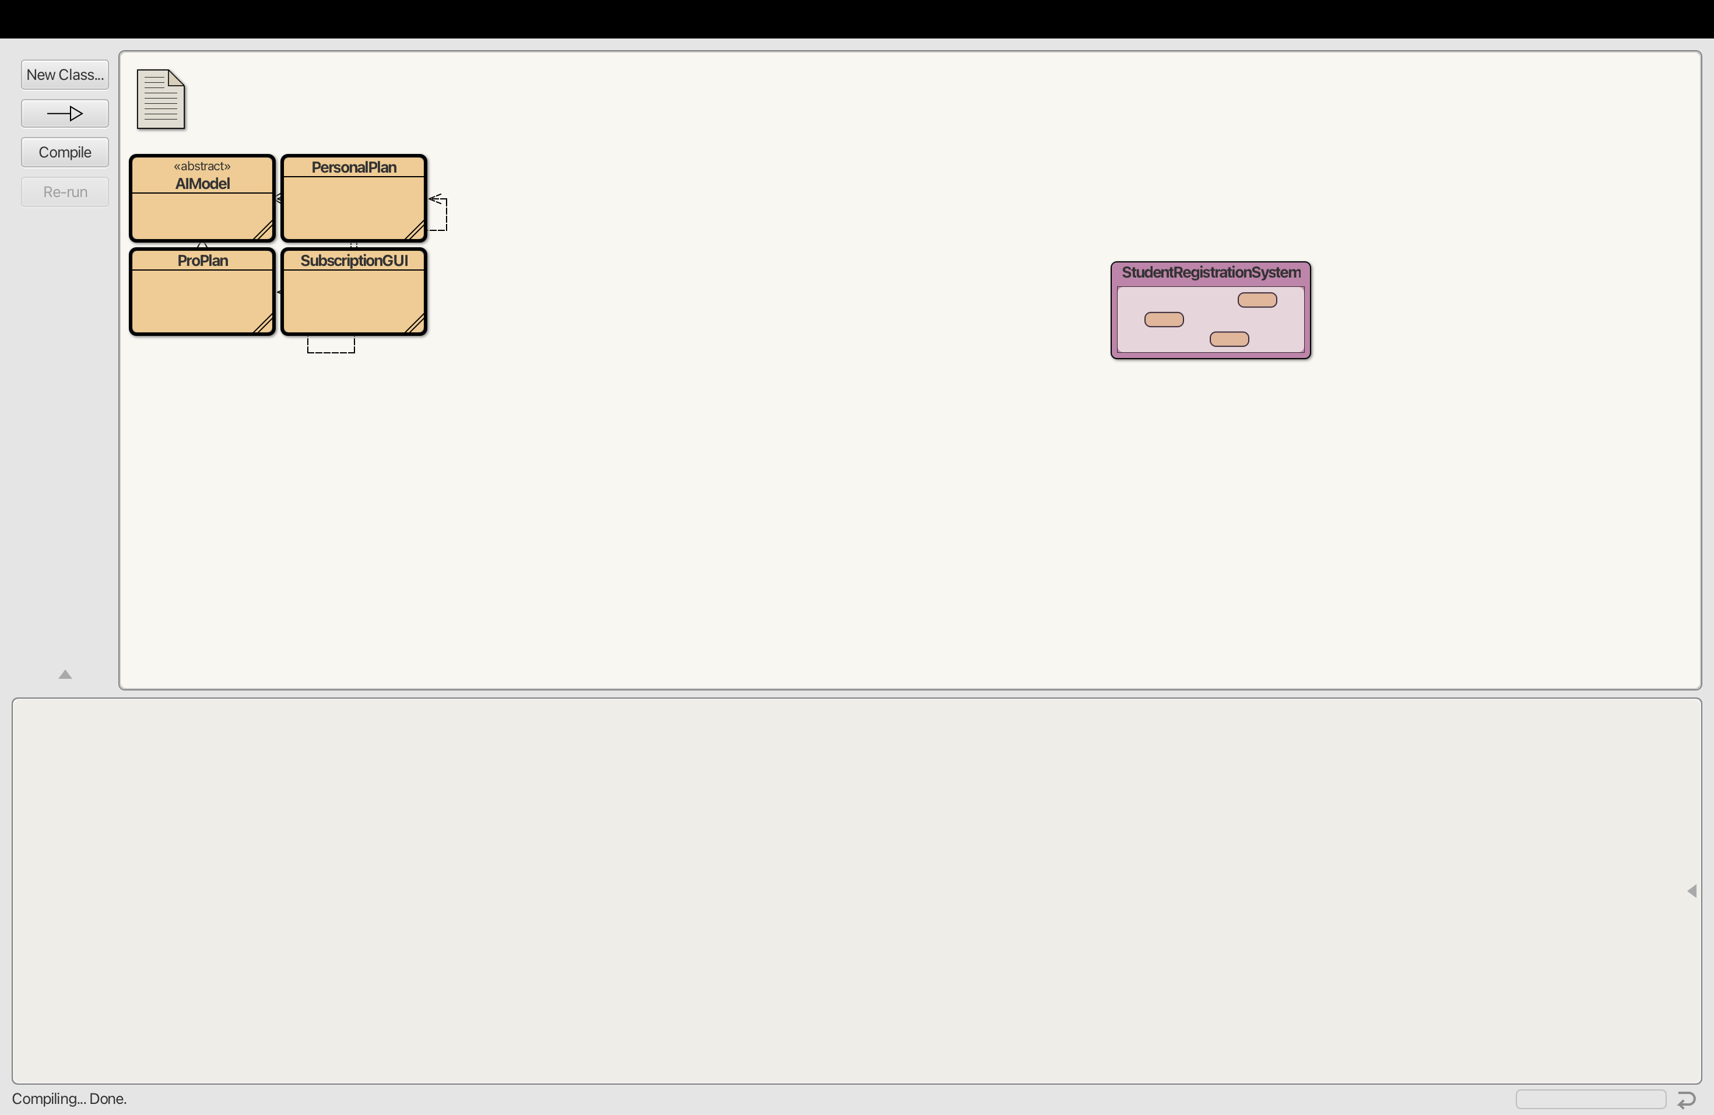
Figure 1. BlueJ project showing the compiled coursework classes.
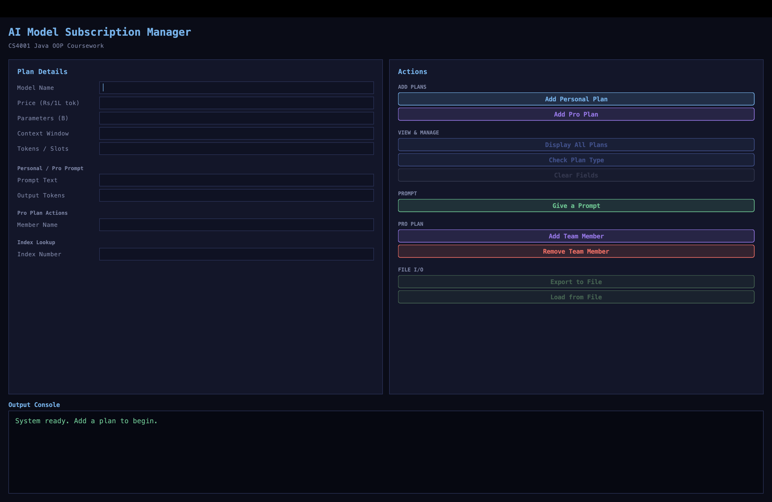
Figure 2. SubscriptionGUI running successfully.

Test 2: Add Personal Plan and Pro Plan
Item | Details
Objective | To check that both plan types can be added to the ArrayList.
Expected result | The output area should show that Personal Plan and Pro Plan were added with index numbers.
Actual result | Personal and Pro plans were added successfully, and Display All showed the saved plan details.
Short explanation | This test confirms plan creation, ArrayList storage and display output.

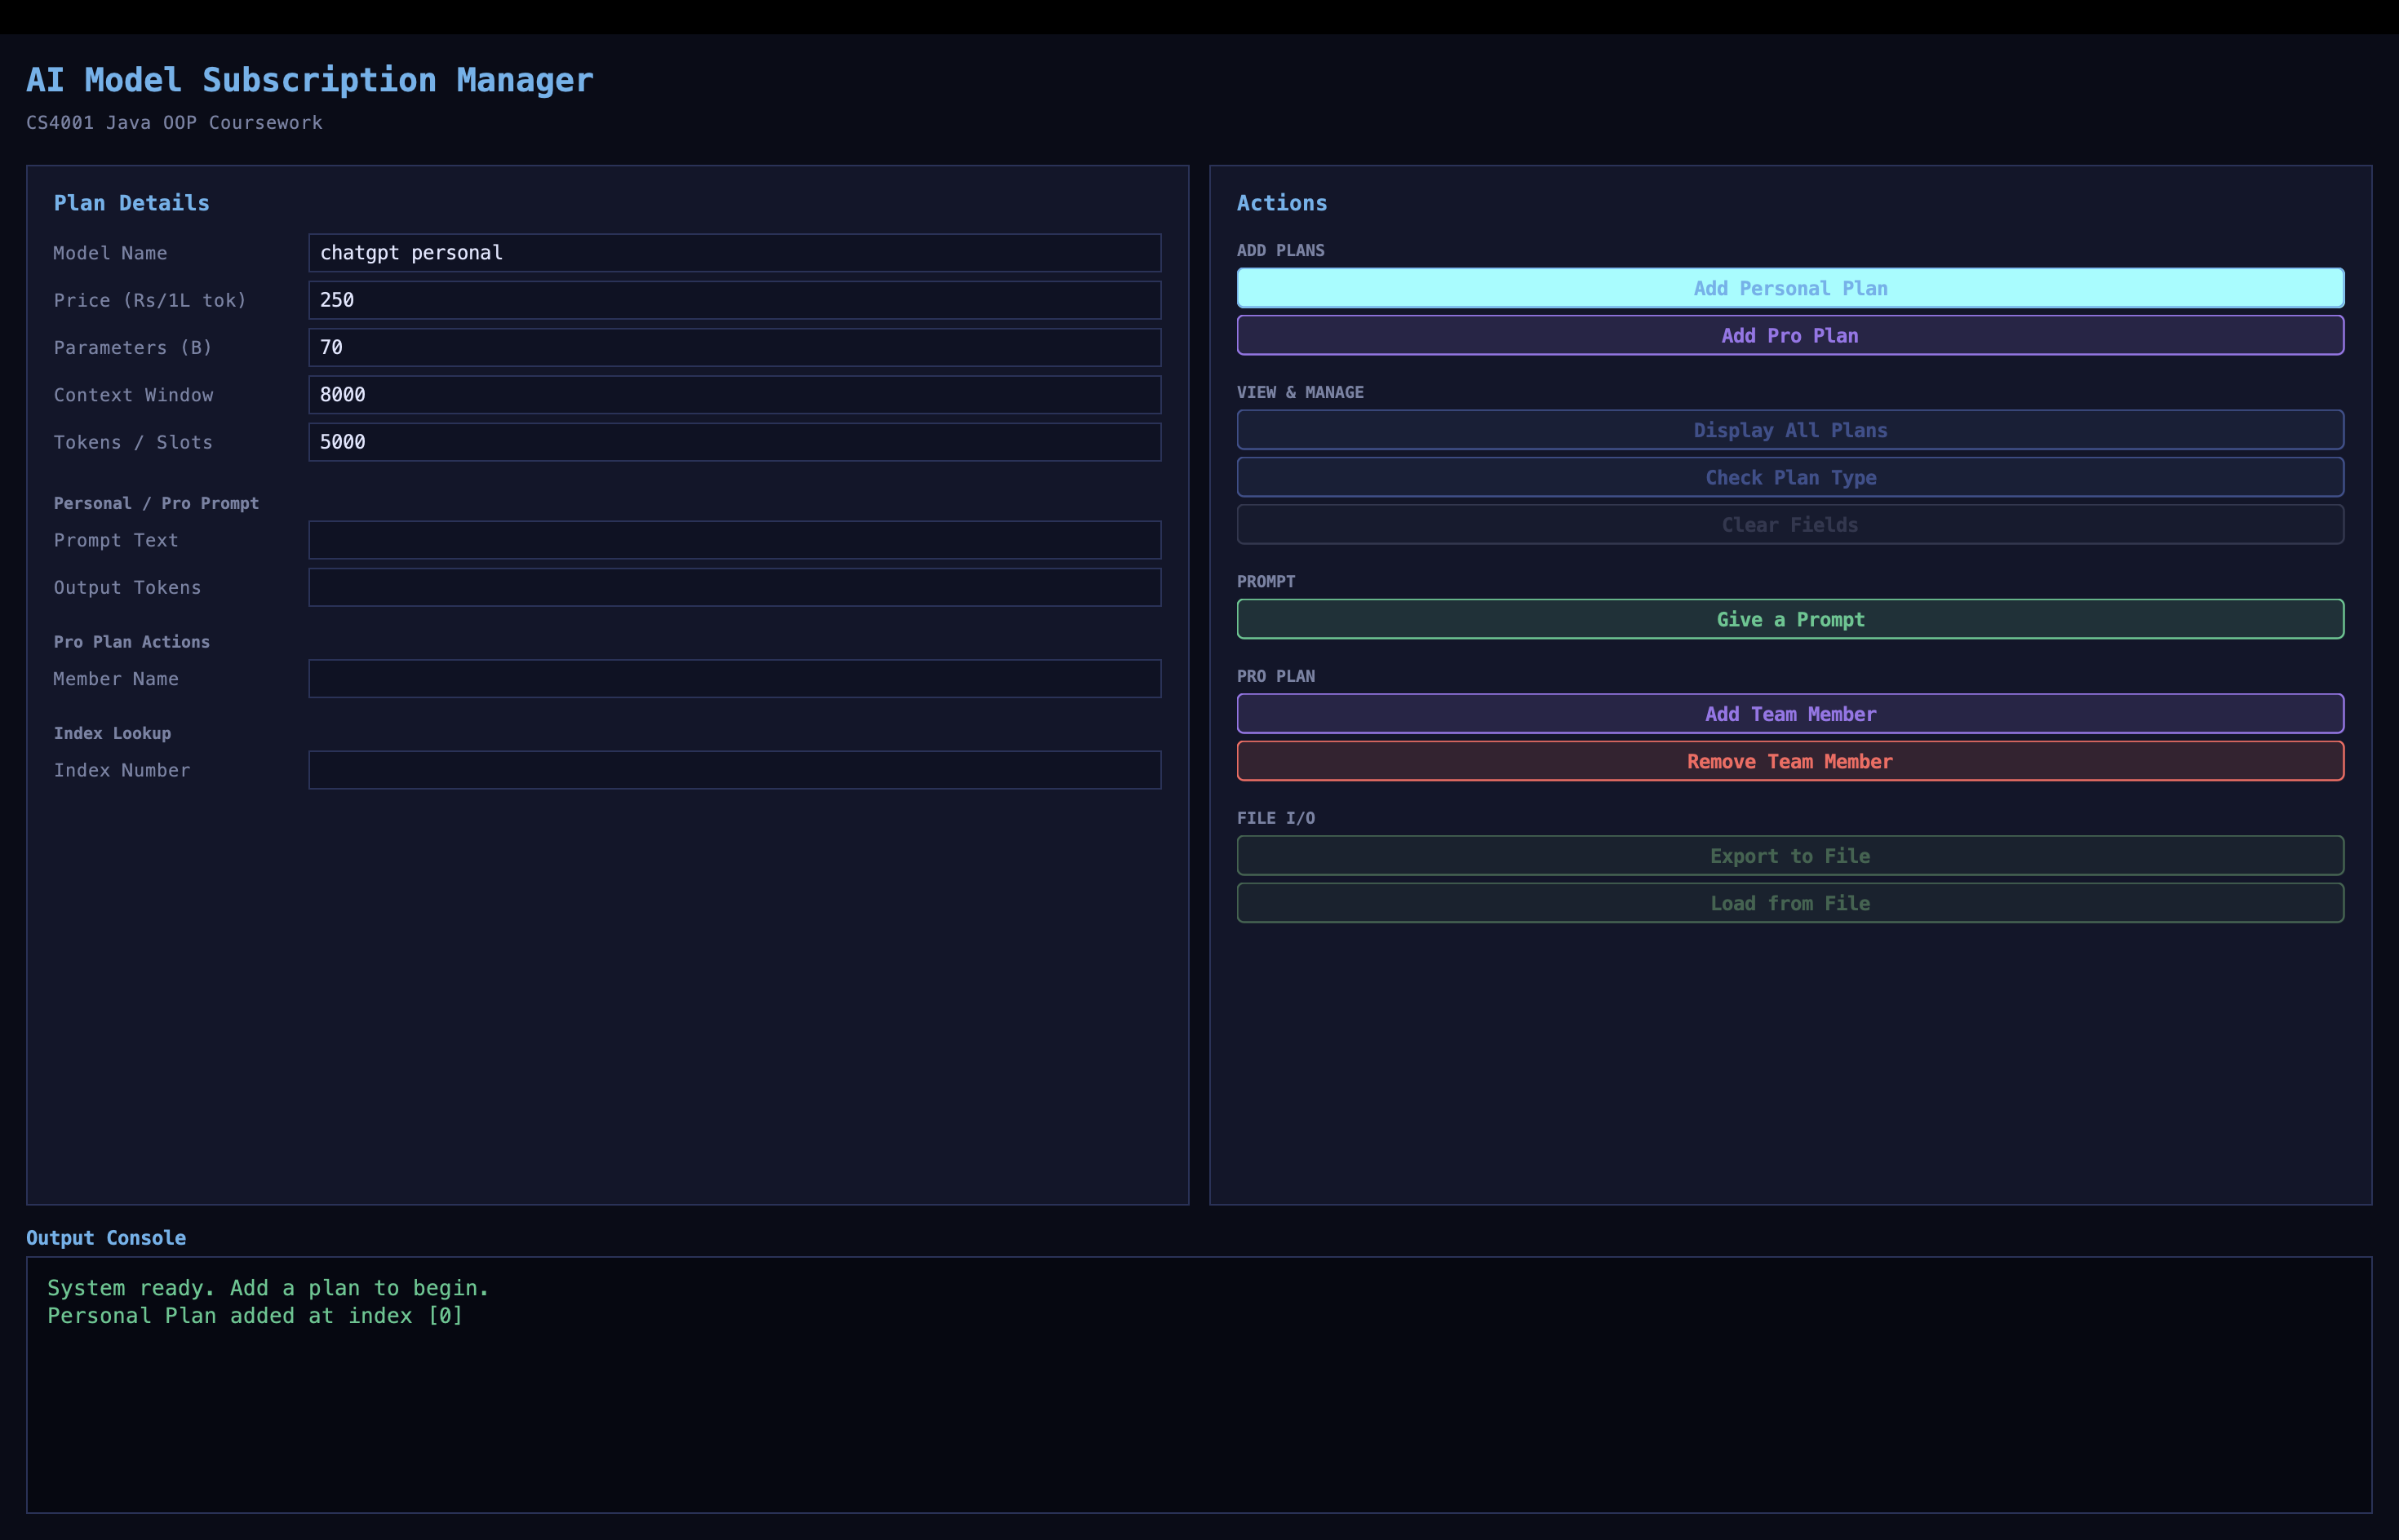
Figure 3. Personal Plan added through the GUI.
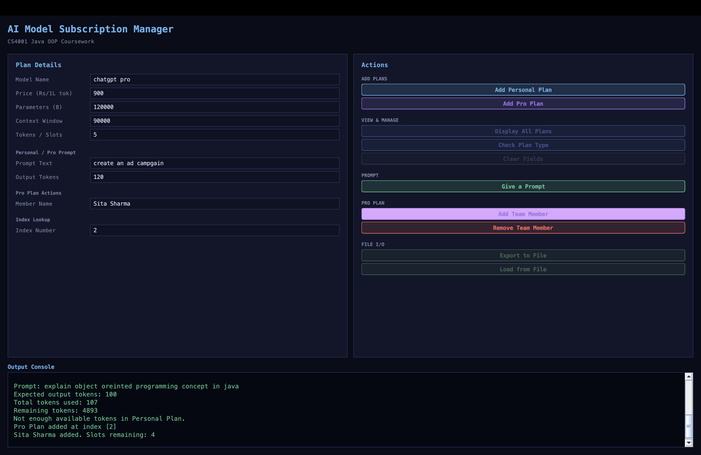
Figure 4. Pro Plan action shown through the GUI.
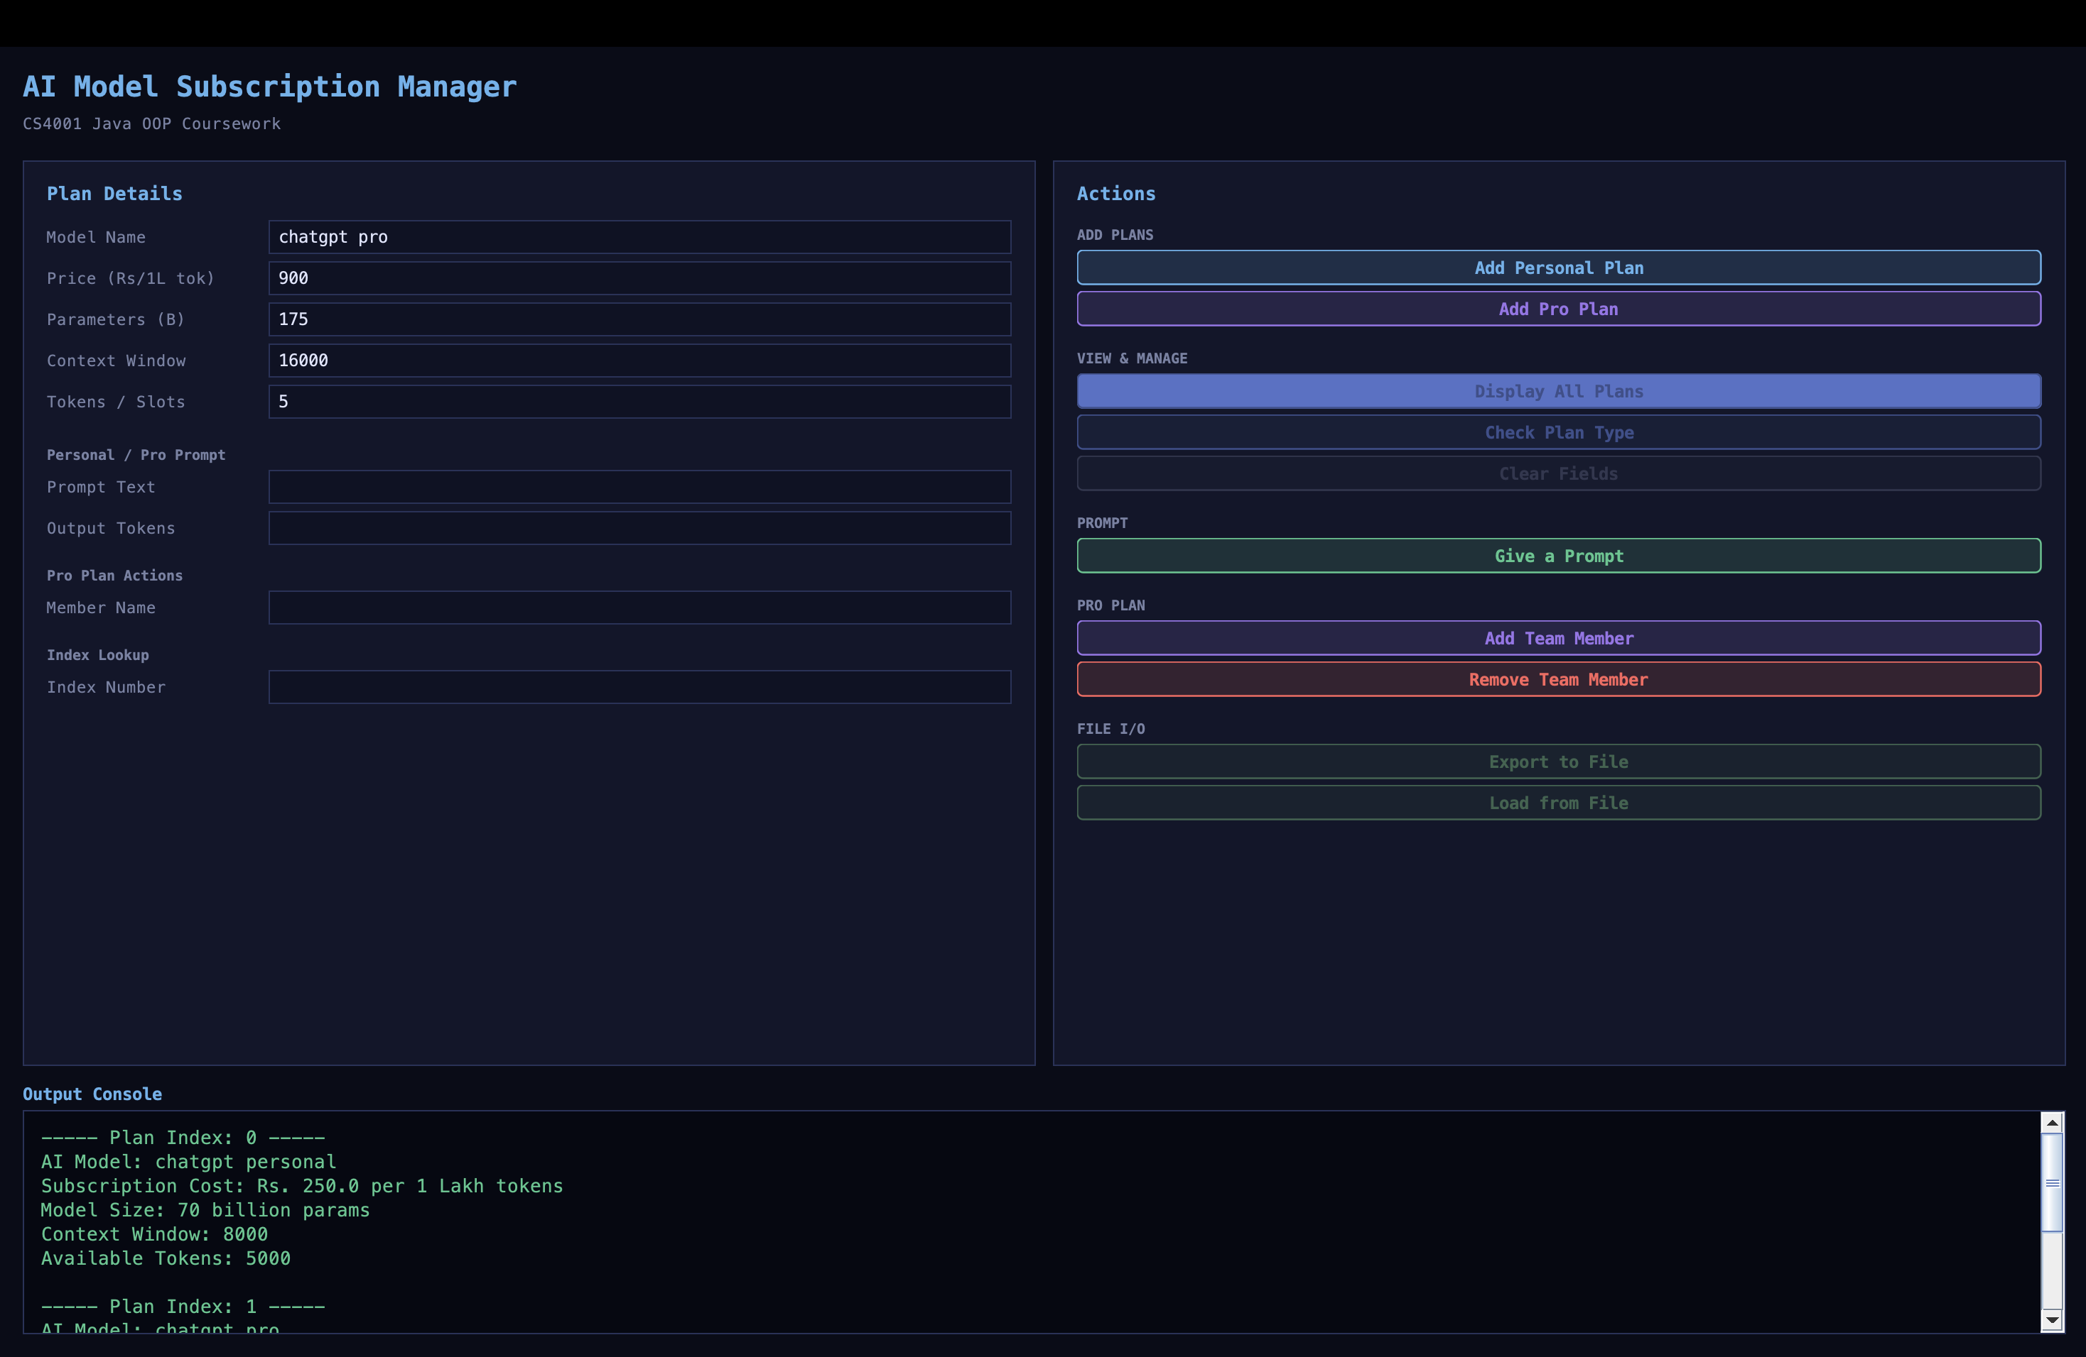
Figure 5. Display All output showing the saved plan details.

Test 3: Give Prompt
Item | Details
Objective | To check prompt execution and token calculation.
Expected result | PersonalPlan should reduce available tokens. ProPlan should show token usage without reducing a token balance.
Actual result | The prompt was executed successfully. Total tokens were calculated and remaining tokens were reduced for the Personal Plan.
Short explanation | This test confirms calculateTotalToken() and PersonalPlan token deduction.

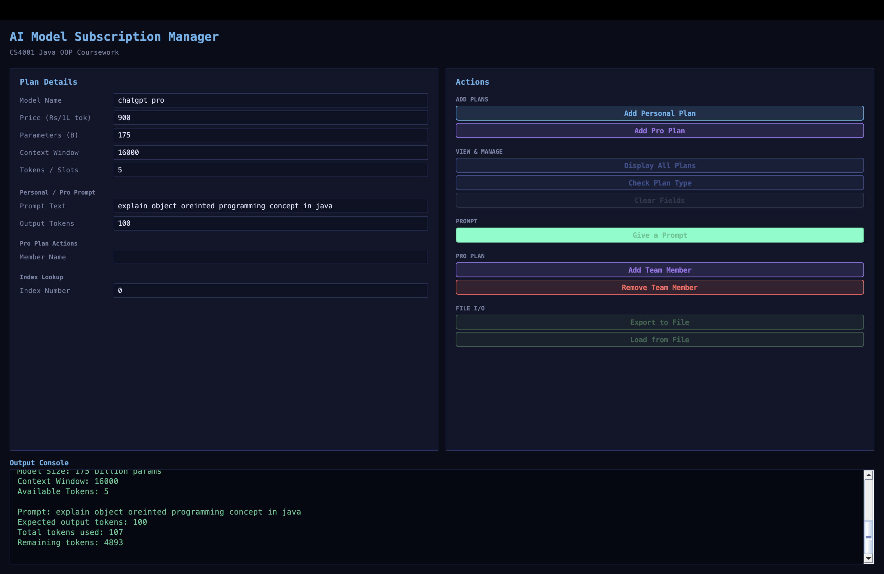
Figure 6. Prompt execution showing token calculation and deduction.

Test 4: Add Team Member
Item | Details
Objective | To check ProPlan team member management.
Expected result | The selected ProPlan should add the member and reduce teamSlots by one.
Actual result | A team member was added to the Pro Plan and the available slot count decreased.
Short explanation | This test confirms ProPlan team member and slot management.


Figure 7. Team member added to the Pro Plan.

Test 5: Invalid index error message
Item | Details
Objective | To check index validation and JOptionPane error handling.
Expected result | The program should show an error message for non-integer or out-of-range index input.
Actual result | An invalid index value displayed a JOptionPane error message.
Short explanation | This test confirms getIndex() validation and dialog-based error handling.

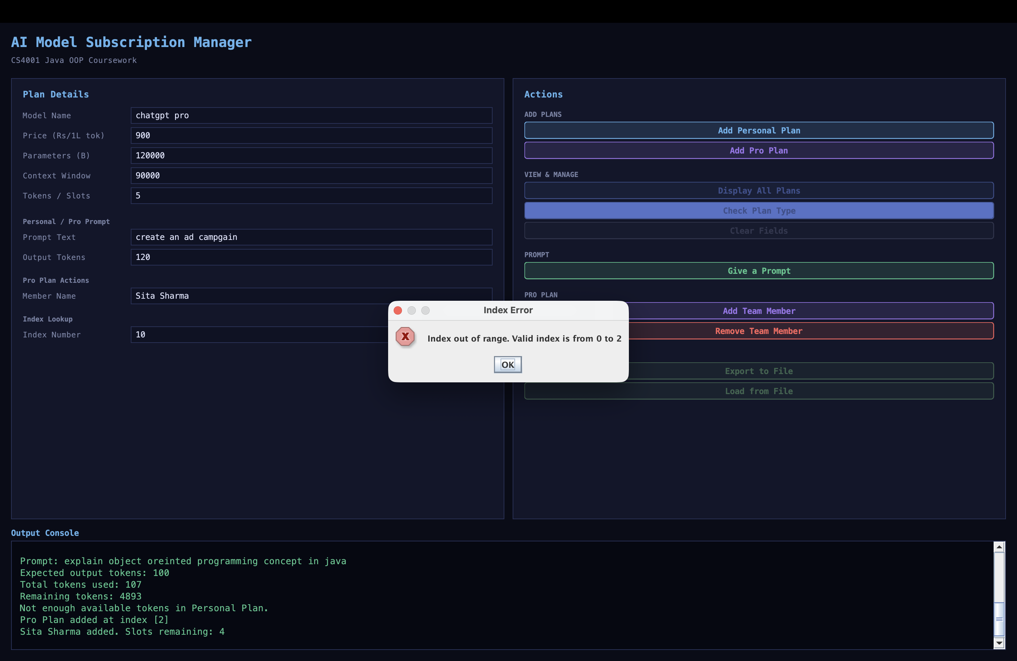
Figure 8. Error dialog displayed for an invalid index value.

Test 6: Export to file and load from file
Item | Details
Objective | To check file writing and file loading.
Expected result | The program should export plan data to plans_export.txt and load it back into the output area.
Actual result | The plan data was exported to plans_export.txt and loaded back into the GUI output area successfully.
Short explanation | This test confirms export to file and load from file behavior.

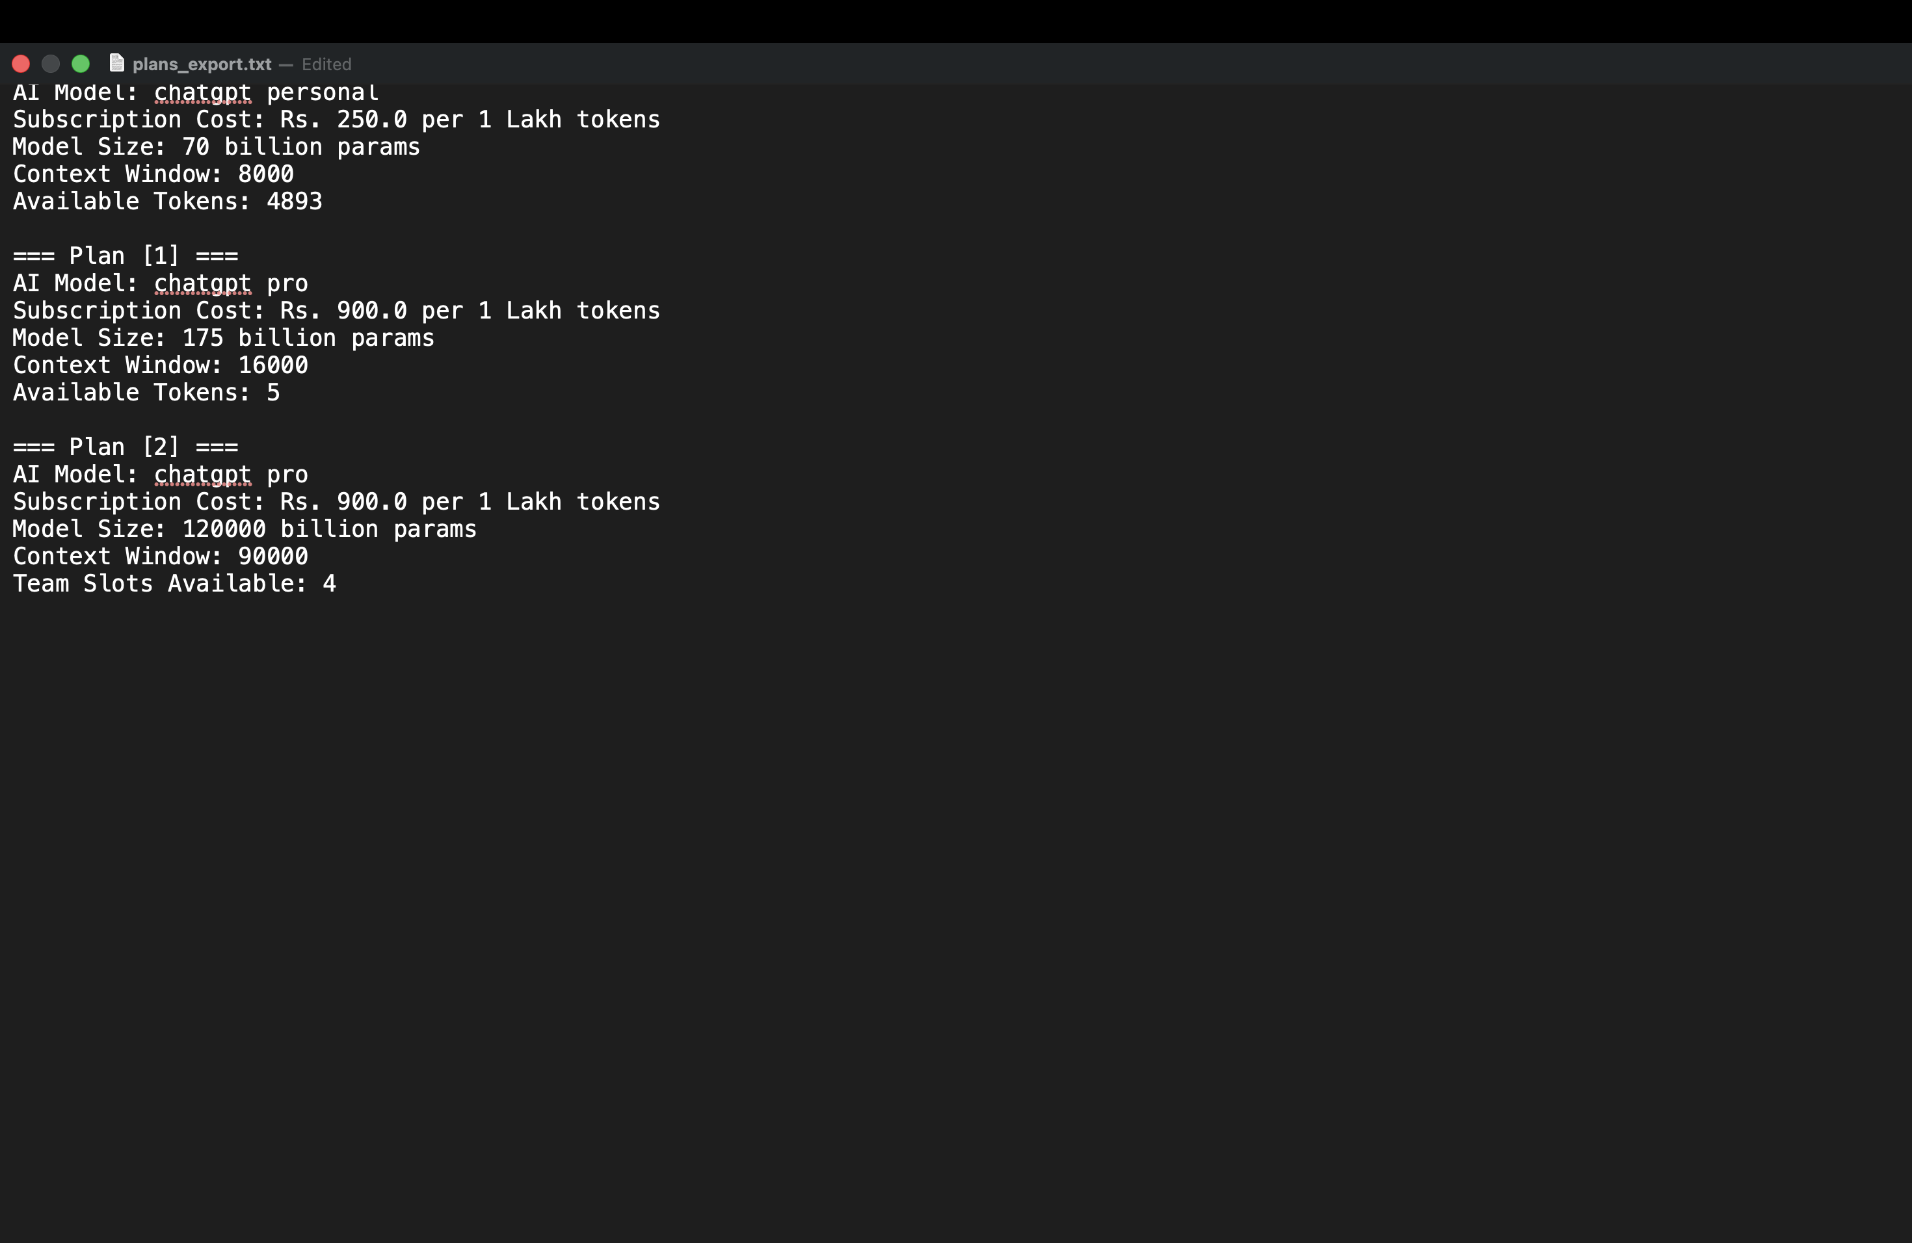
Figure 9. Exported file showing saved plan information.
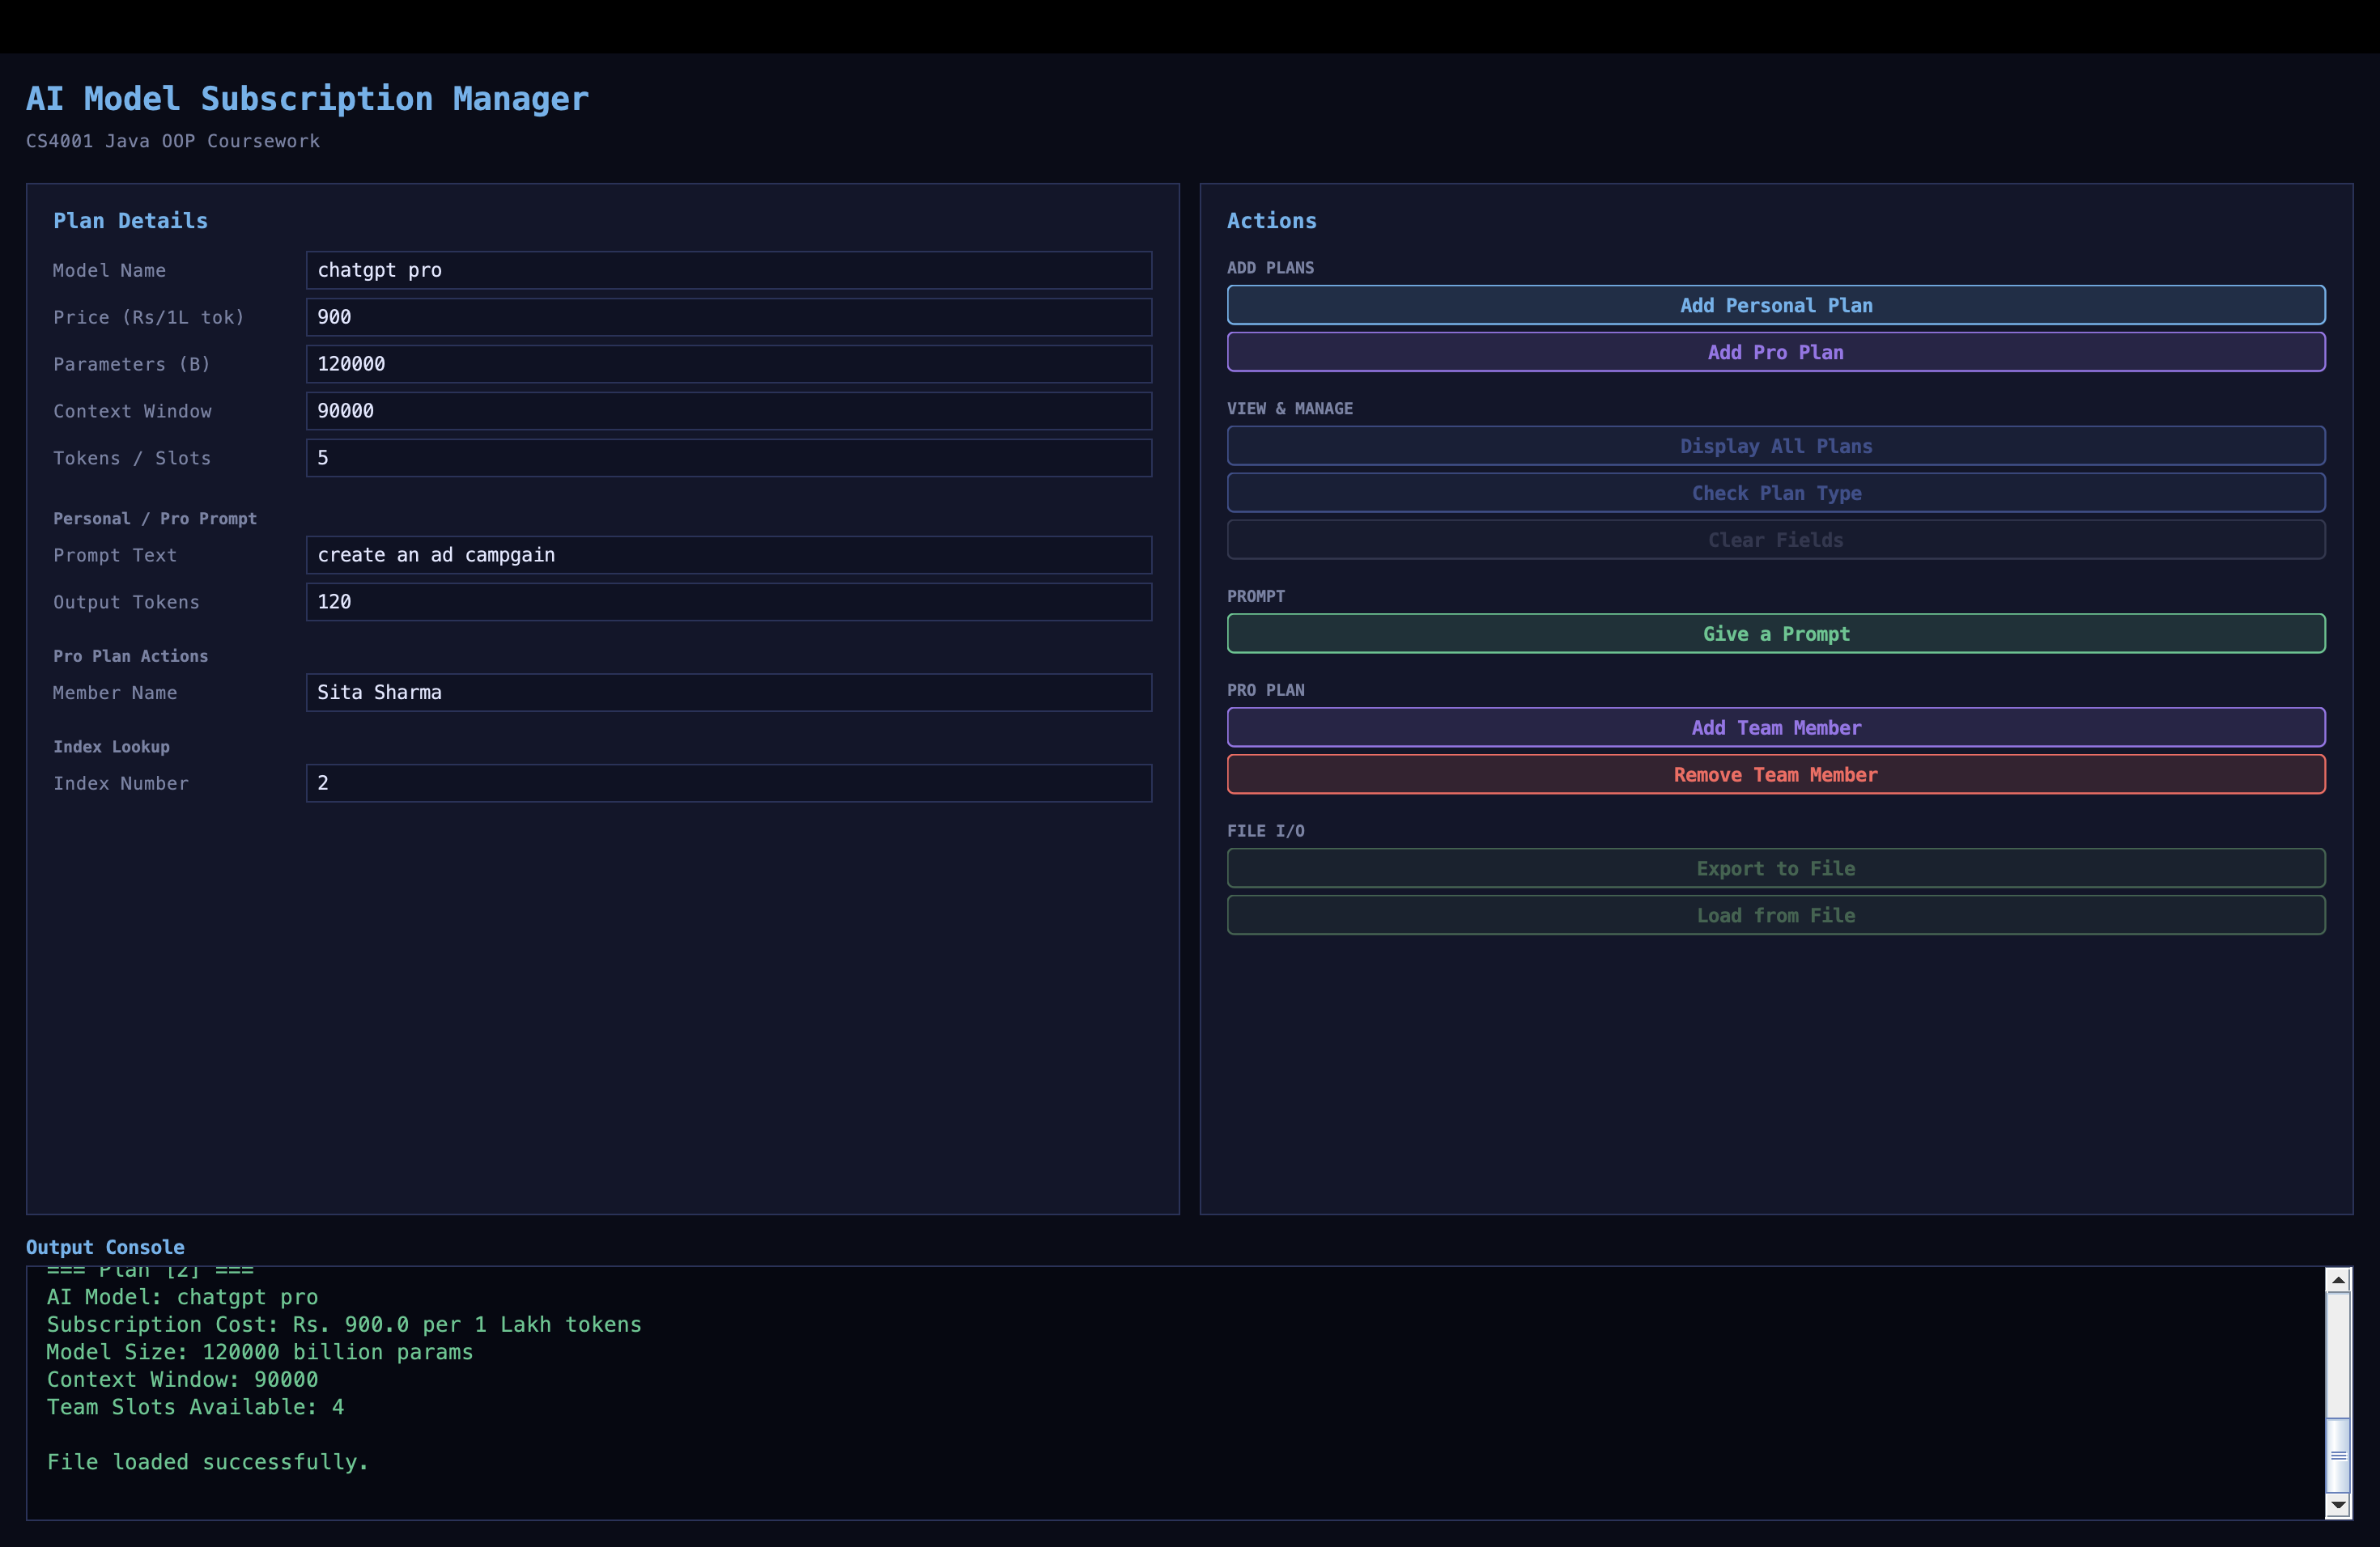
Figure 10. Loaded file content displayed successfully in the GUI.

8. Error Detection and Correction
During development and testing, common errors were checked and corrected. The examples below describe realistic error types in this project and explain how they were handled or corrected.

8.1 Syntax Error
Part | Details
Description of the error | A syntax error can occur if a bracket, semicolon or method signature is typed incorrectly while editing one of the Java classes.
How it was identified | It is identified during compilation in BlueJ or terminal because Java shows a compile-time error.
Solution | The missing or incorrect syntax is corrected, and the project is compiled again.
Evidence | Evidence can be shown using the BlueJ compile screenshot or a corrected code snippet.

8.2 Runtime/Input Error
Part | Details
Description of the error | A runtime/input error can occur if the user enters text into a numeric field such as price, parameters, context window, output tokens or index.
How it was identified | It is identified when the button is clicked and the program cannot convert the text to a number.
Solution | The GUI uses try/catch and JOptionPane messages to inform the user about invalid input.
Evidence | Evidence can be shown using the related GUI input validation message.

8.3 Logic/Input Validation Error
Part | Details
Description of the error | A logic/input validation issue can occur if an invalid index is accepted or if a ProPlan action is attempted on a PersonalPlan object.
How it was identified | It is identified during GUI testing by entering an invalid index or using a team action on the wrong plan type.
Solution | The getIndex() method checks the valid range, and instanceof checks the selected plan type before performing the action.
Evidence | Evidence can be shown using the invalid index JOptionPane screenshot in the testing section.

9. Conclusion and Reflection
Milestone 2 helped improve the coursework from basic classes into a more complete Java application with a graphical user interface. I used abstraction by making AIModel an abstract class, and I used inheritance through PersonalPlan and ProPlan.
The project also helped me understand polymorphism because the GUI stores different plan objects inside one ArrayList<AIModel>. The instanceof operator is then used to decide which action should be performed. I also practised input validation, JOptionPane error messages, file export and file load features. The updated token-based logic made the program more realistic because prompts now use calculated token values instead of only reducing a prompt count.

10. References
- CS4001 Programming Coursework Requirements and Milestone 2 brief, London Metropolitan University / Islington College, 2025-2026.
- Milestone 2 lecturer clarification message about abstract AIModel, numeric contextWindow and token-based plan logic.
- Oracle Java Documentation. Java Platform, Standard Edition documentation for Swing, ArrayList, exception handling and file I/O.

11. Appendix

Appendix A: AIModel.java
public abstract class AIModel {
private String modelName;
private double cost;
private int parameters;
private int contextWindow;

public AIModel(String modelName, double cost, int parameters, int contextWindow) {
this.modelName = modelName;
this.cost = cost;
this.parameters = parameters;
this.contextWindow = contextWindow;
}

public String getModelName() {
return modelName;
}

public double getCost() {
return cost;
}

public int getParameters() {
return parameters;
}

public int getContextWindow() {
return contextWindow;
}

public int calculateTotalToken(String promptText, int expectedOutputTokens) {
int inputTokens = 0;

if (promptText != null && !promptText.trim().isEmpty()) {
String[] words = promptText.trim().split("\\s+");
inputTokens = words.length;
}

int totalTokens = inputTokens + expectedOutputTokens;

if (totalTokens > contextWindow) {
throw new IllegalArgumentException("Total tokens exceed context window.");
}

return totalTokens;
}

public abstract String display();
}

Appendix B: PersonalPlan.java
public class PersonalPlan extends AIModel {
private int availableTokens;

public PersonalPlan(String modelName, double price, int parameters, int contextWindow, int availableTokens) {
super(modelName, price, parameters, contextWindow);
this.availableTokens = availableTokens;
}

public int getAvailableTokens() {
return availableTokens;
}

public String purchaseTokens(int tokens) {
if (tokens < 0) {
return "Error: Please enter a positive token value or upgrade to Pro Plan.";
}

availableTokens += tokens;
return "Tokens added successfully. Available tokens: " + availableTokens;
}

public String enterPrompt(String promptText, int expectedOutputTokens) {
try {
int totalTokens = calculateTotalToken(promptText, expectedOutputTokens);

if (totalTokens <= availableTokens) {
availableTokens -= totalTokens;
return "Prompt: " + promptText +
"\nExpected output tokens: " + expectedOutputTokens +
"\nTotal tokens used: " + totalTokens +
"\nRemaining tokens: " + availableTokens;
} else {
return "Not enough available tokens in Personal Plan.";
}
} catch (IllegalArgumentException e) {
return "Error: " + e.getMessage();
}
}

@Override
public String display() {
return "AI Model: " + getModelName() +
"\nSubscription Cost: Rs. " + getCost() + " per 1 Lakh tokens" +
"\nModel Size: " + getParameters() + " billion params" +
"\nContext Window: " + getContextWindow() +
"\nAvailable Tokens: " + availableTokens;
}
}

Appendix C: ProPlan.java
public class ProPlan extends AIModel {
private int teamSlots;

public ProPlan(String modelName, double price, int parameters, int contextWindow, int teamSlots) {
super(modelName, price, parameters, contextWindow);
this.teamSlots = teamSlots;
}

public int getTeamSlots() {
return teamSlots;
}

public String addTeamMember(String memberName) {
if (teamSlots > 0) {
teamSlots--;
return memberName + " added. Slots remaining: " + teamSlots;
}
return "Error: No available team slots.";
}

public String removeTeamMember(String memberName) {
teamSlots++;
return memberName + " removed. Slots available: " + teamSlots;
}

public String enterPrompt(String promptText, int expectedOutputTokens) {
try {
int totalTokens = calculateTotalToken(promptText, expectedOutputTokens);

return "Prompt: " + promptText +
"\nExpected output tokens: " + expectedOutputTokens +
"\nTotal tokens used: " + totalTokens +
"\nPro Plan token balance is not reduced.";
} catch (IllegalArgumentException e) {
return "Error: " + e.getMessage();
}
}

@Override
public String display() {
return "AI Model: " + getModelName() +
"\nSubscription Cost: Rs. " + getCost() + " per 1 Lakh tokens" +
"\nModel Size: " + getParameters() + " billion params" +
"\nContext Window: " + getContextWindow() +
"\nTeam Slots Available: " + teamSlots;
}
}

Appendix D: SubscriptionGUI.java
import javax.swing.*;
import javax.swing.border.*;
import java.awt.*;
import java.awt.event.*;
import java.awt.geom.*;
import java.util.ArrayList;
import java.io.*;

public class SubscriptionGUI extends JFrame implements ActionListener {

ArrayList<AIModel> planList = new ArrayList<AIModel>();

static final Color BG_DARK = new Color(10, 12, 24);
static final Color BG_CARD = new Color(18, 22, 42);
static final Color ACCENT = new Color(99, 179, 237);
static final Color ACCENT2 = new Color(154, 117, 234);
static final Color SUCCESS = new Color(72, 199, 142);
static final Color DANGER = new Color(252, 100, 94);
static final Color TEXT_MAIN = new Color(225, 230, 255);
static final Color TEXT_DIM = new Color(120, 130, 165);
static final Color BORDER_CLR = new Color(40, 50, 90);

JTextField tfName, tfPrice, tfParams, tfContext,
tfQuotaSlots, tfPromptText, tfResponseLen,
tfMemberName, tfIndex;

JTextArea outputArea;

JButton btnAddPersonal, btnAddPro, btnDisplayAll, btnClear,
btnGivePrompt, btnAddMember, btnRemoveMember,
btnCheckType, btnExport, btnLoad;

public SubscriptionGUI() {
setTitle("AI Subscription Manager");
setDefaultCloseOperation(EXIT_ON_CLOSE);
setSize(900, 680);
setLocationRelativeTo(null);
setBackground(BG_DARK);

JPanel root = new JPanel(new BorderLayout(0, 0));
root.setBackground(BG_DARK);
root.setBorder(new EmptyBorder(16, 16, 16, 16));
setContentPane(root);

root.add(buildHeader(), BorderLayout.NORTH);
root.add(buildCenter(), BorderLayout.CENTER);
root.add(buildOutputPanel(), BorderLayout.SOUTH);
}

private JPanel buildHeader() {
JPanel p = new JPanel(new BorderLayout());
p.setBackground(BG_DARK);
p.setBorder(new EmptyBorder(0, 0, 14, 0));

JLabel title = new JLabel("AI Model Subscription Manager");
title.setFont(new Font("Monospaced", Font.BOLD, 20));
title.setForeground(ACCENT);

JLabel sub = new JLabel("CS4001 Java OOP Coursework");
sub.setFont(new Font("Monospaced", Font.PLAIN, 11));
sub.setForeground(TEXT_DIM);

JPanel left = new JPanel(new GridLayout(2, 1, 2, 2));
left.setBackground(BG_DARK);
left.add(title);
left.add(sub);
p.add(left, BorderLayout.WEST);

return p;
}

private JPanel buildCenter() {
JPanel center = new JPanel(new GridLayout(1, 2, 12, 0));
center.setBackground(BG_DARK);
center.add(buildInputCard());
center.add(buildActionsCard());
return center;
}

private JPanel buildInputCard() {
JPanel card = createCard("Plan Details");

tfName = addRow(card, "Model Name", "e.g. DeepSeek-R1");
tfPrice = addRow(card, "Price (Rs/1L tok)", "e.g. 350.0");
tfParams = addRow(card, "Parameters (B)", "e.g. 90");
tfContext = addRow(card, "Context Window", "e.g. 96000");
tfQuotaSlots = addRow(card, "Tokens / Slots", "Personal=Tokens, Pro=Slots");

card.add(Box.createVerticalStrut(10));
addSectionLabel(card, "Personal / Pro Prompt");
tfPromptText = addRow(card, "Prompt Text", "Enter your query...");
tfResponseLen = addRow(card, "Output Tokens", "e.g. 300");

card.add(Box.createVerticalStrut(6));
addSectionLabel(card, "Pro Plan Actions");
tfMemberName = addRow(card, "Member Name", "e.g. Sita Sharma");

card.add(Box.createVerticalStrut(6));
addSectionLabel(card, "Index Lookup");
tfIndex = addRow(card, "Index Number", "0, 1, 2 ...");

card.add(Box.createVerticalGlue());
return card;
}

private JPanel buildActionsCard() {
JPanel card = createCard("Actions");

addSectionLabel(card, "ADD PLANS");
btnAddPersonal = addBtn(card, "Add Personal Plan", ACCENT);
btnAddPro = addBtn(card, "Add Pro Plan", ACCENT2);

card.add(Box.createVerticalStrut(8));
addSectionLabel(card, "VIEW & MANAGE");
btnDisplayAll = addBtn(card, "Display All Plans", new Color(60, 80, 140));
btnCheckType = addBtn(card, "Check Plan Type", new Color(60, 80, 140));
btnClear = addBtn(card, "Clear Fields", new Color(50, 55, 80));

card.add(Box.createVerticalStrut(8));
addSectionLabel(card, "PROMPT");
btnGivePrompt = addBtn(card, "Give a Prompt", SUCCESS);

card.add(Box.createVerticalStrut(8));
addSectionLabel(card, "PRO PLAN");
btnAddMember = addBtn(card, "Add Team Member", ACCENT2);
btnRemoveMember = addBtn(card, "Remove Team Member", DANGER);

card.add(Box.createVerticalStrut(8));
addSectionLabel(card, "FILE I/O");
btnExport = addBtn(card, "Export to File", new Color(60, 100, 80));
btnLoad = addBtn(card, "Load from File", new Color(60, 100, 80));

card.add(Box.createVerticalGlue());
return card;
}

private JPanel buildOutputPanel() {
JPanel p = new JPanel(new BorderLayout());
p.setBackground(BG_DARK);
p.setBorder(new EmptyBorder(12, 0, 0, 0));

JLabel lbl = new JLabel("Output Console");
lbl.setFont(new Font("Monospaced", Font.BOLD, 12));
lbl.setForeground(ACCENT);
lbl.setBorder(new EmptyBorder(0, 0, 4, 0));

outputArea = new JTextArea(8, 40);
outputArea.setBackground(new Color(6, 8, 18));
outputArea.setForeground(SUCCESS);
outputArea.setFont(new Font("Monospaced", Font.PLAIN, 13));
outputArea.setCaretColor(ACCENT);
outputArea.setEditable(false);
outputArea.setBorder(new EmptyBorder(10, 12, 10, 12));
outputArea.setText("System ready. Add a plan to begin.\n");

JScrollPane scroll = new JScrollPane(outputArea);
scroll.setBorder(BorderFactory.createLineBorder(BORDER_CLR, 1));
scroll.setBackground(BG_DARK);

p.add(lbl, BorderLayout.NORTH);
p.add(scroll, BorderLayout.CENTER);
return p;
}

public void actionPerformed(ActionEvent e) {
Object src = e.getSource();

if (src == btnAddPersonal) {
try {
String name = tfName.getText().trim();
double price = Double.parseDouble(tfPrice.getText().trim());
int params = Integer.parseInt(tfParams.getText().trim());
int context = Integer.parseInt(tfContext.getText().trim());
int tokens = Integer.parseInt(tfQuotaSlots.getText().trim());

if (name.isEmpty()) {
throw new Exception("Model name is empty.");
}

planList.add(new PersonalPlan(name, price, params, context, tokens));
print("Personal Plan added at index [" + (planList.size() - 1) + "]");
} catch (Exception ex) {
JOptionPane.showMessageDialog(this, "Invalid input for Personal Plan.", "Input Error", JOptionPane.ERROR_MESSAGE);
}

} else if (src == btnAddPro) {
try {
String name = tfName.getText().trim();
double price = Double.parseDouble(tfPrice.getText().trim());
int params = Integer.parseInt(tfParams.getText().trim());
int context = Integer.parseInt(tfContext.getText().trim());
int slots = Integer.parseInt(tfQuotaSlots.getText().trim());

if (name.isEmpty()) {
throw new Exception("Model name is empty.");
}

planList.add(new ProPlan(name, price, params, context, slots));
print("Pro Plan added at index [" + (planList.size() - 1) + "]");
} catch (Exception ex) {
JOptionPane.showMessageDialog(this, "Invalid input for Pro Plan.", "Input Error", JOptionPane.ERROR_MESSAGE);
}

} else if (src == btnDisplayAll) {
if (planList.isEmpty()) {
print("No plans added yet.");
return;
}

outputArea.setText("");
for (int i = 0; i < planList.size(); i++) {
print("----- Plan Index: " + i + " -----");
print(planList.get(i).display());
print("");
}

} else if (src == btnClear) {
tfName.setText("");
tfPrice.setText("");
tfParams.setText("");
tfContext.setText("");
tfQuotaSlots.setText("");
tfPromptText.setText("");
tfResponseLen.setText("");
tfMemberName.setText("");
tfIndex.setText("");
print("Fields cleared.");

} else if (src == btnGivePrompt) {
int idx = getIndex();
if (idx == -1) {
return;
}

try {
String promptText = tfPromptText.getText().trim();
int responseLen = Integer.parseInt(tfResponseLen.getText().trim());

AIModel obj = planList.get(idx);

if (obj instanceof PersonalPlan) {
PersonalPlan pp = (PersonalPlan) obj;
print(pp.enterPrompt(promptText, responseLen));
} else if (obj instanceof ProPlan) {
ProPlan pro = (ProPlan) obj;
print(pro.enterPrompt(promptText, responseLen));
} else {
print("Unknown plan type.");
}
} catch (NumberFormatException ex) {
JOptionPane.showMessageDialog(this, "Please enter valid output tokens.", "Input Error", JOptionPane.ERROR_MESSAGE);
}

} else if (src == btnAddMember) {
int idx = getIndex();
if (idx == -1) {
return;
}

AIModel obj = planList.get(idx);
if (obj instanceof ProPlan) {
ProPlan pro = (ProPlan) obj;
print(pro.addTeamMember(tfMemberName.getText().trim()));
} else {
JOptionPane.showMessageDialog(this, "This operation is only for Pro Plan.", "Type Error", JOptionPane.ERROR_MESSAGE);
}

} else if (src == btnRemoveMember) {
int idx = getIndex();
if (idx == -1) {
return;
}

AIModel obj = planList.get(idx);
if (obj instanceof ProPlan) {
ProPlan pro = (ProPlan) obj;
print(pro.removeTeamMember(tfMemberName.getText().trim()));
} else {
JOptionPane.showMessageDialog(this, "This operation is only for Pro Plan.", "Type Error", JOptionPane.ERROR_MESSAGE);
}

} else if (src == btnCheckType) {
int idx = getIndex();
if (idx == -1) {
return;
}

AIModel obj = planList.get(idx);

if (obj instanceof PersonalPlan) {
print("Plan at index [" + idx + "] is Personal Plan.");
} else if (obj instanceof ProPlan) {
print("Plan at index [" + idx + "] is Pro Plan.");
} else {
print("Unknown plan type.");
}

} else if (src == btnExport) {
exportToFile();

} else if (src == btnLoad) {
loadFromFile();
}
}

private int getIndex() {
int idx = -1;

try {
idx = Integer.parseInt(tfIndex.getText().trim());

if (idx < 0 || idx >= planList.size()) {
JOptionPane.showMessageDialog(this,
"Index out of range. Valid index is from 0 to " + (planList.size() - 1),
"Index Error",
JOptionPane.ERROR_MESSAGE);
return -1;
}
} catch (NumberFormatException ex) {
JOptionPane.showMessageDialog(this,
"Please enter a valid integer index.",
"Input Error",
JOptionPane.ERROR_MESSAGE);
return -1;
}

return idx;
}

private void exportToFile() {
try {
PrintWriter pw = new PrintWriter(new FileWriter("plans_export.txt"));

for (int i = 0; i < planList.size(); i++) {
pw.println("=== Plan [" + i + "] ===");
pw.println(planList.get(i).display());
pw.println();
}

pw.close();
print("Exported successfully to plans_export.txt");
} catch (IOException ex) {
print("Export failed: " + ex.getMessage());
}
}

private void loadFromFile() {
try {
BufferedReader br = new BufferedReader(new FileReader("plans_export.txt"));
outputArea.setText("");

String line;
while ((line = br.readLine()) != null) {
outputArea.append(line + "\n");
}

br.close();
print("File loaded successfully.");
} catch (IOException ex) {
print("Load failed: " + ex.getMessage());
}
}

private void print(String msg) {
outputArea.append(msg + "\n");
outputArea.setCaretPosition(outputArea.getDocument().getLength());
}

private JPanel createCard(String title) {
JPanel card = new JPanel();
card.setLayout(new BoxLayout(card, BoxLayout.Y_AXIS));
card.setBackground(BG_CARD);
card.setBorder(BorderFactory.createCompoundBorder(
BorderFactory.createLineBorder(BORDER_CLR, 1),
new EmptyBorder(14, 16, 14, 16)
));

JLabel lbl = new JLabel(title);
lbl.setFont(new Font("Monospaced", Font.BOLD, 13));
lbl.setForeground(ACCENT);
lbl.setAlignmentX(LEFT_ALIGNMENT);
lbl.setBorder(new EmptyBorder(0, 0, 10, 0));
card.add(lbl);
return card;
}

private JTextField addRow(JPanel card, String label, String hint) {
JPanel row = new JPanel(new BorderLayout(8, 0));
row.setBackground(BG_CARD);
row.setMaximumSize(new Dimension(Integer.MAX_VALUE, 32));
row.setAlignmentX(LEFT_ALIGNMENT);

JLabel lbl = new JLabel(label);
lbl.setFont(new Font("Monospaced", Font.PLAIN, 11));
lbl.setForeground(TEXT_DIM);
lbl.setPreferredSize(new Dimension(148, 24));

JTextField tf = new JTextField();
tf.setFont(new Font("Monospaced", Font.PLAIN, 12));
tf.setBackground(new Color(14, 18, 36));
tf.setForeground(TEXT_MAIN);
tf.setCaretColor(ACCENT);
tf.setBorder(BorderFactory.createCompoundBorder(
BorderFactory.createLineBorder(BORDER_CLR, 1),
new EmptyBorder(2, 6, 2, 6)
));
tf.setToolTipText(hint);

row.add(lbl, BorderLayout.WEST);
row.add(tf, BorderLayout.CENTER);
card.add(row);
card.add(Box.createVerticalStrut(5));
return tf;
}

private JButton addBtn(JPanel card, String text, Color color) {
JButton btn = new JButton(text) {
protected void paintComponent(Graphics g) {
Graphics2D g2 = (Graphics2D) g.create();
g2.setRenderingHint(RenderingHints.KEY_ANTIALIASING, RenderingHints.VALUE_ANTIALIAS_ON);

if (getModel().isPressed()) {
g2.setColor(color.darker());
} else if (getModel().isRollover()) {
g2.setColor(color.brighter());
} else {
g2.setColor(new Color(color.getRed(), color.getGreen(), color.getBlue(), 40));
}

g2.fillRoundRect(0, 0, getWidth(), getHeight(), 8, 8);
g2.setColor(color);
g2.setStroke(new BasicStroke(1.2f));
g2.drawRoundRect(0, 0, getWidth() - 1, getHeight() - 1, 8, 8);
g2.dispose();

super.paintComponent(g);
}
};

btn.setFont(new Font("Monospaced", Font.BOLD, 12));
btn.setForeground(color);
btn.setBackground(new Color(0, 0, 0, 0));
btn.setOpaque(false);
btn.setContentAreaFilled(false);
btn.setBorderPainted(false);
btn.setFocusPainted(false);
btn.setCursor(new Cursor(Cursor.HAND_CURSOR));
btn.setMaximumSize(new Dimension(Integer.MAX_VALUE, 34));
btn.setAlignmentX(LEFT_ALIGNMENT);
btn.addActionListener(this);

card.add(btn);
card.add(Box.createVerticalStrut(4));
return btn;
}

private void addSectionLabel(JPanel card, String text) {
JLabel lbl = new JLabel(text);
lbl.setFont(new Font("Monospaced", Font.BOLD, 10));
lbl.setForeground(TEXT_DIM);
lbl.setAlignmentX(LEFT_ALIGNMENT);
lbl.setBorder(new EmptyBorder(4, 0, 4, 0));
card.add(lbl);
}

public static void main(String[] args) {
try {
UIManager.setLookAndFeel(UIManager.getCrossPlatformLookAndFeelClassName());
} catch (Exception e) {
}

SwingUtilities.invokeLater(new Runnable() {
public void run() {
new SubscriptionGUI().setVisible(true);
}
});
}
}

