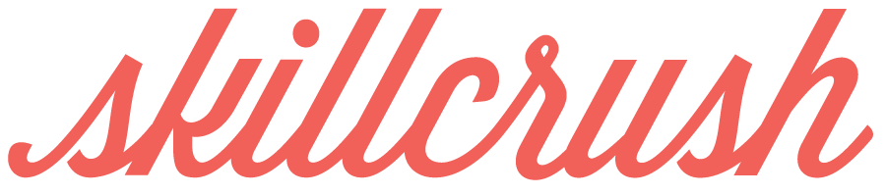

WEBSITE QUESTIONNAIRE

**GENERAL INFORMATION**

**What will the purpose of this site be?**

I want to promote my skills while clearly showing my personality, who I am, and how that relates to my work. I want my audience to clearly know what I do, how to find samples of my work, and to understand who I am as a person.

**AUDIENCE**

**Who are the people I really want to reach with my site?** *Describe your target user for the site (ie. new clients, other design professionals to network with, companies).*

New individual clients looking for online folios, web design and development companies like Squarespace, and small businesses/publishing presses and publications whose MO I find appealing and who does meaningful work (i.e. businesses dealing in fair trade / invested in social justice measures; magazine publications like Darling or Cultivate)

**What are the 3 main actions I want my users to take?** *List the most important first.*

1. View my work in an interactive way

2. Learn my skills, prior experience and areas of expertise

3. Contact me directly and/or connect with me on socials

**WEBSITE DETAILS**

**What will I call my website?**

1. Kathrene Faith
2. K. Faith Websites & Design

I definitely want my name in there for a personal touch. Any variation of the above works (i.e., just plain Kathrene Faith)

**What will the URL be? Is it available?**

[www.kathrenefaith.com](http://www.kathrenefaith.com) -- yes, it is available.