**2AFC – 4labels**

contrasts(picLab.clean$learning)

FL

LF 0

FL 1

Output of the models:

Formula:

acc ~ correctFrequency.ct*learning.ct + (correctFrequency.ct|subjID)

Estimate Std. Error z value Pr(>|z|)

(Intercept) 1.2291 0.2016 6.0982 0.0000

correctFrequency.ct -4.1936 0.3675 -11.4102 0.0000

learning.ct -0.3331 0.3600 -0.9254 0.3547

correctFrequency.ct:learning.ct -0.4140 0.6401 -0.6468 0.5178

Formula:

acc ~ correctFrequency.ct+ correctFrequency: learning.ct + (correctFrequency.ct|subjID)

Estimate Std. Error z value Pr(>|z|)

(Intercept) 1.2291 0.2016 6.0983 0.0000

correctFrequency.ct -4.1936 0.3675 -11.4098 0.0000

correctFrequencyhigh:learning.ct -0.1261 0.5726 -0.2203 0.8257

correctFrequencylow:learning.ct -0.5401 0.3691 -1.4632 0.1434

|  |  |  |  |
| --- | --- | --- | --- |
| Hypotheses  (as outlined in the  Hypotheses section of the preregistration) | Summary of the data from GLME with the following fixed effects: | Effect of interest (beta and SE for the relevant coefficient will be extracted as our model of the data). | BF |
| D | frequency(Centered) * learning(Centered) | main effect of frequency | 4.348894e+26 |
| C | main effect of learning | 1.054435 |
| B | interaction frequency by learning | 0.8701465 |
| A.2 | frequency_Dummy : learning(Centered) | simple effect of learning for high frequency | 1.641388 |
| A.1 | frequency_Dummy : learning(Centered) | Simple effect of learning for low frequency | 1.453641 |

**2AFC – 4pictures**

contrasts(labPic.clean$learning)

FL

LF 0

FL 1

Output of the models:

Formula:

acc ~ correctFrequency.ct*learning.ct + (correctFrequency.ct|subjID)

Estimate Std. Error z value Pr(>|z|)

(Intercept) 0.4492 0.1320 3.4030 0.0007

correctFrequency.ct -3.9138 0.2750 -14.2343 0.0000

learning.ct -0.1739 0.2575 -0.6752 0.4995

correctFrequency.ct:learning.ct 0.3894 0.5380 0.7238 0.4692

Formula:

acc ~ correctFrequency.ct+ correctFrequency: learning.ct + (correctFrequency.ct|subjID)

Estimate Std. Error z value Pr(>|z|)

(Intercept) 0.4492 0.1320 3.4031 0.0007

correctFrequency.ct -3.9138 0.2750 -14.2341 0.0000

correctFrequencyhigh:learning.ct -0.3646 0.4015 -0.9080 0.3639

correctFrequencylow:learning.ct 0.0248 0.3392 0.0731 0.9417

|  |  |  |  |
| --- | --- | --- | --- |
| Hypotheses  (as outlined in the  Hypotheses section of the preregistration) | Summary of the data from GLME with the following fixed effects: | Effect of interest (beta and SE for the relevant coefficient will be extracted as our model of the data). | BF |
| D | frequency(Centered) * learning(Centered) | main effect of frequency | 2.317293e+42 |
| C | main effect of learning | 0.6522567 |
| B | interaction frequency by learning | 0.8701465 |
| A.2 | frequency_Dummy : learning(Centered) | simple effect of learning for high frequency | 1.230521 |
| A.1 | frequency_Dummy : learning(Centered) | Simple effect of learning for low frequency | 0.2938755 |

**2AFC 4pictures + 2AFC 4labels**

FL

LF 0

FL 1

Output of the models:

Formula:

acc ~ correctFrequency.ct*learning.ct + (correctFrequency.ct|subjID)

Estimate Std. Error z value Pr(>|z|)

(Intercept) 0.8174 0.1187 6.8867 0.0000

correctFrequency.ct -4.0007 0.2218 -18.0355 0.0000

learning.ct -0.2483 0.2225 -1.1157 0.2645

correctFrequency.ct:learning.ct -0.0739 0.4129 -0.1789 0.8580

Formula:

acc ~ correctFrequency.ct+ correctFrequency: learning.ct + (correctFrequency.ct|subjID)

Estimate Std. Error z value Pr(>|z|)

(Intercept) 0.8174 0.1187 6.8866 0.0000

correctFrequency.ct -4.0007 0.2218 -18.0345 0.0000

correctFrequencyhigh:learning.ct -0.2117 0.3423 -0.6186 0.5362

correctFrequencylow:learning.ct -0.2856 0.2582 -1.1058 0.2688

|  |  |  |  |
| --- | --- | --- | --- |
| Hypotheses  (as outlined in the  Hypotheses section of the preregistration) | Summary of the data from GLME with the following fixed effects: | Effect of interest (beta and SE for the relevant coefficient will be extracted as our model of the data). | BF |
| D | frequency(Centered) * learning(Centered) | main effect of frequency | 7.551998e+68 |
| C | main effect of learning | 0.9554309 |
| B | interaction frequency by learning | 0.4281764 |
| A.2 | frequency_Dummy : learning(Centered) | simple effect of learning for high frequency | 1.129495 |
| A.1 | frequency_Dummy : learning(Centered) | Simple effect of learning for low frequency | 0.6598647 |

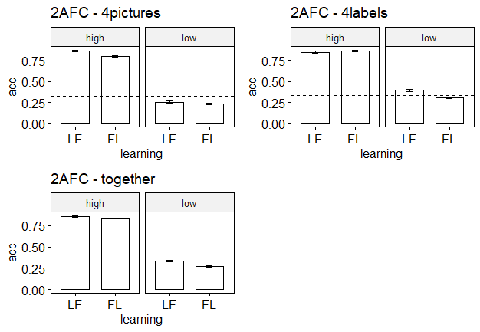

**Contingency judgment task**

contrasts(contingency$learning) contrasts(contingency$trialType)

match

FL mismatch-type1 0

LF 0 match 1

FL 1

Formula:

Formula:

resp ~ frequency:trialType:learning + frequency.ct * trialType.ct + (frequency.ct | subjID)

Estimate Std. Error df t value Pr(>|t|)

(Intercept) 0.0438 1.2382 281.3204 0.0354 0.9718

frequency.ct -2.6032 1.4220 2417.9627 -1.8307 0.0673

trialType.ct 30.9647 1.3939 16425.7524 22.2138 0.0000

frequency.ct:trialType.ct -140.2648 2.7877 16422.0936 -50.3148 0.0000

frequencyh:trialTypemismatch-type1:learningLF -1.9294 2.2742 796.0888 -0.8484 0.3965

frequencyl:trialTypemismatch-type1:learningLF -11.1130 2.5063 585.2578 -4.4341 0.0000

frequencyh:trialTypematch:learningLF -1.4287 2.2709 793.0344 -0.6291 0.5294

frequencyl:trialTypematch:learningLF 2.3640 2.5042 583.1463 0.9440 0.3456

|  |  |  |  |
| --- | --- | --- | --- |
| Hypotheses  (as outlined in the  Hypotheses section) | Summary of the data from: | Effect of interest (beta and SE for the relevant coefficient will be extracted as our model of the data). | Predicted estimates (run from our own pilot) |
| D | LME model with frequency(Dummy) : type(Dummy) :learning(Centered) + frequency(Centered) * type(Centered) | main effect of type | 6.331108e+105 |
| E | Interaction frequency by type | Function reports “Inf”  (incorrect estimation) |
| C1 | Simple effect of learning for frequency high – match | 0.2517062 |
| C2 | Simple effect of learning for frequency low – match | 0.4175141 |
| C3 | Simple effect of learning for frequency high – mismatch-type1 | 0.331838 |
| C4 | Simple effect of learning for frequency low – mismatch-type1 | 4350.70 |

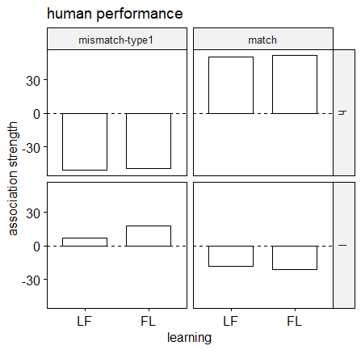

Weights are in the wrong direction.

Exploratory analysis:

correlation between the 2AFC tasks and the contingency task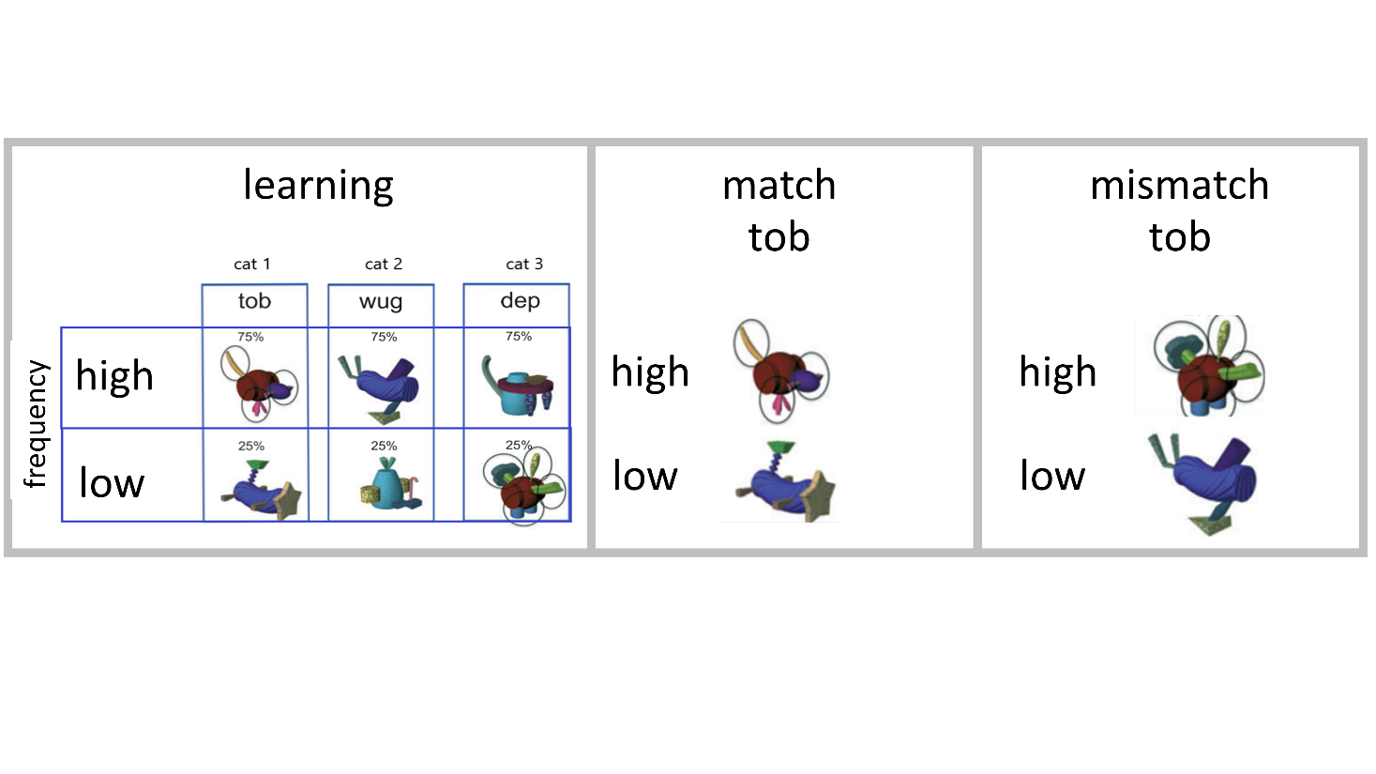Match trials

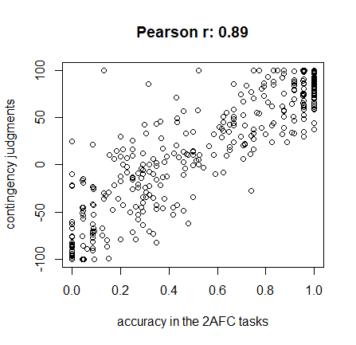

Mismatch trials

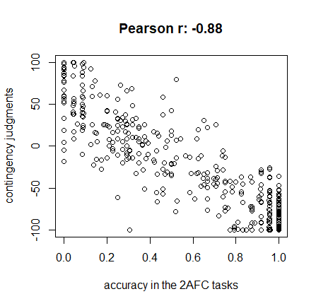

Are people consistent in their judgments? i.e., does positive judgment in match trials, correlate with negative judgment in mismatch trials within subjects?

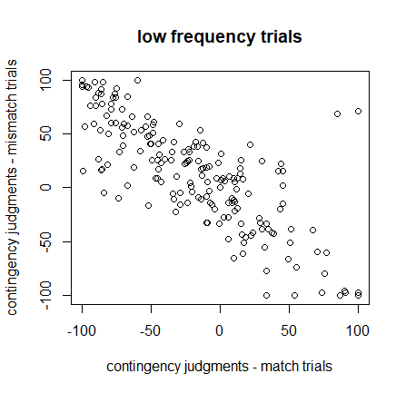

#Eva: contingency judgment indeed reflects learning as predicted by RW model: higher accuracy scores in the 2AFC tasks are associated to positive judgments in the match trials, and negative judgments in the mismatch trials. People also are consistent: they explicitly express a positive score for a fribble that matches the category, and negative if it doesn’t.

If we select only the people that scored >.33 (chance level) we should see the scores in the predicted direction (negative in the mismatch, positive in the match):

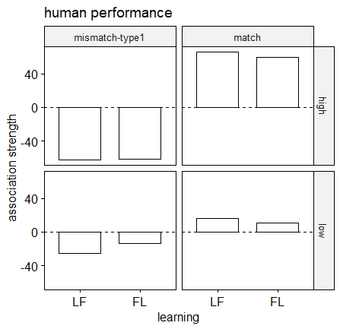

Yey! Now the weights are in the correct direction: positive in the match, negative in the mismatch. Also, as was evident in the 2AFC tasks, LF are better learner than FL in this exp, and this is reflected in the relative difference in estimates between LF and FL, especially in the mismatch – low freq condition, as suggested by the lmer model + BF.

So:

1. the contingency judgment task is consistent with the 2AFC tasks.

2. it’s a more sensitive task that reflects the learning (what was not significant or not supporting enough evidence for H1 or H0 in the 2AFC tasks, it’s significant and very much providing enough evidence for H1/H0 in this task – see lm1 output).

Is the control condition really filtering out bad subjects?

The idea of the control condition (blue bims) is to make our data “cleaner” (lower SDs?) but at the same time this condition shouldn’t affect our frequency by learning interaction.

First of all: do results change if I restore all subjects?

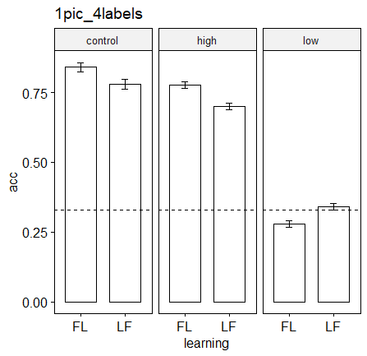

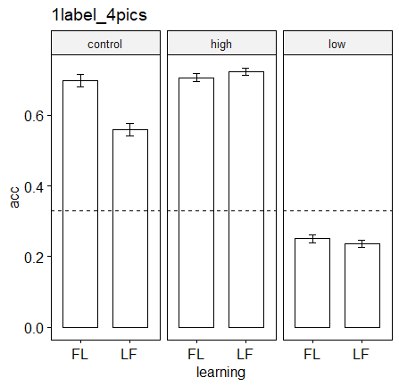

#Eva: No. So what’s the point of filtering out people that perform <.8 in the control category?

Let’s check whether accuracy in the control condition is associated to accuracy in the low/high frequency by task.

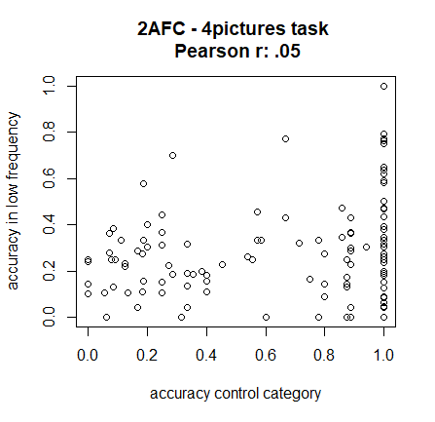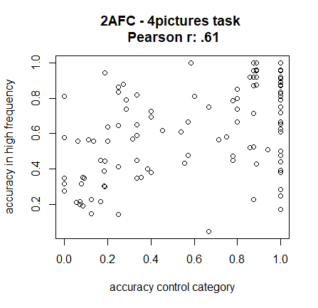

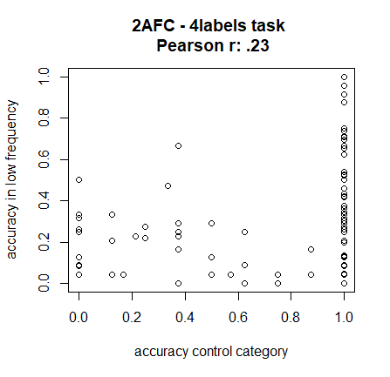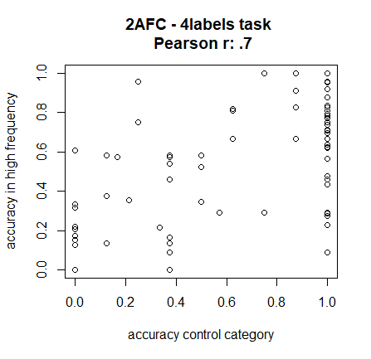

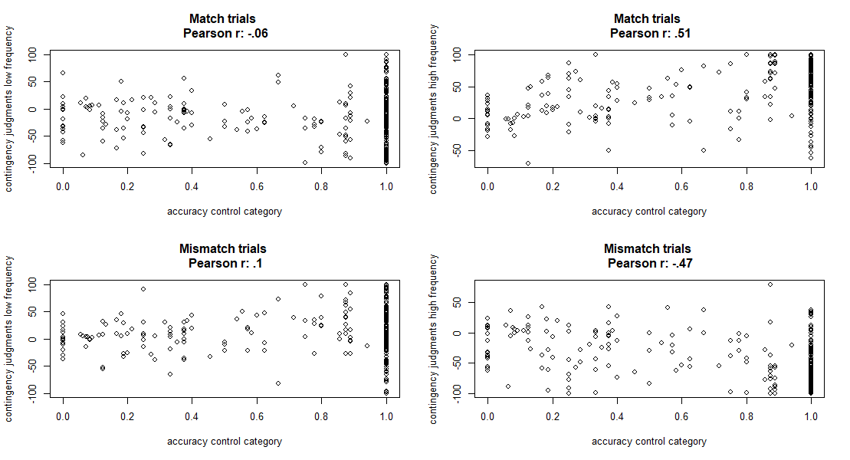

#Eva: in all tasks removing participants that perform badly in the control category improves scores only in the high frequency but not so much in the low frequency. More importantly, this doesn't affect the potential difference between FL and LF learning. So the control category doesn’t affect our ability to find the critical effect (learning by frequency interaction) and it boosts scores only in the high frequency.