**Cover Page**

**COMPSCI 345 / SOFTENG 350 Human-Computer Interaction**

**Assignment Three: Realizing a Design**

**Student Name:** Kathleen Jumamoy

**Student ID:** 846136237

**Student UPI:** kjum912

____________________________________________________________________

Note: To ensure a fair playing field for all students in the class the University of Auckland will not tolerate cheating or assisting others to cheat, and views cheating in coursework as a serious academic offence.

Student Declaration:

* I declare that this work is my own work and reflects my own learning.
* I declare that where work from other sources (including sources on the world-wide web) has been used, it has been properly acknowledged and referenced.
* I understand that my assessed work may be reviewed against electronic source material using computerised detection mechanisms.

Place this page in the front as the first page of your document that you are submitting to Canvas

Task One: Design Documentation

1. 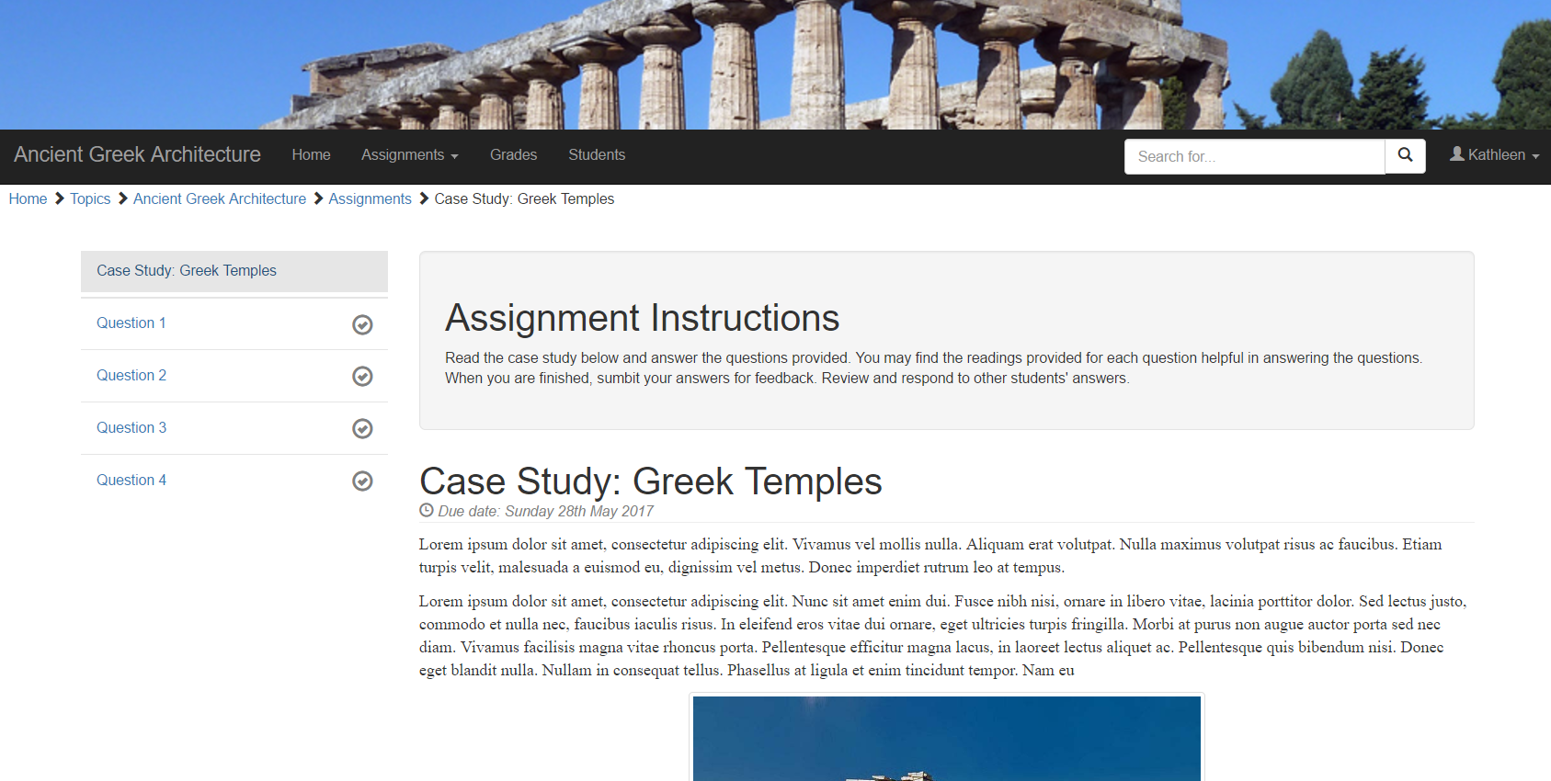Walkthrough: Sub-domain: Ancient Greek Architecture Assignment: Case Study

This is the first screen of the problem-based learning environment the user would see after selecting the assignment Case Study: Greek Temples under the sub-domain(topic) Ancient Greek Architecture. It contains the assignment instructions and the case study. It also shows the due date of the assignment. After reading the case, the user will be able to go to their desired question or click the Question 1 button on the bottom.

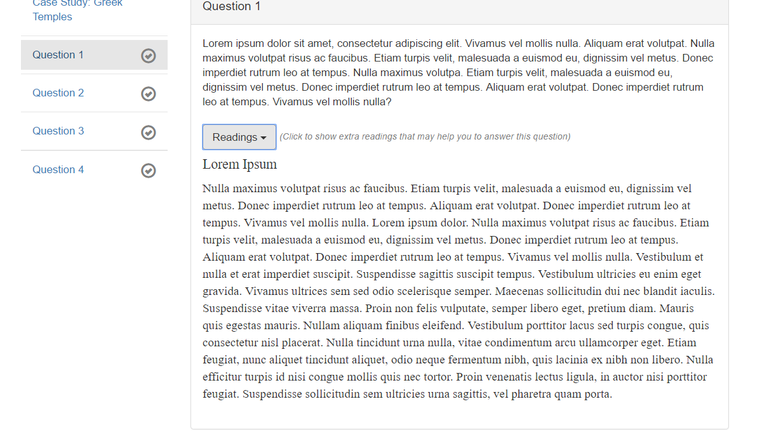

This is the page where the user will be taken to when the user clicks on Question 1 on the sidebar. It has a panel with the question in it. There is a button that says ‘Readings’. This is extra resources for user to guide them with the question. It shows the readings when clicked and hides it when clicked again.

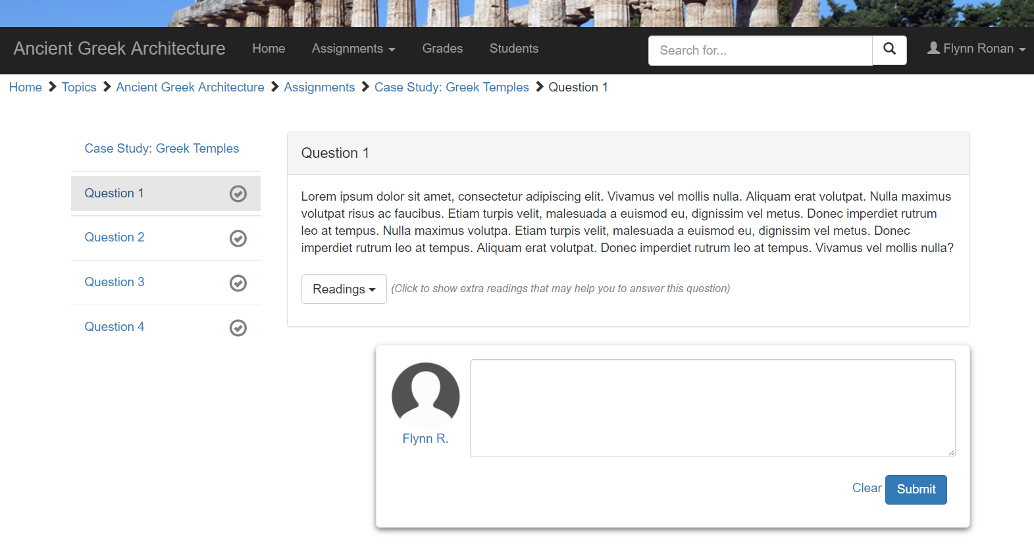

There is an answer box for the user to fill in. On the sidebar, there are grey empty ticks. The ticks are either grey or green which indicates if the question has been answered or not. When the user, clicks submit, the answer box will disappear and answer section will appear.

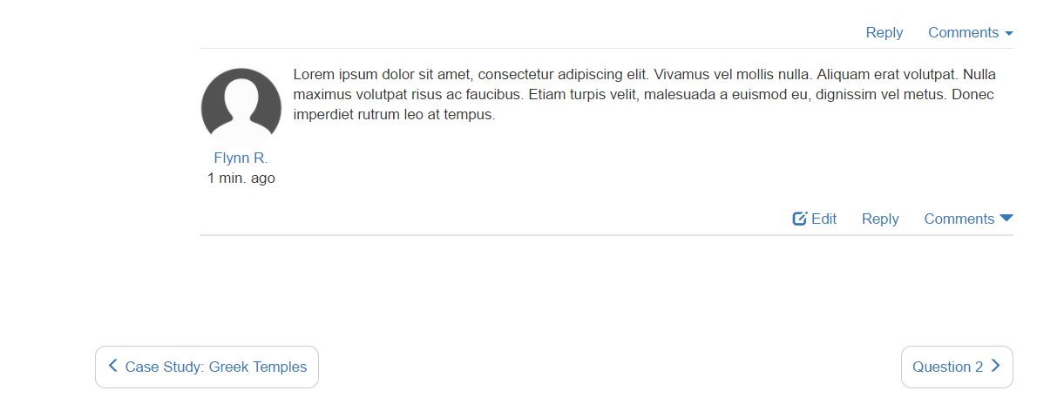

The user can edit its own answer and can also comment on it.

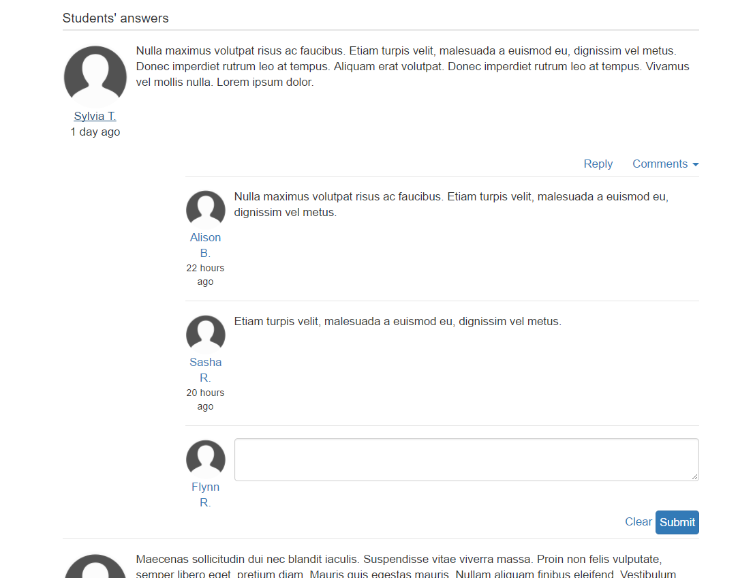

Other students’ answers will appear as well as comments on those answers. User can reply or view comments by clicking reply and comments button respectively. The user can hide comments if not desired by clicking on the comments button again.

Out of Scope-

* Only the Assignments and Kathleen buttons work in the navigation header. The dropdown items are not functional except Case Study: Greek Temples
* The breadcrumbs or navigation under the header displays each page viewed by the user, in the order the pages were viewed. It displays a hierarchy of the current page in relation to the website's structure. The links are not functional except Case Study: Greek Temples.
* Only the Case Study and Question 1 works on the sidebar
* The grey tick on the sidebar doesn’t turn green when user has submitted as it should do.
* The user’s submitted input (answer or comment) will not be added to the peer feedback previously sent.
* Clear and edit button are not functional.
* When screen is resized, elements may not be in their proper place and sizes.

(b) Colour scheme:

The prototype’s colour scheme is a combination of blue hues complimented by white and black and shades of grey. Two different shades of blue are used. As dark blue and grey are neutral colours along with white and black, they easily complement each other. The colours do not oppose each other and helps emphasise elements such as dark blue in white background or white text on a blue button. Blue is a very common colour and is widely used among social media such as Facebook. User can easily feel welcomed and doesn’t need to adjust as it is a very familiar colour. Use of white background makes it easier to contrast and emphasise elements as elements with darker colours are more dominant on a white background. The other colour in the table below gives more variation in the overall site without disturbance as they are not highly saturated colours.

|  |  |  |
| --- | --- | --- |
| Colour | RGB | Element |
|  | (35, 82, 122) | Submit button,  Background of the photos provided for the case study |
|  | (51, 122, 183) | Background of the image header, font colour of hyperlink text |
|  | (0, 0, 0) | Navigation header |
|  |  | Background of user icon, text on the interface |
|  | (211, 211, 211) | Active tab background |
|  | (229, 229, 229) | Borders and separator |
|  | (255, 255, 255) | Background, navigation text when hovered |
|  | (255, 219, 209) | Images provided |
|  | (00, 51, 00) | Image header |

(c) Borders scheme:

Thin grey line (1px #D3D3D3) is used for separators and borders in the prototype. The use of the hairline helps ease reading and identify group of information. It helps the visual flow of information on the interface. An example of this is the use of very thin grey line as a separator for comments in the students’ answer section. It is easy for users to separate comments. There is also the consistent used of light grey background when button/link is selected or hovered. As it contrasts with the white colour, this makes it easier to identify that the object has some function when clicked.

Round corners are used for previous/next buttons, search bar and panels in the prototype. It has been used consistently to give the overall look more unified and inviting. It also differentiates them as functional elements. It is also less intimidating and backs down from the ‘boring’ traditional corners which encourages the students to attempt their assignment. A special of border is used for the answer box of the user. Giving shadow makes it appear in front and dominant on the interface. It gives more 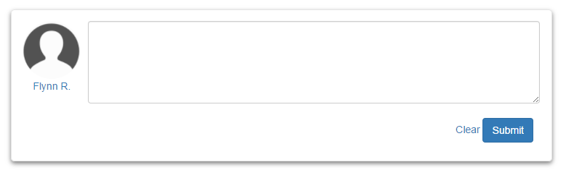focus and emphasis. This effect creates an invitation to the user to focus on the object.

Circular images for user icon balances the overall look of the page with the use consistent use of round and straight lines. It is also calm and exciting. Another use of image in the prototype is the photo as part of the top header. It is a photo of an ancient Greek Temple. This helps user to be reminded which topic they are on the site, while navigating, without reading any headings, title or text therefore a faster recognition. A similar approach is also done by using glyph icons. It gives clarification and gives more meaning to a function. This is advantageous when the user is unsure of the functionality or features a function has.

|  |  |
| --- | --- |
| Font | Justification |
| Helvetica  *Helvetica italic* | The font mainly used in the prototype is Helvetica. It is used for the headings, body text, in the navigation bar, in buttons, hyperlink text and input text in the prototype. This is because it is very easy to read in small and large text. It has a neat and clear typeface which communicates well to the readers. It is a popular font among the Sans Serif fonts. It is dominant in the web and used widely among logos. Helvetica is used especially in the iOS platform and iPod devices. |
| Helvetica in italics was used for the due date of the assignment. As the heading above it is in Helvetica font, the smaller due date text is also in the same font to give an impression of unison and constant flow of information. It is still part of the page but needed to stand out. Italic was used to emphasised that it is essential information for the users. |
| Times New Roman | Times New Roman font is used for the case study paragraph and readings. As Times New Roman font is often associated and popular in book printing and general publishing, it gives the text a different quality compared to the other text on the interface. It emphasises that the text is an educational data and from the books. |

(d) Fonts scheme:

(e) Resources used: List all external resources used for Task Two as a bulleted list or table including the source and a description of the role it plays in your design. This should include all JavaScript libraries you included and any images that you did not create yourself.

* Bootstrap website <http://getbootstrap.com/components/>
* <https://line25.com/tutorials/how-to-create-a-simple-collapsing-header-effect>
* <https://codepen.io/cbracco/pen/corFl>
* <http://callmenick.com/post/animated-resizing-header-on-scroll>
* <http://www.ancient.eu/Greek_Architecture/>
* <https://stackoverflow.com/questions/11525132/css-centred-header-image>
* <https://stackoverflow.com/questions/18529274/change-navbar-color-in-twitter-bootstrap-3>
* <https://work.smarchal.com/twbscolor/css/e74c3cc0392becf0f1ffbbbc0>
* <http://getbootstrap.com/components/#navbar-fixed-top>
* <https://stackoverflow.com/questions/19733447/bootstrap-navbar-with-left-center-and-right-aligned-items>
* <https://www.w3schools.com/css/css3_images.asp>
* <https://www.w3schools.com/bootstrap/tryit.asp?filename=trybs_ref_js_tab&stacked=h>
* <https://www.google.co.nz/search?q=ancient+greek+temples&rlz=1C1CHBF_enNZ712NZ712&source=lnms&tbm=isch&sa=X&ved=0ahUKEwj3t_3hv5LUAhUHerwKHR8WD64Q_AUICigB&biw=1133&bih=572#tbm=isch&q=ancient+greek+architecture&imgrc=dlvHqBAk2jd64M>:
* <https://www.google.co.nz/search?q=ancient+greek+temples&rlz=1C1CHBF_enNZ712NZ712&source=lnms&tbm=isch&sa=X&ved=0ahUKEwj3t_3hv5LUAhUHerwKHR8WD64Q_AUICigB&biw=1133&bih=572#tbm=isch&q=ancient+greek+architecture&imgrc=kbDkaToOK0tlnM>: