

**VIRGINIA COMMONWEALTH UNIVERSITY**

**Statistical analysis and modelling (SCMA 632)**

**A1b: Time Series Analysis**

**KATHRYN SHAJU**

**V01111327**

**Date of Submission: 25-07-2024**

**CONTENTS**

|  |  |  |
| --- | --- | --- |
| **Sl. No.** | **Title** | **Page No.** |
| **1.** | Introduction | **1** |
| **2.** | Objectives | **1** |
| **3.** | Business Significance | **2** |
| **4.** | Results & Interpretations | **3-9** |

**INTRODUCTION**

In this study we focus on time series analysis, mainly we focus on the ARCH (Autoregressive Conditional Heteroskedasticity) and GARCH (Generalized Autoregressive Conditional Heteroskedasticity) models as well as VAR and VECM models. Our study’s main aim is to see how accurately these models can be used to forecast the data based on the given data.

The ARCH model is a time series model that exhibits conditional heteroskedasticity, or volatility that varies across time. Robert Engle created it in 1982. Utilized in financial time series (stock returns, for example) where volatility clustering is prevalent.

By incorporating the lagged values of previous variances and squared errors, GARCH is an extension of ARCH. Tim Bollerslev was invented in 1986. Utilized similar to ARCH, but preferable for financial time series due to its greater flexibility.

The linear interdependencies between several time series are captured by the VAR model. Created in 1980 by Christopher Sims. Utilized in time series that are multivariate and involve interdependent factors.

An extension of the VAR model for co-integrated non-stationary data is the VECM model.  
Adapted from Clive Granger's and other people's work. Utilized in long-term equilibrium relationships between the variables in time series.

These models are tested in both R and Python for more accurate results. For the purpose of this study we are using two different dataset to test out the models. On the dataset of stock prices of Infosys we are running the ARCH and GARCH analysis and on the pinksheet dataset from the World Bank we will use VAR and VECM model.

**OBJECTIVES**

− To Check for ARCH /GARCH effects, fit an ARCH/GARCH model, and forecast the three-month volatility.

− Fitting a VAR, VECM model on the data that contains commodity prices

**BUSINESS SIGNIFICANCE**

When analyzing financial time series, such as the stock prices of businesses like Infosys, the ARCH (Autoregressive Conditional Heteroskedasticity) and GARCH (Generalized Autoregressive Conditional Heteroskedasticity) models are especially helpful.

Understanding the volatility clustering in stock prices—high volatility tends to be followed by high volatility and low volatility tends to be followed by low volatility—is made easier with the use of ARCH/GARCH models. This is important for risk management because it enables Infosys and its investors to identify high-risk periods in advance and modify their investment plans appropriately.

Stress testing is a common tool used by financial models to examine how assets behave under harsh scenarios. In order to help with the planning for unfavorable market scenarios, ARCH/GARCH models can simulate the effects of market shocks on Infosys stock.

These models can be used by Infosys itself to comprehend how external events and market perceptions affect the volatility of its stock. This may have an impact on choices made about capital raising, buybacks of stock, and other financial tactics used to maintain stock price stability or improve capital structure. Excessive volatility may be a sign of unpredictability or shifts in market sentiment.

Analysts can determine market circumstances and investor mood by examining the volatility of Infosys stock. This information aids in the formulation of strategic decisions for both short-term trading and long-term investments. Decisions on portfolio allocation can be enhanced by precise volatility estimates. By modifying the weight of Infosys stock in their portfolios according to projected volatility, investors can maximize returns while controlling risk.

For the analysis and forecasting of multivariate time series data, including commodity prices, the Vector Autoregression (VAR) and Vector Error Correction Model (VECM) models are effective tools.

The dynamic interactions between various commodity prices are captured by VAR models. Businesses that deal with a variety of commodities can make better decisions by understanding how price fluctuations in one commodity impact other commodities.

When commodity prices exhibit a long-term equilibrium relationship but are non-stationary, VECM models are utilized. Ensures that strategic decisions are based on long-term trends rather than cyclical swings by assisting firms in understanding and forecasting long-term price trends.

Businesses can increase the accuracy of their forecasts, manage risks more skillfully, and make strategic decisions that improve their overall financial performance by utilizing VAR and VECM models. These models also provide useful insights into the dynamics of commodities prices.

**RESULTS & INTERPRETATIONS**

− To Check for ARCH /GARCH effects, fit an ARCH/GARCH model, and forecast the three-month volatility

Firstly we will download the data regarding stock prices of Infosys, we clean the data, for any missing values and such and then we fit the ARCH model. The results are as follows,

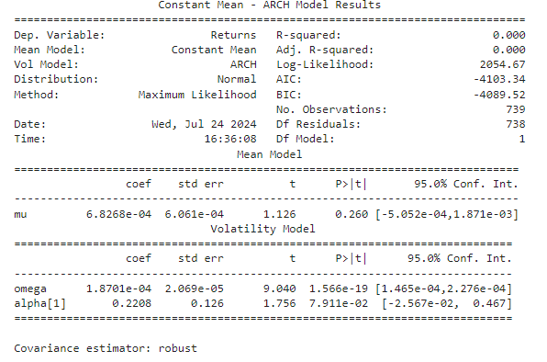

INTERPRETATION **- The** mean return of the time series is not significantly different from zero. The constant term in the volatility model (ω) is highly significant, indicating a substantial constant component in volatility. The ARCH term (α₁) is marginally significant, suggesting that while there is some evidence of volatility clustering, it is not strongly pronounced.

This model indicates that while there is a significant constant level of volatility, the past squared returns do not strongly predict future volatility in this dataset. The graphical representation of the same is given below,

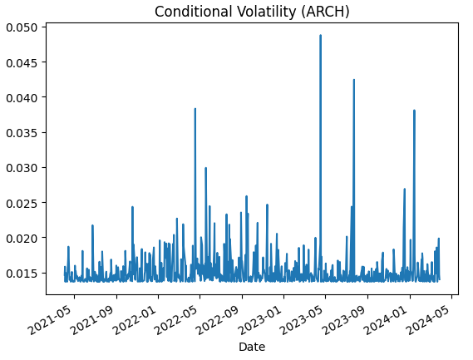

This plot effectively demonstrates the dynamic nature of market volatility over the observed period, highlighting the periods of increased uncertainty and the overall clustering behaviour of volatility. The ARCH model captures these variations, providing insights into the conditional volatility patterns of the returns.

Following this we also use the GARCH model and see if that is a better fit for our data set. The results and interpretation are below,

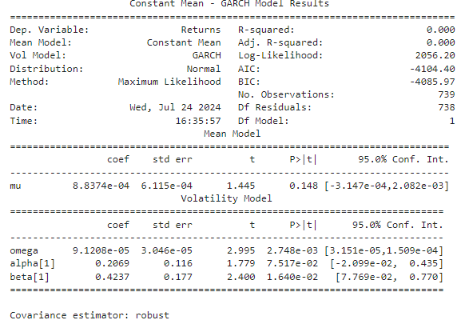

INTERPRETATION - The mean return of the time series is not significantly different from zero. The constant term in the volatility model is highly significant, indicating a substantial constant component in volatility. The ARCH term (α₁) is marginally significant, suggesting weak evidence of volatility clustering based on past squared returns. The GARCH term (β₁) is significant, indicating that past conditional variances significantly influence current volatility. This is consistent with the GARCH model's objective to capture persistent volatility over time.

This model indicates that while the mean return is not significant, the volatility of returns exhibits significant persistence, with both past squared returns and past variances contributing to the current level of volatility. The GARCH model captures these effects, providing insights into the dynamic behavior of market volatility.

Plotting the above GARCH model we get,

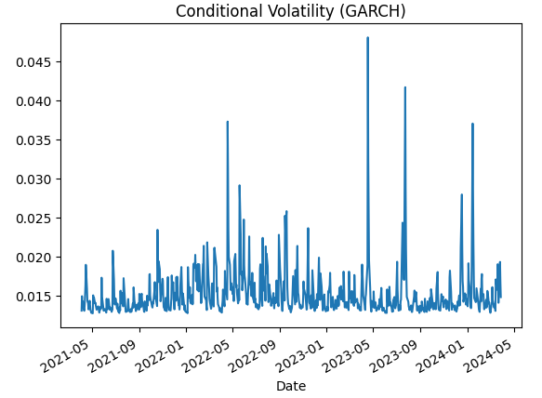

-Fitting a VAR, VECM model on the data that contains commodity prices

For this we have taken the dataset pinksheet from World Bank. We have then proceed to subset the data to only commodities which include crude brent, silver, gold, soybeans, urea, gold and maize. Once we have subsetted, we now have new data called commodities data. We now proceed to first check the stationarity of the data, and check which of them non -stationary variables are. We do this by running it through the loop and also performing the ADF test. Our results indicate none.

Once we do this we test for co-integration using the Johansen’s Test. After this we run the VECM model, and plot the forecast, results are as follows,

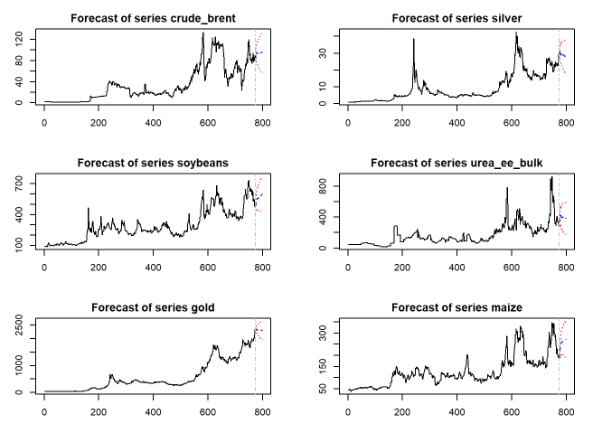

INTERPRETATIONS - Most commodities, except for gold, show a forecasted trend towards stabilization or decrease. The confidence intervals reflect the inherent volatility and uncertainty in commodity price. The VAR model captures the interdependencies among these commodities, affecting their future price forecasts.

Following this we have also run the VAR model, results are as follows,

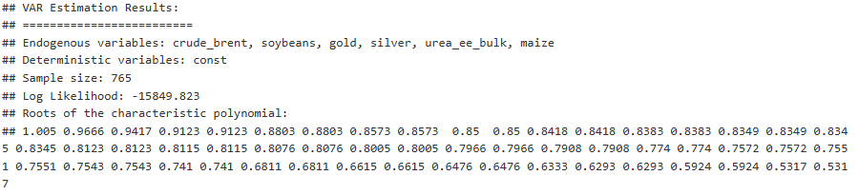

INTERPRETATION - The stability of a VAR model is assessed by examining the roots of the characteristic polynomial.For the VAR model to be stable, all roots should lie within the unit circle (i.e., their magnitudes should be less than 1).The roots provided are all less than or very close to 1, suggesting that the model is stable.

The VAR estimation results indicate that the model includes multiple commodity prices, captures their dynamic interrelationships, and appears to be stable based on the characteristic polynomial roots.

We have also run a Granger Casualty test on the VAR model, the results are as follows,

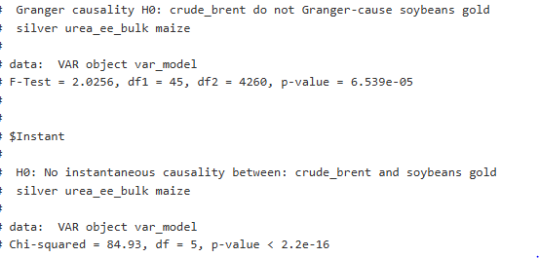

INTERPRETATION - Null Hypothesis (H0): "crude_brent" does not Granger-cause "soybeans," "gold," "silver," "urea_ee_bulk," and "maize."

Results: F-Test: 2.0256

Degrees of Freedom (df1): 45

Degrees of Freedom (df2): 4260

P-value: 6.539e-05

The p-value is very small (less than 0.05), so we reject the null hypothesis. This means "crude_brent" Granger-causes at least one of the variables: "soybeans," "gold," "silver," "urea_ee_bulk," or "maize."

Similarly we have also plotted the VAR model Forecast results, they are as follows,

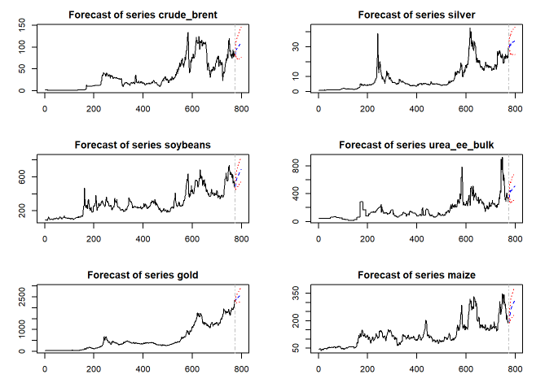

The forecasts for all six series provide insights into potential future trends, showing either stabilization or slight increases. The confidence intervals indicate the uncertainty and range of possible values, reflecting the variability observed in historical data.