Stylez

Kathryn, Michael, Austin

Iteration 1

This game started with two decks of cards: one with a theme and another with style cards. There would be one judge each round and the other players would each draw 5 cards from the style deck. The players were then given 1 minute to make up a character that incorporated everything on the cards fit the overall theme. The judge would then choose who they thought did the best job and would award them a point. The role of judge would go around the players clockwise. The first person to five points wins (point total could change based on how long you wanted to play).

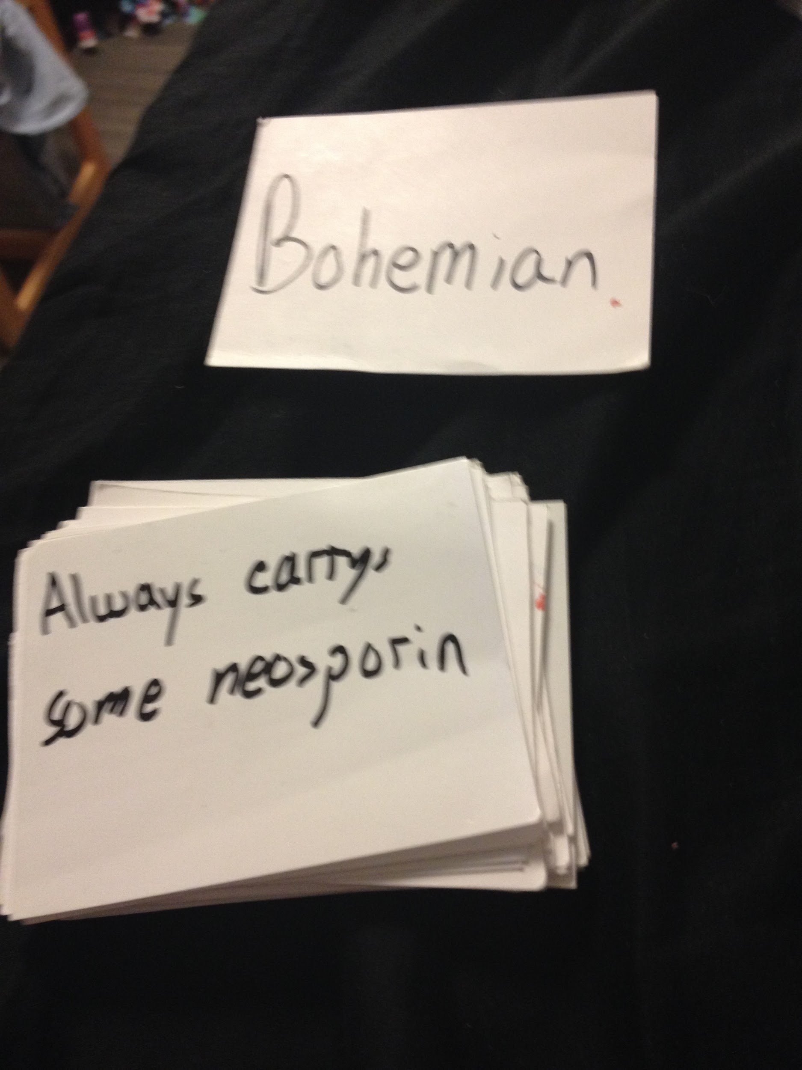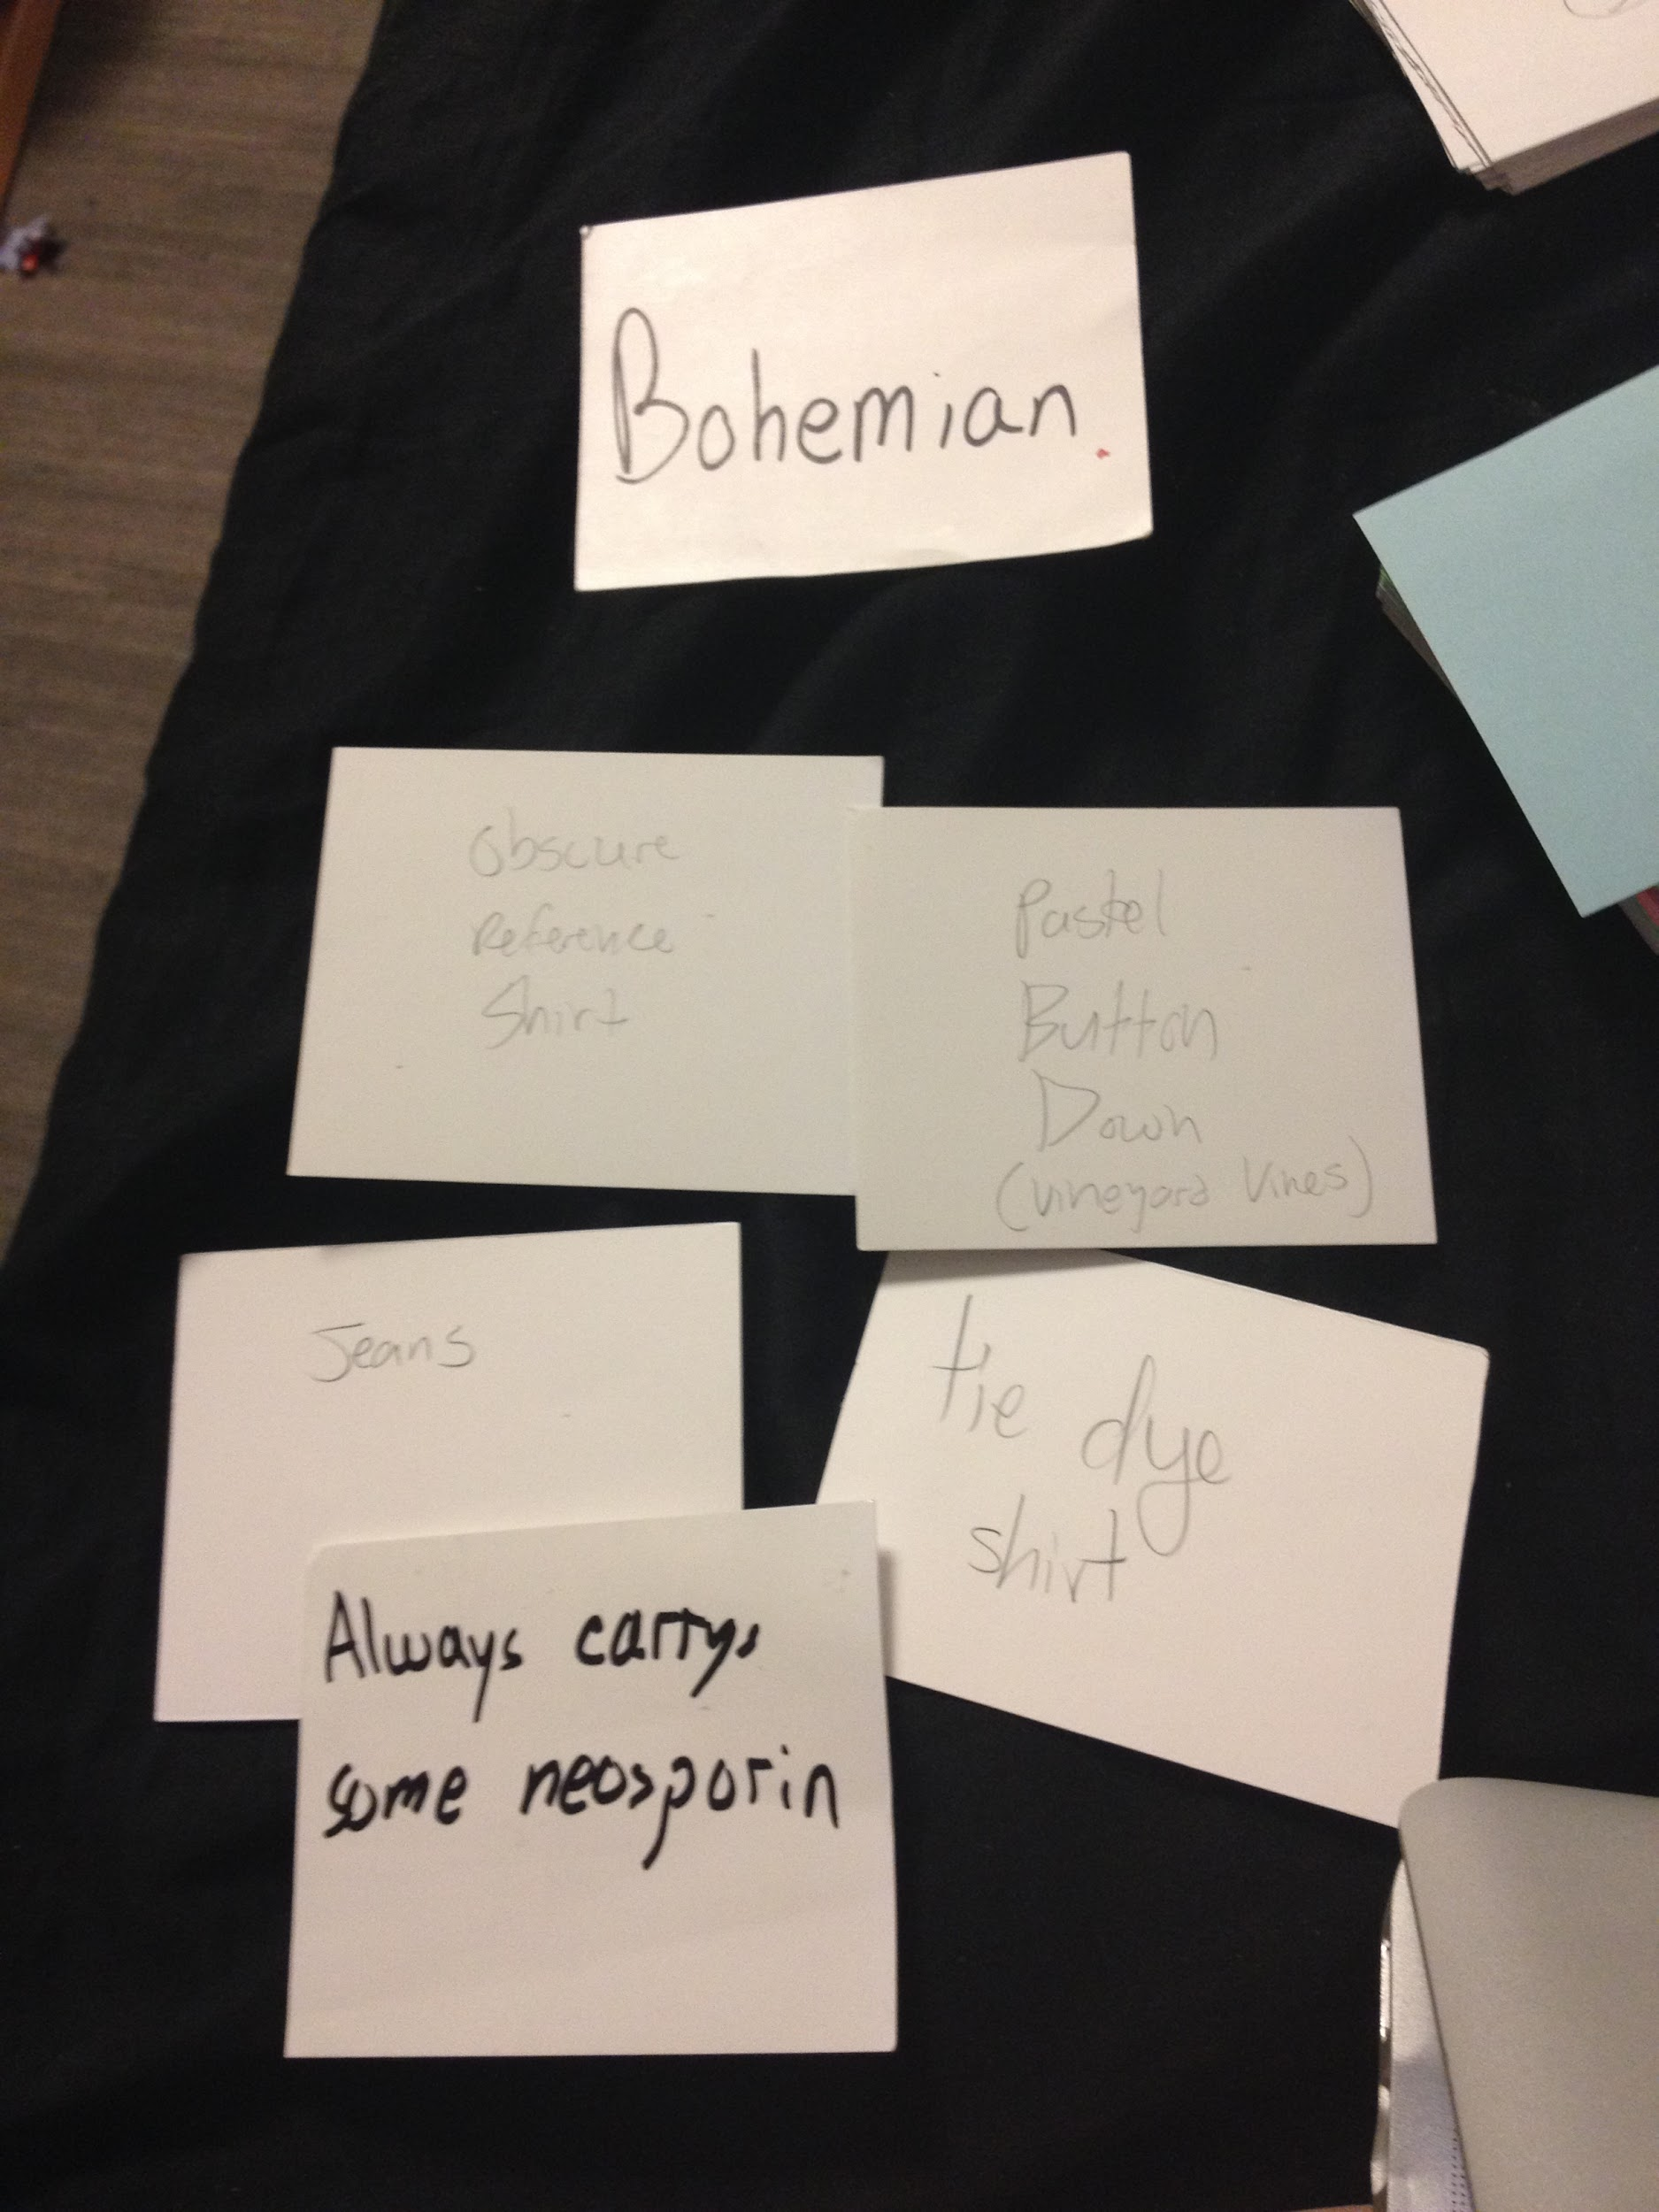

Iteration 2

Because there was initially only one large deck that the players drew from a potential hand could be just draw five different shirts. We decided to remedy this by making separate decks (one for tops, things that would go on their head, bottoms, and one for lifestyle choices) and each person draws one from each clothing article pile and two from the lifestyle pile. This ensures that they will get a variety of cards for different aspects of their character.

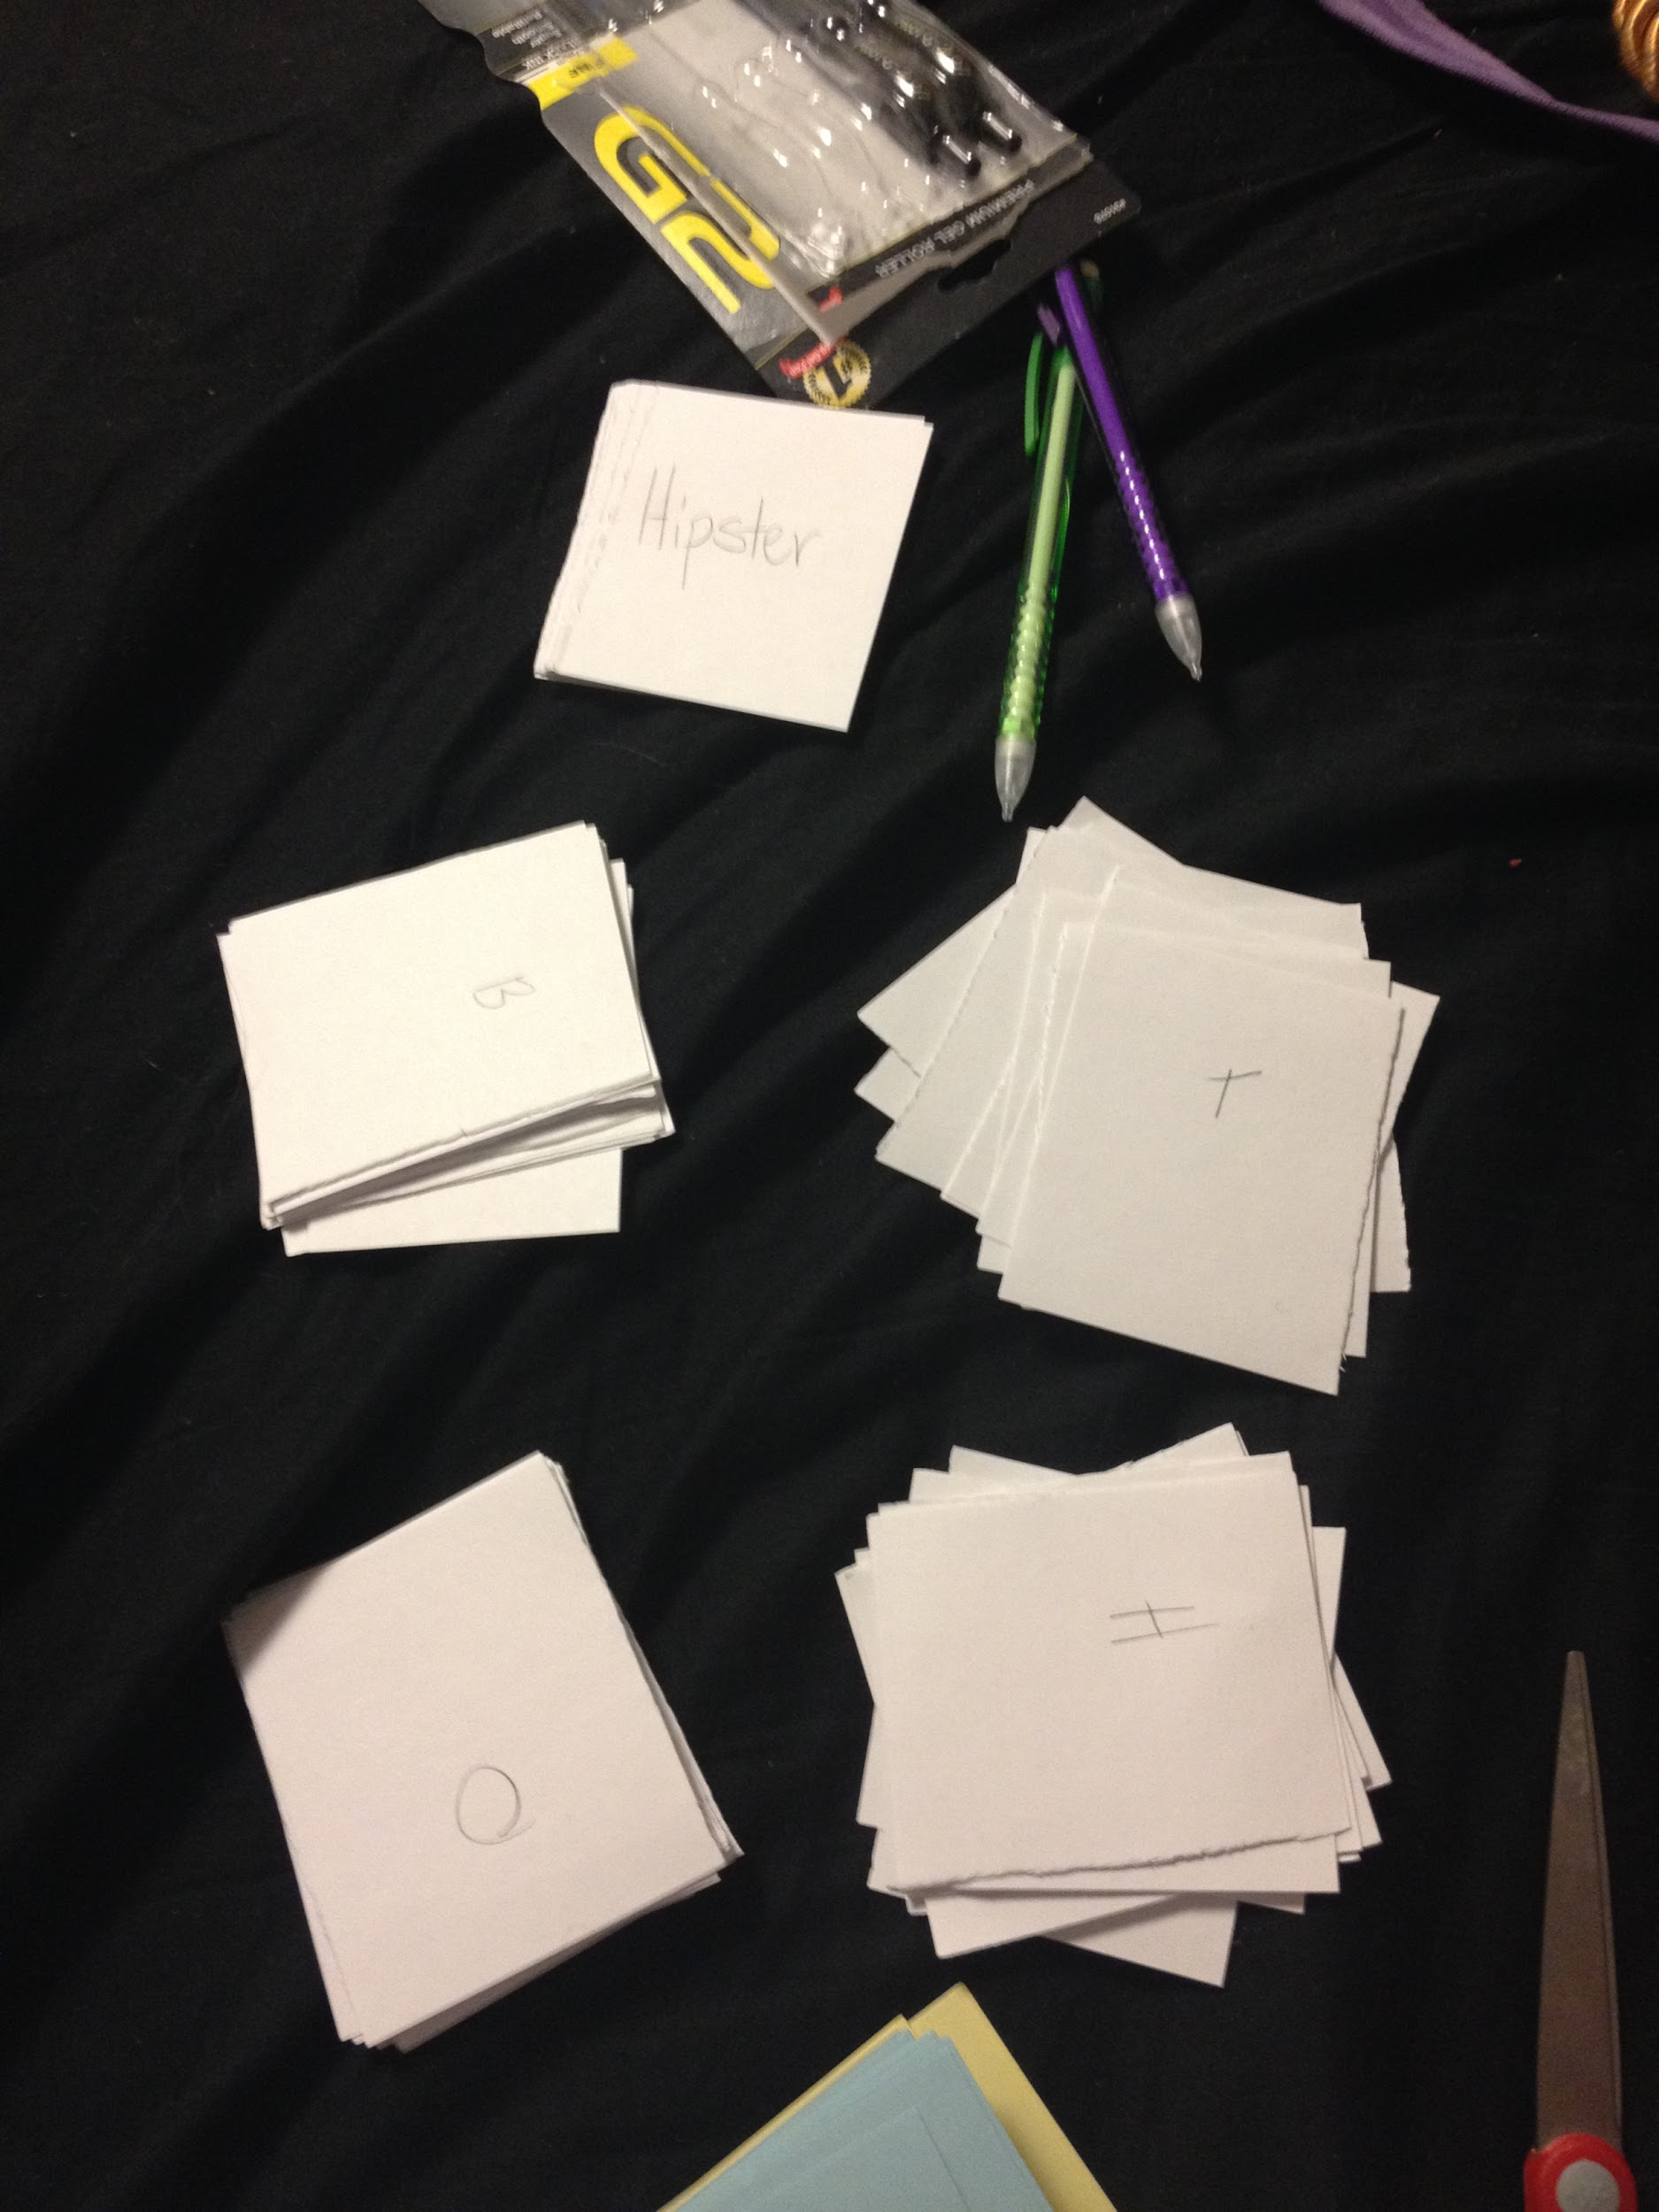

When we initially played we gave a minute time to come up with the character. We have since shortener it to 30 seconds because we found the improv aspect of it was more fun, and originally everyone was done before time was called and got bored.

We’ve also changed the point system so instead of having a single judge per round. There are potentially 2 points to be earned each round, one from the judge and one from the other players. All of the players get to choose who their favorite was that rond (they can’t vote for themselves) and if a majority is reached that player gets a bonus point. If there is no majority just the judges point will be awarded. This will make the points more balanced if judges play favorites.

Iteration 3

After playtesting with these changes the main feedback we got was to add more structure. Players wanted examples of how to make up a character and suggestions for things they could potentially include before going for the first time.

We wrote out an instruction card with an example and a list of things that can be included as a result to show people before they play. Our main concern was making sure that the only thing that is mandatory in coming up with the character is using the cards, and not making a checklist for people to fill out in limited time.

