# How do we become infected in enclosed spaces?

# *Hvordan bliver vi smittet i lukkede rum?*

A viral infection occurs when a **susceptible population** becomes contaminated by a virus, as shown in Figure 1, after which it becomes the **infected population**. Usually the **infected population** at some point become active virus producers and spreaders.

*En viral infektion opstår, når en* ***modtagelig befolkning*** *bliver forurenet af en virus, som vist i figur 1, hvorefter det bliver den* ***inficerede befolkning****. Som også vist I figur 1, normalt bliver den* ***inficerede befolkning*** *på et tidspunkt aktive virusproducenter og spredere.*

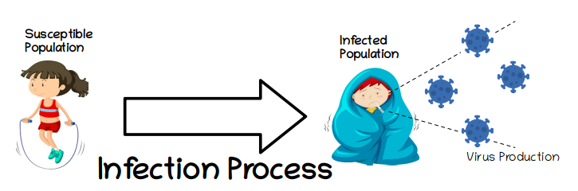Figure 1: Basic infection process

The only way in which a susceptible person can become infected is if they come in contact with the virus, and the only known source of virus are other infected people. Therefore the virus production shown in Figure 1 can be further completed to show how the virus produced by those infected ends up infecting other susceptible people that come in contact with them.

*Den eneste måde, hvorpå en* ***modtagelig person*** *kan blive smittet, er, hvis de kommer i kontakt med virussen, og den eneste kendte viruskilde er andre* ***inficerede mennesker****. Derfor kan virusproduktionen vist i figur 1 yderligere afsluttes for at vise, hvordan den virus, der produceres af de inficerede, ender med at inficere andre modtagelige mennesker, der kommer i kontakt med dem.*

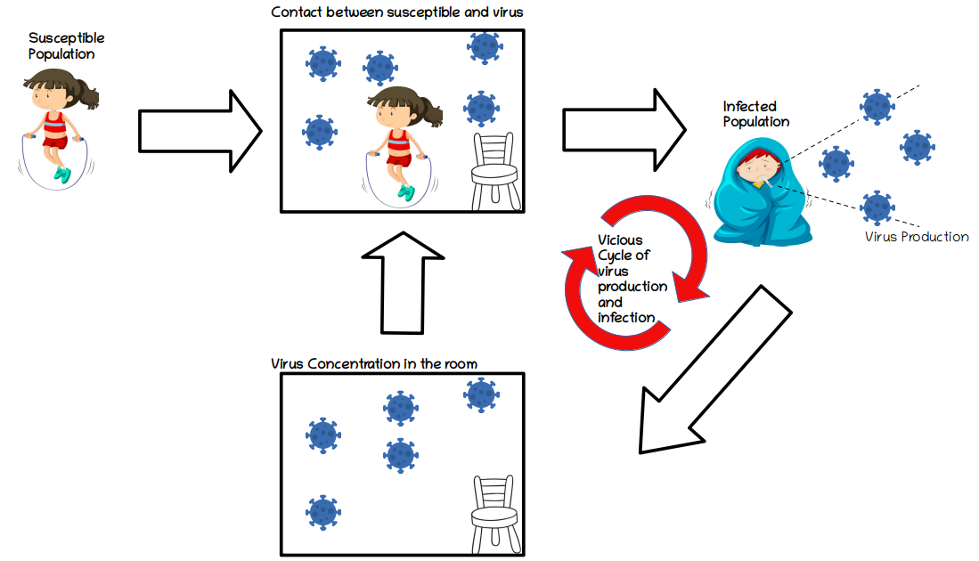Figure 2: Basic Epidemiological Model

Figure 2 represents a process where a susceptible person comes into contact with the virus in an enclosed space. Infected people produce viruses which increase the virus concentration inside a room. Susceptible people in the room come into contact with these pathogens and becoming infected, joining the group that produces more viruses into the air. This is the vicious cycle of virus production and infection, and it will continue until there are no more susceptible people left to infect.

*Figur 2 repræsenterer den proces, hvor en* ***modtagelig person*** *kommer i kontakt med virussen i et lukket rum. Inficerede producerer vira, der øger viruskoncentrationen inde i et rum. Modtagelige mennesker i lokalet kommer i kontakt med disse patogener og bliver smittede og slutter sig til gruppen, der producerer flere vira i luften. Dette er den onde cirkel med virusproduktion og infektion, og den vil fortsætte, indtil der ikke er flere modtagelige mennesker tilbage til at inficere.*

# Not all infection processes are equal

# *Ikke alle infektionsprocesser er ens*

The speed at which infections take place depends on many different factors. From the model shown in Figure 2, one could argue that the more infected people in the room, the more virus that is produced, the higher concentration and exposure of susceptible people to pathogens, and as a result the higher the infection rate. The advantage of identifying vicious cycles like this one, is that by interrupting any part of the cycle, its multiplying effect is also affected. Our model addresses one of the ways in which this vicious cycle can be affected, namely the concentration of viral particles in the air of a room. If somehow this concentration is reduced, then the susceptible people in the room would be less in contact with viruses, and as a result, become less infected.

*Den hastighed, hvormed infektioner finder sted, afhænger af mange forskellige faktorer. Fra modellen vist i figur 2 kan man argumentere for, at jo flere inficerede mennesker i rummet, jo mere virus der produceres, jo højere koncentration og eksponering af modtagelige mennesker for patogener, og som et resultat jo højere infektionshastighed. Fordelen ved at identificere onde cyklusser som denne er, at ved at afbryde en hvilken som helst del af cyklussen påvirkes dens multiplikationseffekt også. Vores model adresserer en af måderne, hvorpå denne onde cirkel kan påvirkes, nemlig koncentrationen af virale partikler i luften i et rum. Hvis denne koncentration på en eller anden måde reduceres, ville de modtagelige mennesker i rummet være mindre i kontakt med vira og som et resultat blive mindre inficeret.*

Our model integrates four ways researchers have shown help limit virus concentrations in enclosed spaces, as represented in .Figure 3. Ventilation systems can extract viruses from a room by both trapping viruses with filters, and by getting rid of viruses by bringing in new fresh air during air recirculation. Additionally, viral particles are also subject to gravity, and these fall to the ground or other surfaces after some time. Finally, viral particles only survive for a specific time, after which they deactivate, this is they become non infectious. A quicker particle deactivation can be promoted through the use of, for example, disinfectants or by using UV light, for example.

*Vores model integrerer fire måder, som forskere har vist, at de hjælper med at begrænse viruskoncentrationer i lukkede rum, som vist i. Figur 3. Ventilationssystemer kan udtrække vira fra et rum ved både at fange vira med filtre og ved at slippe af med vira ved at bringe ny frisk luft ind under luftcirkulation. Derudover udsættes virale partikler også for tyngdekraften, og disse falder til jorden eller andre overflader efter nogen tid. Endelig overlever virale partikler kun i et bestemt tidsrum, hvorefter de deaktiverer, dette er, at de bliver ikke infektiøse. En hurtigere partikeldeaktivering kan fremmes ved f.eks. Anvendelse af desinfektionsmidler eller ved at sagsøge UV-lys.*

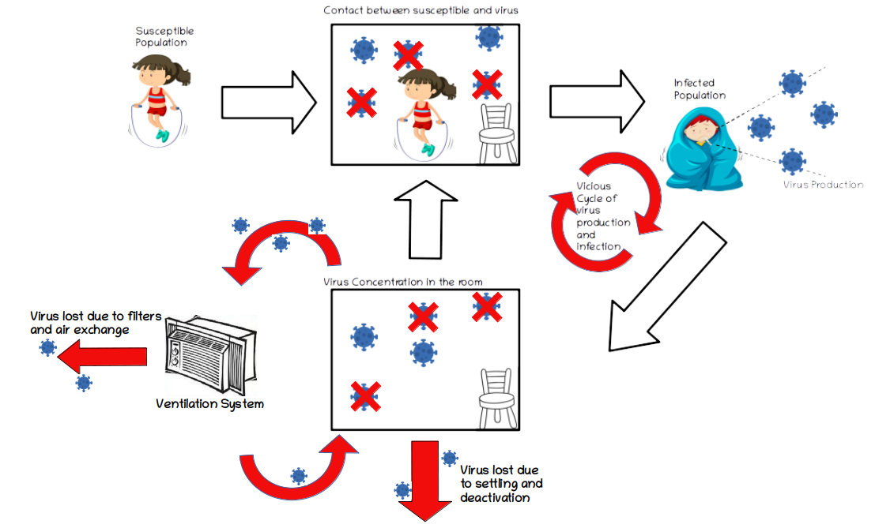Figure 3: Extended Epidemiological Model

Our model represented in Figure 3 simulates the basic relationships between virus production, ventilation rate and the speed at which infections take place. This allows us to use this model to answer questions that combine these factors, like: 1) with a given ventilation system and room size, what type of activities can be carried out, and for what length of time, in order to limit the infection risk?, or 2) For an activity with a particular duration, what is the room size and/or ventilation that is needed to limit the infection risk?

*Vores model repræsenteret i figur 3 simulerer de grundlæggende sammenhænge mellem virusproduktion, ventilationshastighed og den hastighed, hvormed infektioner finder sted. Dette giver os mulighed for at bruge denne model til at besvare spørgsmål, der kombinerer disse faktorer, f.eks: 1) med et givet ventilationssystem og rumstørrelse, hvilken type aktiviteter der kan udføres, og i hvor lang tid, for at begrænse infektionen risiko ?, eller 2) Hvad er den rumstørrelse og / eller ventilation, der er nødvendig for at begrænse infektionsrisikoen, for en aktivitet med en bestemt varighed?*