I developed today the infection risk part of the model:

As per Buonanno (2020)

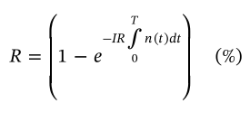

IR: Inhalation rate in (m3/h)

n(t) : quanta concentration in (quanta/m3)

T : is the exposure rate

R is the Infection Risk.

This is equivalent to the following SD structure:

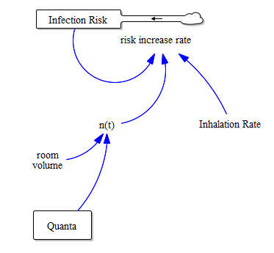

When integrated to a simple SE epidemic model, it has the following structure:

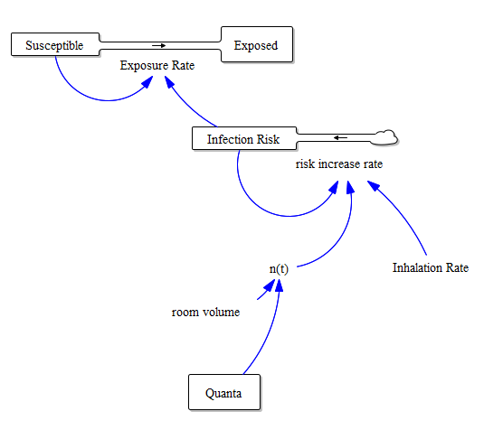

And a run of this in a simplified model has the following results:

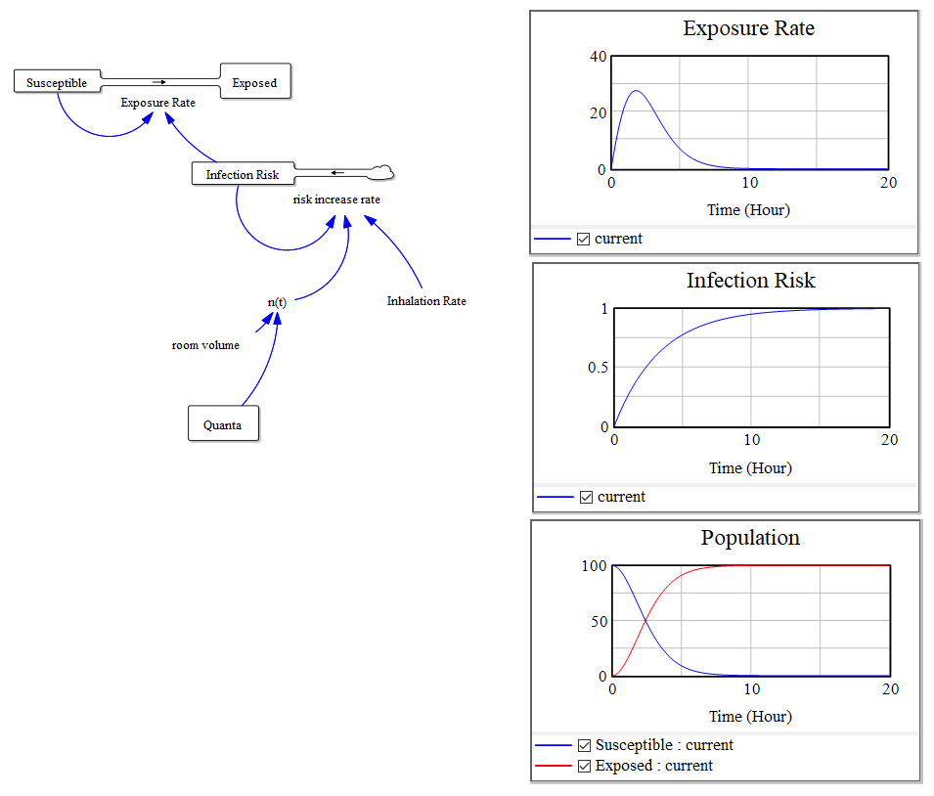

I attach also the VENSIM Model for your review.