How do we become infected in enclosed spaces?

An infection occurs when a susceptible population becomes infected by a pathogen such as a virus, as shown in Figure 1.

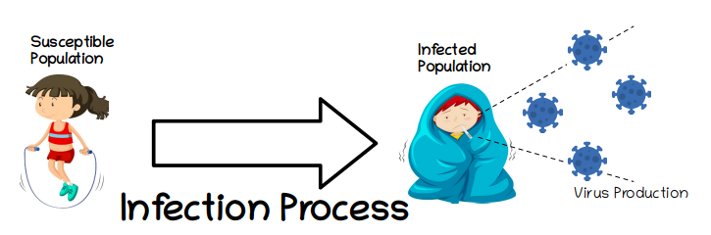Figure 1: Basic infection process

Look deeper at the way in which the infection happens, the only way in which a susceptible person can become infected is if they come in contact with the virus, and the only known source of virus are other infected people. Therefore the virus production shown in Figure 1 can be further completed to show how the virus produced by those infected ends up infecting other susceptible people that come in contact with them.

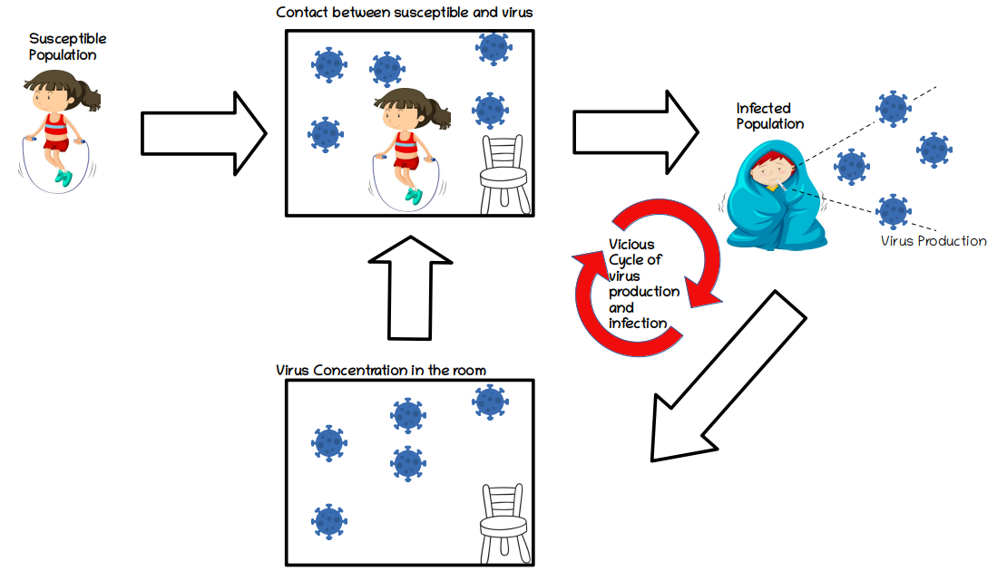Figure 2: Basic Epidemiological Model

Figure 2 represents a process where a susceptible person comes into contact with the virus in an enclosed space. Infected people produce viruses which increase the virus concentration inside a room. Susceptible people in the room come into contact with these pathogens and becoming infected, joining the group that produces more viruses into the air. This is the vicious cycle of virus production and infection, and it will continue until there are no more susceptible people left to infect.

Not all infection processes are equal

The speed at which infections take place depends on many different factors. From the model shown in Figure 2, one could argue that the more infected people in the room, the more virus that is produced, the higher concentration and exposure of susceptible people to pathogens, and as a result the higher the infection rate. The advantage of identifying vicious cycles like this one, is that by interrupting any part of the cycle, its multiplying effect is also affected.

Our model integrates several ways researchers have shown limit virus concentrations in enclosed spaces as seen in .Figure 3 Ventilation systems can extract viruses from a room by both trapping viruses with filters during air recirculation, and by getting rid of viruses by bringing in new fresh air during air recirculation. Also, viral particles are also subject to gravity, and these fall to the ground or other surfaces after some time. Finally, viral particles only survive for a specific time, after which they deactivate, this is they become non infectious. A quicker particle deactivation can be promoted through the use of, for example, desinfectants.

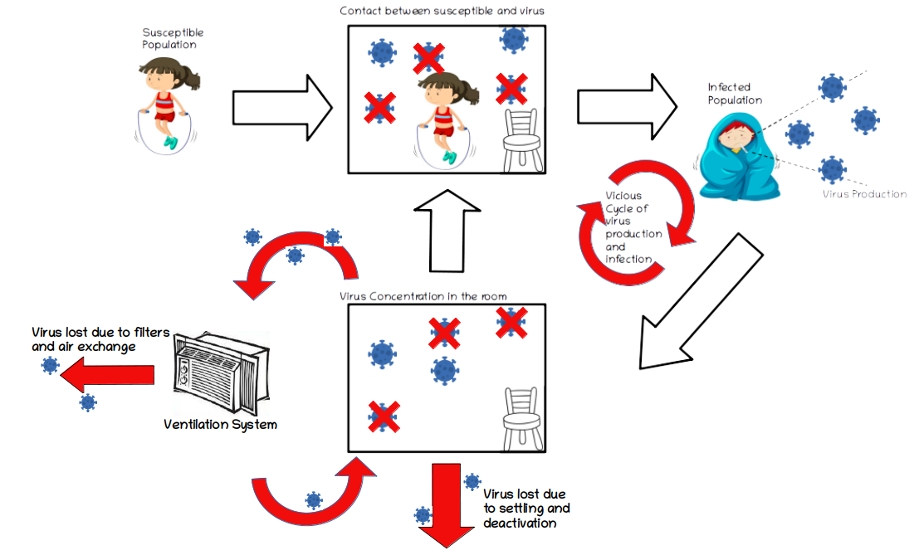Figure 3: Extended Epidemiological Model

Our model based on the representation shown in Figure 3 simulates the basic relationships between virus production, ventilation rate and the speed at which infections take place.

