Sales Analysis Report
1. Project Overview
This project focuses on analyzing sales transactions to understand revenue trends, delivery performance, and return behavior. Using sales and logistics data, the goal is to identify operational patterns that impact business performance and provide actionable insights to improve efficiency and customer satisfaction.
The analysis helps businesses monitor sales performance, reduce delivery delays, and minimize product returns through data-driven decision-making.

2. Dataset Summary
- Rows: 5,901
- Columns: 22
Key Features:
- Order ID
- Order Date
- Delivery Date
- Sales Amount
- Product Category
- Customer Region
- Return Status
- Delivery Time
Data Quality:
- Missing values were identified in the Return column
- Data types were checked and corrected for date and numeric fields
- Unnecessary columns were removed to improve performance and analysis accuracy

3. Data Cleaning and Preparation
Initial Data Exploration
The dataset was examined to understand its structure and identify data quality issues.
Data Cleaning Steps
- Checked and corrected data types for all columns
- Removed unnecessary columns to improve dataset efficiency
- Replaced null values in the Return column
- Verified data consistency across records
Feature Engineering (using DAX)
A calculated measure was created:
Avg Delivery Date
This measure helps evaluate delivery performance and identify delays in shipping operations.

4. Exploratory Data Analysis
The following analyses were performed to understand sales and operational performance:
Sales Performance Analysis
- Total sales trends were analyzed to monitor revenue performance
- Sales distribution across product categories was evaluated
Delivery Performance Analysis
- Delivery timelines were analyzed to identify delays
- Average delivery duration was calculated to monitor logistics efficiency
Return Behavior Analysis
- Product return patterns were examined
- Return trends were analyzed to identify operational or product issues
Regional Sales Analysis
- Sales performance was analyzed across different regions
- Geographic distribution of orders was evaluated

5. Dashboard in Power BI
An interactive dashboard was developed in Power BI to visualize key sales and operational metrics.
The dashboard provides real-time insights into:
- Total Sales
- Delivery Performance
- Return Behavior
- Category-wise Sales
- Regional Sales Distribution
- Delivery Time Trends
This dashboard enables decision-makers to monitor performance and quickly identify operational issues.
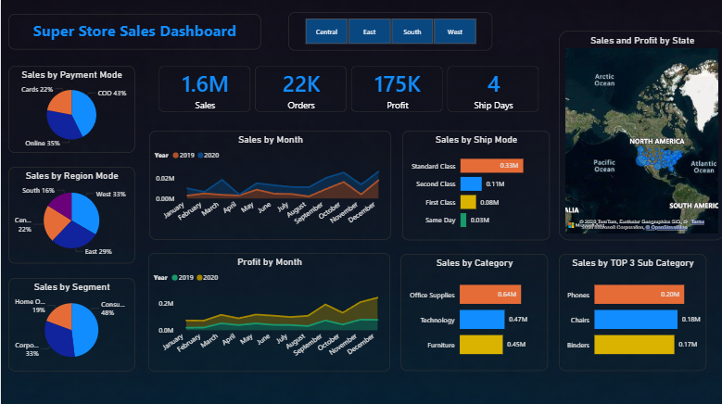

6. Key Insights
- Delivery delays were identified in several orders, indicating inefficiencies in logistics operations.
- Product returns were observed in a portion of transactions, suggesting potential issues in product quality or delivery handling.
- Sales performance varied across product categories, highlighting differences in customer demand.
- Monitoring delivery time helps identify operational bottlenecks and improve service reliability.

7. Business Recommendations
- Optimize delivery processes to reduce shipping delays
- Monitor return trends to identify product or logistics issues
- Focus on high-performing product categories to maximize revenue
- Improve coordination between warehouse and logistics teams
- Use delivery performance metrics to enhance customer satisfaction

