1.

(a)

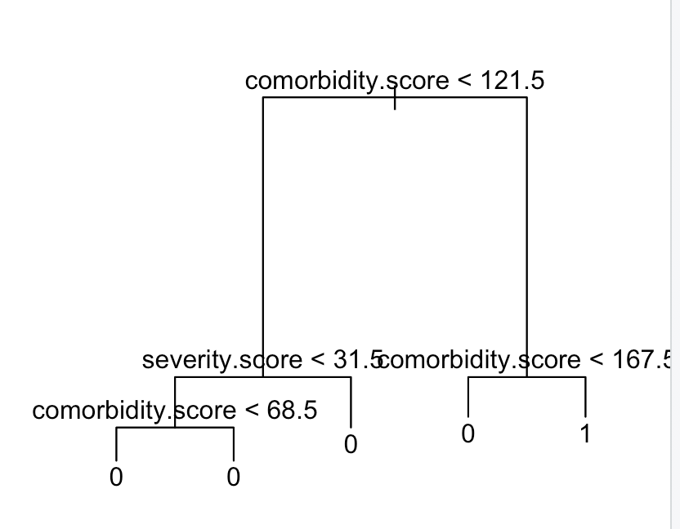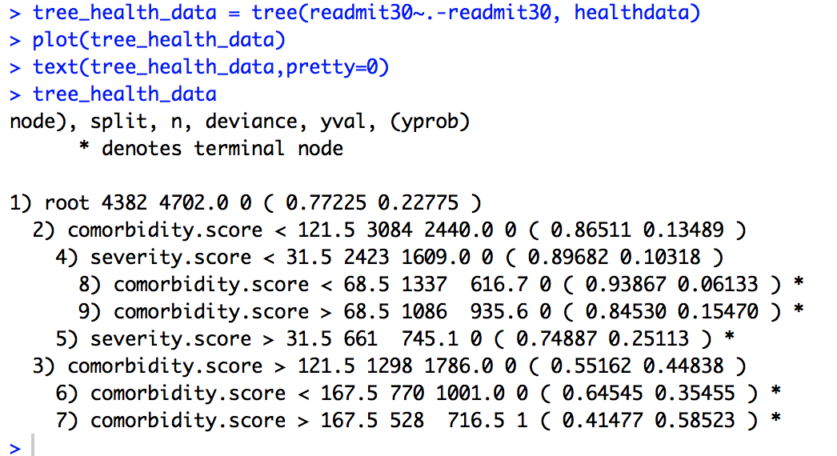

(b)

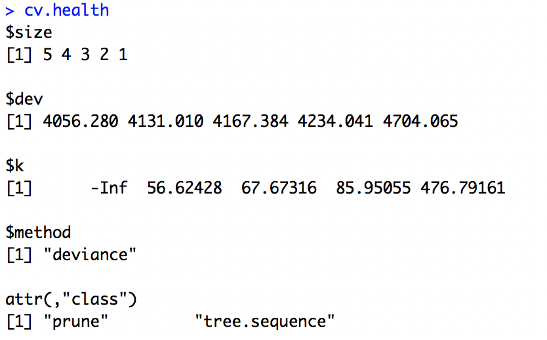

(c)

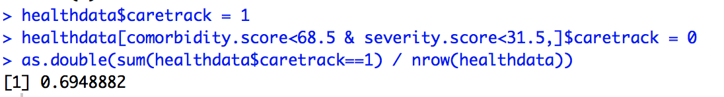

(d) The unawareness difference between male and female is about 0.0395, while the accuracy parity difference is about 0.0745

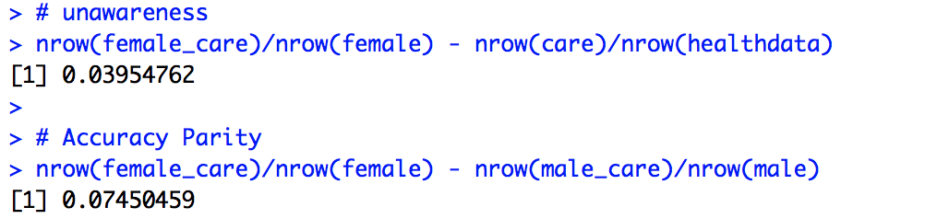

2.

(a)

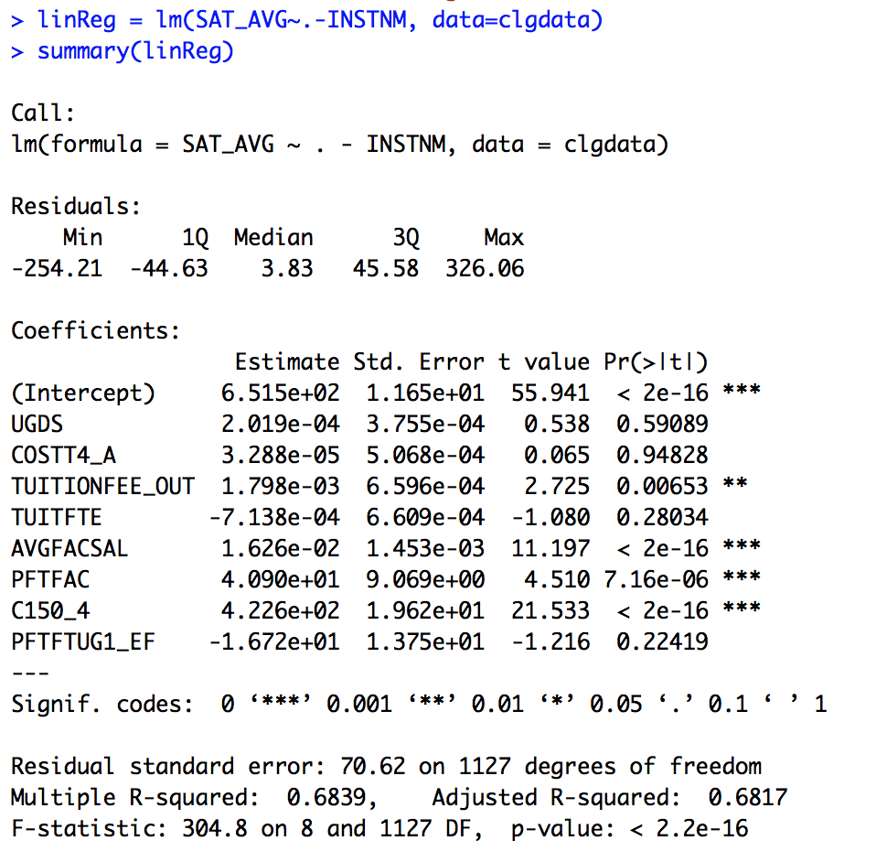

(b) I will choose k=10, because WSS[10] is quite small and k=10 is not large.

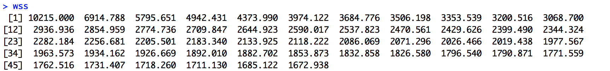

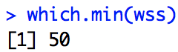

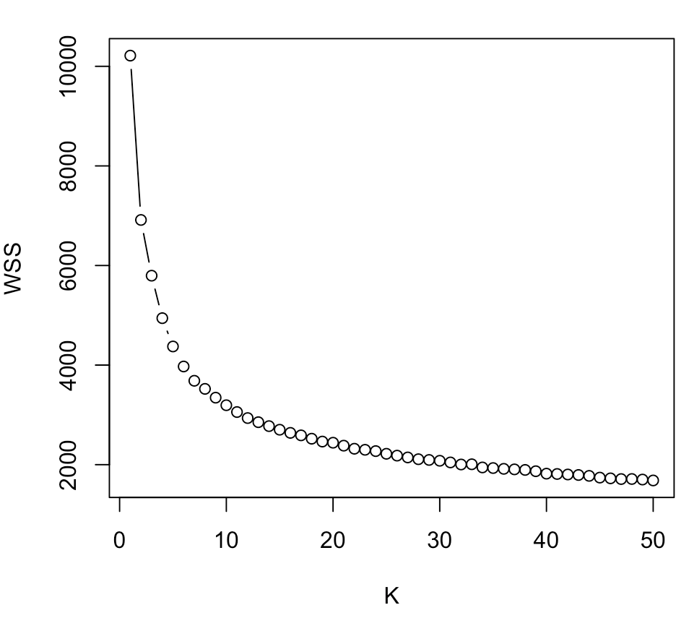

(c) Four centroids are as below

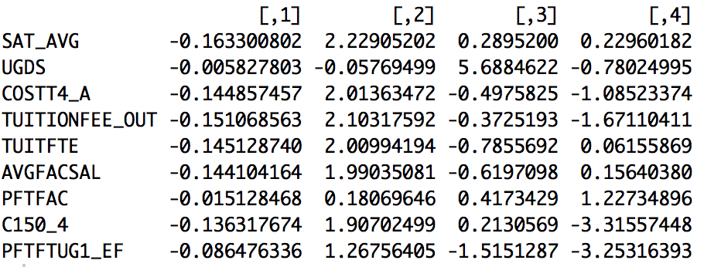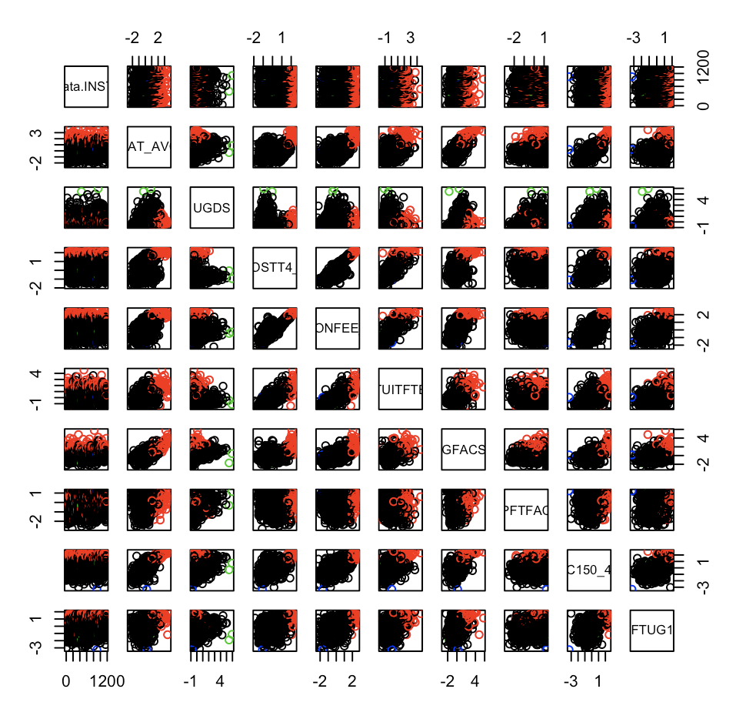

(d) PVE values and cumulative PVE plot is as below.



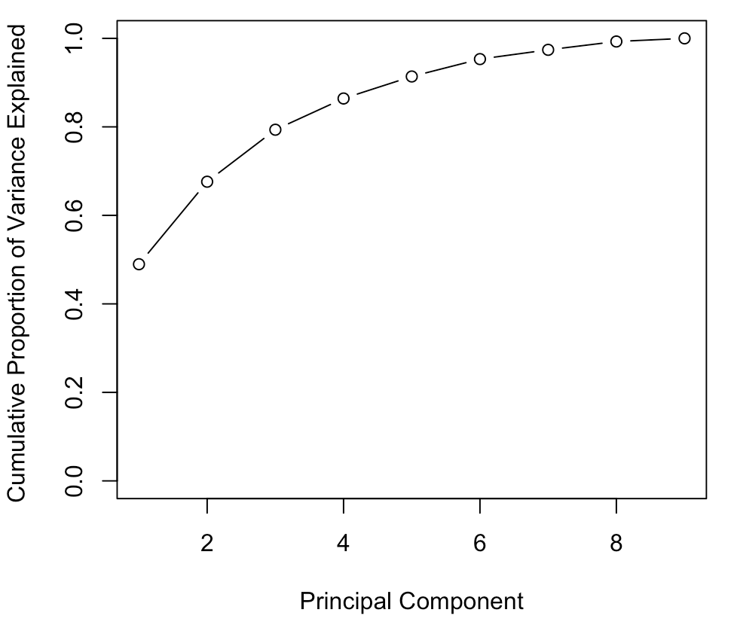

(e)

PC1 indicates a linear combination of COSTT4_A, TUITFTE, TUITIONFEE_OUT, PFTFTUG1_EF, C150_4, SAT_AVG and AVGFACSAL, and obviously that PFTFTUG1_EF plays an important part on it. While PC2 indicates another linear combination of UGDS, PFTFTUG1_EF, C150_4, SAT_AVG, AVGFACSAL, COSTT4_A, TUITFTE and TUITIONFEE_OUT, and obviously that UGDS, PFTFTUG1_EF play an important part on it. In addition, PC1 and PC2 are orthogonal.

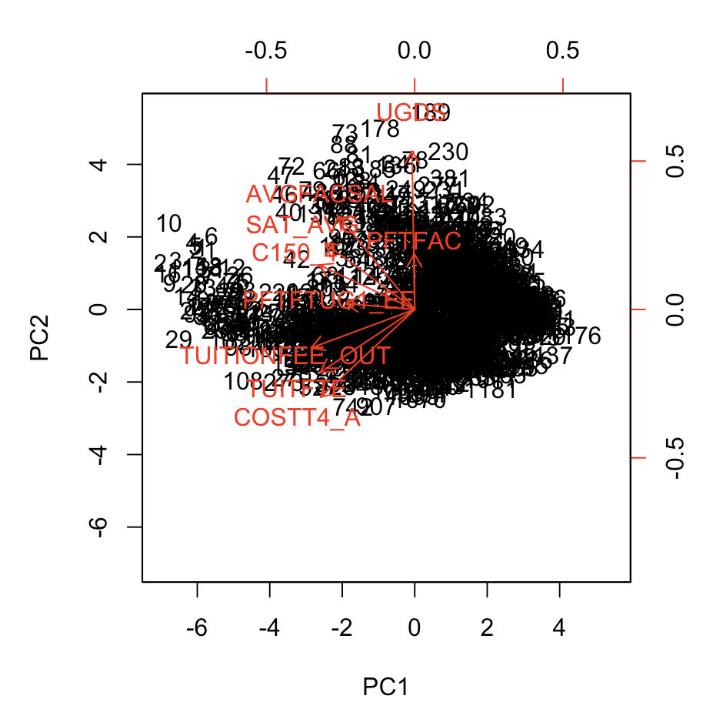

(f)

Below is the summary for PCR, I will choose M=5 because it explains 92% of the variance.

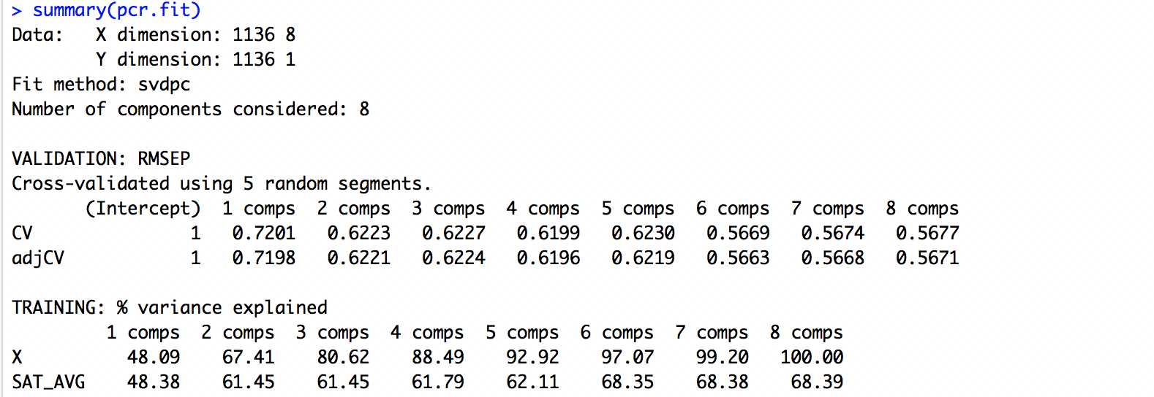

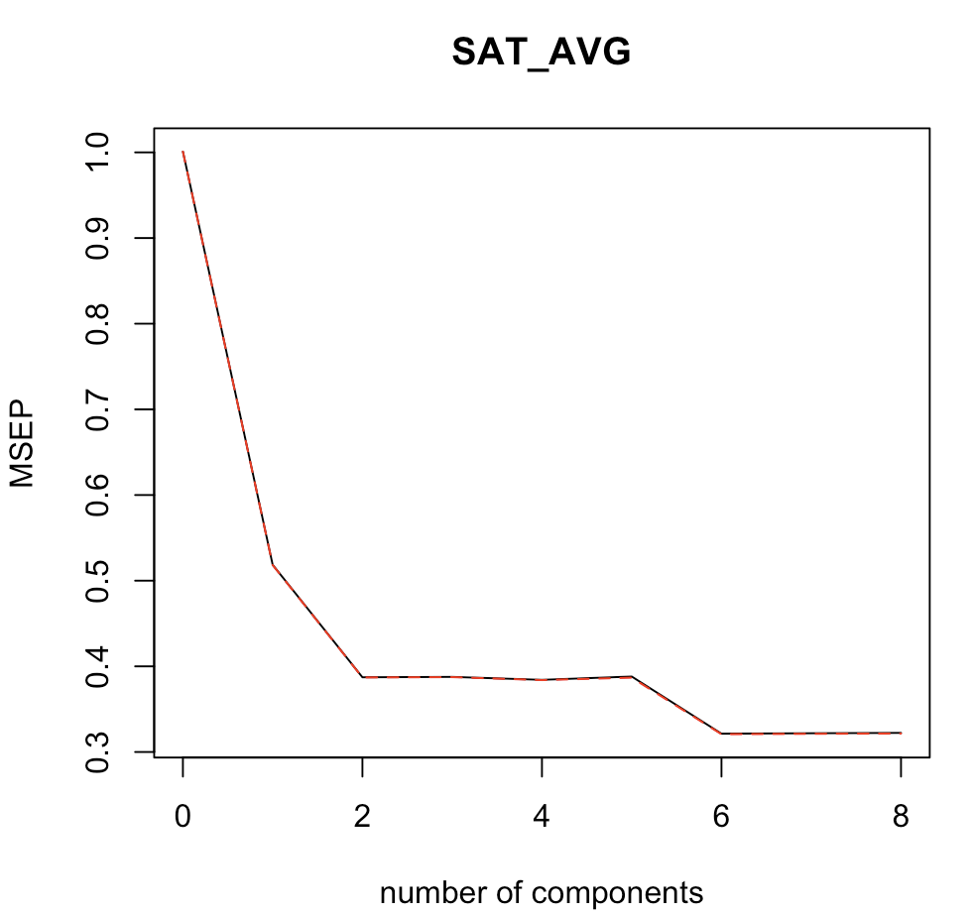

Below is the summary for PLS, I will choose M=6 because it explains 94% of the variance.

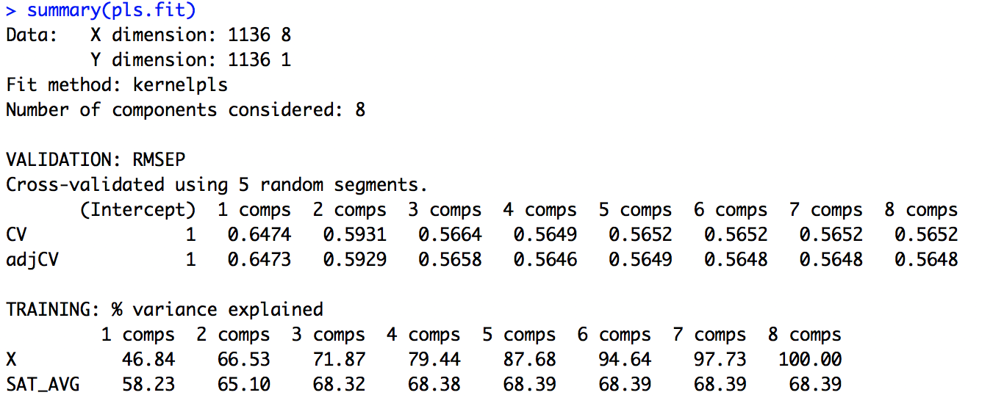

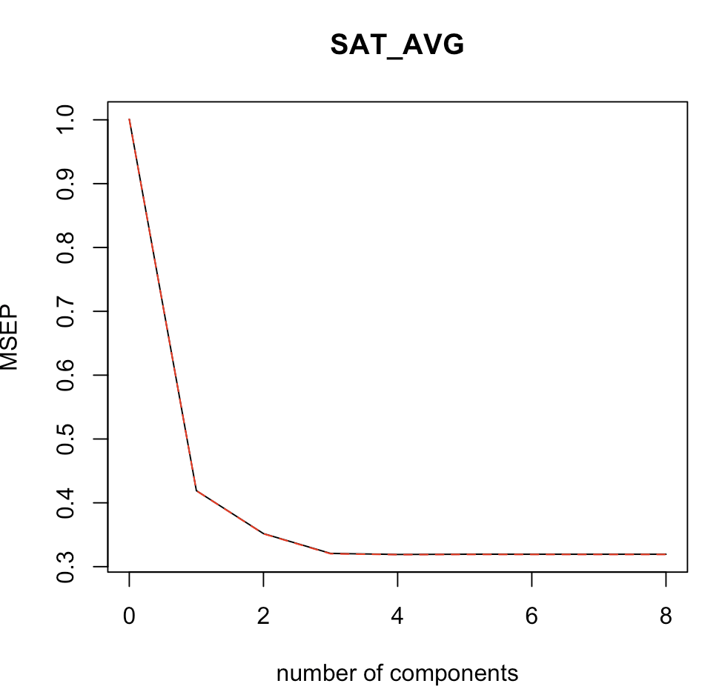

PCR works better because it only requires M=5 while PCR asks for M=6