1.

(a) The average percent change for stores in USA is -10.17%, the average percent change for stores in Canada is -15.90%.

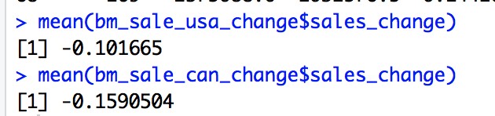

(b) The coefficient of affected (whether involved in BOPS program) is 0.05739, and stand error is 0.01566. Because the P value is 0.000439 so it’s significant. Thus BOPS has positive influence on sales.

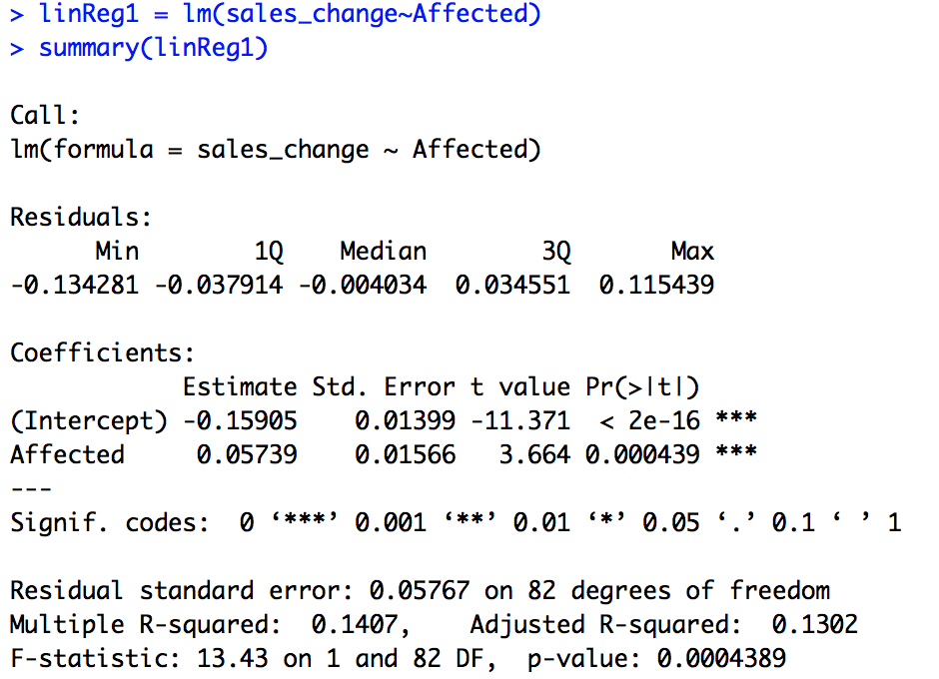

(c) The average sales percent change for DMAs close to stores with BOPS is -19.65%.



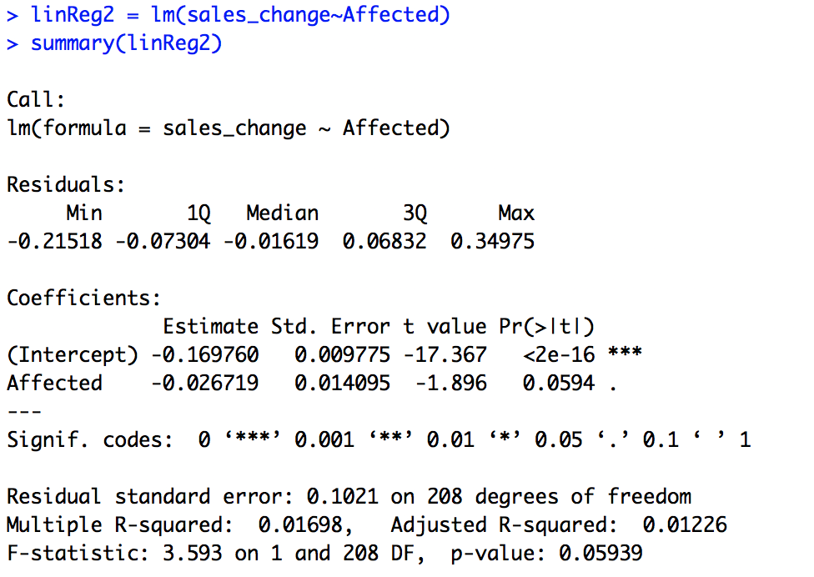(d) The coefficient of affected (whether involved in BOPS program) is -0.0267, and stand error is 0.014. Because the P value is 0.0594 so it’s not significant.

(e) After using 13 months data, the coefficient of affected (whether involved in BOPS program) is -0.0387, and stand error is 0.0265. Because the P value is 0.147 so it’s still not significant.

