Data Visualization

Kathy Kelsey

2023-03-01

knitr::opts_chunk$set(echo = TRUE)

## Load Libraries

library(leaflet)  
 library(dplyr)

##   
## Attaching package: 'dplyr'

## The following objects are masked from 'package:stats':  
##   
## filter, lag

## The following objects are masked from 'package:base':  
##   
## intersect, setdiff, setequal, union

library(tidyr)  
 library(ggplot2)  
 library(DT)  
 library(scales) # install.packages("scales")

## Read Data

data_url <- "https://knb.ecoinformatics.org/knb/d1/mn/v2/object/urn%3Auuid%3Af119a05b-bbe7-4aea-93c6-85434dcb1c5e"  
  
esc <- tryCatch(  
 read.csv("data/escapement.csv"),  
 error=function(cond) {  
 message(paste("Escapement file does not seem to exist, so get it from the KNB."))  
 esc <- read.csv(url(data_url, method = "libcurl"))  
 return(esc)  
 }  
)

## Warning in file(file, "rt"): cannot open file 'data/escapement.csv': No such  
## file or directory

## Escapement file does not seem to exist, so get it from the KNB.

head(esc)

## Location SASAP.Region sampleDate Species DailyCount Method Latitude  
## 1 Akalura Creek Kodiak 1930-05-24 Sockeye 4 Unknown 57.1641  
## 2 Akalura Creek Kodiak 1930-05-25 Sockeye 10 Unknown 57.1641  
## 3 Akalura Creek Kodiak 1930-05-26 Sockeye 0 Unknown 57.1641  
## 4 Akalura Creek Kodiak 1930-05-27 Sockeye 0 Unknown 57.1641  
## 5 Akalura Creek Kodiak 1930-05-28 Sockeye 0 Unknown 57.1641  
## 6 Akalura Creek Kodiak 1930-05-29 Sockeye 0 Unknown 57.1641  
## Longitude Source  
## 1 -154.2287 ADFG  
## 2 -154.2287 ADFG  
## 3 -154.2287 ADFG  
## 4 -154.2287 ADFG  
## 5 -154.2287 ADFG  
## 6 -154.2287 ADFG

## Summary Data (the Challenge!)

annual_esc <- esc %>%  
 separate(sampleDate, c("year", "month", "day"), sep = "-") %>%  
 mutate(Year = as.numeric(year)) %>%  
 group_by(Species, SASAP.Region, Year) %>%  
 summarize(escapement = sum(DailyCount)) %>%  
 filter(Species %in% c("Chinook", "Sockeye", "Chum", "Coho", "Pink"))

## `summarise()` has grouped output by 'Species', 'SASAP.Region'. You can override  
## using the `.groups` argument.

head(annual_esc)

## # A tibble: 6 × 4  
## # Groups: Species, SASAP.Region [1]  
## Species SASAP.Region Year escapement  
## <chr> <chr> <dbl> <int>  
## 1 Chinook Alaska Peninsula and Aleutian Islands 1974 1092  
## 2 Chinook Alaska Peninsula and Aleutian Islands 1975 1917  
## 3 Chinook Alaska Peninsula and Aleutian Islands 1976 3045  
## 4 Chinook Alaska Peninsula and Aleutian Islands 1977 4844  
## 5 Chinook Alaska Peninsula and Aleutian Islands 1978 3901  
## 6 Chinook Alaska Peninsula and Aleutian Islands 1979 10463

glimpse(annual_esc)

## Rows: 1,484  
## Columns: 4  
## Groups: Species, SASAP.Region [39]  
## $ Species <chr> "Chinook", "Chinook", "Chinook", "Chinook", "Chinook", "C…  
## $ SASAP.Region <chr> "Alaska Peninsula and Aleutian Islands", "Alaska Peninsul…  
## $ Year <dbl> 1974, 1975, 1976, 1977, 1978, 1979, 1980, 1981, 1982, 198…  
## $ escapement <int> 1092, 1917, 3045, 4844, 3901, 10463, 4506, 5046, 6503, 11…

##Plot Static Figures Basic ‘ggplot’ figure.

ggplot(annual_esc,  
 aes(x = Species,  
 y = escapement)) +  
 geom_col()

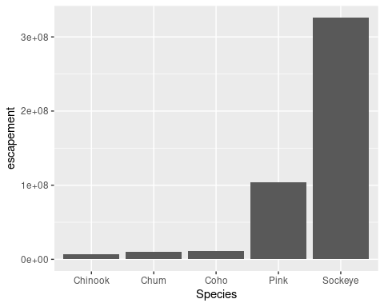

Basic plot with blue bars

ggplot(annual_esc,  
 aes(x = Species,  
 y = escapement)) +  
 geom_col(fill = "blue")

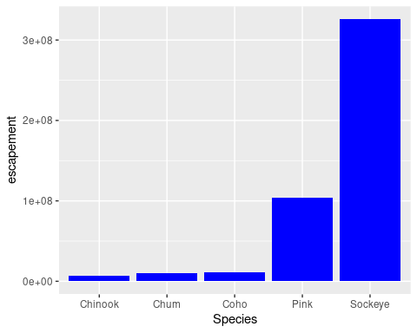

Plotting escapement for each species by region

ggplot(annual_esc,  
 aes(x = Species,  
 y = escapement,  
 fill = SASAP.Region)) +  
 geom_col()

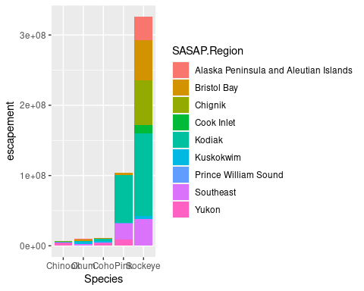

## ‘ggplot’ and the pipe operator

Annual escapement from Kodiak

annual_esc %>%   
 filter(SASAP.Region == "Kodiak") %>%   
ggplot(aes(x = Year, y = escapement, color = Species)) +   
 geom_line() +  
 geom_point()

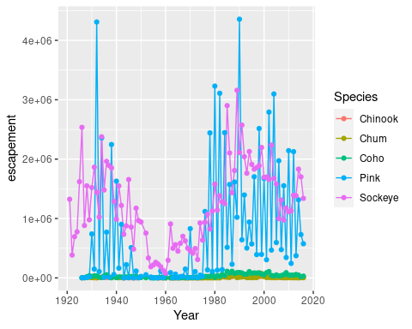

## Customize our plot using theme

kodiak_esc <- annual_esc %>%  
 filter(SASAP.Region == "Kodiak")

ggplot(kodiak_esc,  
 aes(x = Year,  
 y = escapement,  
 color = Species)) +  
 geom_line() +  
 geom_point() +  
 ylab("Escapement") +  
 ggtitle("Kodiak Salmon Escapement") +  
 theme_classic() +  
 theme(legend.position = "bottom",   
 legend.title = element_blank())

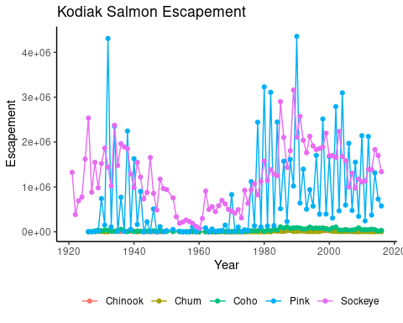

## Saving my custom theme

my_theme <- theme_bw() +  
 theme(legend.position = "bottom",  
 legend.title = element_blank())

ggplot(kodiak_esc,  
 aes(x = Year,  
 y = escapement,  
 color = Species)) +  
 geom_line() +  
 geom_point() +  
 scale_y_continuous(labels = comma) +  
 ylab("Escapement") +  
 ggtitle("Kodiak Salmon Escapement") +  
 my_theme

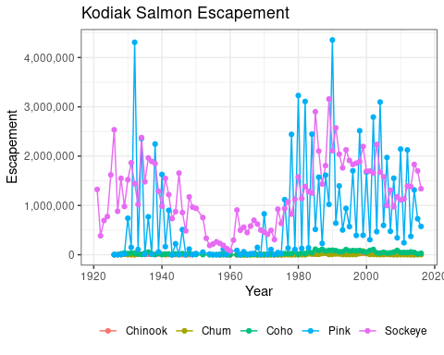

## Saving my plot

ggsave("kodiak_esc.png", width = 12, height = 3, units = "in")

## Creating multiple plots

Plotting escapement by year for all regions

ggplot(annual_esc,  
 aes(x = Year,  
 y = escapement,  
 color = Species)) +  
 geom_line() +  
 geom_point() +  
 scale_y_continuous(labels = comma) +  
 facet_wrap(~SASAP.Region,   
 scales = "free_y",  
 ncol = 3) +  
 ylab("Escapement") +  
 my_theme

