mydata=read.table("apple2.csv", sep = ",",header = TRUE)  
sales=ts(mydata$sales, start = c(2007,3), frequency = 4) # take the sales column and make it as the time series, start from 2007, and frequency is 1 (start=c(2007, 3), frequency=4) indicates quarterly data from 2007 Q3

# plot each quarter's sales

plot(mydata$sales,type = "l", col="red", ylab = "",xlab = "mydata$time")  
points(mydata$sales, col="blue")  
title("Quarterly Iphone Sales")

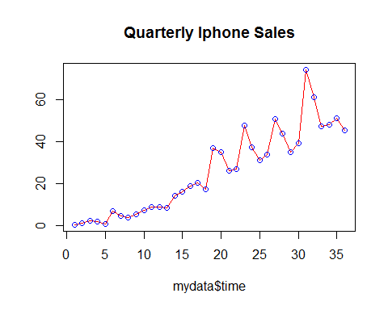

# cumulative sales

Y=cumsum(mydata$sales)  
Y=ts(Y, start = c(2007,3), frequency = 4) # make it as a time series  
plot(Y,type = "l", col="pink", ylab = "",xlab = "")   
points(Y, col="green")  
title("Cumulative Iphone Sales")

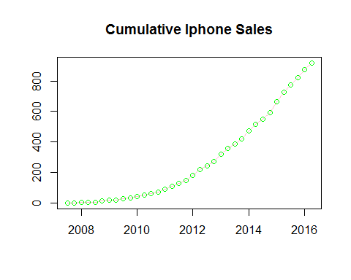 #run the regression model between sales and

Y=c(0,Y[1:length(Y)-1]) # we need the lagged cummulative sales  
Ysq = Y**2  
model=lm(mydata$sales~Y+Ysq)  
summary(model)

##   
## Call:  
## lm(formula = mydata$sales ~ Y + Ysq)  
##   
## Residuals:  
## Min 1Q Median 3Q Max   
## -14.225 -3.332 -1.280 2.466 23.229   
##   
## Coefficients:  
## Estimate Std. Error t value Pr(>|t|)   
## (Intercept) 3.376e+00 2.019e+00 1.672 0.104   
## Y 1.459e-01 1.592e-02 9.164 1.38e-10 ***  
## Ysq -1.098e-04 2.038e-05 -5.386 5.90e-06 ***  
## ---  
## Signif. codes: 0 '***' 0.001 '**' 0.01 '*' 0.05 '.' 0.1 ' ' 1  
##   
## Residual standard error: 7.435 on 33 degrees of freedom  
## Multiple R-squared: 0.8709, Adjusted R-squared: 0.8631   
## F-statistic: 111.3 on 2 and 33 DF, p-value: 2.144e-15

a<-model$coefficients[1]  
b<-model$coefficients[2]  
c<-model$coefficients[3]  
  
mplus =(-b+sqrt(b^2-4*a*c))/(2*c)  
mminus=(-b-sqrt(b^2-4*a*c))/(2*c)  
m<-mminus  
p=1/m  
q=b+p

# Bass model

bassModel = function(p,q,m,T=100) # T how many period you want  
{  
 s=double(T)  
 y=double(T+1)  
 y[1]=0  
 for(t in 1:T){  
 s[t]=p*m+(q-p)*y[t]-(q/m)*y[t]**2  
 y[t+1]=y[t]+s[t]  
 }  
 return(list(sales=s, cumSales=cumsum(s)))  
}  
  
# compute sales  
spred =bassModel(p,q,m,T=38)$sales # predicted sales for 2007 Q3 to 2013 Q1 as there are 23 data points  
spred =ts(spred, start=c(2007,3),frequency = 4)  
ts.plot(sales, spred, col=c("blue","red"))  
legend("bottomright", legend = c("actual", "bass model"),fill = c("blue","red"))

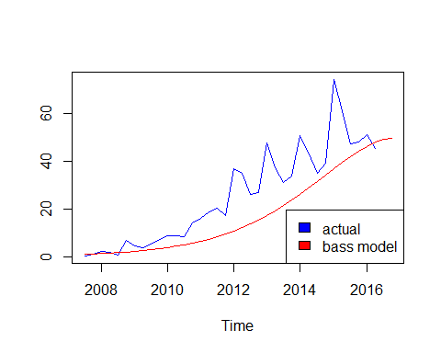

# compute cummulative sales

spred=bassModel(p,q,m, T=100)$sales # you can delete T=100, as it is defaulted to be 100  
cumspred = ts(cumsum(spred), start = c(2007,3), frequency = 4)  
cumsales = ts(cumsum(sales),start = c(2007,3), frequency = 4 )  
ts.plot(cumsales, cumspred, col=c("blue","red"))  
legend("bottomright", c("actual", "bass model"),fill = c("blue","red"))

