# ResPitch – 3D Slicer Cheat Sheet

## Vocabulary

|  |  |
| --- | --- |
| Voxel | A unit of information in 3D space. Similar to a pixel in a 2D picture. |
| Segmenting | The act of separating structures to create a 3D model, also called a segment. |
| Module | Sets of tools you can use to manipulate data. There’s a whole universe of modules and extensions you can download and explore! |
| DICOM | Scans are saved as DICOM files, which you can upload and use in 3D Slicer. Stands for “Digital Imaging and Communications in Medicine.” |
| stl file | A file type which stores information about 3D models. After segmenting, you can export your work as an stl file to work on in other programs. There are different file types which also store 3D data, such as obj files. |
| X-ray | An X-ray machine emits electromagnetic radiation, which travels through the object being scanned, to hit X-ray film. Structures can be distinguished by their density, and how easily the radiation travels through them. |
| Computerised tomography (CT) | Computerised tomography. Rotating X-ray machines create multiple images. These can be viewed individually in 2D, or stacked together to make 3D images. |
| Magnetic resonance imaging (MRI) | Powerful magnets generate a magnetic field that aligns all the hydrogen atoms (protons) in the body. When the magnets are released, the sensors detect the energy emitted by the protons as they realign in their original configuration. This allows tissues to be distinguished by their water content. No radiation is required to generate the image. |
| Contrast media | An agent that can be added to highlight structures in a scan. Has many uses, such as tracking structures, detecting blockages, or visualising soft tissues. |

## Hounsfield scale

Medical scanners often use radiation to produce images. When looking at a scan, the tissues of the body can distinguished by their radiodensity – that is, how easily radiation passes through them. The Hounsfield scale and Hounsfield units are a measure of radiodensity. The scale is frequently used to interpret X-rays and CT scans in particular.

For example, bone looks white because it is the densest tissue in the body and radiation does not pass through it easily. In contrast, air looks black because it is the least dense material. This is a good rule of thumb for x-rays or CTs, but is not always the case for more complex imaging modalities, where computers can add colours afterwards.

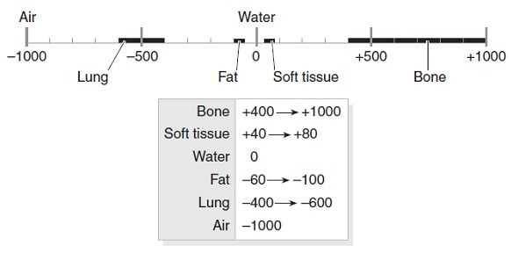

## Keyboard shortcuts

|  |  |
| --- | --- |
| Move through slices | Scroll, or move the slider at the top of the slice viewer |
| Move the image in the frame | Hold shift, and click and drag |
| Zoom in/out | *Mac:* Hold command and scroll  *Windows:* Right click and scroll |
| Align at a point | Shift + move mouse |
| Brightness (level) | Left click + drag the mouse up and down |
| Contrast (window) | Left click + drag the mouse right and left |
| 3D view | *Rotate:* Click and drag  *Move:* Shift click and drag  *Zoom in/out:* Scroll up or down  *Reorient:* Hover over the pin icon in the top left hand corner. Select the perspective you wish to view from. |

## Anatomical planes

In medicine, particular terms are used to describe the human body in 3D space. For example, what you would refer to as your front and back would be referred to as your anterior aspect and posterior aspect. Similarly, one could say that your head is superior to (on top of) your toes, or your toes are inferior to (underneath) your head.

There are also terms used to identify the three planes of the human body. Please note that synonyms have been provided in the image below, however we will stick to referring to these as the sagittal, axial and coronal planes, as they are used in 3D Slicer..

Please also note that in medical images your right and left are *reversed*. This is because the patient’s own right and left are used for reference.

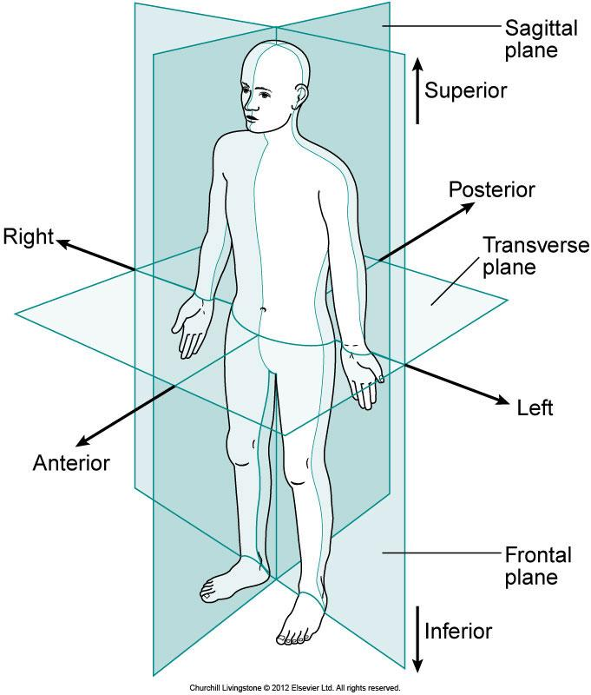

/ Axial

/ Coronal