# Bensler



[Lillian Brown](https://medium.com/@lillianbrown?source=post_page-----b97d84ac0e7c----------------------)

Follow

[Dec 26, 2016](https://medium.com/cliffhanger/bensler-b97d84ac0e7c?source=post_page-----b97d84ac0e7c----------------------) · 4 min read



Olivia Benson (played by Mariska Hargitay) and Elliot Stabler (played by Chris Meloni) in Season 12 of ‘Law & Order: SVU.’ Image Credit: [NBC](http://www.nbc.com/law-and-order-special-victims-unit/photos/season-16/olivia-benson-through-the-years/1960246).

There’s a line from *The Good Wife* that Will and Alicia both voiced about their almost relationship throughout the series: “It’s romantic because it didn’t happen.” While both a different show universe and an alternate take on “not happening,” this comment encapsulates the twelve-year-long relationship between Olivia Benson and Elliot Stabler of *Law & Order: Special Victims Unit*, also known as one of TV’s greatest and earliest “almost couples.” I realize that the show is in no way about a ship, or a “will-they-won’t-they” plot, but often the most tragic storylines, like those portrayed on *SVU*, are routed in profound love of some kind, which is a major component as to why the show has lasted for eighteen seasons and counting.

The show starts out during Benson and Stabler’s first year as partners, and Benson’s first year as a sex crimes detective. Despite functioning in a constant state of unresolved sexual tension, the partners manage to keep it platonic, even after Stabler’s wife leaves him. Viewers recognized the chemistry immediately, and dubbed their “ship” name “Bensler.”

Amidst long, unsubtle glances, and angsty fights where the two blame each other for everything, Benson and Stabler finally acknowledge that they “chose each other over the job” and separate for a while, before coming back together. Mariska Hargitay’s pregnancy and subsequent maternity leave created space for an eight-episode arc with a new female partner for Stabler (they had Benson “go undercover” for the FBI). Stabler and the other detective, Dani Beck, share a kiss, but it doesn’t appear to amount to anything, and Beck soon departs the show. By the time Benson returns, their dynamic has shifted again, and they spend a season getting back on even footing, only to have Stabler reunite with his wife. Bensler’s story is ultimately comprised of a series of missed moments.

…Often the most tragic storylines, like those portrayed on ‘*SVU*,’ are routed in profound love of some kind, which is a major component as to why the show has lasted for eighteen seasons and counting.

“Some partners are closer than married couples.” This passionate, borderline necessary relationship was noticed by all and even used against Benson and Stabler in Season 12, which is why it was such a shock when Meloni abruptly departed the series at the end of the season, taking Stabler, and Bensler’s relationship history, with him.

[According to *TVLine*](http://tvline.com/2011/05/24/chris-meloni-exits-law-order-svu/), the publication that first reported the Meloni’s exit, contract negotiations between the actor and NBC fell through. “For the past 12 years Chris has been my partner and friend, both on screen and off,” Hargitay [told *TVLine*](http://tvline.com/2011/05/27/mariska-hargitay-chris-meloni-law-order-svu-exit/)a few days after the news broke. “He inspired me every day with his integrity, his extraordinary talent, and his commitment to the truth. I love him deeply and will miss him terribly—I’m so excited to see what he’ll do next.”

Image for post

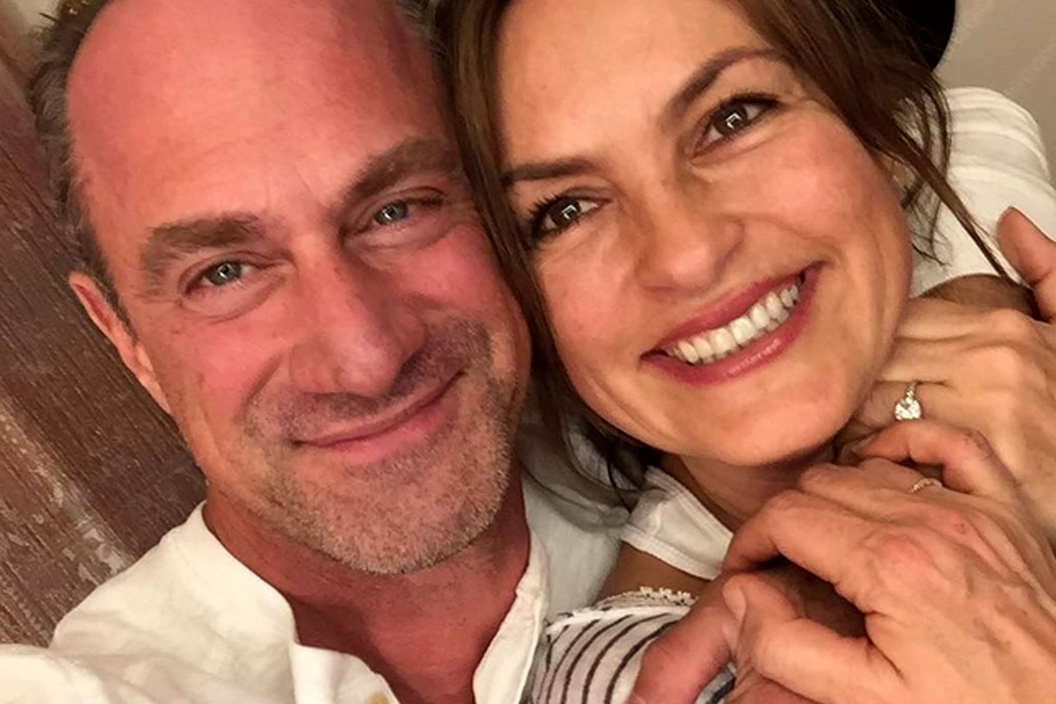

Christopher Meloni and Mariska Hargitay in December 2016. Image Credit: [Chris Meloni Instagram](https://www.instagram.com/p/BOP64mhhNGg/?hl=en).

Tumblr user [yay-its-sara once commented](http://yay-its-sara.tumblr.com/post/95161566710/can-i-be-honest-and-fangirl-for-a-moment-i-know) that Hargitay and Meloni are “like parents that were super awesome together, then got divorced—out of nowhere, yet remain really close for the sake of their kids.” It’s in this oddly specific yet completely accurate description that the public essence of the pair is captured, as they often reunite and take to sharing photos of their friendship on social media. They posted a photo last week of their most recent get-together, which had all fans swooning once again.

In an [interview](https://www.youtube.com/watch?v=wAm3YdmkCLE), Hargitay described what they have as “a sacred union, both on screen and off.” Meloni has shared similar sentiments, so a Stabler return isn’t necessarily out of the picture. It has been [rumored](http://www.hollywoodreporter.com/live-feed/law-order-svu-christopher-meloni-861568) that Meloni will come back when the show ends (*if* the show ever ends).

People often wonder if the pair could be endgame, but Benson has changed, and Stabler most likely has, too. They couldn’t grow with each other. Namely, Liv couldn’t grow. At one point in the fifteenth season, while interviewing a cop who constantly covered for her partner, Benson asks, “You love him, don’t you? You’re forty years old, wondering if you’ll ever have a family, or if riding around with him will be enough for the rest of your life. Did you really think he’d leave his wife and kids for you? You spent the last five years hoping he’d suddenly turn and realize you’re the woman he can’t live without.” It hit a little bit too close to home to be just an interrogation point.

Would I love for the characters to get together? Yes. Would I love just to get a reunion or some sort of resolution between the former partners? Of course. But this is OK, too.

Image for post

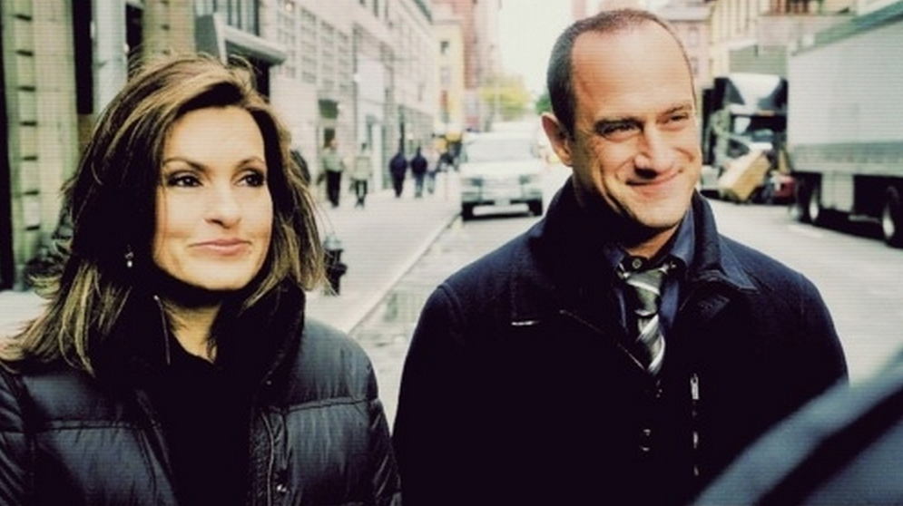

Olivia Benson (played by Hargitay) and Elliot Stabler (played by Meloni) in ‘Law & Order: SVU.’ Image Credit: [NBC](http://www.nbc.com/law-and-order-special-victims-unit/episodes).

After originally telling Will that “It’s romantic because it didn’t happen” over a phone call, Alicia adds, “If it had happened, it would’ve just… been life.”

While this argument could certainly be used to justify the Bensler romance, or lack thereof, it should be noted that Will responds with, “And what’s wrong with life? I could see that.”