Practical Work Report (TP)

Evaluation and Comparison of Search Algorithms

1. Introduction & Objectives
The objective of this practical work is to evaluate and compare the performance of four fundamental search algorithms:
- Simple Sequential Search (Recherche Séquentielle Simple)
- Optimised Sequential Search (for sorted tables)
- Iterative Binary Search
- Recursive Binary Search
The comparison is based on two primary criteria:
- a. Number of Comparisons: The total number of element checks performed during the search.
- b. Execution Time: The CPU time taken to complete the search operation (measured in seconds).

2. Experimental Methodology & Instructions
Following the lab instructions:
- Dataset Generation: Large arrays of random elements were generated with sizes of N = 10^3, N = 10^4, and N = 10^6.
- Testing Protocol: To ensure statistical accuracy and mitigate anomalies, 30 independent tests were conducted for each case, and the average values were recorded.
- Implementation: All algorithms were implemented in Python, using high-precision timers (time.perf_counter()) to measure execution duration.

3. Experimental Results & Visual Graphs Analysis
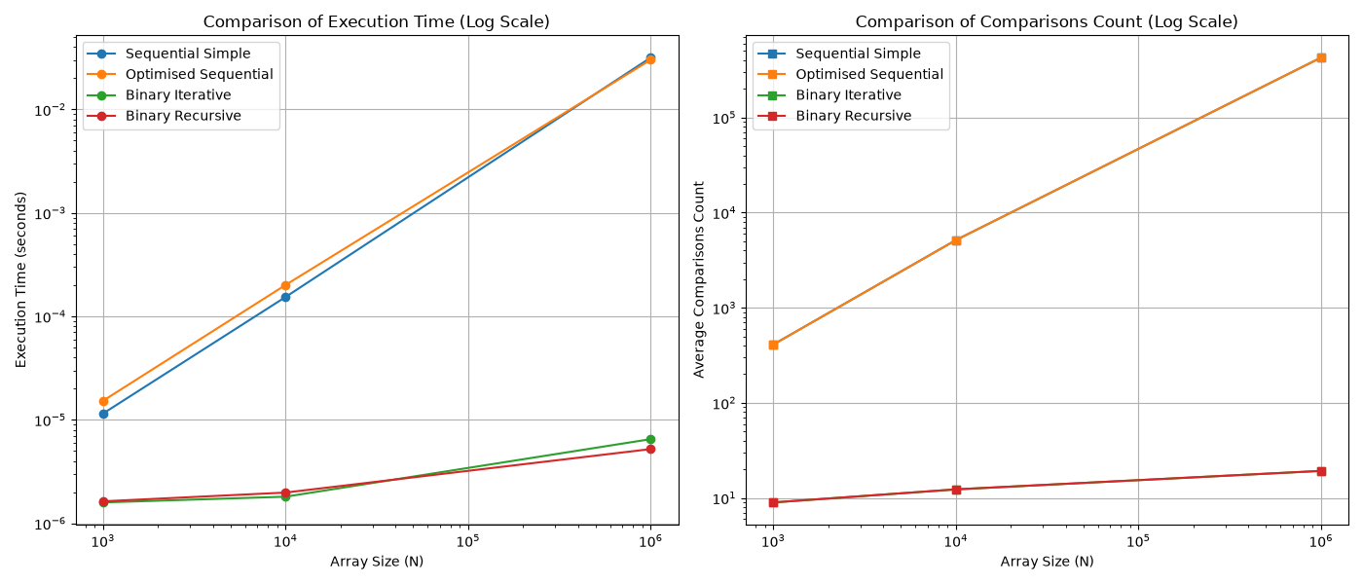
Graph Analysis:

- Execution Time (Log Scale):
  - The Sequential Search algorithms exhibit a linear time complexity (O(N)), causing execution times to escalate rapidly as the array size increases to 10^6.
  - The Binary Search algorithms (both Iterative and Recursive) demonstrate a logarithmic time complexity (O(\log N)). Their execution times remain extremely fast and nearly flat even for very large datasets (10^6 elements).
- Number of Comparisons:
  - Simple sequential search performs an average of N/2 comparisons for successful searches, scaling directly with array size.
  - Optimised sequential search improves performance slightly on sorted arrays by terminating early when an element exceeds the target, but it remains bounded by O(N).
  - Binary search drastically reduces the number of comparisons (requiring at most \approx \log_2(N)comparisons), proving vastly superior at scale.

4. Conclusion
Through this experimental study, it is evident that algorithm choice heavily dictates performance on large datasets. While sequential searches are simple and suitable for small or unsorted collections, they become highly inefficient for large arrays. Binary search (whether implemented iteratively or recursively) offers optimal performance, making it the industry standard for searching within large sorted datasets.
Submitted to: eboubakkar@gmail.com

