

School of Electronic Engineering

RFID Side Channel Analysis for IoT Devices
Project Portfolio

Katherina Keogh
ID Number: 19423752

August 2025

MEng in Electronic and Computer Engineering

Supervised by Liam Meany

Acknowledgements

I would like to thank Mr Liam Meany, for giving me the opportunity to work on such an interesting project. I am also thankful to my family and friends for their encouragement and understanding during my studies.

RFID Side Channel Analysis for IoT Devices
Katherina Keogh
MEng. Electronic and Computer
Engineering,
Dublin City University,
Dublin, Ireland
katherina.keogh24@mail.dcu.ie

Abstract— Side channel attacks on RFID devices present a significant threat by enabling attackers to extract secrets through indirect information such as power consumption or electromagnetic (EM) emissions. Existing approaches to RFID security often focus on cryptographic protocol analysis, but may overlook vulnerabilities exposed by physical layer leakage. This paper applies side channel analysis techniques to MIFARE Classic cards using a Proxmark3 reader, an RTB2002 oscilloscope, and probes for both power and EM emissions. Controlled authentication sequences with known keys and data were repeated and measured, generating CSV samples for power and EM signals across multiple RFID memory blocks. These datasets were analysed using leakage modelling and side channel evaluation metrics to assess the possibility of key retrieval. The findings demonstrate the practical risks associated with existing RFID systems.

I. INTRODUCTION
R
ADIO Frequency Identification (RFID) technology is widely used in applications like access control, ticketing, and contactless payments, driven by the convenience of smart cards and tags. As RFID systems become more prevalent, their security is increasingly challenged, not only by cryptographic attacks, but also by side channel analysis. [1] [2].
Side channel attacks exploit unintended information leakage through physical factors such as power consumption, electromagnetic (EM) emissions, timing variations, or acoustic emissions. Unlike traditional cryptanalytic attacks that target mathematical weaknesses in algorithms, side channel attacks focus on implementations which are dependent on physical characteristics that may reveal secret keys through statistical analysis of measurement data.
Previous research has demonstrated successful side channel attacks against various cryptographic implementations, particularly through Differential Power Analysis (DPA) and Correlation Power Analysis (CPA) techniques [3]. These methods exploit correlations between measured power consumption and intermediate cryptographic values, often using leakage models such as Hamming weight or Hamming distance of processed data.
This paper examines whether MIFARE Classic, one of the most widely used contactless smart cards, authentication commands affect power consumption and EM emissions differently based on the Crypto1 key used [4]. The power usage and EM emissions were measured and recorded, and statistical analysis was used to evaluate the potential for identifying keys through side channel analysis.

II. Prior Work
Picek et al. [5] demonstrated the effectiveness of machine learning techniques for analysing side channel traces, showing that classifiers can improve key recovery success, this inspired the advanced analysis methods beyond traditional statistics. Xu et al. [6] conducted a detailed side channel attack on protected RFID cards using practical measurements, directly influencing this experiment design and the choice of statistical tests for evaluating leakage on MIFARE Classic cards. Additionally, the attack by de Koning Gans et al. [4] on MIFARE Classic revealed real world protocol and implementation weaknesses, highlighting the necessity of investigating multiple attack surfaces, including both logical and physical vulnerabilities. Collectively, these works provided critical context and methodological ideas for both data collection and analysis in this paper.
This investigates how both power and EM emissions vary with different keys during MIFARE Classic authentication, measuring the size and significance of this key dependent leakage. This dual channel approach offers a more complete picture of practical vulnerabilities that were not fully explored in earlier studies.

III. Experiment Setup and Implementation
This paper investigates side channel leakage from MIFARE Classic RFID cards by measuring power consumption and EM emissions during authentication. The aim is to investigate whether the secret key used for encryption or block data processed by the Crypto1 stream cipher produces measurable physical signatures exploitable in practical attacks.

A. Experimental Hardware Setup
The hardware used in this experiment consisted of a Proxmark3 device, a Rohde & Schwarz RTB2002 digital oscilloscope, a RaspberryPi and a MIFARE Classic 1K RFID card.
The Proxmark3 was used to communicate directly with the RFID card and issue commands such as key authentication and block writing. The Iceman firmware was running on the Proxmark3. The Iceman repo is recognised for its extensive features, active development, and broad compatibility with various RFID standards [7], which allow advanced commands and scripting. The supportive firmware documentation made it especially effective for tasks such as MIFARE Classic card manipulation, providing reliability and flexibility. The Proxmark3 also acted as the trigger source for synchronising oscilloscope captures.
A RIGOL Passive Probe PVP3150 was connected to the Proxmark to capture the power used when executing the commands.
A high sensitivity, near field EM probe, NAE Hprobe, was used to capture side channel emissions during card communication.
The RTB2002 oscilloscope was used to record traces from these two analog channels, measuring EM and power related signals during MIFARE operations. The horizontal scale was configured to cover the full authentication exchange, and the vertical scaling was adjusted individually per channel to maximise signal to noise ratio without saturation.
The MIFARE Classic 1K card served as the target of the analysis. It was placed directly on the Proxmark, which was attached to a sensing probe and the EM probe was placed directly on top of the MIFARE card during trace collection to ensure consistency.
A Raspberry Pi 3 running Raspberry Pi OS was used to power the Proxmark3 via its USB port and to orchestrate authentication sequences. The Raspberry Pi 3 was used to interface with the Proxmark3 and manage data collection due to its Linux based operating system and small size which it ideal for integrating both the Proxmark3 and oscilloscope into a compact, self contained measurement platform. The Pi issued commands over USB to the Proxmark3 and mounted the RTB2002’s USB stick storage so that the CSV trace files could be transferred to the Pi’s filesystem before being uploaded to Google Drive.
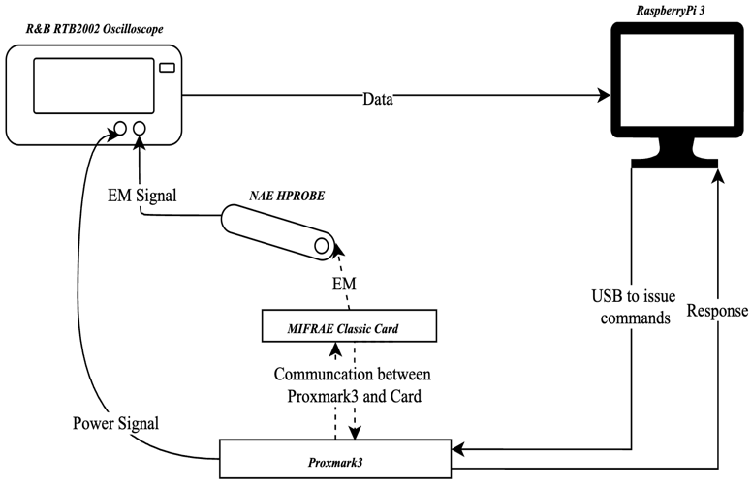
Fig 1: Block Diagram of Hardware Setup

B. MIFARE Classic Setup
The MIFARE Classic card is organised into sectors, each containing four data blocks. The last block in each sector is known as the sector trailer and stores two 6 byte cryptographic keys, Key A and Key B. These keys are represented in hexadecimal format and consist of 12 hexadecimal characters. The keys are used to control access to the data within the sector. [8]
The Proxmark3 was used to communicate with the MIFARE Classic card. Initial identification of the card type and basic properties was performed using the ‘hf search’ and ‘hf mf info’ commands, which revealed the UID, ATQA, SAK, and detected keys [9]. These commands provided confirmation of the card type and manufacturer, ensuring that it was compatible with Crypto1 based authentication. Before running the authentication command, individual authentication tests, ‘hf mf auth’ and read operations were performed to validate known keys and confirm sector access.
Three distinct Crypto1 keys were programmed into different sectors of the MIFARE Classic card to enable comparative analysis. The keys were selected at random.
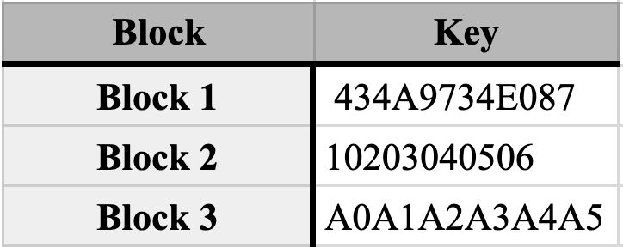
Table 1: Block and Key combinations
The Proxmark3 ‘hf mf wrbl’ command was used to program sector trailer blocks with the respective keys, followed by verification using ‘hf mf chk’ commands [9].
The ‘hf mf chk’ command is a key checking function used to test a supplied key against a target block on a MIFARE Classic card [9]. When executed, the command triggers a full authentication sequence using the Crypto1 cipher, making it highly relevant for side channel analysis.
The creates a consistent authentication process with few extra steps, which produce clear and comparable data for analysis. Its predictable nature and direct use of the target key make it a good choice for checking if different keys show different, noticeable patterns in side channel measurements.
Please see Appendix H for Proxmark3 Command Line Interface output screenshots illustrating these commands.

C. Data Collection
To gather consistent side channel data, a list of repeatable measurement steps was created. For each test, a single MIFARE Classic 1K card was placed directly on the Proxmark with the EM probe placed on top of the card, which was connected to the oscilloscope. Each test sequence involved sending the same command multiple times to the same block, with the hardware setup remaining in the same physical position throughout the experiments to minimise any variations in the data.
The authentication sent from the Proxmark was repeated 15 times for each block and key combination. Each command triggered a waveform capture on the oscilloscope, which recorded power, EM and timing data. The oscilloscope was configured to begin capturing as soon as the command was issued, using digital triggering based on signal activity to align each trace.
Waveforms were saved in CSV format with filenames clearly indicating the key, and repetition number. This ensured proper trace tracking and data labelling during analysis. All captures were carried out using the same sampling rate, voltage scale, and time base settings to ensure consistency across the entire dataset. There was a total of 45 CSV files.
This list of steps allowed for fair comparisons between different keys and blocks, making it possible to evaluate whether observable variations in power or EM patterns could be linked to the specific key used.

D. Data Processing and Visualisation
All of the data preprocessing, visualisation, and statistical analysis were conducted using Google Colab, a cloud based Jupyter notebook environment. Google Colab was chosen for its accessibility, preconfigured Python libraries, and integration with Google Drive for storing the CSV files [10]. Google Colab provided access to essential libraries, including NumPy was used for numerical calculations, Pandas for organizing and managing trace data, Matplotlib for plotting power and EM signals, and SciPy for performing statistical analysis like $t$-tests and correlations. The cloud based environment also eliminated the need for local software installation. The oscilloscope waveform files were uploaded to Google Drive and were accessed directly within the Colab notebooks, allowing for easy data import and preprocessing techniques. All statistical computations, including Cohen’s $d$ effect size calculations and Pearson correlation analysis between key Hamming weight and EM peak values, were performed using standardised Python functions within the Colab environment.
The data sets were first trimmed to begin at the authentication command’s time zero, ensuring the analyses focused on the Crypto1 processing window and eliminated noise not relevant to the command. The 15 samples for each key were then combined and the average was taken. The selected preprocessing techniques are designed to ensure that comparable metrics were obtained for subsequent $t$-tests, effect-size calculations, and correlation analysis.

E. Limitations and Environmental Factors
Sample size was limited to 15 traces per key due to manual measurement, making results less conclusive than studies using thousands of traces.
Automation challenges and environmental noise further affected signal quality and reduced reliability, as the testing conditions were less controlled than those in larger research projects.

IV. Results Obtained

A. Trace Characteristics
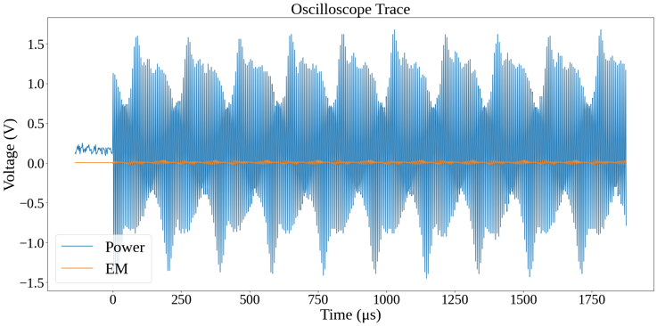
Fig 2: A Section of the Power and EM Signals of a Unprocessed CSV File of a Key
The snippet of an oscilloscope trace in Fig 2. displays the measurement of power and EM signals collected during a typical RFID transaction. The power signal, in blue, displays rhythmic oscillations spanning voltage values from around $-1.5$V to $1.5$V, reflecting the alternating nature of the underlying RFID communication and energy exchanges between reader and tag. The EM signal, in orange, captured in parallel, displays significantly lower amplitude, close to the zero volt baseline, represents the EM leakage associated with device activity. While it is less noticeable, this signal holds important information for security analysis. Its slight changes can expose vulnerabilities that attackers could exploit.

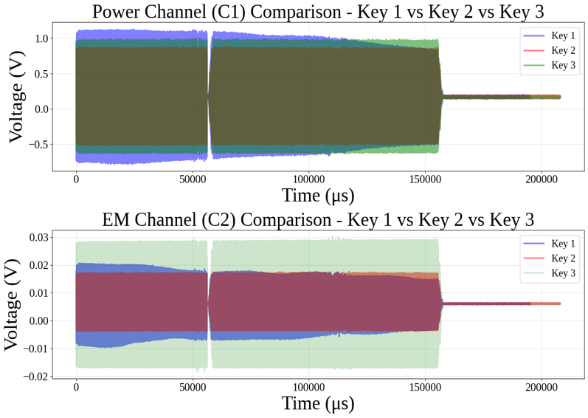
Fig 3: Overlay of averaged power (C1) and EM (C2) traces for all three keys during MIFARE Classic authentication
Figure 3 shows the averaged side channel traces for all three keys and blocks. Both power and EM measurements show identical timing structure, confirming that all traces successfully captured the same ‘hf mf chk’ authentication protocol.
For each key, Channel 1 displays the average power profile, showing how voltage fluctuates from negative to positive values throughout the transaction, typically ranging between approximately $-0.75$V to $1.0$V for key 1, $-0.4$V to $0.8$V for key 2, and $-0.5$V to $1.0$V for key 3. Channel 2 then displays the corresponding EM leakage, with shifts in voltage observed in the range of $-0.01$V to $0.02$V for keys 1 and 2, and a slightly wider spread of $-0.02$V to $0.03$V for key 3.
The time axis shows these processes happening quickly, emphasising the repeated yet complex interactions in RFID communications.

B. Statistical Analysis
The statistical analysis in this study compares signal features between different keys using the $t$-statistic, $p$-value, and Cohen’s d effect size. The $t$-statistic tests whether the means of two independent groups differ significantly, while the $p$-value indicates the likelihood that any observed difference is due to chance [11]. The formulas for the $t$-statistic, degrees of freedom, and $p$-value are provided in Appendix G. These metrics are essential for side channel analysis, as they reveal whether variations in power and EM signals are statistically significant, suggesting key dependent leakage.
The statistical comparison between key pairs was quantified using Cohen’s $d$, a metric for measuring effect size which is the standardised difference between two means. This standardisation helps show not just whether a difference exists, but how large that difference is.
Table 1 summarises the statistical comparisons of side channel features between each pair of keys. The mean and peak amplitudes in power (C1) and EM (C2) channels over a 0 – 110 000 µs window were analysed.
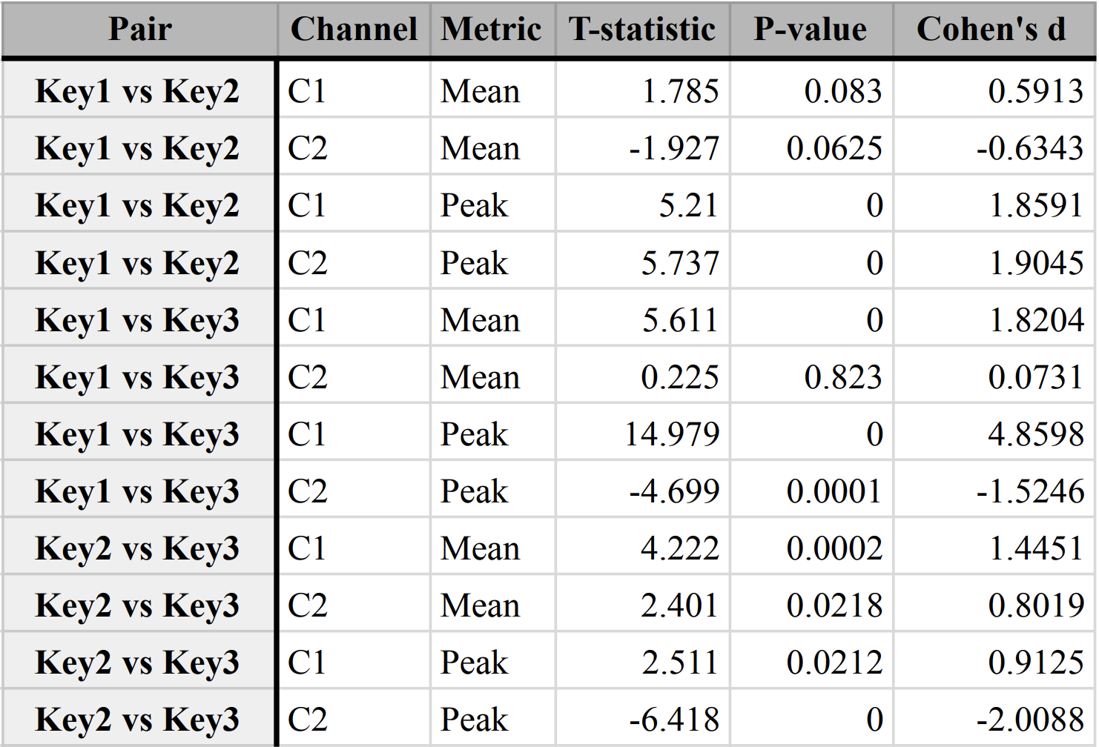
Table 2: Statistical Test Results for Power (C1) and EM (C2) Channels

C. Hamming Weight Correlation Analysis
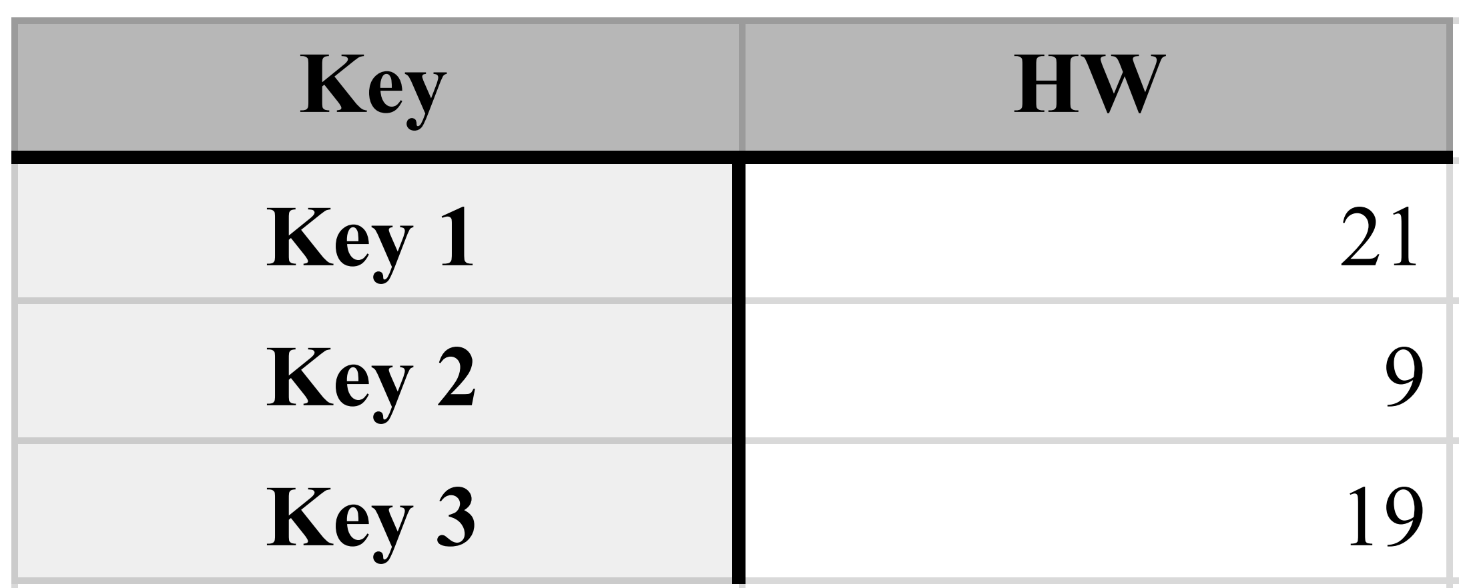
Table 3: Hamming Weight of Keys per Key
Given the limitations of traditional statistical tests, CPA techniques were used to investigate whether side channel amplitudes correlate with the Hamming weight of the processed keys. Hamming weight, which represents the number of ‘1’ bits in a binary key, is an indicator of how internal data operations may affect physical leakage in cryptographic devices.

D. Leakage Model Validation
The scatter plots in Fig. 3 illustrate the correlation between key Hamming weight and peak channel voltage for both power (C1) and EM (C2) measurements. Each dot on the scatter plot represents the data from one CSV file, showing the signal recorded for a single authentication attempt and the Hamming weight of the key used.

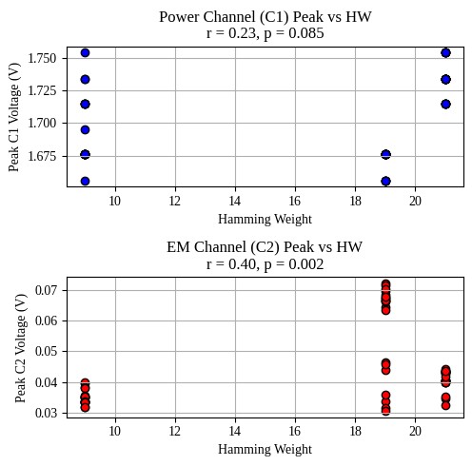
Fig 3: Correlation Between Peak and Hamming Weight For C1 and C2
In the power channel (C1) plot the correlation coefficient $r=0.23$ and p-value $p=0.085$
The EM channel (C2) plot shows a notably stronger correlation ($r=0.40$, $p=0.002$).
V. Analysis

A. Visual Analysis
A comparison across all three keys reveals similar overall signal structure and timing, with two major peaks and a pronounced dip observed around the middle of each trace (approximately 50,000 μs).
These features align with critical phases of RFID protocol execution, likely corresponding to authentication or data transfer events. The consistency in shape across all keys suggests a uniform operational process, while minor differences in amplitude and spread may reflect variations in the cryptographic computations or the underlying key dependent operations.
By averaging the traces for each block/key, noise is reduced, and recurring features are accentuated, allowing for comparative analysis for potential side channel leakage. The subtle distinctions in EM channel amplitudes, especially in key 3, could be significant when probing for key dependent variations, highlighting regions of interest for further security analysis.
Overall, these visualisations are useful for identifying protocol phases, assessing process uniformity, and pinpointing windows where sensitive operations occur.
From these traces, it was determined that the timings were almost identical, but there was a visible difference in amplitude.

B. Statistical Analysis
The statistical analysis reveals evidence of key dependent side channel leakage in MIFARE Classic authentication. Peak amplitudes differ significantly for every key pair in both channels, with Cohen’s d ranging from $0.886$ to $4.737$, represent effect sizes that exceed the conventional threshold for significant effects ($d ≥ 0.8$). These magnitudes suggest that the observed differences between keys are not only statistically significant but practically meaningful for cryptographic exploitation.
The consistently higher effect sizes observed in EM measurements compared to power analysis suggest that EM emissions provide a more reliable side channel factor for MIFARE Classic cards. This also coincides with previous research demonstrating that EM probes can capture spatially localised leakage that may be obscured in power measurements due to circuit complexity and current distribution [3] [1].
Mean amplitudes also show significant differences in most comparisons, particularly for the power channel. These results confirm that both power and EM side channels leak key dependent information, and that peak based features show the most significant difference.

C. Leakage Model Analysis
The Hamming weight and measured peak voltage of the power channel (C1) suggest a weak, statistically nonsignificant relationship. This indicates that, in this dataset, power measurements provide limited information on key dependent leakage.
In contrast, the EM channel (C2) plot shows a notably stronger correlation (𝑟 = $0.40$, 𝑝 = $0.002$), which is statistically significant. This indicates that approximately 16% of the variance in EM emissions can be due to the key dependent characteristics. In the context of side channel analysis, this level of correlation suggests sufficient leakage for practical exploitation, particularly when combined with advanced attack methodologies.
The observed leakage pattern follows the established Hamming weight model, where cryptographic operations on data with higher bit densities produce correspondingly higher physical emissions. This relationship has been successfully exploited in numerous side channel attacks against various cryptographic systems, including AES, DES, and RSA [3].

D. Implications for Practical Security
Although key recovery was not demonstrated within the scope of this study, the statistical evidence strongly supports the possibility of practical attacks given appropriate resources and methodology refinement. The combination of large effect sizes, significant correlations, and established leakage models creates a foundation for advanced attack development.
MIFARE Classic cards are commonly used in RFID systems and sensitive areas like building access, public transport, and payment systems. This recent discovery of a security flaw adds a new way for attackers to exploit these cards, alongside existing weaknesses in their encryption system, Crypto1.

VI. Conclusion
This study examined whether MIFARE Classic, an RFID card, authentication produces measurable power and EM side channel leakage that could reveal information about the secret keys used for Crypto1 encryption. Using a Proxmark3 to trigger repeated authentication commands and an oscilloscope to record both power and EM signals, distinct patterns were observed between keys of differing Hamming weight. Statistical analysis demonstrated a strong correlation between the peak amplitudes of EM signals and the key Hamming weight. This suggests that MIFARE Classic systems might reveal sensitive information beyond the known weaknesses in the Crypto1 encryption method.
Although the dataset was limited in size, the results suggest a potential for key discrimination or recovery through targeted side channel analysis. Expanding the sample set, applying advanced techniques such as CPA, and exploring additional leakage models could strengthen these findings. The evidence presented reinforces the importance of considering physical leakage in the security evaluation of contactless smart cards, even for systems already compromised at the algorithmic level.

References
[1] T. Kasper, D. Oswald, and C. Paar, “Side-Channel Analysis of Cryptographic RFIDs with Analog Demodulation,” 2012, pp. 61–77. doi: 10.1007/978-3-642-25286-0_5.
[2] R. Jain, D. Kumar Chaudhary, and S. Kumar, “Analysis of Vulnerabilities in Radio Frequency Identification (RFID) Systems,” in 2018 8th International Conference on Cloud Computing, Data Science & Engineering (Confluence), IEEE, Jan. 2018, pp. 453–457. doi: 10.1109/CONFLUENCE.2018.8442623.
[3] P. Kocher, J. Jaffe, B. Jun, and P. Rohatgi, “Introduction to differential power analysis,” J Cryptogr Eng, vol. 1, no. 1, pp. 5–27, Apr. 2011, doi: 10.1007/s13389-011-0006-y.
[4] G. de Koning Gans, J.-H. Hoepman, and F. D. Garcia, “A Practical Attack on the MIFARE Classic,” 2008, pp. 267–282. doi: 10.1007/978-3-540-85893-5_20.
[5] S. Picek et al., “Side-channel analysis and machine learning: A practical perspective,” in 2017 International Joint Conference on Neural Networks (IJCNN), IEEE, May 2017, pp. 4095–4102. doi: 10.1109/IJCNN.2017.7966373.
[6] R. Xu et al., “Side-Channel Attack on a Protected RFID Card,” IEEE Access, vol. 6, pp. 58395–58404, 2018, doi: 10.1109/ACCESS.2018.2870663.
[7] C. Herrmann, Teuwen P., Moiseenko M., Walker M., and Others, “Proxmark3 -- Iceman repo,” GitHub.
[8] NXP Semiconductors, “MIFARE Classic EV1 1K - Mainstream contactless smart card IC for fast and easy solution development,” 2018, NXP. Accessed: Aug. 16, 2025. [Online]. Available: https://www.nxp.com/docs/en/data-sheet/MF1S50YYX_V1.pdf
[9] “Mifare Tag Ops.” Accessed: Aug. 16, 2025. [Online]. Available: https://github.com/Proxmark/proxmark3/wiki/Mifare-Tag-Ops#command-set-hf-mf
[10] Google, “Welcome to Colab!” Accessed: Aug. 16, 2025. [Online]. Available: https://colab.research.google.com/#scrollTo=Wf5KrEb6vrkR
[11] B. A. G. P. Bruce Peter, Practical Statistics for Data Scientists, 2nd Edition, 2nd ed. O’Reilly Media, Inc., 2020.

Appendix A

Literature Review


School of Electronic Engineering

RFID Side Channel Analysis for IoT Devices

Literature Survey

Katherina Keogh
ID Number: 19423752

January 2025

MEng in Electronic and Computer Engineering

Supervised by Liam Meany

Declaration

I hereby declare that, except where otherwise indicated, this document is entirely my own work and has not been submitted in whole or in part to any other university.

Signed: Katherina Keogh Date: 19th of Jan 2025

RFID Side Channel Analysis for IoT Devices

Katherina Keogh
MEng. Electronic and Computer
Engineering,
Dublin City University,
Dublin, Ireland katherina.keogh24@mail.dcu.ie

Abstract—The rapid increase of Radio Frequency
Identification (RFID) technology within the Internet of Things (IoT) ecosystem has revolutionised applications ranging from inventory management to healthcare. However, alongside its benefits, RFID systems face critical security vulnerabilities, particularly in the context of side-channel analysis (SCA). This paper investigates the susceptibility of RFID systems to side channel attacks, which exploit unintended physical emissions such as power consumption and electromagnetic radiation to extract sensitive information. Supported by prior research and analysis, this work highlights key security challenges, focusing on vulnerabilities in RFID protocols and their implications for privacy and data integrity. The potential of enhancing side channel analysis techniques using tools such as the Proxmark 3 proposing firmware modifications to improve its utility in evaluating RFID security is also discussed.

Index Terms— Internet of Things, Proxmark, Radio Frequency
Identification, Side Channelling

I. INTRODUCTION
R
ADIO Frequency Identification (RFID) technology has become an important part of the Internet of Things (IoT) ecosystem, enabling communication and identification in applications ranging from supply chain management to healthcare and smart cities [1]. As RFID systems continue to grow, their security and reliability have lacked significant attention, particularly in protecting sensitive data and ensuring operational integrity [2]. Despite advancements in encryption and authentication protocols, RFID systems remain susceptible to various vulnerabilities, including side-channel attacks, which exploit unintended information leaks to compromise security [3]. Side-channel analysis (SCA) is a growing area of concern in RFID security, using signals such as timing information, power consumption, and electromagnetic emissions to extract confidential data [3]. These non-invasive attacks bypass traditional cryptographic defences, making them hard for RFID systems to detect. Given the increasing deployment of RFID in security-critical applications, understanding and reducing the risks posed by SCA is essential to enhancing IoT device security.
A – 1

This review explores the RFID technology and side-channel analysis, focusing on identifying vulnerabilities and evaluating the potential of tools like the Proxmark 3 to display their weaknesses.

II. RFID IN IOT
An RFID (Radio Frequency Identification) system is a wireless communication technology for automatically identifying and tracking objects, animals, or people. It consists of three main components: a tag, a reader, and a backend system. The tag, which can be either passive, active, or semiactive, contains a microchip for storing data and an antenna for transmitting that data to a reader. The reader emits radio frequency signals to power and communicate with the tag in the case of passive tags or to receive data from active tags that have their own power source. The backend system processes the data received by the reader and integrates it into applications such as inventory management, access control, or supply chain logistics. RFID systems operate at various frequency ranges, such as low frequency (LF), high frequency (HF), and ultra-high frequency (UHF), depending on the use case. Their ability to enable contactless communication over short distances makes them popular in numerous
industries.[4]
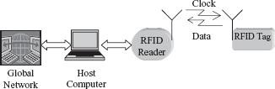
Fig. 1. Block diagram of a typical RFID system. [4]
In practical applications, RFID has transformed industries by enabling real-time asset tracking, automation, and data collection. Retail giants like Wal-Mart leverage RFID for efficient inventory management [4], while the healthcare industry relies on it for equipment tracking and patient identification. Transportation systems integrate RFID in toll collection and contactless fare cards, and smart cities use the technology to monitor infrastructure and deploy IoT solutions. These implementations highlight RFID's ability to enhance efficiency and precision in complex operations.
Despite these advancements, several underlying aspects of RFID systems can introduce challenges. The reliance on radio frequency signals, while enabling continuous communication, also creates opportunities for interception or disruption of data transmissions. In applications requiring low-cost tags, the computational limitations of passive tags often restrict their ability to implement robust cryptographic protocols [5]. These characteristics make RFID systems attractive targets for malicious actors seeking to exploit authentication or data protection vulnerabilities. As RFID systems become increasingly integrated with IoT networks, the consequences of security weaknesses are amplified, demanding significant research efforts to enhance the resilience of this critical technology.

III. RFID VULNERABILITIES
RFID technology, while revolutionising industries with its data transmission capabilities, faces significant security challenges. Side-channel attacks (SCAs) represent a critical and often underappreciated threat among the numerous attack vectors. SCAs exploit physical characteristics and unintended emissions of RFID devices rather than directly targeting the underlying communication protocols.
A – 2
RFID systems are vulnerable to side-channel attacks due to their constrained computational resources and reliance on lightweight cryptographic protocols. Unlike traditional attacks such as eavesdropping or cloning, SCAs analyse physical emissions, such as power consumption, electromagnetic radiation, and timing information, generated during the operation of RFID tags or readers [3]. For example, during cryptographic operations like encryption or authentication, variations in power usage or electromagnetic emissions can leak sensitive information, including cryptographic keys. This vulnerability arises because many RFID devices are designed to prioritise cost and efficiency over physical security.

A. Cloning RFID Cards
The study carried out by Jain, Chaudhary, et al. underscores the inherent vulnerabilities in RFID technology, particularly in its current state of implementation. The ability to easily access, alter, or clone data stored on RFID tags reveals significant weaknesses that can compromise privacy and security. The research highlights the susceptibility to denialof-service attacks, where card data can be maliciously overwritten, further highlighting the fragility of these systems. The experiments performed on a University Identification card and blank cards demonstrated how effortlessly such attacks can be executed, reinforcing the urgent need for advancements in RFID security. [2]

B. Hamming Distance Leakage Model
The study carried out by Xu, Zhu, et al. further emphasises the critical vulnerabilities inherent in RFID and smart card systems when subjected to side-channel attacks. By using Hamming distance leakage and targeting specific rounds of DES encryption, the research highlights how sophisticated combinations of attack methods can bypass existing security measures [3]. This highlights the inadequacy of traditional countermeasures such as "head and tail" protection, which fail to prevent attackers from exploiting subtle leaks in the cryptographic process. These results not only demonstrate the possibility of side-channel attacks but also point to the need for enhanced defensive strategies to reduce these risks and ensure the integrity of sensitive data in RFID systems.

C. Reverse Engineering
The study carried out by Fraga-Lamas and FernándezCaramés further emphasises the importance of securing RFID systems. In this study, the authors reverse-engineered the communication protocol of an RFID public transportation card. They demonstrated how an attacker could manipulate the system to gain unauthorised access and clone the RFID card. This research highlights the vulnerability of RFID in realworld scenarios, particularly in public-facing applications such as transportation, where attackers can exploit communication protocol weaknesses to compromise the system.[6]
D. Machine Learning-Based Side-Channel Attacks Recent advancements in side-channel analysis have introduced machine learning (ML) as a state-of-the-art approach for attacking cryptographic systems. These techniques use ML algorithms to model and exploit physical leakage, such as power consumption or electromagnetic radiation, during sensitive computations. Unlike traditional methods, machine learning-based side-channel attacks are especially powerful in scenarios where only a limited number of profiling traces are available. By combining machine learning methods with side-channel analysis, researchers have identified new ways to bypass the constraints of classical approaches like template attacks (TAs) [7].
To validate these findings, researchers conducted experiments using a novel metric called the Data Confusion Factor (DCF), which measures the success of machine learning models in profiling and attack phases. These experiments showed that ML-based side-channel attacks achieved higher success rates than TAs, especially in cases involving high-dimensional traces with many irrelevant samples. The use of dimensionality reduction techniques, such as principal component analysis (PCA), has further enhanced the efficiency of ML-based attacks by focusing only on the most informative features of the leakage traces [7].

IV. SIDE-CHANNEL ANALYSIS ON RFID RESEARCH
Side-channel analysis (SCA) is a powerful tool for evaluating vulnerabilities in RFID systems. SCA exploits physical information leakage, such as electromagnetic (EM) emissions, power consumption, or timing discrepancies, to infer sensitive data without directly attacking cryptographic algorithms [3]. Side-channel attacks reveal critical weaknesses in RFID systems by analysing physical manifestations of computations. Differential power analysis (DPA), for instance, can extract cryptographic keys by comparing power consumption across multiple operations, while timing attacks deduce sensitive data based on processing delays. Electromagnetic attacks are particularly relevant to RFID due to the wireless nature of its communication, allowing EM emissions to be intercepted and analysed. [8] The Proxmark is a versatile, open-source tool designed for the analysis, manipulation, and emulation of RFID systems [9]. The device is widely used in security research, enabling tasks such as reading and writing RFID tags, capturing communication data, and performing advanced attacks like cloning, eavesdropping, and replay attacks. With its customisable firmware and powerful hardware capabilities, the Proxmark is a critical platform for investigating vulnerabilities in RFID systems and testing potential countermeasures. To maximise Proxmark's efficacy for SCA, several firmware modifications can be made.
A – 3

A. High-Resolution Signal Capture
The current functionality of the Proxmark device captures communication signals from RFID systems, but it may lack the granularity required for detailed side-channel analysis. As stated, side-channel attacks often rely on detecting subtle variations in physical signals such as EM emissions or power consumption, meaning these variations can reveal sensitive data, including cryptographic keys or sensitive information being processed by RFID devices.
The firmware could be enhanced to address this limitation and support high-resolution sampling and data storage. Modifications can allow for a more precise analysis of the physical characteristics of RFID communication, improving the ability to detect leaks in physical emissions. For example, the client/src/cmdhf.c [10] file, which handles high-frequency commands, could be modified to introduce a high-resolution capture mode. By enhancing this section of the firmware, the Proxmark would be better equipped to collect and store detailed EM data, enabling fine-grained analysis of physical leakage. This capability would facilitate more accurate timing, power, and electromagnetic analysis, which are crucial for identifying vulnerabilities in RFID systems.

B. Enhanced Timing Analysis Tools
Timing analysis is a common technique in side-channel analysis, relying on precise measurements of processing delays and computation timings. Many side-channel attacks, such as timing attacks, exploit these processing delays to infer sensitive information, such as cryptographic keys or data patterns. These delays are often generated during cryptographic operations in RFID tags or readers.
Upgrading the Proxmark firmware to log timestamps with higher accuracy could significantly improve the reliability of timing-based attack experiments. For example, the file client/src/cmdhf14a.c handles high-frequency ISO14443A commands, which are often used in RFID communication protocols [10]. By modifying this file to increase timestamp resolution, researchers could accurately capture the precise timing of events within the system. This would allow researchers to observe even small delays, which could reveal vulnerabilities in cryptographic operations or authentication protocols.
With this enhancement, researchers could detect variations in processing times that would otherwise go unnoticed with lower-resolution timestamp logging. These subtle variations can be exploited in timing-based side-channel attacks to obtain cryptographic keys or to reveal patterns in data transmission. For example, side-channel analysis could reveal information such as whether a tag is performing encryption, the timing of key generation, or whether certain cryptographic steps are skipped during processing.
Through these proposed firmware modifications, the Proxmark would provide a secure platform for conducting more effective and detailed timing-based side-channel analyses in RFID systems. These tools would not only validate existing research but also explore vulnerabilities that could be exploited in practical scenarios.

V. PRELIMINARY WORK
To establish a functional environment for conducting the research, preliminary setup steps were carried out on a macOS machine. The essential development tools, including Apple's XCode Command Line Tools, which provide functions like git and make files for building software, had already been previously installed and set up. The Proxmark 3 Iceman firmware repository was then cloned from GitHub using git, enabling access to the latest firmware updates and modifications. Homebrew, a widely-used package manager for macOS, was used to install dependencies such as gcc, libusb, and cmake, ensuring the Proxmark client and firmware could be compiled and executed seamlessly.
The next step will involve downloading the Proxmark client software and following detailed instructions to flash the firmware onto the Proxmark 3 hardware. This will require connecting the device to the Mac via USB, ensuring compatibility with the device's serial drivers. Specific configuration files within the firmware repository, such as cmdhf.c and cmdhf14a.c, were examined to identify potential areas for customisation. Testing the setup will involve running basic Proxmark commands to verify communication between the software and hardware.

VI. CONCLUSION
The security of RFID systems remains a critical concern as these technologies become increasingly essential in the Internet of Things (IoT) ecosystem. This paper has examined the vulnerabilities of RFID systems, with a focus on their susceptibility to side-channel attacks (SCAs). By exploiting physical emissions such as electromagnetic emissions, timing variations, and power consumption, SCAs bypass traditional cryptographic protections, exposing sensitive data to malicious actors. These attacks are particularly concerning given the constrained resources of RFID tags, which often prevent the implementation of secure security measures.
Prior research has demonstrated the possibility and effectiveness of SCAs in exposing weaknesses in RFID systems. Studies such as those by Jain et al. and Xu et al. have highlighted the ability of attackers to extract cryptographic keys and manipulate data through methods like Hamming distance leakage analysis and differential power analysis. These findings underline the inadequacy of existing countermeasures and the urgent need for advanced security strategies to protect RFID systems.
A – 4

The use of tools like the Proxmark 3 offers significant potential in identifying and reducing vulnerabilities. The ability to capture high-resolution signals and conduct detailed timing analysis makes the Proxmark an invaluable resource for evaluating the security of RFID systems. Proposed firmware enhancements, such as increasing signal capture resolution and improving timing precision, would further strengthen its side-channel research and testing capabilities.
As RFID continues to integrate with critical applications in supply chain management, healthcare, transportation, and smart cities, ensuring the security and resilience of this technology is increasingly important. This research highlights the need for continued research in defensive measures, such as side-channel-resistant cryptographic protocols and improved hardware designs, to further reduce risks. Addressing these challenges is essential to maintaining and protecting sensitive data.

REFERENCES
- P. V. Dudhe, N. V. Kadam, R. M. Hushangabade, and M. S. Deshmukh, "Internet of Things (IOT): An overview and its applications," in 2017 International Conference on Energy, Communication, Data
Analytics and Soft Computing (ICECDS), IEEE, Aug.
2017, pp. 2650–2653. doi:
10.1109/ICECDS.2017.8389935.
- R. Jain, D. Kumar Chaudhary, and S. Kumar, "Analysis of Vulnerabilities in Radio Frequency Identification (RFID) Systems," in 2018 8th International Conference on Cloud Computing, Data Science & Engineering (Confluence), IEEE, Jan. 2018, pp. 453–457. doi:
10.1109/CONFLUENCE.2018.8442623.
- R. Xu et al., "Side-Channel Attack on a Protected RFID Card," IEEE Access, vol. 6, pp. 58395–58404, 2018, doi: 10.1109/ACCESS.2018.2870663.

[4] N. C. Karmakar, Handbook of Smart Antennas for
RFID Systems. Wiley, 2010. doi:
10.1002/9780470872178.
- N. Kannouf, Y. Douzi, M. Benabdellah, and A. Azizi, "Security on RFID technology," in 2015 International Conference on Cloud Technologies and Applications (CloudTech), IEEE, Jun. 2015, pp. 1–5. doi: 10.1109/CloudTech.2015.7336997.
- P. Fraga-Lamas and T. M. Fernandez-Carames, "Reverse engineering the communications protocol of an RFID public transportation card," in 2017 IEEE International Conference on RFID (RFID), IEEE, May 2017, pp. 30–35. doi: 10.1109/RFID.2017.7945583.
- S. Picek et al., "Side-channel analysis and machine learning: A practical perspective," in 2017 International Joint Conference on Neural Networks (IJCNN), IEEE, May 2017, pp. 4095–4102. doi: 10.1109/IJCNN.2017.7966373.
- M. L. Liya, M. Aswathy, and V. M. Jayakrishnan, "An Overview of Radio Frequency Identification systems," in 2022 7th International Conference on

Communication and Electronics Systems (ICCES),
IEEE, Jun. 2022, pp. 530–535. doi:
10.1109/ICCES54183.2022.9835782.
- F. Chantzis and I. Stais, Practical IoT Hacking. 2021.
- C. Herrmann, Teuwen P., Moiseenko M., Walker M., and Others, “Proxmark3 -- Iceman repo,” GitHub.

A – 5

Appendix B

Project Plan

Side Channel Analysis on RFID Devices

Research Question
“Can power analysis attacks extract cryptographic information from RFID cards using a
Proxmark3, an oscilloscope, and an electromagnetic probe?”

Project scope
- Electromagnetic power analysis of RFID communication.
- Use of the Proxmark3 to trigger and control RFID transactions.
- Integration of an oscilloscope and NAE Hprobe 15 to capture electromagnetic emissions.
- Use of tools for trace capture and analysis.
- Investigation of leakage from RFID cards.
- Manual implementation of encryption for test inputs.
- Side-channel data visualisation and statistical correlation analysis.
- Development of scripts or tools to automate trace alignment and analysis.

Design Approach
- Setup Design:
  - Use the Proxmark3 to initiate RFID authentication or read/write operations.
  - Position the NAE Hprobe 15 near the RFID card antenna to capture emissions.
  - Use an oscilloscope connected to a Mac to record power traces for each interaction.
- Experimentation:
  - Perform repeated RFID operations with fixed and varying keys.
  - Record and label corresponding power traces.
  - Inject known encrypted values to study electromagnetic changes.
- Analysis:
  - Use side channel techniques to identify key leakage.
  - Compare the leakage of weak cards..
  - Evaluate noise, signal alignment, and possible countermeasures.
- Validation:
  - Demonstrate successful extraction of known key bits or authentication outcomes from side channel data.
  - Measure leakage using metrics like signal to noise ratio and correlation coefficients.

B – 1

Time Line
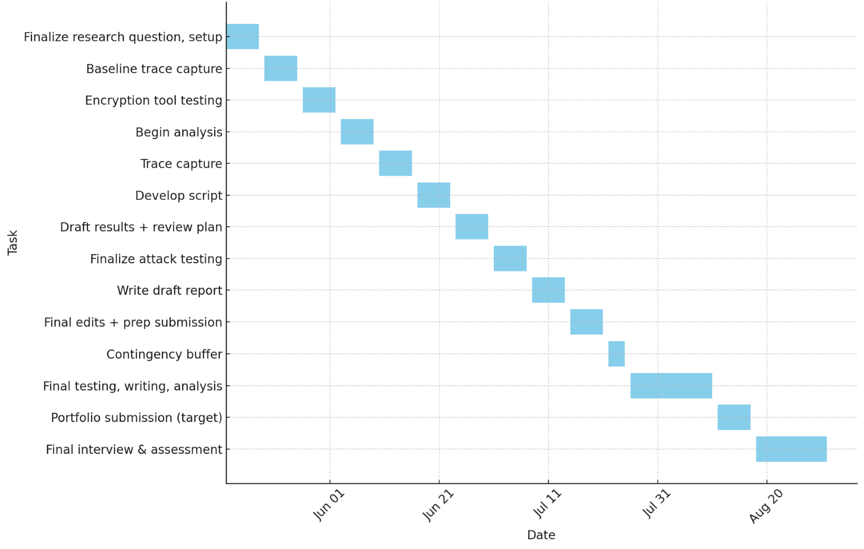
May–June: Complete project design plan and full hardware/software setup.
Late May: Capture and analyse baseline power traces from RFID cards.
Early June: Test encryption tools and choose a suitable cipher for experiments.
Mid-June: Begin analysis of captured traces using statistical techniques.
Late June: Continue capturing traces from additional card types and test cases.
Late June – Early July: Develop automation scripts for trace handling and analysis.
Mid-July: Finalise side channel attacks and complete results documentation.
Late July: Complete writing of the final project report and materials.
Early August: Conduct final validation of tools, testing, and results.
Mid–Late August: Submit final project portfolio.
Late August – Mid-September: Complete final interview and assessment.

Success Criteria
This project will be considered successful if the following criteria are met:

- Electromagnetic traces can be successfully captured.
- Side channel leakage correlating to key or encrypted value can be statistically demonstrated.
- Test data can be written and analysed on simple RFID memory cards.
- Trace analysis is reproducible using scripts or documented steps.
- The final report includes a clear summary of methods, findings, and ethical considerations.

This plan has been approved by my supervisor.
B – 2

Appendix C

Research log

Masters Project Research Log
Masters in Electronic and Computer Engineering 2024/2025

Student Name: Katherina Keogh
Student ID: 19423752
Project Title: RFID Side Channel Analysis for IoT Devices

Please read before making entries in this log

The purpose of this Project Research Log is to capture concise, focused summaries of research materials you read, as you progress through your project. The emphasis is to record (i) how the material you have read will determine or influence your project solution approach and (ii) your assessment of the key strengths and weaknesses of the solutions, methods, technologies, etc. proposed in the material you have read.

In the first stage of your project, the literature review, use the Log to capture this information for the key papers you have read (for example, the three most important papers of your 10 literature review references). As your project progresses into the design and implementation phases, you will need to continue to search the literature so you can review, revise and refine your initial thinking and the details of your approach to a project solution. Use this Research Log to capture your continued research reading and its influence on your project design and implementation.

Be selective about what you record in this log. Do not use it as an informal notebook while you are reading a new paper. Only make an entry after you have read a paper that you consider important to the development of your project solution. It is expected that, by the end of the project, you will have made between 10 and 20 entries (20 maximum).

Share your log with your supervisor for viewing throughout the project. You will submit the final version of the log for grading, at the end of the project implementation period. It will be assessed on the basis of how well you have used your analysis of the literature to inform your project design, implementation and the evaluation of your project results. The Research Log contributes 5% to the overall project mark.

Note: All entries you make in this log must use the prescribed format shown on the next page. You will maintain other notes as you progress through your project but they should not be recorded here. Fill in the details where the *** signs are.

C – 1

Statement of project problem / research question (maximum 200 words)
This statement should be periodically reviewed and updated, as necessary, as your project progresses and you gain further insight into the detailed project challenges, requirements and objectives as your project work moves from background reading, literature review, initial project design planning and detailed design and implementation. Initially, start by stating your current understanding of the project objectives. After each meeting with your supervisor, review and refine your project problem statement, as required.
The main objective of this project is to investigate whether MIFARE Classic RFID cards, widely used for access control and payment systems, leak key dependent information through physical side channels such as power consumption and electromagnetic (EM) emissions during authentication. While previous research has exposed weaknesses in the Crypto1 cipher and demonstrated protocol based attacks, there is limited evidence on the extent to which physical signals can be exploited for practical key recovery. The project aims to collect, process, and statistically analyse side channel measurements from repeated authentication attempts using different keys, assessing correlations between recorded signals and key properties like Hamming weight.

Side-Channel Analysis of Cryptographic RFIDs with Analog Demodulation
C – 2

A complete reference for the paper
Kasper, T., Oswald, D., & Paar, C. (2012). Side-Channel Analysis of Cryptographic RFIDs with Analog Demodulation (pp. 61–77). https://doi.org/10.1007/978-3-642-25286-0_5
Summary of paper (maximum 100 words)
This paper presents an analog demodulator that boosts the clarity of electromagnetic side-channel signals from RFID tags during cryptographic operations. Plugged into standard lab equipment, it filters and amplifies leaked EM emissions so that secret keys can be extracted more reliably from commercial cards (MIFARE DESFire). The authors demonstrate that, with this low cost add on, key recovery attacks succeed using modest hardware, revealing that even secure RFID implementations are vulnerable in practice.
How is this paper relevant to solving your project problem or addressing your research question? (maximum 100 words)
The demodulator’s role in improving EM signal quality directly guides my experimental setup for MIFARE Classic cards. It shows how hardware enhancements can make leakage easier to detect, informing my choice of probe placement, signal conditioning, and the importance of maximising trace clarity before statistical analysis.
What are the strengths and weaknesses of the solutions/methods/technologies proposed in this paper? (maximum 100 words)
Strengths:
- Simple, low cost device that significantly improves EM trace quality
- Validated on real world RFID cards, making attacks practical
- Easy to integrate into existing lab setups
Weaknesses:
- Focuses on signal capture, not on preventing leaks
- Tested on limited devices, performance on others may vary
- Requires precise calibration and tuning for optimal results

Analysis of Vulnerabilities in Radio Frequency Identification (RFID) Systems.

A complete reference for the paper
Jain, R., Kumar Chaudhary, D., & Kumar, S. (2018). Analysis of Vulnerabilities in Radio Frequency Identification (RFID) Systems. 2018 8th International Conference on Cloud Computing, Data Science & Engineering (Confluence), 453–457. https://doi.org/10.1109/CONFLUENCE.2018.8442623
Summary of paper (maximum 100 words)
This paper analyses practical vulnerabilities in RFID systems by demonstrating attacks such as cloning, data tampering, and denial-of-service on university ID cards. Through experiments using common tools, the authors show how easily tags can be copied or disabled, exposing risks to access control and identity applications. They provide detailed attack procedures and emphasise the need for stronger authentication and data integrity measures in RFID systems.
How is this paper relevant to solving your project problem or addressing your research question? (maximum 100 words)
This paper broadens my understanding of RFID security threats beyond side channels, highlighting how physical and protocol weaknesses can be exploited. It reinforced the importance of examining all attack surfaces, motivating my focus on side channel leakage as an additional vulnerability. The experimental approach to realistic attacks influenced my design of controlled test scenarios with Proxmark3 and oscilloscope measurements.
What are the strengths and weaknesses of the solutions/methods/technologies proposed in this paper? (maximum 100 words)
Strengths:
- Hands on experiments on real RFID cards
- Clear demonstration of multiple attack types
- Uses readily available tools, making findings accessible
Weaknesses:
- Limited focus on countermeasures or defences
- Small scale tests may not generalize to all RFID products
- Does not include statistical analysis or quantitative assessment of attack success rates

Introduction to differential power analysis. Journal of Cryptographic Engineering
C – 3

A complete reference for the paper
Kocher, P., Jaffe, J., Jun, B., & Rohatgi, P. (2011). Introduction to differential power analysis. Journal of Cryptographic Engineering, 1(1), 5–27. https://doi.org/10.1007/s13389-011-0006-y
Summary of paper (maximum 100 words)
This paper introduces Differential Power Analysis (DPA), a technique that exploits variations in a device’s power consumption during cryptographic operations to recover secret keys. By collecting many power traces and using statistical correlation with hypothetical power models (like Hamming weight), the authors demonstrate successful key extraction attacks on DES and AES smartcards. This work proves that even well designed ciphers leak information through their physical power usage.
How is this paper relevant to solving your project problem or addressing your research question? (maximum 100 words)
DPA is the foundation of my analysis. It explains how to link side channel traces to key dependent values. This paper guided my choice of Hamming weight leakage models and statistical methods (t-tests, Pearson correlation) for detecting key information in power and EM measurements from MIFARE Classic cards.
What are the strengths and weaknesses of the solutions/methods/technologies proposed in this paper? (maximum 100 words)
Strengths:
- Provides a clear, generalisable method for key recovery via power analysis
- Validated on real DES/AES implementations
- Lays groundwork for many side channel techniques
Weaknesses:
- Requires thousands of traces for reliable results
- Assumes precise trace alignment and low noise
- Focuses on power, not EM, so additional adaptations are needed for EM leakage scenario

Side-channel analysis and machine learning: A practical perspective
C – 4

A complete reference for the paper
Picek, S., Heuser, A., Jovic, A., Ludwig, S. A., Guilley, S., Jakobovic, D., & Mentens, N. (2017). Side-channel analysis and machine learning: A practical perspective. 2017 International Joint Conference on Neural Networks (IJCNN), 4095–4102. https://doi.org/10.1109/IJCNN.2017.7966373
Summary of paper (maximum 100 words)
This paper examines applying machine learning to side channel analysis, comparing algorithms like Support Vector Machines and Random Forests against traditional template attacks. By extracting statistical features from power traces and training classifiers, the authors show ML methods can more accurately distinguish key dependent patterns, even with noisy data or fewer traces. Experiments on AES implementations demonstrate ML based attacks often succeed with fewer samples and show a greater ability to measurement variability.
How is this paper relevant to solving your project problem or addressing your research question? (maximum 100 words)
The paper’s demonstration of ML techniques offers an alternative to classical statistical methods for analysing side channel data. It suggests that, after collecting EM or power traces from MIFARE Classic cards, training a classifier could improve key recovery accuracy compared to correlation analysis alone. This informs potential future enhancements to my analysis.
What are the strengths and weaknesses of the solutions/methods/technologies proposed in this paper? (maximum 100 words)
Strengths:
- Achieves higher accuracy with noisy or limited data
- Requires fewer traces than classical attacks
- Clearly outlines feature extraction and classifier training steps
Weaknesses:
- Depends on labelled profiling data, which may be unavailable
- Risk of overfitting models to specific devices
- Introduces computational complexity and parameter tuning challenges

Side-Channel Attack on a Protected RFID Card
C – 5

A complete reference for the paper
Xu, R., Zhu, L., Wang, A., Du, X., Choo, K.-K. R., Zhang, G., & Gai, K. (2018). Side-Channel Attack on a Protected RFID Card. IEEE Access, 6, 58395–58404. https://doi.org/10.1109/ACCESS.2018.2870663

Summary of paper (maximum 100 words)
This paper demonstrates a successful side channel attack on a commercially protected RFID card implementing DES. By capturing power traces during authentication and applying DPA, the authors recover secret keys despite built in hardware countermeasures. Their experiments on three card models show key extraction in under 5,000 traces, proving that standard protections (noise filtering, random delays) can be bypassed with optimised statistical techniques.
How is this paper relevant to solving your project problem or addressing your research question? (maximum 100 words)
Their methodology directly informs my approach to measuring and analysing leakage from MIFARE Classic cards. It shows that even counter measured devices leak exploitable information, guiding my choice of feature extraction (peak amplitudes) and statistical tests. The paper’s experimental design also helps refine my trace alignment and preprocessing steps to maximize signal clarity.
What are the strengths and weaknesses of the solutions/methods/technologies proposed in this paper? (maximum 100 words)
Strengths:
- Validates attack possibility on protected, real world RFID cards
- Uses optimised statistical distinguishers to reduce required traces
- Provides detailed procedural guidance for trace capture and analysis
Weaknesses:
- Focuses only on power side channels, not EM emissions
- Requires specialised statistical tools that may be complex to implement
- Experiments limited to DES-based cards, results may differ on other ciphers

Proxmark3 -- Iceman repo.

A complete reference for the paper
Herrmann, C., Teuwen P., Moiseenko M., Walker M., & Others. (n.d.). Proxmark3 -- Iceman repo. GitHub.
Summary of paper (maximum 100 words)
The Proxmark3 Iceman firmware repository offers enhanced tools and scripts for interacting with RFID tags. It includes commands for card detection, authentication, reading/writing memory blocks, and advanced side channel measurement triggers. The firmware’s modular design and active community support enable researchers to script automated RFID operations, capture precise timing events, and integrate with oscilloscopes for waveform collection.
How is this paper relevant to solving your project problem or addressing your research question? (maximum 100 words)
It was the firmware that was running on the Proxmark
What are the strengths and weaknesses of the solutions/methods/technologies proposed in this paper? (maximum 100 words)
N/A

MIFARE Classic EV1 1K

A complete reference for the paper
NXP Semiconductors. (2018). MIFARE Classic EV1 1K - Mainstream contactless smart card IC for fast and easy solution development. NXP. https://www.nxp.com/docs/en/data-sheet/MF1S50YYX_V1.pdf
Summary of paper (maximum 100 words)
The documentation for the MIFARE Classic card
How is this paper relevant to solving your project problem or addressing your research question? (maximum 100 words)
This documentation is essential for understanding how MIFARE Classic cards authenticate and store data
What are the strengths and weaknesses of the solutions/methods/technologies proposed in this paper? (maximum 100 words)
N/A
C – 6

Mifare Tag Ops.

A complete reference for the paper
Mifare Tag Ops. (2017, August). https://github.com/Proxmark/proxmark3/wiki/Mifare-Tag-Ops#command-set-hf-mf

Summary of paper (maximum 100 words)
The documentation for Proxmark3 commands for the MIFARE Classic card
How is this paper relevant to solving your project problem or addressing your research question? (maximum 100 words)
This documentation is essential for understanding the types of commands for MIFARE Classic cards
What are the strengths and weaknesses of the solutions/methods/technologies proposed in this paper? (maximum 100 words)
N/A

Practical Statistics for Data Scientists
C – 7

A complete reference for the paper
Bruce Peter, B. A. G. P. (2020). Practical Statistics for Data Scientists, 2nd Edition (2nd ed.). O’Reilly Media, Inc.
Summary of paper (maximum 100 words)
This book provides a practical guide to essential statistical techniques for data analysis, covering topics like hypothesis testing, regression, classification, clustering, and resampling methods.
How is this paper relevant to solving your project problem or addressing your research question? (maximum 100 words)
The book guided my selection and implementation of statistical tests (t-tests, Cohen’s d, Pearson’s r), ensuring I apply them correctly and interpret results properly. Its clear explanations of effect sizes and correlation analyses helped me choose appropriate thresholds and report findings.
What are the strengths and weaknesses of the solutions/methods/technologies proposed in this paper? (maximum 100 words)
Strengths:
- Accessible explanations with practical examples in code
- Broad coverage of core techniques relevant to data science
- Emphasises interpretation and best practices for reproducible analysis
Weaknesses:
- Not focused on side channel or security specific statistics
- Examples use generic datasets rather than hardware leakage traces
- Limited depth on advanced topics like high dimensional or time series analysis

A Practical Attack on the MIFARE Classic

A complete reference for the paper
de Koning Gans, G., Hoepman, J.-H., & Garcia, F. D. (2008). A Practical Attack on the MIFARE Classic (pp. 267–282). https://doi.org/10.1007/978-3-540-85893-5_20

Summary of paper (maximum 100 words)
This paper describes a practical attack on MIFARE Classic cards, detailing how researchers exploited weaknesses in the card’s cryptographic protocol to recover secret keys and clone cards. By reverse engineering the Crypto1 cipher and using known vulnerabilities, the authors show how standard MIFARE Classic cards can be compromised using low cost hardware in real world scenarios. Their findings reveal risks for systems relying on these cards for secure access control and payments.
How is this paper relevant to solving your project problem or addressing your research question? (maximum 100 words)
This work provides background on MIFARE Classic security flaws, motivating the need to investigate additional vulnerabilities, such as side channel leakage. Understanding protocol level attacks helped me design experiments targeting physical signals during authentication and ensured my approach addresses multiple risk factors, not just cryptanalysis.
What are the strengths and weaknesses of the solutions/methods/technologies proposed in this paper? (maximum 100 words)
Strengths:
- Demonstrates a real, repeatable attack on commercial cards
- Offers detailed procedural insights and hardware requirements
- Makes clear the practical risk for widespread deployments
Weaknesses:
- Focuses only on protocol/cipher weaknesses, not physical side channel leakage
- Findings may not generalise to newer or more secure platforms
- Does not propose direct countermeasures for discovered vulnerabilities

C – 8

Appendix D
Project Design & Implementation

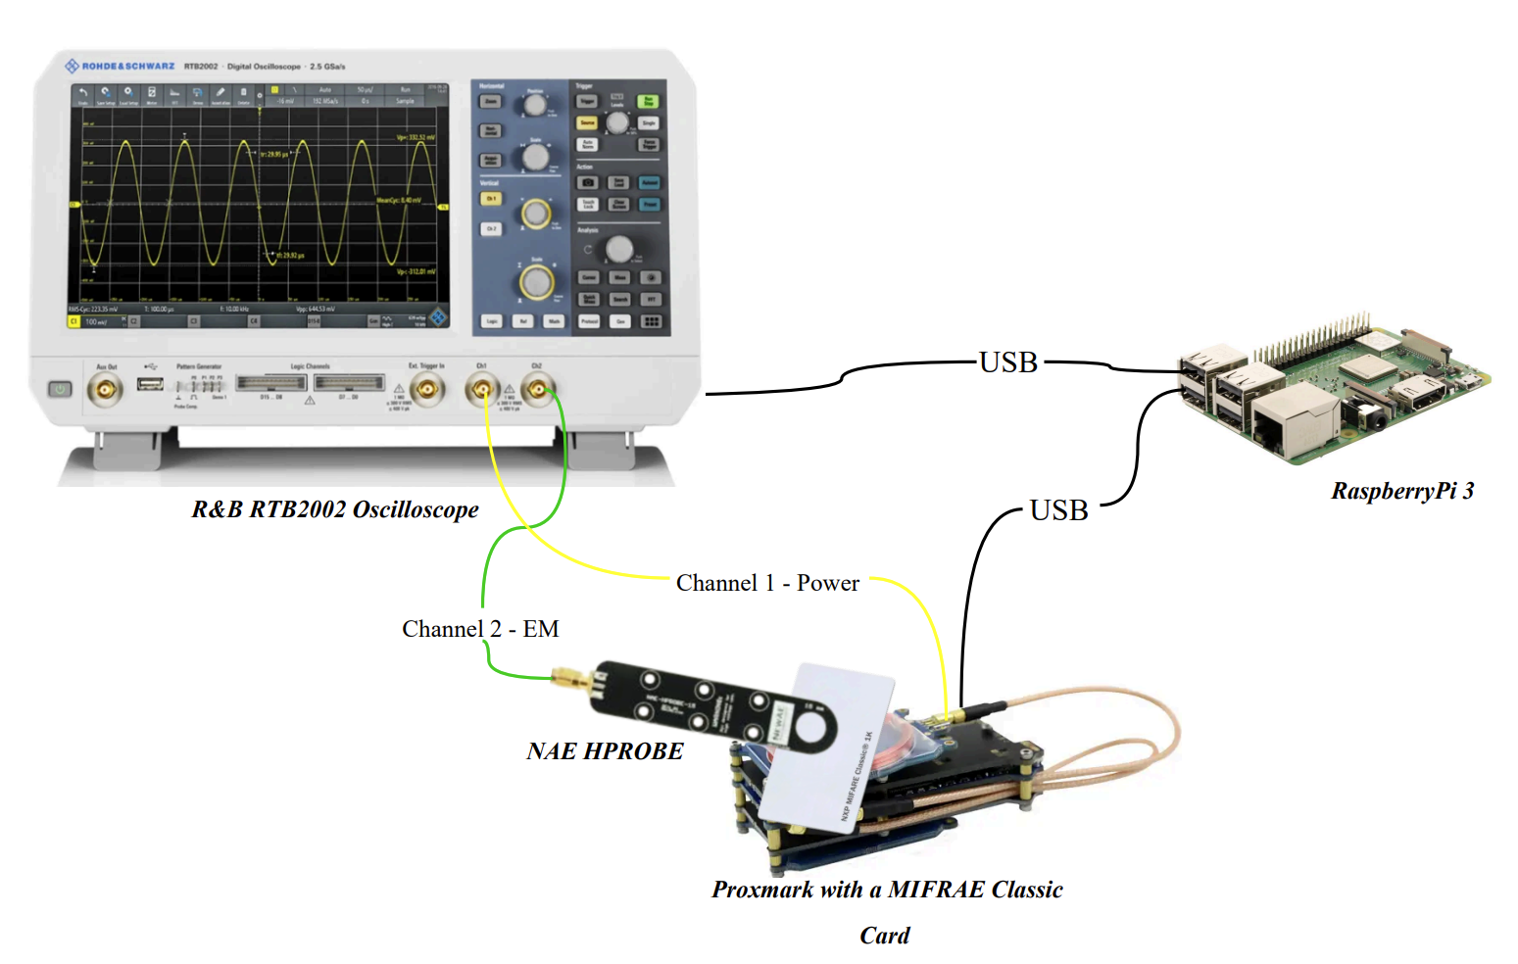
Figure 1: Experiment Hardware Setup
D – 1

Appendix E
Testing & Results

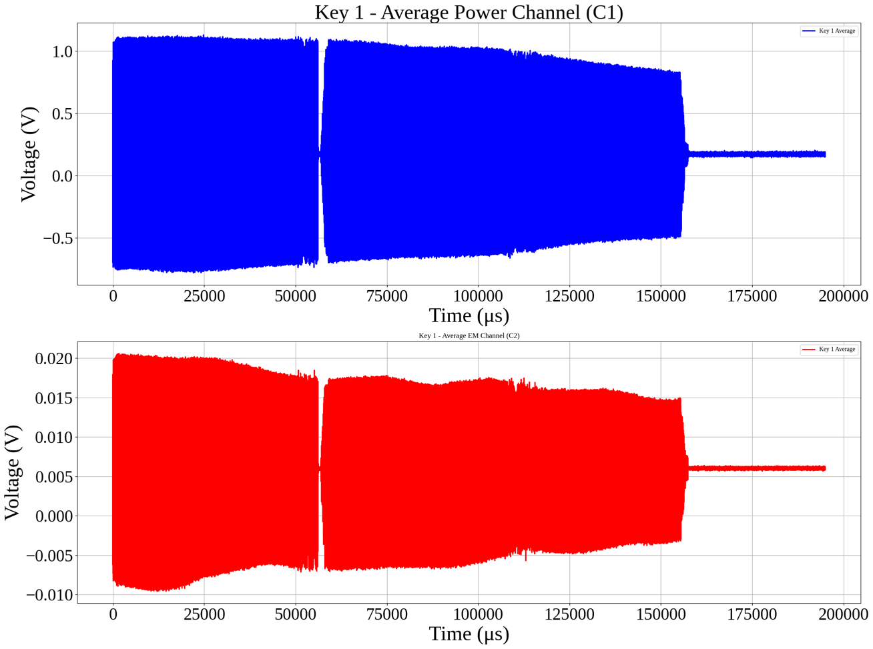
Figure 1: The Average of Key 1’s Power and EM Signals
E – 1
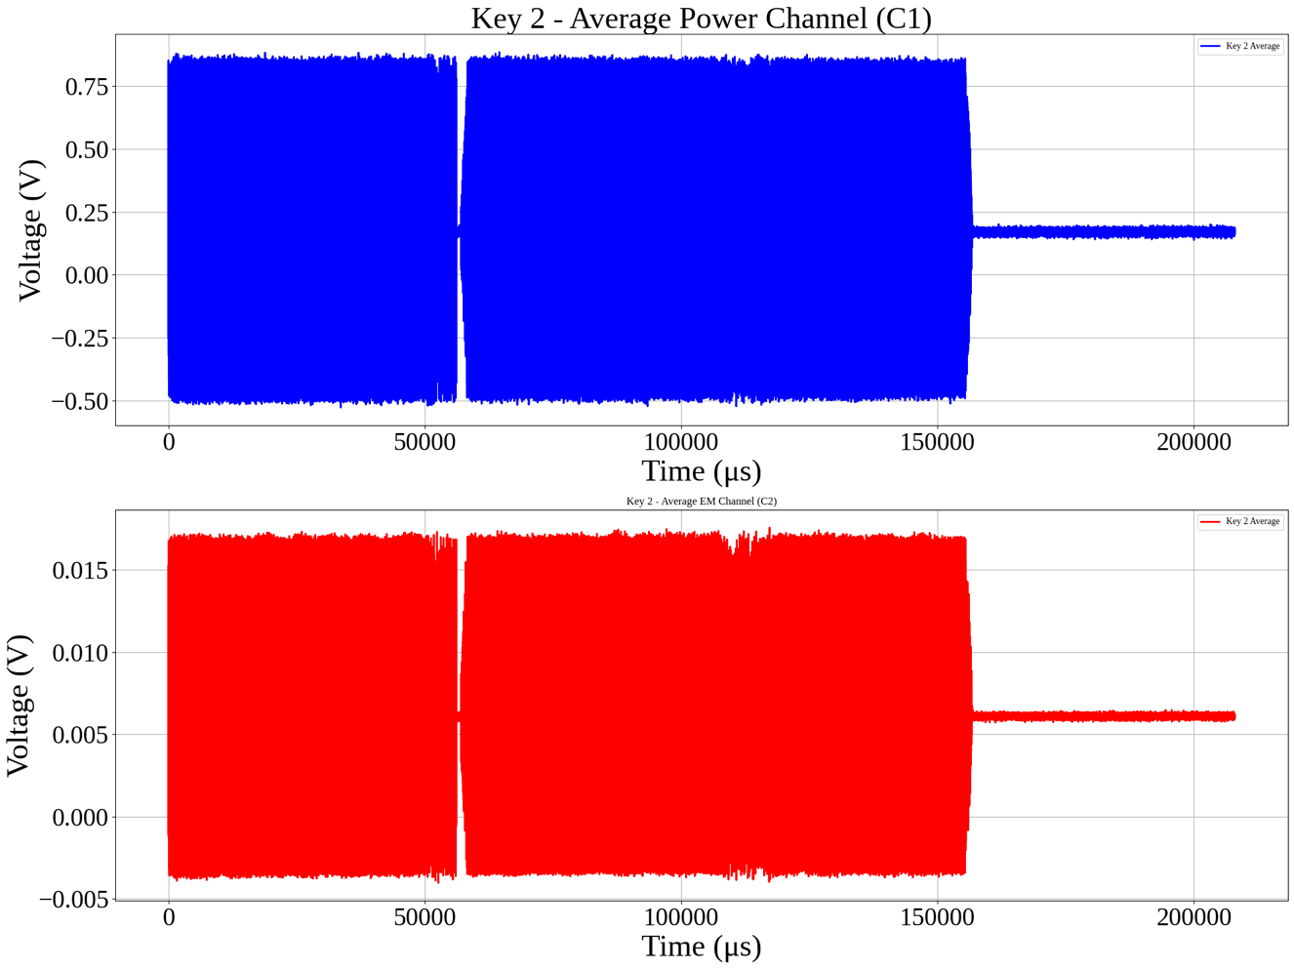
Figure 2: The Average of Key 2’s Power and EM Signals
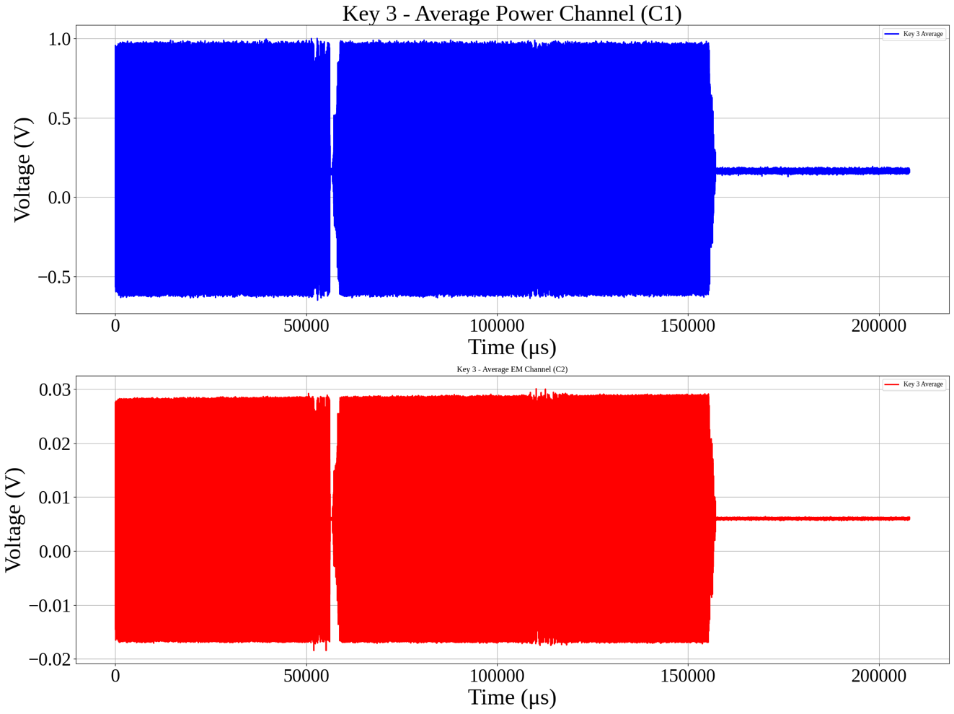
Figure 3: The Average of Key 3’s Power and EM Signals
E – 2

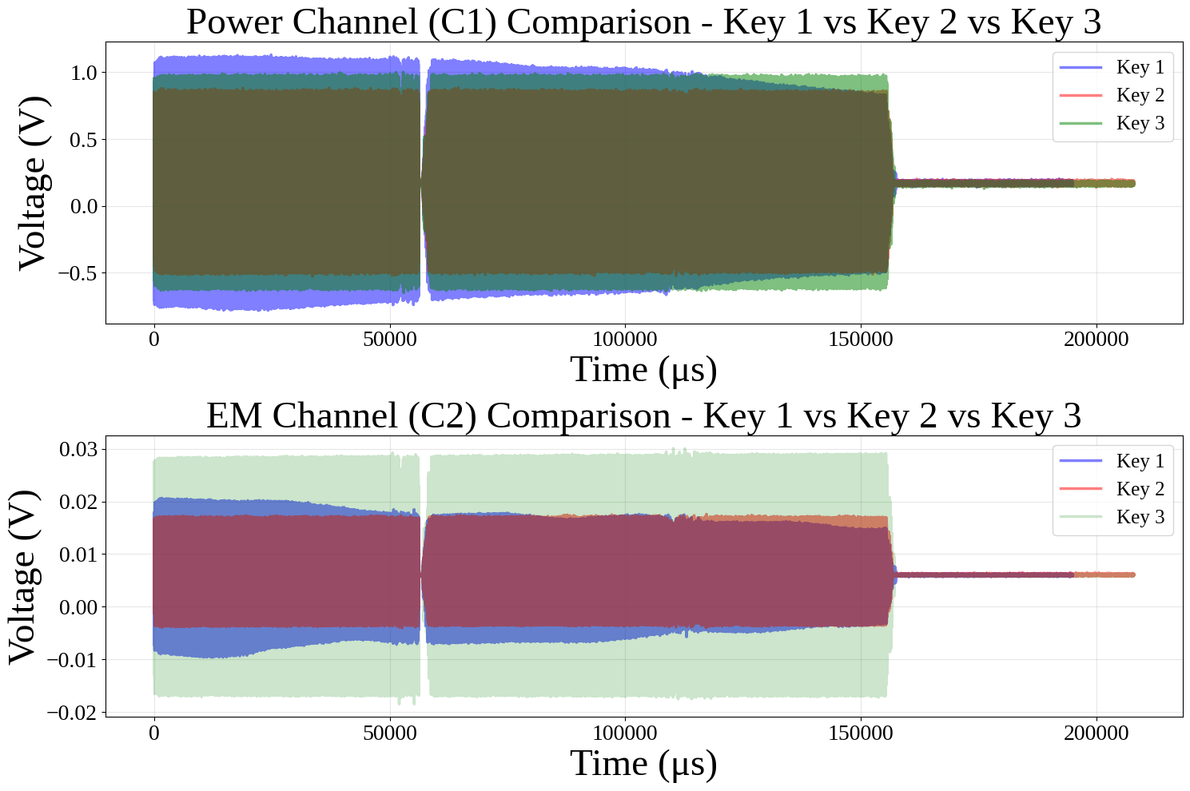
Figure 4: The Average of All Three Keys Overlayed

E – 3

Appendix F

Source Code And CSV Files

Link to Google Colab
All the code used for preprocessing and analysis can be found in this Google Colab. Each section is clearly marked with headers, the code is fully commented, and all generated figures include titles and legends, ensuring that it is easy to follow and reproduce.

Link to Google Drive
All the unmodified CSV files that were downloaded from the oscilloscope can be found here. These were originally named using the format CARD1_X, though a more accurate label would be BLOCK to reflect the specific card block tested. The reader should note this naming mismatch when interpreting the datasets.

F – 1

Appendix G

Mathematical Equations

Independent two-sample t-test

$$t= \frac{{\overline{X}}_{1}- {\overline{X}}_{2}}{\sqrt{\frac{s_{1}^{2}}{n_{1}}+ \frac{s_{2}^{2}}{n_{2}}}}$$
- [1]
- ${\overline{X}}_{1}$ and ${\overline{X}}_{2}$ are the sample means of groups 1 and 2
- $s_{1}^{2}$ and $s_{2}^{2}$ are the sample variances of groups 1 and 2
- $n_{1}$ and $n_{2}$are the sample sizes of groups 1 and 2

the appropriate degrees of freedom were computed using Welch’s formula to account for unequal group variances:

$$df= \frac{{\left(\frac{s_{1}^{2}}{n_{1}} + \frac{s_{2}^{2}}{n_{2}} \right)}^{2}}{\frac{{\left(\frac{s_{1}^{2}}{n_{1}}\right)}^{2}}{n_{1}-1}+ \frac{{\left(\frac{s_{2}^{2}}{n_{2}}\right)}^{2}}{n_{2}-1}}$$
(2) [1]

The independent t-test checks whether the difference between two groups is meaningful. Alongside the t-statistic, it produces a $p$-value. The $p$-value is the chance that the observed difference happened randomly. A $p$-value below $0.05$ is typically considered “statistically significant,” meaning it’s unlikely that the difference is due to chance alone.

Cohen’s $d$
$$d= \frac{{\overline{x}}_{1 }- {\overline{x}}_{2}}{s_{pooled}}$$
(3) [2]
- $M_{1 }$and $M_{2}$ are the means of the two signals
- $s_{pooled}$ is the pooled standard deviation:
$$s_{pooled}= \sqrt{\frac{ \left(n_{1}-1\right) s_{1}^{2}+ (n_{2}-1)s_{2}^{2}}{n_{1}+ n_{2}- 2}}$$
(4) [2]
- $s_{1}$ and $s_{2}$ are the standard deviation of each signal.
Values around 0.2 are considered small, 0.5 moderate, and above 0.8 large. Higher values indicate bigger differences between signals.
G – 1

Pearson correlation coefficient
$$r= \frac{\sum{\left(x- m_{x}\right)\left(y- m_{y}\right) }}{\sqrt{\sum{{\left(x- m_{x}\right)}^{2}}\sum{{\left(y- m_{y}\right)}^{2}}}}$$
(5) [3]
- $m_{x}$ and $m_{y}$ are the mean of the vectors $x$ and $y$
Values range from $-1$ to $1$. A value close to 0 means little or no relationship, values near $1$ mean a strong positive relationship, and values near $-1$ mean a strong negative relationship. A value above $0.5$ generally suggests a moderate to strong relationship.
[1] “Student’s t-test — Independent two-sample t-test,” Wikipedia. Available: https://en.wikipedia.org/wiki/Student%27s_t-test#Independent_two-sample_t-test.
[2] “Effect size — Cohen’s d,” Wikipedia. Available: https://en.wikipedia.org/wiki/Effect_size#Cohen's_d.
[3] “Pearson correlation coefficient,” Wikipedia. Available: https://en.wikipedia.org/wiki/Pearson_correlation_coefficient.
G – 2

Appendix H

Proxmark3 Command Line Interface Output

[usb] pm3 --> hf search
🕗 Searching for ISO14443-A tag...
[=] ---------- ISO14443-A Information ----------
[+] UID: 6D 04 24 C4 ( ONUID, re-used )
[+] ATQA: 00 04
[+] SAK: 08 [2]
[+] Possible types:
[+] MIFARE Classic 1K
[=]
[=] Proprietary non iso14443-4 card found
[=] RATS not supported
[#] Static nonce....... 01200145
[+] Static nonce....... yes

[?] Hint: Try `hf mf info`

[+] Valid ISO 14443-A tag found

[usb] pm3 --> hf mf info

[=] --- ISO14443-a Information -----------------------------
[+] UID: 6D 04 24 C4
[+] ATQA: 00 04
[+] SAK: 08 [1]

[=] --- Keys Information
[+] loaded 2 user keys
[+] loaded 61 hardcoded keys
[+] Sector 0 key A... 434A9734E087
[+] Sector 0 key B... FFFFFFFFFFFF
[+] Sector 1 key A... 010203040506
[+] Sector 1 key B... FFFFFFFFFFFF
[+] Block 0.......... 6D0424C4890804006263646566676869 | bcdefghi

[=] --- Fingerprint
[+] Fudan based card

[=] --- Magic Tag Information
[=] <n/a>

[=] --- PRNG Information
[#] Static nonce....... 01200145
[+] Static nonce... yes

[usb] pm3 --> hf mf chk --1k -a --tblk 0 -k 434A9734E087
[+] loaded 1 user keys
[+] loaded 61 hardcoded keys
[=] Start check for keys...
[=] ..
[=] Time in checkkeys 0 seconds
H – 1

[=] Testing to read key B...
[=] Sector: 0, First block: 0, Last block: 3, Num of blocks: 4
[=] Reading sector trailer
Data:FF FF FF FF FF FF

[+] -----+-----+--------------+---+--------------+----
[+] Sec | Blk | key A |res| key B |res
[+] -----+-----+--------------+---+--------------+----
[+] 000 | 003 | 434A9734E087 | 1 | FFFFFFFFFFFF | 1
[+] 001 | 007 | ------------ | 0 | ------------ | 0
[+] 002 | 011 | ------------ | 0 | ------------ | 0
[+] 003 | 015 | ------------ | 0 | ------------ | 0
[+] 004 | 019 | ------------ | 0 | ------------ | 0
[+] 005 | 023 | ------------ | 0 | ------------ | 0
[+] 006 | 027 | ------------ | 0 | ------------ | 0
[+] 007 | 031 | ------------ | 0 | ------------ | 0
[+] 008 | 035 | ------------ | 0 | ------------ | 0
[+] 009 | 039 | ------------ | 0 | ------------ | 0
[+] 010 | 043 | ------------ | 0 | ------------ | 0
[+] 011 | 047 | ------------ | 0 | ------------ | 0
[+] 012 | 051 | ------------ | 0 | ------------ | 0
[+] 013 | 055 | ------------ | 0 | ------------ | 0
[+] 014 | 059 | ------------ | 0 | ------------ | 0
[+] 015 | 063 | ------------ | 0 | ------------ | 0
[+] -----+-----+--------------+---+--------------+----
[+] ( 0:Failed / 1:Success )
H – 2

