*ENG2 - report*

Y3877930

# 1.1 Architecture

Define the overall architecture using recognised notations (e.g. UML component/deployment diagrams or C4 diagrams). Justify how the architecture can scale with increasing user demands, and be adapted to new requirements in the future (e.g. a recommendation system). [15 marks, max 2 pages]

The architecture used is a microservice architecture rather than a Monolithic architecture. As each microservice can be deployed independently and therefore scaled independently, particularly if there is increased user demands then microservices handling core functions such as authentication or main data throughput can be scaled both horizontally (adding more docker containers for example) or vertically (increasing the CPU power or memory available). Furthermore, each microservice can be worked on separately by different teams as each is responsible for a different function and is only loosely coupled, so this can increase how quickly additional features can be added to a system.

The database choice of MariaDB and docker compose means that it can be scaled horizontally in the same with as the microservices, adding additional nodes to the cluster would mean that the MariaDB could handly more I/O operations at once. Furthermore, Kafka similarly allows scaling, it currently hads 3 nodes but more can easily be added. Kafka handles clustering very easily, having one leader node and the rest are in eventual consistency.

In terms of adding new features to the service, the microservice architecture means that to add new features, a new microservice can be added to the architecture. The new microservice can consume and produce events and do api calls without effecting existing microservices and features.

Level 2: Containers

Key

Level 1: Context

Level 3: Components (Same for all 3 microservices)

# 1.2 Microservices

**Video microservice**

This microservice has a database that stores all users, videos and hashtags as entities. It exposes endpoints to be able to create, retrieve and update these entities, such as marking a video as watched by a user and liking a video.

Video microservice exposes 18 endpoints, under the paths /user, /video and /hashtag. (Listed and described fully in microservices/README.md)

This microservice does not interact with any other microservice and does not consume any events. This means that it does not rely on anything else and will continue working if other microservices go down.

However, it does produce events to kafka topics:

* new-hashtag – upon a hashtag being created (Key: Hashtag ID, Value: Hashtag Object)
* new-user – upon a user being created (Key: User ID, Value: User Object)
* watch-video – upon a video being marked as watched by a user (Key: User ID, Value: Video Object)
* new-video – upon a video being created (Key: User Posted ID, Value: Video)
* like-video – upon a video being liked by a user (Key: User Liked ID, Value: Video)
* dislike-video – upon a video being disliked by a user. (Key: User Liked ID, Value: Video)

Architecture design decisions:

* Separate entities for hashtags means that they can be stored in a database separately and have relationships to other classes. This is due to the first normal form of a database being that each cell contains only one piece of information and should not contain relationships. We could have used a comma separated string to store hashtags in a video entity, but this would break the first normal form. Instead a new table is created that stores the relation between videos and hashtags.
* Each entity has a controller that exposes endpoints that create, or make changes to, the respective entity. UserController, HashtagController and VideoController. This is similar for event producers, UserProducer, HashtagProducer and VideoProducer. This is to improve readability of the system for developers.
* All endpoints return

**Trending Hashtag Microservice**

The Trending Hashtag Service is responsible for calculating the trending hashtags in the system. It does this by listening to the `video-liked` topic in the Kafka cluster and keeping track of the trending hashtags accordingly in a 1-hour sliding time window. It also keeps track of the hashtags id’s that have been created in a database. This is so that during the Kafka stream, it will check every hashtag that has been created for occurrences of likes in the stream on every update.

It exposes an endpoint /trendingHashtags which lists the id’s of the top 10 trending hashtags.

The stream in this microservice, upon every event received, looks at the previous hour of events and counts how many occurrences of each hashtag there is, this is then stored in a materialized store.

If this microservice goes down, as long as the video microservice is still producing events, when it comes back on, it will be able to resume after the next event it receives as the kafka topic would persist.

This microservice does not directly communicate with any other, instead it only listens to kafka topic events, this means that the updates are slightly delayed.

Design decisions:

* The microservice consumes ‘liked-videos’ events in order to decide on trending hashtags, and also keeps a record of the hashtags that have been created by consuming the ‘new-hashtag’ event and stores in a database. On each new video-like, the stream breaks a video up into its respective hashtags, has a value of 1 assigned to the hashtag, and adds an event for each other hashtag that exists and gives it a value of 0. This is so that when the stream is windowed, it updates the count for all of the hashtags rather than just ones that are liked. An aggregate is used to count all likes within the rolling 1 hour window.
* Event streams were used rather than simple producers and consumers as it handles partition rebalancing and is less computationally intensive to do it in this way rather than storing in a database with timestamps to allow for windowing.
* A copy of the databases are stored in a separate database to VM so that the microservices stay loosely coupled. Again, using events rather than api requests also allows the microservices to stay loosely coupled.

**Subscription Microservice**

**TODO**

**CLI Client Usage**

The client can be run with either the dev mode of ./gradlew run args=”<command> <args>” or after running the ./gradlew dockerbuild command in the client directory, can be run with ./videoCLI.sh <command> <args>. This is a wrapper around a docker run command that runs the client docker container with the command given.

The CLI client can be used to interact with the microservices. It can be run as above and the following commands are available:

* add-user <name> - Adds a new user with the given name to the system.
* get-user -id <id> or get-user -name <name> - Gets the user with the given id from the system or by name.
* list-users - Lists all users in the system.
* post-video <title> <id> <hashtags (space seperated)…> Adds a new video with the given title, user posted by id and (optional) hashtags to the system.
* get-video -id <id> or get-video -postedBy <userId> or get-video -hashtag <hashtagName> - get videos by id, user posted or hashtag
* list-videos - Lists all videos in the system.
* like-video <videoID> <userID> - Marks the video with the given id as liked by a user.
* dislike-video <videoID> <userID> - Marks the video with the given id as disliked by a user.
* watch-video <userID> <videoID> - Marks the video with the given id as watched by a user.
* trending-hashtags - Gets the top 10 trending hashtags in the system.
* subscribe **TBD** - Subscribes a user with the given id to the hashtag with the given name.
* unsubscribe **TBD** - Unsubscribes a user with the given id from the hashtag with the given name.

# 1.3 Containerisation

Discuss how the solution can scale up to larger numbers of users, and be resilient to failures (e.g. of a container, or a node)

Each microservice has its own container, as well as each database and all 3 kafka nodes. Also there is a kafka-init container that adds the topics to the kafka nodes. These are all run with the orchestrator docker compose.

Lastly the client (CLI) is containerised and is started briefly upon each command.

As each part (resources and services) are containerised separately, this means that they can be scaled separately. They can be scaled up to a larger number of users by:

* Multiple containers – multiple containers of each microservice can easily be added to ensure that there is constant availability. Also additional kafka nodes could be added. This means that if any containers go down, the others may be able to continue regardless.
* Database replication – MariaDB supports database replication in multiple ways including master-slave whereby changes made on the master server are asynchronously replicated to one or more slave servers. This means that if a database volume becomes corrupted or if a database node goes down, the system will carry on.
* Load Balancers – The addition of load balancers would be able to distribute requests evenly over multiple microservice containers to reduce risk of crashes due to too many requests.
* Scaling up – Giving more resources to the services such as RAM, disk space, CPU availability.

For the system to be resilient to failures the following could be/has been added:

* Automated restart containers – The restart: unless-stopped stategy has been added to all containers to ensure that if they stop for any reason other than being stopped, they will restart.
* Monitoring – monitoring of the services and containers could be added with the addition of a Prometheus container which could send data to either an on-prem or cloud Grafana in order to easily configure alerts and create dashboards. This would allow a fast response to problems such as highload or a full disk.
* Healthchecks – Implemented on each microservice and resource to aid with monitoring
* Loose coupling – Where possible, microservices rely on kafka events rather than direct request based communication. This reduces reliance on each microservice and means that the microservices are more resilient to failures.

2.1.4 Quality Assurance

**Docker Image inspecting**

When scanning my microservice images with docker scout, the following vulnerabilities where found:

The first 2 are dependencies from the micronaut-http-client dependency defined in my build.gradle and are were found in all 3 microservices. (This was traced using the dependency task in gradle). In order to resolve this, I found the earliest point in which these security advisories were resolved, and overrode the version to io.netty:netty-codec-http2:4.1.100.Final.

The 3rd is a dependency of kafka-streams, I overrode the dependency to "com.fasterxml.jackson.core:jackson-databind:2.16.0" which also resolved it.   
Ideally I would have traced back to the version of kafka streams or micronaut that caused the dependency version however I did not have enough time to feasibly do this and ensure there were no breaking changes in my microservices.

Figure 1 - Microservice docker scout scan before fix

My client container uses ubuntu:20:04 and eclipse temurin as the base images which has many vulnerabilities:

In order to resolve this I have changed the base image to "amazoncorretto:17-alpine3.17" which **resolved all vulnerabilities**.

There were 51 vulnerabilities in MariaDB containers, the highest risk ones were related to parsing javascript which is mostly unrelated to my system. This many vulnerabilities cannot feasibly be resolved in the time given as the MariaDB version is the most up to date at the time.

Figure 2 - Client (CLI) image docker scout scan before fix

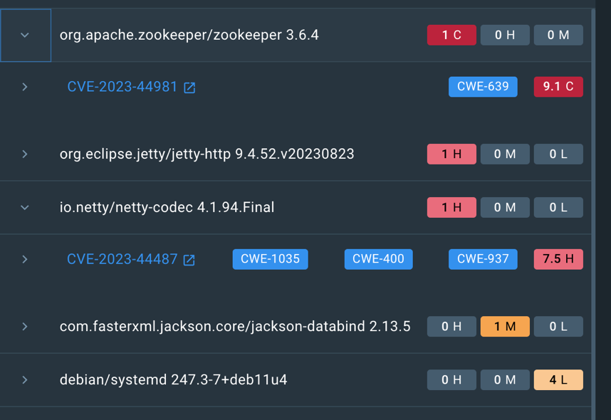

There were 36 vulnerabilities in the kafka containers, in order to fix the most critical, I have upgraded my kafka image version to 3.6.1. This fixes the critical vulnerability although that relates to zookeeper, which my kafka cluster does not use. It also resolves a netty-code vulnerability as before which is a dependency in the image. This is good because these vulnerabilities were critical and high respectively.

# 2.1.1 Metamodel

From <https://eclipse.dev/epsilon/playground/>

At the top level of my metamodel, there is a "System" class encapsulating all elements within models using this metamodel. The "System" includes "EventStreams," representing Kafka topics for event production and consumption. Each "EventStream" has a name and an event type, further categorized into "KeyType" and "ValueType." This design choice allows for the creation of EventStreams that may not be immediately utilized by microservices. This feature aids in visually assessing whether topics are actively used or if adjustments are needed. It also helps improve extendability, if EventStreams were needed to be used by additional services inside the system that are not yet modelled. This was a decision made rather than having EventStreams in microservices but this means that when microservices are removed, any eventStream that is a val in it is also removed. Furthermore, in an actual system, EventStreams or Kafka Topics are not actually contained within microservices but instead are in the event streaming platform or Broker.

The "System" class encompasses "CLI" instances, representing command-line interfaces interacting with microservices. Multiple CLIs can interact with either a subset or all microservices, indicated by a reference to microservices in the CLI class. Each CLI has a name and includes commands represented by the "Command" class, featuring a name, description, and parameters represented by the "Attributes" class.

Furthermore, the "System" class includes "Microservices," each having a name, port, and package representation. Microservices consist of entities with names, attributes, and associated DTOs. Additionally, microservices involve consumers and producers, where consumers have a Boolean flag indicating whether they are streams. Both consumers and producers reference "EventStreams" for topic interaction. This design decision improves the visual representation and understanding of how microservices interact with event streams.

Microservices also incorporate controllers, featuring a name, a path (base URL path for controller endpoints), and API endpoints represented by instances of the "Endpoint" class. Endpoints include a name, URL path, and an enumerated endpoint type (GET, PUT, POST, DELETE). This simplifies the representation of RESTful APIs and enhances the DSL's ability to describe various API resource types. Endpoints may have request parameters and a response body, adhering to DSL specifications for API resource descriptions.

Microservices can possess DTOs, each with a name and attributes. The "Entity" class represents the domain within microservices, featuring a name and one or more "EntityAttributes" with type and name attributes. Entities also reference DTOs, graphically linking them. This association also aids in maintaining a concise and organized structure, fostering better readability and understanding of the relationships between entities and their corresponding DTOs."EntityAttributes" extend the standard attribute class and include additional attributes like JsonIgnore, GeneratedValue, uniqueness, nullability, optionality, insertability, upgradability, mappedBy, columnDefinition, fetch type (LAZY or EAGER), and a relationship type (ManyToMany, OneToMany, ManyToOne). Including a comprehensive set of attributes (e.g., JsonIgnore, GeneratedValue, uniqueness) in the "EntityAttribute" class allows for a detailed specification of entity attributes and allows for the accurate generation of entities code.

Lastly, each microservice includes a "Repository" with a name associated with the entity it manages. The separation of Repositories rather than assuming a repository for every entity, allows persistence of entities to be optional. Rather than having a Boolean for if an entity is persisted or not, a repository class promotes a clean and modular architecture where data access operations are encapsulated in repository classes.

I have assumed that each eventStream will only have one type of key and one type of value entering it. Also that a producer/consumer can interact with multiple eventStreams, eg. In a java and kafka representation, a class is a producer that has multiple methods that produce to different topics and can be called separately.

One of the decisions I made was whether to have DTO’s and entities be shared across my microservices. Due to the way in which my project is set up, ie. Without it being a mutlti project and instead each microservice being a separate gradle project, DTO’s and Entitys, although they can be the same across multiple projects, are separate values in my model. This is to ensure it is an accurate representation of the architecture and also ensure that they can be generated as code separately into each project where needed. It also allow different services to drop some attributes of classes, allowing services to only hold a subset of entities and repositories. For example, the trending hashtag microservice does not need the relationship of “watcher” between video and user.

2.2.2 Graphical Concrete Syntax

As my model is in picto and I have decided to break it up into smaller models as the picto language allows, I have provided a subset of my diagrams which shows all types of graphical syntax.

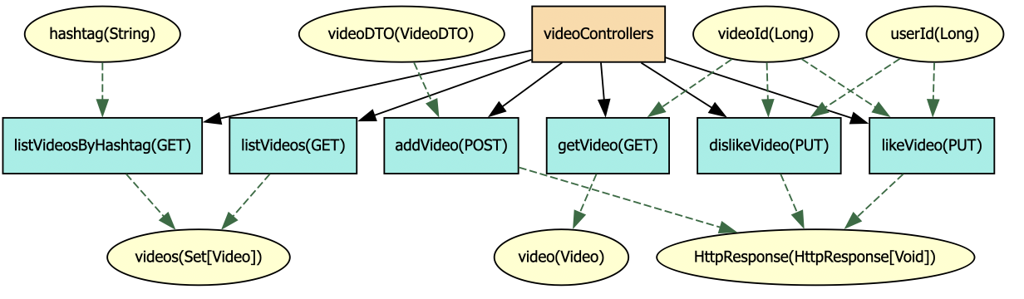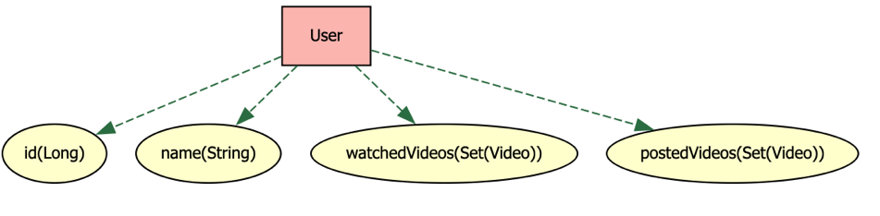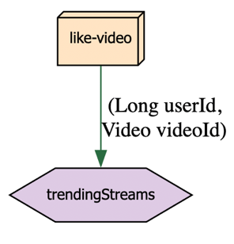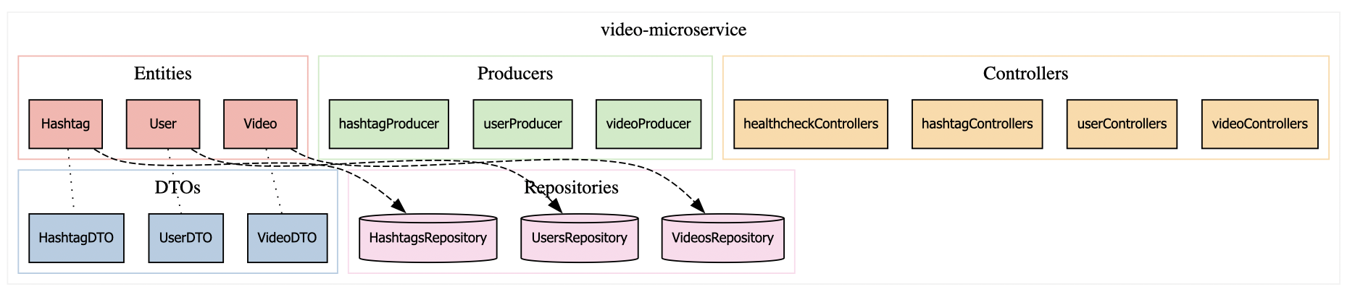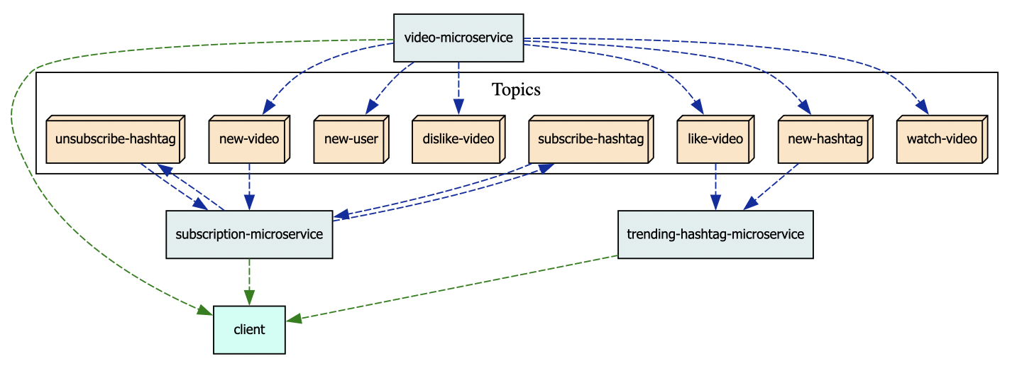TODO: REPLACE THESE

The graphical implementation can generate diagrams of the system as a whole, and singular microservice, entity, dto, consumer and producer. This is implemented using picto.

In the highest-level system view, microservices are represented as boxes, and event streams are depicted as 3D orange boxes connected by blue dashed lines, indicating the flow of information. The use of 3D boxes for event streams enhances semantic transparency, conveying that they hold data. The consistency of dashed lines throughout the graphical syntax maintains a clear representation of input/output flows. Arrows indicate the direction of information flow, aligning with users' natural cognitive processes. CLI’s are showed as blue boxes, linked to the respective microservices that it interacts with by another dashed line.

The next level of granularity is the microservice view. This view shows all components of the system, including Controllers, Consumers, Producers, Entities, DTO’s and Repositories. These components are in a container which represents the microservice as a whole and each component type has its own subgraph with an edge that represents the grouping by type. One of the important parts of this view of the system is that it shows the links between the Entities and its representation as a DTO. This is shown by a dotted black edge without an arrowhead, as there is no direction to the relationship, only that there is a link between them. Furthermore, this view also shows a dashed arrow between the entity and its respective repository.

This shows that the entity is stored within the repository for the entities persistence. The dashed line, as previously, shows the flow of data. The database, similar to the KafkaStream, is a 3d shape, in the form of a cylinder, which represents again, that information is stored within it. Although it is technically stored within the associated database, the repository provides the CRUD interface for it and to non technical users of the graphical syntax, this is a logical representation. The cylinder was also chosen as it is the way in which databases are typically represented in C4 diagrams and other system diagrams.

Component colors and shapes denote distinct types, simplifying identification however a disadvantage of this is that it relies on the user being able to distinguish between colours. A hexagonal consumer shows that it is a stream rather than a simple consumer. Entities and DTOs are shown in smaller diagrams, with yellow oval attributes and green dashed lines between them. The yellow oval attributes are consistent across the diagrams as attributes. Attribute nodes show the name of the attribute and its type. However, the entity attributes do not show all of the additional features allowed in the ‘EntityAttribute’ class because there is a lot of information that can be added which is not necessary to understand the system. Similarly, the relationships are not shown in the microservice view either, this is to stop there being too much clutter and to reduce complexity, particularly when there are multiple types of relationship between two entities.

The decision to omit relationship details in the microservice view may limit the comprehensiveness of the representation for users who require a more detailed understanding of entity relationships. An extension to my graphical syntax might be to add a toggleable layer showing the relationships between entities and the additional details of the Entity Attributes.

Attributes are used in the controller view to show the request parameters and response body from each endpoint. They use the same yellow oval and dashed arrow. The dashed arrow shows whether the attribute is a request parameter (arrow goes towards endpoint) or response body (away from endpoint).

Lastly, consumers and producers are shown with another diagram view each, with the consumer/producer node being the same colour/shape as it is in the microservice view to show if they consume or produce and show if they are a stream or not. Furthermore they also show the various EventStreams they interact with with them being shown in the same 3d box form as in the system view.

Picto was chosen for its simple usage as my development of my model was iterative, I wanted the process of adjusting my graphical model to be simple and clearly readable in the diff of version controle for if I wanted to revert back. Furthermore the lightweight nature of it and the fact that I was already relatively familiar with graphviz, made it more appealing from a developers point of view. Also the fact that it is useable in other IDE’s means that it is more accessible to other stakeholders. However, an advantage of using Sirius would be that it provides many additional features customization and extensibility, allowing the creation of graphical editors for stakeholders to interact with.

# 2.2.3 Model Validation

Use the Epsilon Validation Language to implement any validation constraints specified in Section 1.2, which cannot be expressed in the metamodel itself. Briefly explain the rationale and implementation of each constraint. [5 marks] (max 1 page)

The DSML must support automated validation. It must check these properties:

• There should be at least one microservice.

* This is checked in the EVL. Although it could have been expressed in the metamodel with the usage of [+] rather than [*], the use of the phrase ‘should’ suggests that only a warning should be given rather than an error. Therefore the EVL rule AtleastOneMicroservice checks whether the size of ‘microservices’ in the system is atleast one. If there isn’t, it throws a warning rather than an error.

• Every event should be used in least one event stream.

* This is checked automatically with the design of my metamodel. An event cannot exist unless it is contained within an EventStream as a value rather than a reference. Although this could be checked in an EVL, it would always be true and therefore a waste to implement or run unless the design of the metamodel changes.

• Every event stream needs to have at least one publisher and one subscriber.

* Similar to the first check, this is also in EVL form and Is also a critique and therefore gives a warning. (assumption based on clarification on the VLE) This check is implemented by two rules, hasProducer and hasConsumer. These rules, for every eventStream, checks there exists a producer/consumer that references this eventStream. It does this by looping through, checks if any of them reference it and then checks whether there is any of the producers/consumers that are true using exists().

• Every microservice needs at least one “health” resource using the HTTP GET method and taking no parameters, for reporting if it is working correctly.

* This check is implemented in EVL by a rule HasHealthcheck, which for every microservices, it checks that there exists a controller such that there exists a healthcheck endpoint in a controller. To do this, I implemented a function isHealthcheck that checks if an endpoint fulfils all of the following conditions:
  + EndpointType is GET
  + The name of the endpoint starts with “health” (converted to lowercase first so as to cover health, healthcheck, Healthcheck etc.)
  + There are no request Paramaters
  + The responseBody type starts with HttpResponse

This is an error due to the word “needs”.

# 2.2.4 Model-to-Text Transformation

Discuss the model-to-text transformations and justify the organisation of the generated code. [15 marks] (max 2 pages)

The purpose of the model to text generation is to generate parts of the microservice as a scaffold and as usable classes, as well as to generate the production compose file for the system.

My generated Java code is generated into src-gen folders within each microservice directory. This allows each microservice to have different generated code rather than sharing a src-gen folder. This decision was made rather than generating into src and using protected regions for manually written code. A dedicated src-gen folder allows us to maintain a clear separation between the automatically generated code and code that was manually written. This is important because it means generated code is less likely to be modified directly. It also means that src-gen can be marked as a generated source in an IDE which means it would be read-only, preventing changes entirely. Although protected regions would allow for integration between generated and manual code, it can make it confusing to a developer. The use of src-gen also allows easy ignoring of the folder in version control systems if needed.

The classes are sorted into separate packages to aid in reducing the complexity of the code for developers. DTO’s are in .dto, entities in .domain, controllers in .controller and repositories in .repository.

The model produces all of the DTOs from the model including the getter and setter for each attribute. It also produces all entities. To enable all of the annotations for each attribute in the entity to be added, the models EntityAttribute class has needed to become very detailed in order to include all of the information needed for the code generation.

Controllers are generated as interfaces that can be implemented by a developer. It includes the annotation in each abstract method to show the http type (GET, PUT etc.) and the uri path (“/”, “/video”). The interfaces act as a blueprint for a class, allowing developers to focus on the implementation of business logic rather than spending time on the initial setup. This accelerates development by providing a starting point for coding that aligns with the overall architecture. Standardized interfaces make collaboration among team members more straightforward. If I had more time, I might also have added some commonly used methods or properties, eliminating the need for developers to rewrite them for each class.

Repositories have been created as standard interfaces without any additional defined methods. To add additional methods, it would need to be extended to create new interfaces with additional functionality.

I considered adding the overrides for common methods (eg. findById) as standard with the additional annotations that may be needed, like joins, calculated from the entities and their attributes types depicting joins between entities.

The final part of my code generation is to generate the docker compose files needed to start the system, `docker-compose-gen.yml` and `docker-compose-secrets.yml`. This has the yaml configuration for all microservices in the system. If a microservice has a repository configured then the generation assumes it needs a database. It also generates a suggest docker compose secrets file with a generic username and password set and the name of the DB is the name of the microservice it is meant to be used by. The secret is left with ‘todo’ to show that it needs to be changed. The use case would be the file to be copied and the password changed before starting the services.

If I was to have more time, generating the client interface for microservices into test folders and the cli would be beneficial for cutting down on the amount of work a developer needs to do in order to integrate the microservices into a CLI and also to test. This would be useful because when more endpoints are added etc, if they are added to the model, they will be added to the client automatically upon the next model to text transformation.