# Questions for Chapter 6

## Q 6.1 Lightness constancy



Both bars are uniform but appear to vary in luminance because their ratios with the background vary (this particular version of the illusion is courtesy of Mike Harris, Birmingham, UK)

Create this illusion using Matlab.

n = 101;

[X, Y] = meshgrid(linspace(-1,1,n));

X(30:40, 10:90)=.1;

X(60:70, 10:90)=.8;

imagesc(X); axis off

colormap(gray(256))

For fun, check out what it looks like with different colormaps.

## Q 6.2 Peripheral drift illusion

This is the peripheral drift illusion: patches containing sawtooth luminance profiles produce a sensation of motion when viewed in the periphery (when you don’t look directly at it). In this example the direction of apparent motion is clockwise.

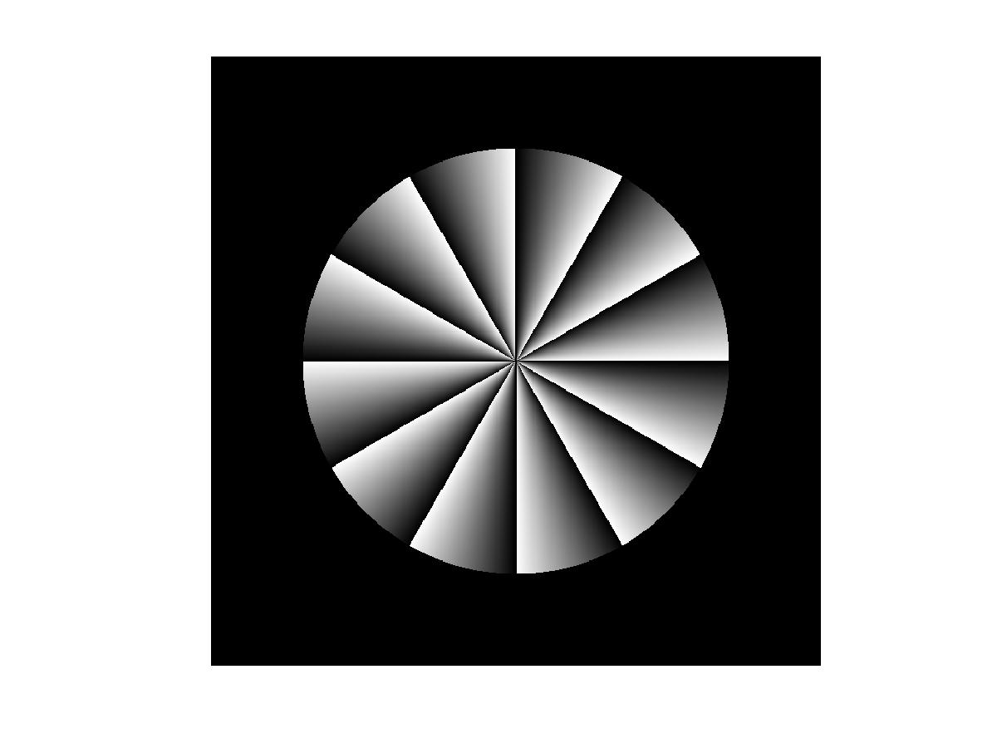

*Faubert, J and Herbert, A. (1999). The peripheral drift illusion: A motion illusion in the visual periphery. Perception, 28, 617-622.*

1. Make this illusion. For fun, check out what it looks like with different colormaps.

n = 701;

nseg=6;

radius=.7;

[X, Y] = meshgrid(linspace(-1,1,n));

theta= atan2(Y,X)./pi;

theta=mod(theta*nseg, 1);

radiusimage=sqrt(X.^2+Y.^2);

aperture=NaN(size(radiusimage));

aperture(radiusimage<radius)=1;

aperture(radiusimage>=radius)=0;

illusion= theta.*aperture;

imagesc(illusion);

axis square

axis off

colormap(gray(256))

1. Now modify your code to make this version. What direction is the apparent motion now?

n = 701;

nseg=-6;

radius=.7;

[X, Y] = meshgrid(linspace(-1,1,n));

theta= atan2(Y,X)./pi;

theta=mod(theta*nseg, 1);

radiusimage=sqrt(X.^2+Y.^2);

aperture=NaN(size(radiusimage));

aperture(radiusimage<radius)=1;

aperture(radiusimage>=radius)=0;

illusion= theta.*aperture;

imagesc(illusion);

axis square

axis off

colormap(gray(256))

