# Questions for Chapter 6

## Q 6.1 Koffka Ring.

Make these three stimuli: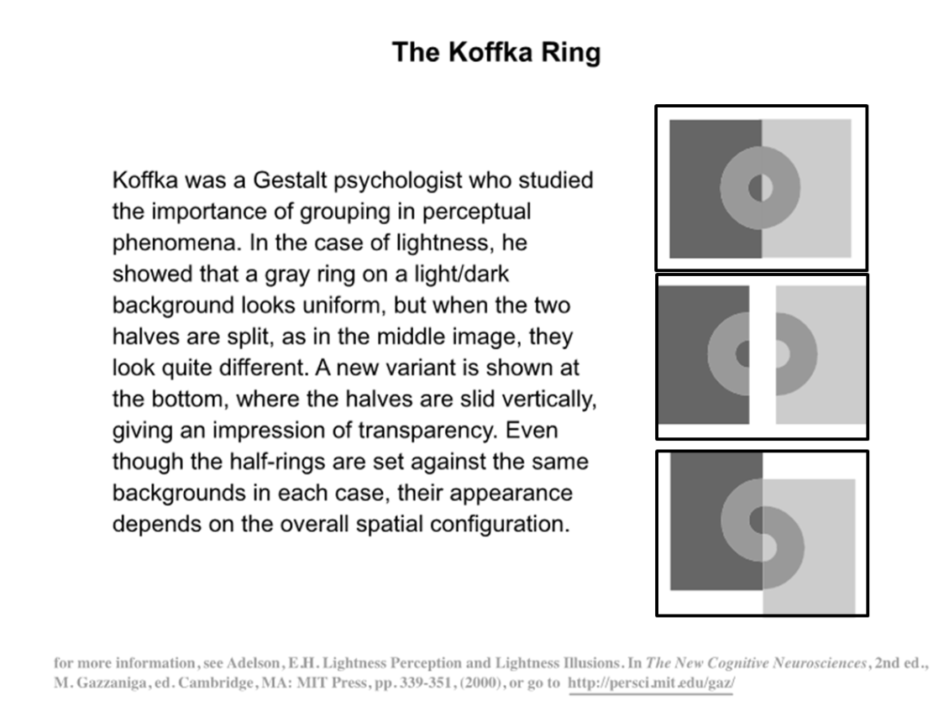

**1)**

clear all

clrs.white=1;

clrs.lightGray=.8;

clrs.midGray=.6;

clrs.darkGray=.4;

sz.ringWidth=1/3;

sz.imgSize = 100;

[X,Y]=meshgrid(linspace(-1,1,sz.imgSize));

R=sqrt(X.^2+Y.^2);

Rinner=zeros(size(R));

Rinner(find(R<sz.ringWidth/2))=1;

Router=zeros(size(R));

Router(find(R<1.5*sz.ringWidth))=1;

Rring=Router-Rinner;

RringL=logical(Router-Rinner);

%Router=R<.8; shortcut

imagesc(Rring)

bigMat=ones(size(R)) * clrs.darkGray;

bigMat(:, 51:end) = clrs.lightGray;

bigMat(find(Rring)) = clrs.midGray;

image((bigMat * 255)+1);

colormap(gray(256)); axis square

**2)**

bigMatLeft=bigMat(:,1:size(bigMat,2)/2);

bigMatRight=bigMat(:,size(bigMat,2)/2+1:end);

addFac=round(sz.imgSize*sz.ringWidth/2);

bigbigMat=clrs.white * ones(sz.imgSize,sz.imgSize+addFac);

bigbigMat(:,1:size(bigMatLeft,2))=bigMatLeft;

bigbigMat(:,size(bigMatLeft, 2)+addFac+1:end)=bigMatRight;

imagesc(bigbigMat)

colormap(gray)

**3)**

finalMat=ones(sz.imgSize+addFac, sz.imgSize);

finalMat(1:size(bigMatLeft, 1), 1:size(bigMatLeft,2))=bigMatLeft;

finalMat(addFac+1:addFac+size(bigMatLeft, 1), ...

size(bigMatLeft,2)+1:end)=bigMatRight;

imagesc(finalMat)

## Q 6.2 Funkystim

Create the following two stim (note, you need to go back to Chapter 6 and do exercise 6.2 first)



**1)**

clear all

[X,Y]=meshgrid(linspace(-1,1,1000));

T1=atan2(Y,X) * -180/pi;

T1=mod(T1, 30);

T2=mod(-T1+1,30);

R=X.^2+Y.^2;

R=R<.5;

T1(R)=T2(R);

imagesc(T1)

axis off

**2)**

[X,Y]=meshgrid(linspace(-1,1,500));

T1=atan2(Y,X) * -180/pi;

T1=mod(T1+10, 30);

T2=mod(-T1+10,30);

R=X.^2+Y.^2;

R=R<.5;

T1(R)=T2(R);

imagesc(T1)

axis off