1. 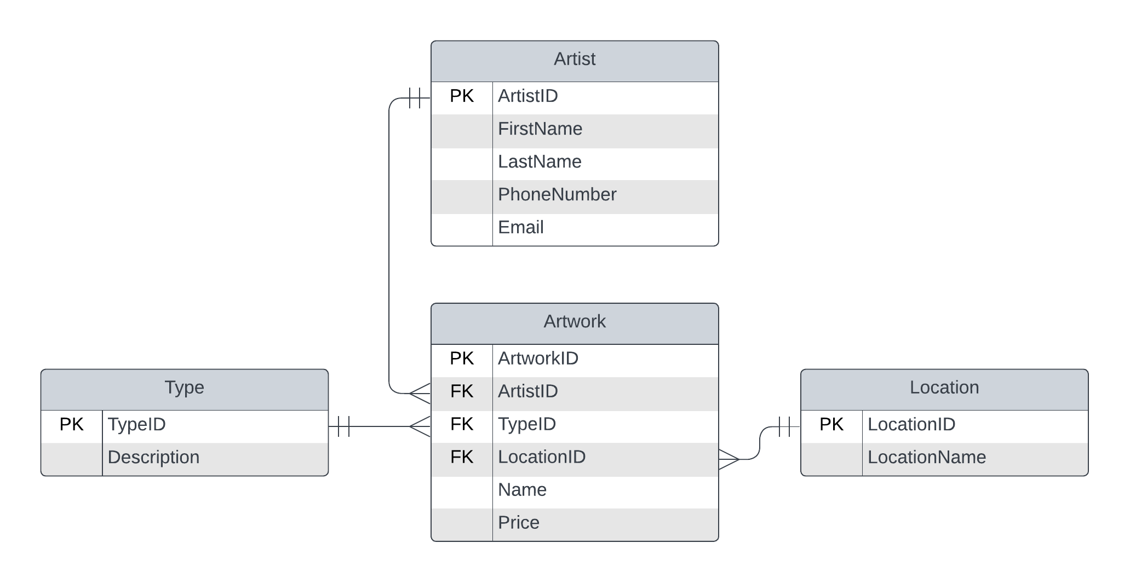ART GALLERY
2. A screenshot of a computer

   Description automatically generatedBUSINESS SCHOOL
3. 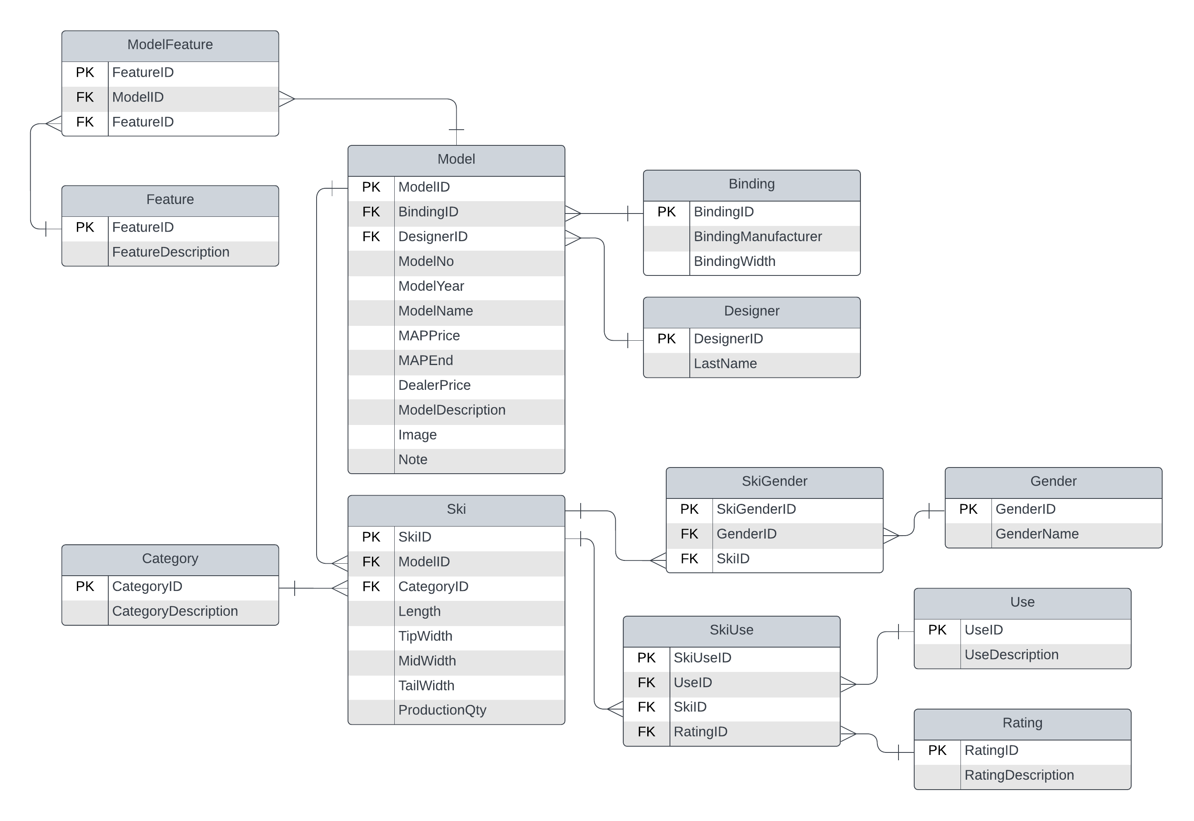PACK SKI