^^ meeting on 9/23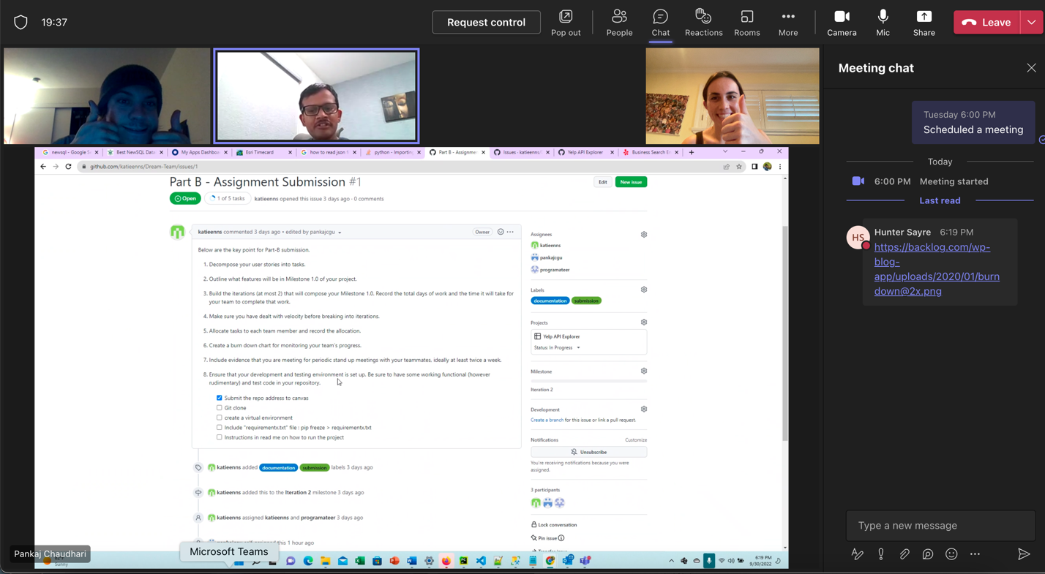

^^ meeting on 9/30



