**Classification and Network Graphing of Opioid Abusers**

Katie Fotion and Neharika Mazumdar

May 18, 2017

# **Table of Contents**

**1 Introduction** **3**

**2 Prior Work** **4**

**3 Data Description** **5**

**4 Methodology** **7**

4.1 Division of Work 7

4.2 Classification of Opioid Abusers 8

4.2.1 K-Nearest-Neighbors Parameter Tuning 9

4.2.2 Random Forest Parameter Tuning 11

4.2.3 Support Vector Machine Parameter Tuning 14

4.3 Classifier Evaluation and Results 17

4.4 Social Network Extraction 20

4.5 Network Graphing 22

**5 Results** **24**

**6 Conclusion** **26**

6.1 Future Work 26

**Appendix A: Results using additional metrics for classifier evaluation** **28**

KNN 28

RF 32

SVM 38

**Appendix B: Training Datasets** **46**

“Opioid Abusers” 46

“Nonusers” 62

# **1 Introduction**

Much can be discovered about an individual by simply exploring social media pages. Text, photos and videos can all be analyzed to form a relatively accurate picture of who the person is. One network in particular, however, is more telling than the rest. Reddit—a discussion website in which users can vote up or down submissions based on their content and quality—is unique in the fact that users tend to be more honest with their posts. Perhaps it is the fact that there is no photo associated with each user or the fact that the site is used more for anonymous discussion than for personal virtual relationships. Regardless, Reddit happens to be one of the richest sites for extracting information about individuals—both incriminating and benign.

This paper will present findings from an exploratory study, whose goal is to develop and analyze a network graph of opioid abusers based on Reddit submissions. The goal requires the completion of two main subtasks: positively identifying opioid abusers based on text analysis and tracking and graphing the users’ connections with one another. Accomplishing this can provide useful information about primary influencers (perhaps dealers or support groups) and those in need of constructive intervention. It is important to note that the problem of identifying opioid abusers through social media is far more complex than the scope of this paper; however, it serves as a gateway to understanding the potential of more impactful approaches to tackling the opioid epidemic, a devastatingly relevant problem that faces 21st century America.

The paper will be organized as follows. Section 2 will provide a brief overview of prior work. Section 3 will explain the data collection process and outline the data format and trends. Section 4 will cover the methodology; more specifically, section 4.1 will clarify the way the work was divided between contributors, section 4.2 will discuss the three classification algorithms with four different sets of features implemented for the purpose of identifying opioid abusers, section 4.3 will reveal the model with the best performance, section 4.4 will cover the procedure for extracting information about the network between opioid abusers, and section 4.5 will discuss the software used to graph the network. Consequently, section 5 will present the results of the final product, while section 6 will provide concluding remarks and a note on future work.

# **2 Prior Work**

Due to the opioid epidemic being a recently emerging phenomenon, much work in this area has been done in recent years. One particular work, “Using natural language processing to identify problem usage of prescription opioids” by Carrel et. al[1], attempted to use NLP technologies to analyze doctors notes in electronic health records and detect signs of prescription abuse. Katsuki et. al[2] conducted a study involving scraping Twitter for tweets containing drug-pertaining keywords and performing unsupervised topic extraction to identify illicit online pharmacies. Chary et. al[3] take more of a network graphing approach by extracting social network data, forming it into a graph structure, and observing the types of online interactions that promote drug abuse and the differences between interactions across various drugs. From these three journal articles, it is clear that in recent years, researchers have began thinking about how to use technology to assist in this deadly epidemic. This paper is unique, however, in the fact that it is an end-to-end approach, developing a powerful tool for data collection, classification, and visualization.

# **3 Data Description**

The most challenging aspect of this project was found in the training data collection process. Due to the enormous amount of Reddit data available and the inherent challenge of text analysis, scraping for definitively positive examples of opioid abusers was far from automated. The goal of data collection was to develop two main datasets: “opioid abusers” and “non-users”. These two datasets were then combined into a single heterogeneous dataset for 3-fold cross validation to evaluate and compare the three developed classifiers and be used as a training set when classifying new incoming submissions. Copies of both datasets can be found in Appendix B.

Beginning with the construction of the “opioid abusers” dataset, two key pieces of information were collected—the username and the text of the submission that caused the user to be added to the list. The data was stored in two separate text files (one for all usernames and one for all submissions). Overall, 152 submissions were collected, which corresponded to 68 distinct usernames. These were collected using PRAW[4] (an API for streaming Reddit data). Each opioid abuser was obtained by targeting opiate-themed subreddits such as “r/glassine” and “r/opiates” and then undergoing manual screening. Interestingly, many of these submissions consisted of very little text and at least one image—mostly of pills, pill bottles, and needles—which suggests a possibly more reliable computer vision approach to solving this Reddit scraping problem.

The “non-users” dataset was collected in a much less deliberate manner. The top 152 submissions in “r/popular” were gathered, where 152 comes from the fact that only 152 submissions of opiate abusers could be found. In order to avoid an imbalanced dataset, the same number of submissions were pulled for the “non-users” category.

For the sake of becoming familiar with the data, Figures 1 and 2 below display word clouds for each dataset. The most frequent words in each dataset should be understood since the proposed classifiers use variations of term frequency features to identify opioid abusers.

# Screen Shot 2017-05-10 at 1.10.32 PM.pngScreen Shot 2017-05-10 at 1.10.12 PM.png

**Figure 1.** Word cloud of “opioid abusers” submissions.

**Figure 2.** Word cloud of “non-users” submissions.

# **4 Methodology**

It is clear that a dataset of 68 opioid abusers is insufficient to build a meaningful network graph. As such, it was necessary to collect more positive examples. In order to minimize the amount of manual labor, as was explained in section 3, a classifier had to be developed to identify additional opioid abuser submissions. To accomplish this, three supervised classifiers were developed, all using features from variations of the term frequency matrix. The classifier with the best performance was selected and used to mark incoming submissions as “opioid abuser” or “nonuser.” These final positively marked users were then referred to in the network extraction and graphing procedure.

## **4.1 Division of Work**

Fortunately, this project presented a fairly natural and evenly distributed line of division. As such, the work was divided according to the following:

**Katie**

* Training data collection
* Implementation and evaluation of the classification algorithms
* Writing sections 1 - 4.3

**Neharika**

* Submission crawling and network extraction from a list of users
* Final graph of the network
* Writing sections 4.4 – 6

## **4.2 Classification of Opioid Abusers**

Due to the lengthy nature of Reddit posts, a term frequency matrix approach was selected for representing features of the data. Three separate classifiers were compared: k-Nearest-Neighbors, Random Forestm and Support Vector Machine. Four feature sets were compared, all using two primary term frequency techniques: Term Frequency Inverse Document Frequency (TFIDF) and Latent Semantic Analysis (LSA). The sets of features used, therefore, were TFIDF alone, LSA alone, LSA on the TFIDF matrix (TFIDF + LSA), and TFIDF on the LSA matrix (LSA + TFIDF). For all three classifiers using each of the four sets of features, the necessary parameters were tuned to that specific implementation. In addition, cosine similarity was used for k-Nearest-Neighbors due to its effectiveness in the document similarity context.

Scikit-learn was used to calculate the TFIDF matrix, the term count matrix, and perform dimensionality reduction for LSA. Furthermore, as recommended by scikit-learn documentation for LSA, the n_components parameter (the number of components desired after dimensionality reduction), was set to 100.

### 4.2.1 K-Nearest-Neighbors Parameter Tuning

Since the only parameter for K-Nearest-Neighbors is k, a linear scan for the optimal k value was performed between 1 and 100 (although the experiment was extended to 150 for LSA). Results can be found in Table 1 for each set of features. These values were selected based on the 3-fold cross validation F1-measure. The reason for selecting this particular metric for model evaluation can be found in section 4.3 below.

**Table 1.** Selected k values for k-Nearest-Neighbors for each set of features.

|  |  |  |  |  |
| --- | --- | --- | --- | --- |
|  | TFIDF | LSA | TFIDF + LSA | LSA + TFIDF |
| k | 13 | 111 | 79 | 45 |

Figures 3 – 6 demonstrate the parameter tuning results for each of the four sets of features. The red circle indicates the point at which k was chosen, as listed in Table 1.

## Screen Shot 2017-05-10 at 4.40.04 PM.png

**Figure 3.** KNN with TFIDF parameter tuning results.

## Screen Shot 2017-05-10 at 3.34.00 PM.png

**Figure 4.** KNN with LSA parameter tuning results.

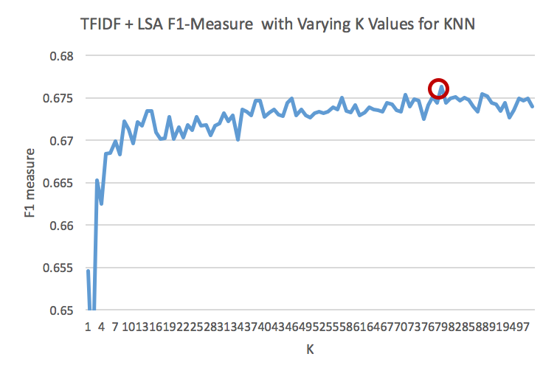

**Figure 5.** KNN with TFIDF + LSA parameter tuning results.

## Screen Shot 2017-05-11 at 8.08.03 AM.png

**Figure 6.** KNN with LSA + TFIDF parameter tuning results.

### 4.2.2 Random Forest Parameter Tuning

Random forests require two main parameters: n_estimators (sometimes referred to as ntree) and mtry. N_estimators refers to the number of trees required to make up the forest and mtry references the number of candidate features considered at each node split. Due to time constraints of the project, the default mtry value was used and n_estimators was the only parameter that was tuned (between 1 and 100). Again, the F1-measure was used and results can be found in Table 2 below.

**Table 2.** Selected n_estimators values for Random Forest for each set of features.

|  |  |  |  |  |
| --- | --- | --- | --- | --- |
|  | TFIDF | LSA | TFIDF + LSA | LSA + TFIDF |
| n_estimators | 7 | 33 | 52 | 41 |

Figures 7 - 10 demonstrate how this n_estimators value was picked for each feature set.

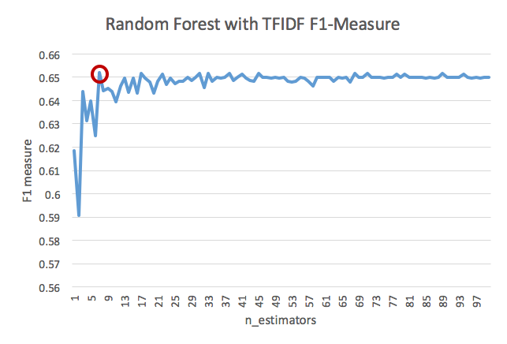

**Figure 7.** Random Forest with TFIDF parameter tuning results.

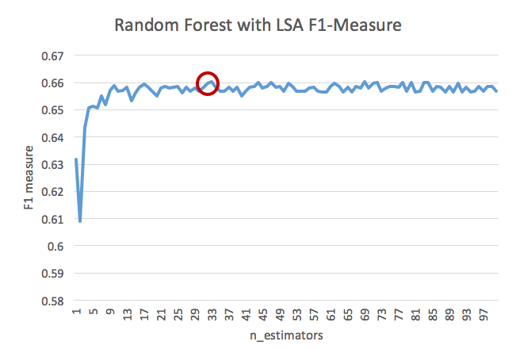

**Figure 8.** Random Forest with LSA parameter tuning results.

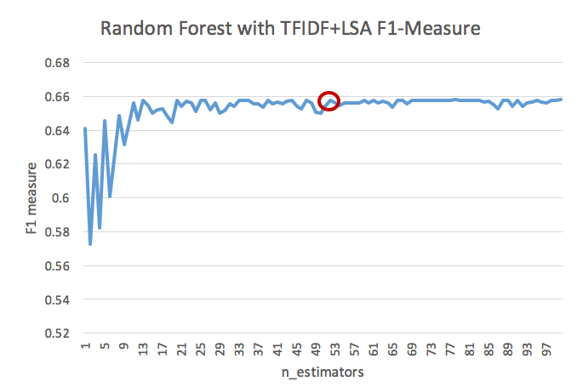

**Figure 9.** Random Forest with TFIDF+LSA parameter tuning results.

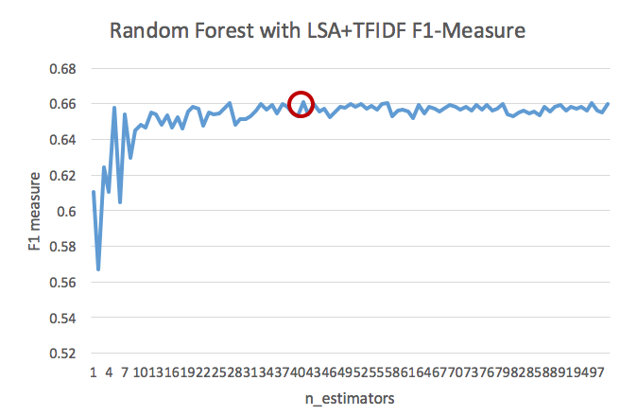

**Figure 10.** Random Forest with LSA+TFIDF parameter tuning results.

### 

### 4.2.3 Support Vector Machine Parameter Tuning

Similar to Random Forests, Support Vector Machines have two primary parameters: C and gamma. Due to a combination of lack of extensive knowledge regarding SVM and limited time, the default gamma was applied and only C was tuned, as opposed to performing a thorough grid search. The tuning methodology for C involved testing the following values: 0.00001, 0.0001, 0.001, 0.01, 0.1, 1, 10, 100, and 1000. It is very important to note that it is likely that SVM could outperform Random Forest on this data given the correct parameters. Further research should be done on this topic prior to making any grand conclusions regarding the official ranking of the three models. Table 3 displays the selected C values based on largest observed F1-measure.

**Table 3.** Selected C values for SVM for each set of features.

|  |  |  |  |  |
| --- | --- | --- | --- | --- |
|  | TFIDF | LSA | TFIDF + LSA | LSA + TFIDF |
| C | 1000 | 10 | 100 | 1000 |

Figures 11 - 14 demonstrate the point at which these values were selected.

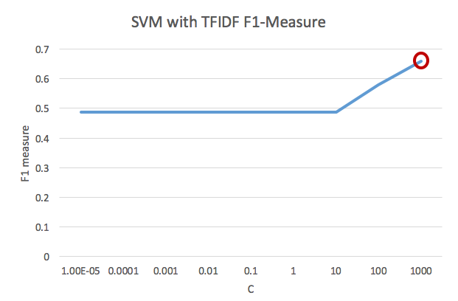

**Figure 11.** SVM with TFIDF parameter tuning results.

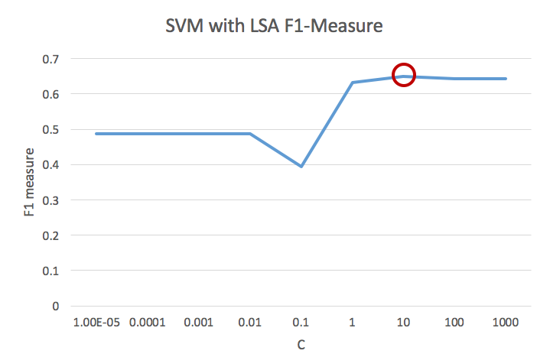

**Figure 12.** SVM with LSA parameter tuning results.

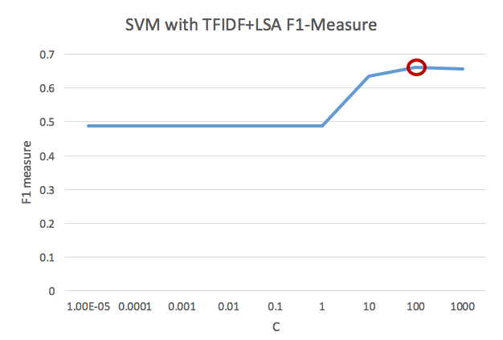

**Figure 13.** SVM with TFIDF+LSA parameter tuning results.

## Screen Shot 2017-05-17 at 9.37.30 PM.png

**Figure 14.** SVM with LSA+TFIDF parameter tuning results.

## **4.3 Classifier Evaluation and Results**

Much care was devoted to deciding which measure should be used for evaluating the classifiers and choosing the most fit for opioid abuser classification. The classic precision/recall paradox was once again encountered. On one hand, the purpose of this classifier was to ensure that non-users do not appear in the network graph. As such, perhaps a high precision would be desired (small false positives). On the other hand, submissions from opioid abusers are relatively sparse; thus, passing over several positive examples could be harmful. Therefore, perhaps a high recall would be more desirable (small false negatives). Ultimately, the decision was to select F1-measure as the deciding factor, due to its inherent balancing of precision and recall. In total, however, four metrics were calculated; figures corresponding to accuracy, precision, and recall can be found in Appendix A.

The values found in Table 4 below were calculated with 3-fold cross validation, using the optimal parameter for each prospective classifier. The accuracy values in particular indicate results superior to random guessing, which would yield a 50% accuracy. As such, we can assume that any of these classifiers will be sufficient in extracting opioid abusers from Reddit data. It is important to note that the code produces new, randomly generated folds each time it is called. Therefore, repeating these experiments will result in similar values, though potentially not identical numbers.

**Table 4.** Model comparison with optimal parameters across all metrics.

|  |  |  |  |  |  |  |  |
| --- | --- | --- | --- | --- | --- | --- | --- |
|  | TFIDF | LSA | | TFIDF+LSA | | LSA+TFIDF | |
| **KNN**  Accuracy | 0.56 | | 0.63 | | 0.57 | | 0.74 |
| Precision | 0.53 | | 0.58 | | 0.54 | | 0.67 |
| Recall | 0.91 | | 0.81 | | 0.90 | | 0.67 |
| F1-measure | 0.67 | | 0.68 | | 0.68 | | 0.67 |
| **RF**  Accuracy | 0.95 | | 0.94 | | 0.94 | | 0.85 |
| Precision | 0.99 | | 0.94 | | 0.94 | | 0.79 |
| Recall | 0.49 | | 0.51 | | 0.51 | | 0.57 |
| F1-measure | 0.65 | | 0.66 | | 0.66 | | 0.66 |
| **SVM**  Accuracy | 0.95 | | 0.94 | | 0.96 | | 0.88 |
| Precision | 0.97 | | 0.99 | | 0.98 | | 0.84 |
| Recall | 0.50 | | 0.48 | | 0.50 | | 0.55 |
| F1-measure | 0.67 | | 0.65 | | 0.66 | | 0.66 |

Observing the data above, it is clear that all models have very comparable F1-measures. Furthermore, nearly all KNN implementations struggle in the precision category and excel in recall. Random Forest and Support Vector Machine, on the other hand, do not suffer this same problem, actually significantly outperforming in precision. Both RF and SVM also display superior accuracies to KNN. Ultimately, it was determined that Random Forest with LSA+TFIDF was best fit to classify submissions into “opioid abuser” and “nonuser” classes due to its high accuracy, while still attempting to balance between precision and recall. The remainder of the paper will be referring to the RF with LSA+TFIDF implementation.

The next logical question becomes, “Why do SVM and RF demonstrate such larger precisions and accuracies in comparison to KNN?” The answer lies in the nature of the data. After observing some of the false positives that KNN produced, resulting in such a low precision score, it became clear that the algorithm became distracted with unusual words that two posts had in common. For example, in a particular instance, one of the training data samples was a review of a product by an opioid abuser using the words “star wars” due to the fact that the heroin product was named after the iconic movie. In the same experiment, one of the testing samples was submission from a non-user discussing the actual movie. The classifier determined the testing sample to be an opioid abuser due to the rarity of the use of “star wars” in submissions. It is clear, however, that a comment about the movie is not an indication of opioid abuse.

Random Forest, on the other hand, excels in detecting the natural determinant value within a single feature. For example, RF may notice that submissions that use the term “dope” once are less likely to be from an opioid abuser (think the sentence “I had a dope time at the concert”). If the word “dope” is used more than once, however, RF may determine that is an indication of opioid abuse (think using “dope” to represent drugs as opposed to meaning “great”). Due to this strength of Random Forest, the algorithm is able to decrease the number of false positives, thus improving precision.

## **4.4 Social Network Extraction**

The final part of the project was to graph a network involving active users of opioid to represent the interactions between the users on Reddit visually. This entire task was divided into two components: crawling reddit to gather submissions and comments and selectively adding the authors of these submissions and comments to the network graph, and graphing the network. The strategy used for network extraction was the following: Since it was meant to be a representation of the interactions between users, the submissions of subreddits and their comments were targeted. A set of subreddits were crawled and a specified number of the top submissions from these subreddits were read and classified. This number was selected as 50, but it can be changed to read more submissions.

For gathering submissions, 10 subreddits were considered. These subreddits were selected based on the title of the subreddits and the type of content and discussions posted on them. Since, the objective of the project was to identify and classify opioid users, the subreddits selected were related to the use of and/or measures taken against drugs. Following were the subreddits considered: Rehabilitation, Weed_Drugs, opiates, OpioidEpidemic, SubstanceAbuseHelp, drugrehabcenters, drugs, Addiction, TeenageDrugs, DrugNerds

Some of these subreddits, as their names suggest are focussed discussion groups for active users of drugs. But some others are not directly for drug users, but for discussions about how to come out of drug addiction, preventive and curative methods taken to avoid substance abuse, and people seeking rehabilitation. Because of this, we encountered a lot of posts that were not posted by drug users, but by medical professionals or therapists, to help people get out of the drug abuse problem. We used PRAW: Python Reddit API Wrapper for crawling through subreddits and their submissions.

The objective of data crawling, was to gather users that would be nodes in the network graph, and determine the pairs of users between which there would be edges signifying interactions

The submissions from the selected subreddits were gathered and sent as input to the classifier. The authors of the submissions that were classified as a posting of an abuser were extracted and stored. For the classified submissions, all the comments were iteratively crawled and classified as well. The assumption made here was that, the comments of the submissions posted by active opioid users, will lead us to more opioid users. The comment text was iteratively sent as inputs to the classifier as well. The comment authors that were classified as posting of an active user were extracted and stored in a list that was given as a value to a dictionary that stored the submission author and all it’s corresponding comment authors as key value pairs.

At the end of this, we had a key value list of users where, the keys were the names of classified submission authors and the value was a list of classified comment authors corresponding to each submission author. This dictionary was given as an input to the network graphing module

In the context of network graphing, we can consider the submission authors as the primary users to be plotted, and the comment authors as the secondary users to be plotted in the graph, since they were considered in relation to the submission authors. Care was taken to ensure that all the primary submission authors were considered only once, across all submissions and across all subreddits. Thus, the list of comment authors associated with each submission authors represent the interaction of the primary user with users in all submissions and all subreddits under consideration.

## **4.5 Network Graphing**

Network graphing can be a very powerful tool in case of large datasets gathered from social media, to understand the relationships, dependencies and interactions of different entities involved. It gives a holistic understanding of the data and the underlying network from where the data is extracted.

We considered reddit data for this project to classify redditors as active opioid users and non users. A lot can be deciphered from the network of opioid using redditors and their interactions between each other. Our aim was to extract these interactions of users with each other and plot a graph based on that, to represent visually the frequency and intensity of drug related discussions on reddit between abusers. Initially, our goal was to extract the follower structure of reddit to see how many followers of an active opioid user are also active opioid users themselves. But, due to the restriction of the reddit API of not allowing extraction of follower list of any other account other than your own, the strategy was changed to extracting the interaction structure on the selected subreddits.

The tool used for network graphing was NetworkX. It can be imported and used as a python module, which was one of the main advantages, as our base development language used was python. NetworkX is a powerful tool that allows the plotting and storage of network graphs in many formats. It accepts any hashable object as nodes to the network, that makes it very flexible to work with. In addition to this, the nodes and edges in the graphs can have attributes that they can be identified with. There are several layouts in which the graph can be plotted like circular, random, shell, spring, spectral. We used the random layout to display the extracted network graph. There are multiple graph types that can be plotted using NetworkX, depending on whether the edges are directed or undirected and whether a pair of nodes can have multiple edges between them. The types of graphs that can be plotted are: graph, digraph, multigraph and multidigraph. We have used the basic graph that has undirected edges and ignores multiple edges between a pair of nodes. i.e. two nodes have at most one edge between them. We used matplotlib to plot the graph. It can also be used to save the generated graph on disk.

The input provided to the network graphing module was a dictionary with the classified users. The key was all the submission authors classified as active opioid users and the value was a list of comment authors corresponding to that submission author, that were classified as active opioid users. The strategy used for network graphing was as follows: all the submission authors were first added as independent nodes to the graph. Then the list for each user was traversed to get the comment authors that were also added as nodes. An edge was constructed between a submission author and each of the associated comment authors. Finally, the graph was plot using the random layout.

Currently, the plotted graph gives a meshwork of users with edges between them signifying their interaction on reddit, that is opioid related. All the users shown in the graph are classified as active opioid users by our classifier. Also, the submission authors added as the initial nodes in the graph are counted only once across all submissions of a subreddit and across all the subreddits considered, in order to avoid replication and cluttering the graph.

# **5 Results**

Initial entries of 152 users and 152 non-users were considered, using which a classifier was built to automate the screening of redditors into users and non users. The users were considered for the network graphing. The following is the network graph obtained after crawling through 276 number of submissions and comments, out of which 170 number of users were classified. The network plotted as result of this is shown in Figure 15 below:

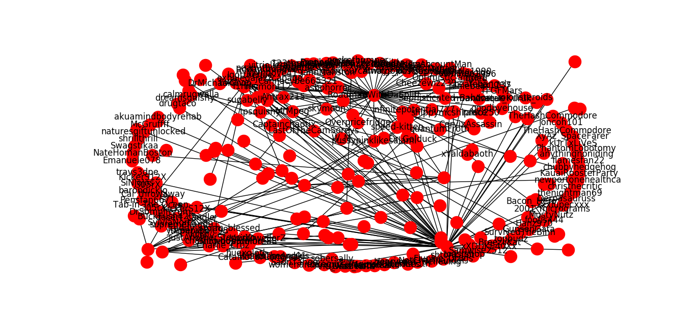

**Figure 15.** Network graph showing interactions between submission authors and their comment authors

The network graph was obtained after plotting the classified submission authors and their corresponding comment authors and their interactions. It is a dense graph, and it becomes denser with the increase in the count of subreddits considered and number of submissions crawled in each subreddit. A 3-D view or a more sophisticated representation using other graphing packages would be more visually appealing for a graph that is plotted for a large number of submissions, comments and subreddits.

# **6 Conclusion**

In conclusion, our project was successfully able to crawl through several submissions in a selected number of subreddits, and identify the submission and their corresponding comment authors as active opioid users. Using these users as nodes, we plotted a network graph reflecting the interactions of active opioid users on reddit.

## **6.1 Future Work**

There are several areas that can be focused on to improve the existing system:

1. *Use the information retrieved from the network graph to make predictions*

A lot of inferences can be made from the network graph plotted from the interactions of drug users. If the same experiment is conducted multiple times for a larger number of subreddits, a pattern or frequency of connections can be determined. This inference will be instrumental in predicting opioid or other drug users based on their interactions with existing drug users

2.  *Subreddit subgraph*

The existing network graph can be improved and made more insightful by separating out the subgraphs for each subreddits. Using advanced graph plotting techniques, a graph of subgraphs can be created, by providing different colored nodes for subgraphs of different subreddits, and joining all of them to form a bigger graph. This will give more clarity about the interactions taking place in each subreddit, and inter subreddit interactions

3.  *Follower structure*

The strategy currently used for network graphing, is focussed on the discussions and interactions of drug users on reddit. This could be updated to reflect the follower structure as well. A lot could be said about the follower pattern for active drug users. It would help trace the influence network online in the context of substance abuse.

4. *Other social media platforms*

The same classification and network plotting idea could be extended to other social media platforms like twitter, facebook, etc. It would be interesting to see how differently the other social media graphs would be plotted. Different and unique features of each social media platform can be leveraged to gain for meaningful network graphs.

# **Appendix A:** Results using additional metrics for classifier evaluation

## KNN with TFIDF

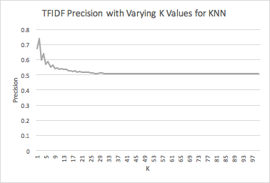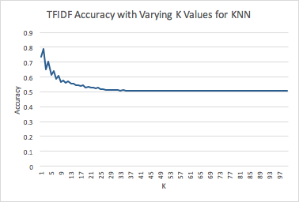

**Figure A.2.** KNN with TFIDF precision.

**Figure A.1.** KNN with TFIDF accuracy.

## 

**Figure A.3.** KNN with TFIDF recall.

## KNN with LSA

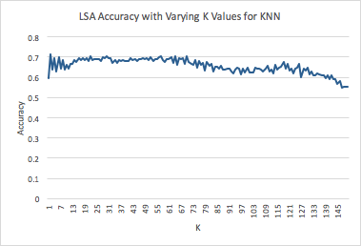

**Figure A.4.** KNN with LSA accuracy.

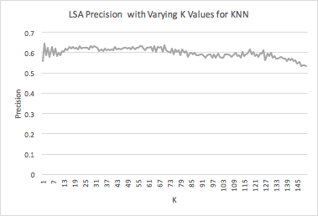

**Figure A.5.** KNN with LSA precision.

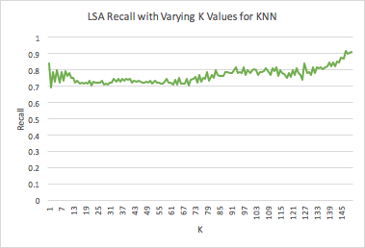

**Figure A.6.** KNN with LSA recall.

## 

## KNN with TFIDF + LSA

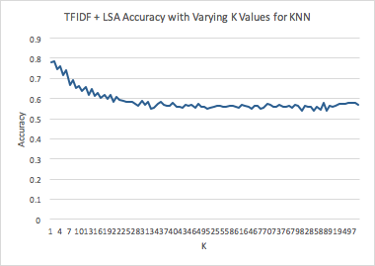

**Figure A.7.** KNN with TFIDF + LSA accuracy.

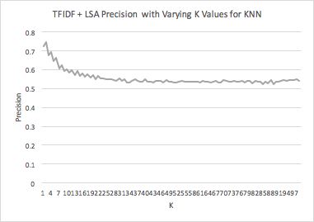

**Figure A.8.** KNN with TFIDF + LSA precision.

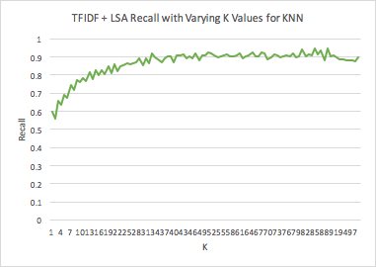

**Figure A.9.** KNN with TFIDF + LSA recall.

## KNN with LSA + TFIDF

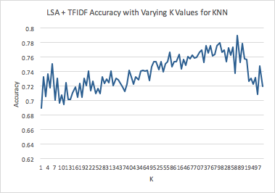

**Figure A.10.** KNN with LSA + TFDIF accuracy.

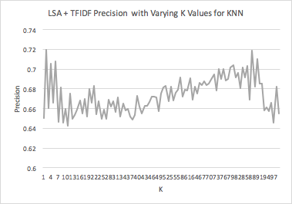

**Figure A.11.** KNN with LSA + TFDIF precision.

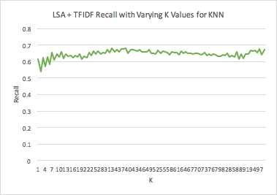

**Figure A.12.** KNN with LSA + TFDIF recall.

## RF with TFIDF

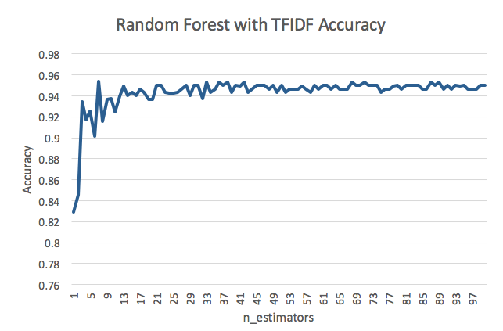

**Figure A.13.** RF with TFDIF accuracy.

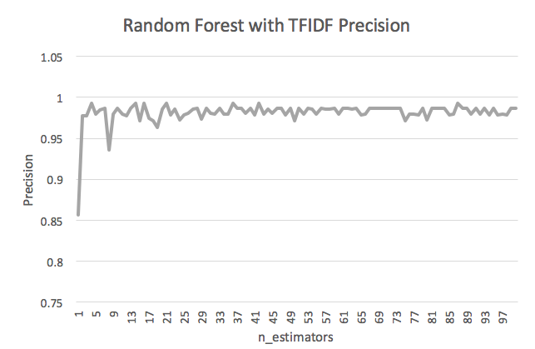

**Figure A.14.** RF with TFIDF precision.

## Screen Shot 2017-05-17 at 2.21.38 PM.png

**Figure A.15.** RF with TFIDF recall.

## 

## 

## 

## RF with LSA

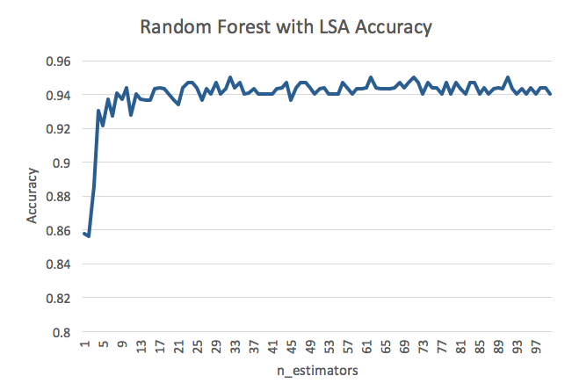

**Figure A.16.** RF with LSA accuracy.

## Screen Shot 2017-05-17 at 2.22.37 PM.png

## 

**Figure A.17.** RF with LSA precision.

## 

## 

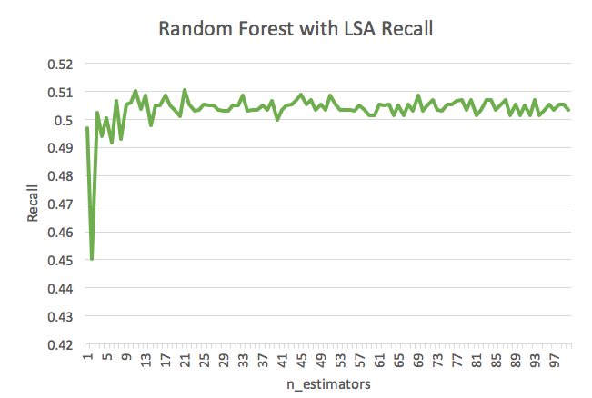

## 

**Figure A.18.** RF with LSA recall.

## RF with TFIDF + LSA

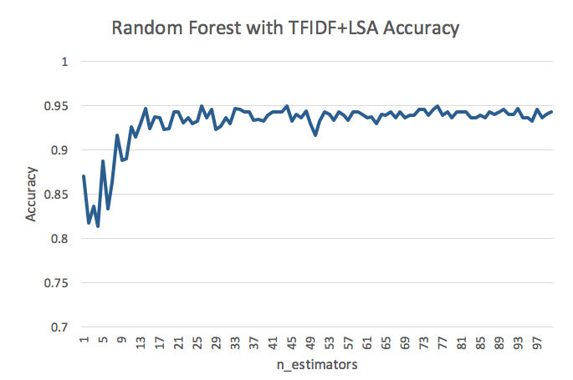

**Figure A.19.** RF with TFIDF+LSA accuracy.

## 

## Screen Shot 2017-05-17 at 5.47.04 PM.png

**Figure A.20.** RF with TFIDF+LSA precision.

## Screen Shot 2017-05-17 at 5.47.18 PM.png

**Figure A.21.** RF with TFIDF+LSA recall.

## 

## 

## RF with LSA + TFIDF

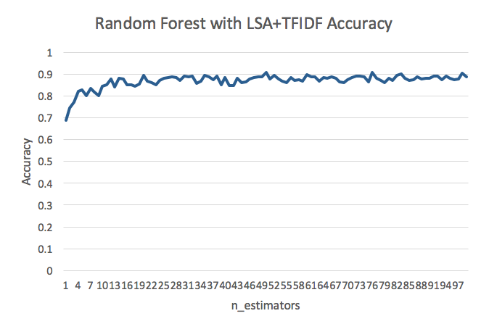

**Figure A.22.** RF with LSA+TFIDF accuracy.

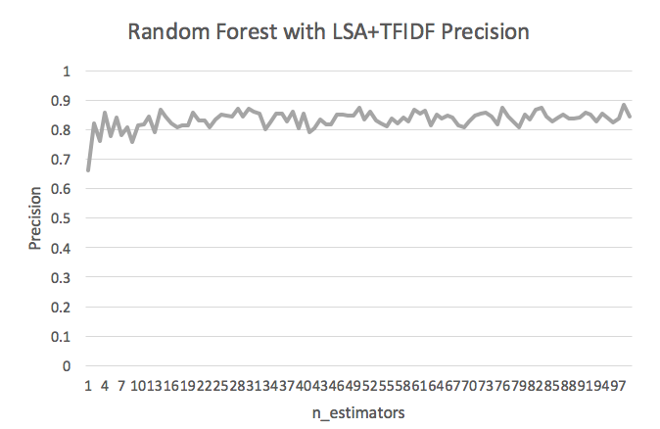

**Figure A.23.** RF with LSA+TFIDF precision.

## 

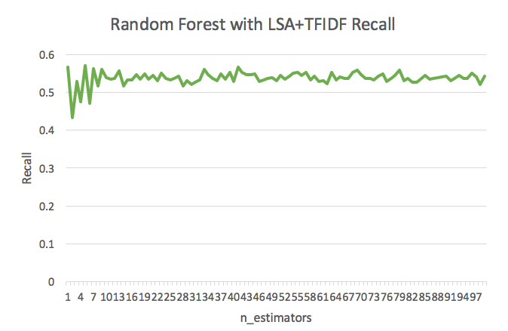

## 

**Figure A.24.** RF with LSA+TFIDF recall.

## 

## 

## 

## SVM with TFIDF

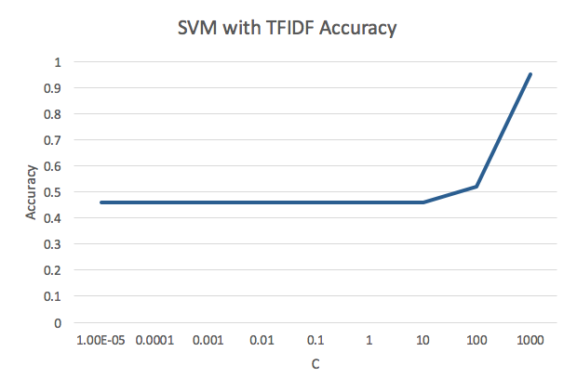

**Figure A.25.** SVM with TFIDF accuracy.

## Screen Shot 2017-05-17 at 9.33.18 PM.png

**Figure A.26.** SVM with TFIDF precision.

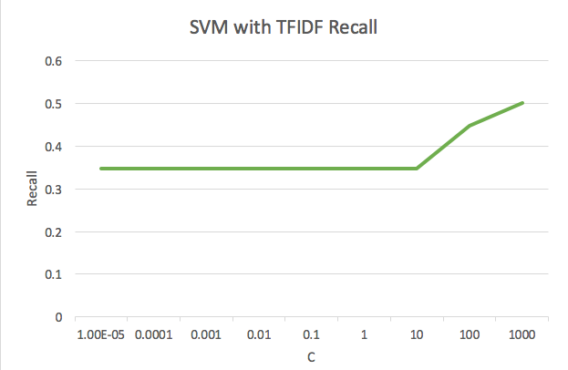

**Figure A.27.** SVM with TFIDF recall.

## 

## SVM with LSA

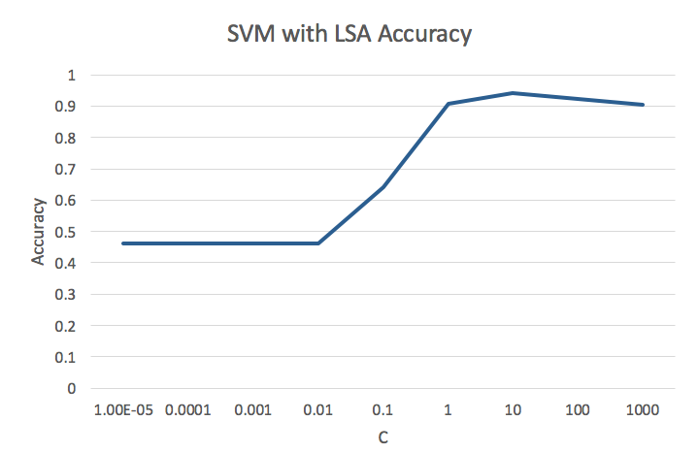

**Figure A.28.** SVM with LSA accuracy.

## Screen Shot 2017-05-17 at 9.34.35 PM.png

## 

**Figure A.29.** SVM with LSA precision.

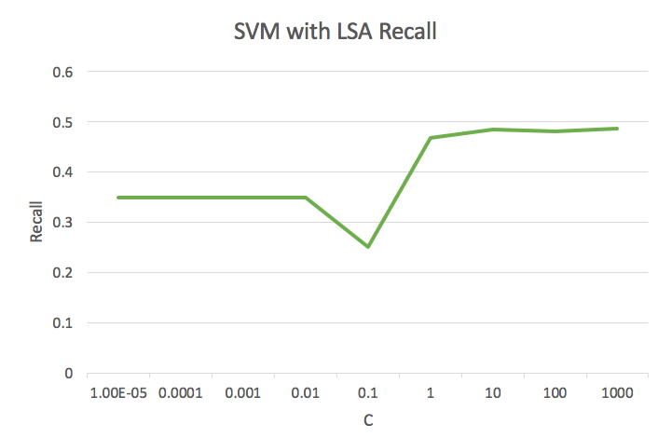

**Figure A.30.** SVM with LSA recall.

## 

## SVM with TFIDF + LSA

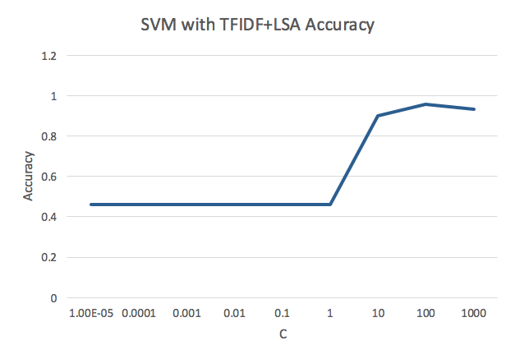

**Figure A.31.** SVM with TFIDF+LSA accuracy.

## 

## 

## Screen Shot 2017-05-17 at 9.35.46 PM.png

## 

**Figure A.32.** SVM with TFIDF+LSA precision.

## Screen Shot 2017-05-17 at 9.35.55 PM.png

**Figure A.33.** SVM with TFIDF+LSA recall.

## 

## 

## 

## SVM with LSA + TFIDF

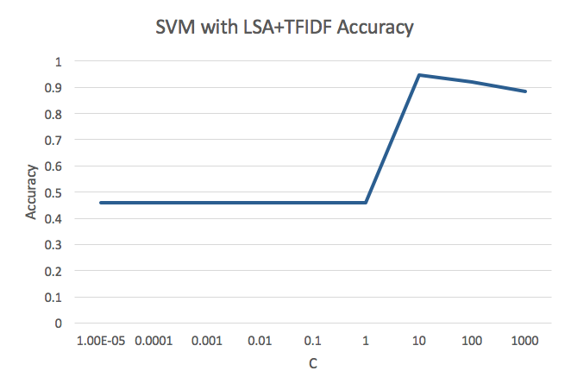

**Figure A.34.** SVM with LSA+TFIDF accuracy.

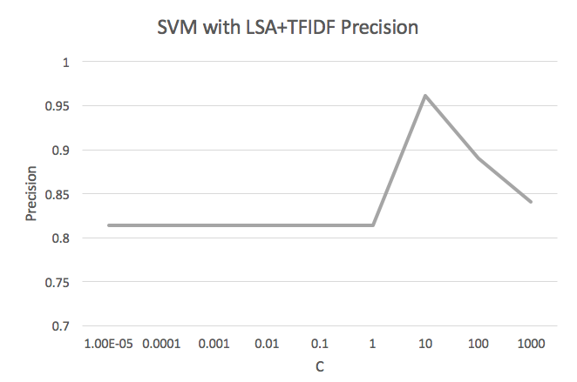

# 

**Figure A.35.** SVM with LSA+TFIDF precision.

# Screen Shot 2017-05-17 at 9.37.58 PM.png

**Figure A.36.** SVM with LSA+TFIDF recall.

# **Appendix B:** Training Datasets

## “Opioid Abusers”

a+ Haven't had anything but fetty, fetty analogs and research chemicals for a minute here. It's been bullshit lately. Got some Red and Black A+ and it's REAL D. Got me well and has some legs on it too. Good stuff. Found it out East. Finally pgh has some read D and not just some fake stuff that lasts for an hour, gets you super sick and is so weird or strong that suboxone won't even help sometimes. Watch out for these kids hustling fent and who knows what else. A+

rolex 412 Aiight, so I got these black label with a crown and says Rolex. Imo. They're not even dope, or fet. Some sort of rc.. I smoke and snort my shit. Smoke tastes God awful and I usually enjoy the taste. Sniff, normal burn but made my friend sneeze every single hit. High is nothing like opies.. Just stay away from these. I ended up throwing away 5 bags. Monroe area just sayin.. Wish my dude was a better business man...

412 Creed red print 0 fake shit and red Pepsi same print as the last ones that where in the city but some one put some bull shit in them bags and is trying to get sales off of the old names saying it's the same thing but we know that's not true don't waste your money you will be pissed

973 paterson 1st ward "amazing race" black stamp ~ warning not dope Got stuck with 2 buns of this bullshit...I wouldn't even rate it a 1...not dope, not RC's, not fent...a complete waste of $60. However this bs got me pissed off enough to venture over to the 4th Ward and got some decent stuff...review to come shortly

blue magic & red lobster 973/609 3/10 BLUE MAGIC blue stamp white bag disappointing; 2/10 Red Lobster even more disappointing red stamp white bag... what the fuck man... fuck me.

free el chappo. rainbow stamp patterson (fire) Just copped 3 more movies!! The stamps called "free El chappo" and Thier is no picture just the words stamped I in rainbow colored ink. The quantity is above average like a 6.5 but the quality is awesome like a true 7.5 in my opinion. This is the best shit I have gotten in recent memory I almost never use the word fire but these qualify as fire and I will keep stocking up long as I can. If u see these get them!!! They b up the hill!! Happy Hunting!!! I usually do like a bun of good shit just to feel good and if I get a nod off a bun I consider it top notch but I b drueling off like 5-6 bag of this. B very careful, if u shoot u should do small test shot to see how u like it. Thier has been like a dozen over doses in and around the 973 in last few weeks please everyone b careful!!!!! Let me know if u guys like it as much as I do?!?!?!?!?

412 Strong man red ink fetty they are small and no legs I would say a 2.5/3 will get you off sick if you do enough but I wouldn't buy again!

rocky and first aid Rocky- A solid 6. Nothing crazy but definitely got the job done and more with a normal dose. First Aid (Skull and Crossbones)- 5, again did the job well but not quite as good as the rocky stamps.

bangman purple stamp 973 ptown I got it yesterday from and old connect up the hill by putnum and it's was actually pretty good. I have a very high tolerance and I still got a really good rush everytime i shot and nodded no prob so I rate it 6.5

412 final four blue stamp I got more of them final four I think there two maybe three different batches going around I had ones that were d and then I got some more and they were brown like d with a fetty taste they got me right but I felt like shit the next morning I just got more and they are tan with sparkles threw them they got a fetty taste and made me feel good I would say that this batch is the better one over the last two times I got these

several Black preprint Cobras-garbage I don't even think it's dope 0/10 White no names- fetty not very strong but will do the job 3.5/10 Blue bag red Jaguar stamp- garbage it's d but barely 1/10 Small white bag preprint Spartan helmet or something- eh soso I guess if u do enough ull get high but maybe a 3 or 4/10 Where is all the good ones? I was gettin masters and diesel mans for the longest now all I can find is shit I need HELP!!!

gucci 973/609 6/10 GUCCI from Newark, blue stamp w/ symbol and text on white bag. I've shot 5 bags over the course of the day so far and feel pretty damn good. Nice rush, decent legs and mixes up nice clear golden brown.

412 Green hello - 4.5/5/10 nothing special wouldn't look for them but if there all that's around they'll get job done. Size 5/10 legs 4/10 Blue frank Lucas-6/10 good d. I'd be happy getting these any day size 5/10 legs 6/10 Blue get outs-2/10 sucked wouldn't reccomend at all. Size 2/10 very small no legs. All around shitty d Green diesel pre print -0/10 not even d idk what it is. Gave a bunch of us cotton fever. AVOID. Small white bags with black / green star - 6.5/10 good rush 7/10 size very fat nice legs 6/10 but it's sparkly and leaves behind dark nasty cut. Green hitmans - 6.5/10 good d almost same as blue feraris. Nice size 6/10 legs 7/10. Seek em out if ya can. Blue feraris - best I've had n a while 6.5-7/10 deffly recommend these. Size 7/10 fat dips. Legs 6/10 Blue hits - 4/10 not the best but get job done. Size regular 412 dips 5/10 legs 3/10 not the best but they work. Don't like them myself Blue camaro's - 5/10 dark d. Size 5/10 legs 6/10 all around decent dips. Red get outs - 5/10 decent dark d. Size 4/10 legs 6/10. All within last 3-4 weeks. Feraris and hitmans and stars are most recent. From last few days.

frank lucas Good dope 7/10

several Power (green) with money sign in a bill - 5.5/6 better than most of the ones I've had recently Warning we are back (blue) - they were good at the beginning then got better now they are just ok. Either there is 2 different batches or they stomped the fuck outta them. When they got better they were light. Now they are dark and cloudy and smell like vitamins. The legs are good regardless but the high is definitely weaker with the dark ones. So I don't know how to even rate. I liked them better than the power or at least the same as the power til this new darker batch came thru. Red bulls (red) - same as the warnings. Were good then better now OK. Stomped on too I guess. Anyone else getting the warnings and red bulls ?

relish and dusse These are another new name for the 3 folds. There fent pretty good compared to anything else that I've been getting. This is always my go to shit wen there's no other fire fent around just because they've been consistent at least I know what I'm getting. Same as the uggs.

back on track, ny jets, kiss me, good mood, tmt the money team Snort and Plug, 3 is disappointing, 9 is fire, perfect range is 7 to 8, in my rating system. Been doing for 3 years, like fetty and d mixes. Back on Track, black w railroad pic- solid 6.5 really good imo, definitely a mixture. My friend who shoots didn't like them nearly as much as I did. Great legs, okay kick NY Jets, red- solid 6, mixture of old school d, okay kick and legs Kiss Me, red- fetty, disappointing, small bags, no legs at all, no euphoria, solid for getting off sick 4/10. Good Mood, turquoise- plain d, nothing special, average, 5 TMT The Money Team, blue- similar to Back on Track, mixture of a bunch of shit, maybe d and pills, loved it, great kick and legs, 7 imo. Again, my girl said that shooters didn't like it as much as snorters. Snorted and plugged all of these with snort giving more kick, plug giving legs. Be safe!

ugg 412 3 folds like the freebandz and cobras...not as good IMO but I don't know of much else better. They're purple

pablo escobar and lexus 973 These are the best I have had recently. I give them a7/10. Nice rush and legs.

973 ptown -blue- "roc a fella" & -blue- "miracle watts" Copped the Roc A fella from a newer but quickly becoming my steady and main connect. Grabbed both stamps down the hill, 1st ward area. Also both myself and my wife sniff, that might affect my opionion on particular stamps. Roc A fella was was some real solid stuff, definitely the best I've gotten out there in about a week. I'd give it a 6 on count & quality, but def a 7 for legs. Lasted over 24hrs without having to do more. Haven't been able to do that since the bags this time last year with the extra fold Miracle watts was about on par with the other stuff I'd been copping not horrible, but nothing special either. I'd give this one a solid 5 all around Be safe out there guys and let's keep the ptown info flowing

609 white magic White Magic white bags with green print all d no fent I give it a 6.5 decent sized bags

best buy, dab lords, and dead presidents Okay I sniff and smoke so take my review as you will. best buys were purple with the best buy tag logo. Decent size, medium strength high, nice legs. Wouldn't seek them out but they were good. Dead presidents, again purple stamp. Fat bags, good high and short legs. Would definitely get them again. Dab lords, another purple stamp. Okay size, strong high, great legs. Definitely seek those ones out. Best of the bags I've been getting the past 3 weeks. All those were diesel definitely worth it. Also got some preprints with "Indian chief" Indian being misspelled, fetty bags decent but not great. Short high, low strength for fett definitely wouldn't buy again.

money power 412 Green stamp that says money and has a picture of a dollar. Some decent dope brown mixes clear. Nice legs and decent rush. I'd say this is your standard dope. 6/10 best stuff my dude came through with in awhile since hes been fucking slipping. Go pens

nino brown 7/10 pretty good shit from Newark. Looking forward to doing more tmoro with less sub in my system. White bag, blue stamp, decent size, mixes up real nice: clear golden brown.

973 ptown- red 2017 Really, really good. Long legs 8/10 id say. Strength probably 7.5-8/10 as well. Overall really solid. Better then alot going around right now in my experience. avoid orange 2017, top secret/killa season/tight theyre all the same shit and are trash.

973 top secret and tunnel vision. Ptown Top secret 8 quantity, 5 quality Tunnel vision 5 quantity 7 quality

green jaguar 412 do not fuck with these. they coagulate instantly and when i tried to cook them they literally bubbled up into like a foam? never seen anything like that. they clog your rig. there is some sort of high but totally not worth it. 2/10

973 ptown TIGHT blue letters in the rectangular shaped bags Quantity 6 Quality 8 fucking nodding off two bags snorting

412 Purple penguins. Colored bands untaped and fire..also nice size for fbags..

973 ptown blue - "fight night" & red "made in mexico" Haven't posted in a minute...shits been really mediocre at best. Got a new connect, from the same area (Down the Hill / by the main / 1st ward) anyway nothing to get excited about the fight was crap, 4.0 overall, got me off E, but found myself back there in about 10hrs...pretty crazy to be sick again after doing 15 bags, the bun I saved for the next day lasted even less. Made in Mexico red stamp was better, be still just eh...I'd give it a 4.5-5.0...at least a bun would hold me for 12-14hrs...I really feel like for someone who only sniffs and has never shot I should be lasting good longer...I remember last summer getting the bags that were folded an extra time and were such fire that a bun would last me and my wife 24hrs Where tf is the good dope at in Paterson???....I went over to the 4th and got more crap with a bun of definite fake stuff mixed in...like Gatorade mix, not even dope at all....good luck out there guys and let's get some more jersey reviews going, be safe

warning we are backs man my connects are slipping. theyve been bring me bullshit. these warnings are the best around and thats saying nothing. got some red stars that were garbage. white powder that dont mix up and clog your shit. did a bun of those and nothing. red bulls which dont do shit. getting pissed wasting my money

soul survivors 412 so my dude had me try these. soul survivor stamp with a skull with a eye patch above it. its blue with black detail in the skull. never seen two colors stamps like this tone of detail. look really cool. the stuff mixes clear but has a darker brown color. i only did 4 but noticed a rush and a nice high. im gonna get more and give them a full test. i give them a 5

973 feel the high Ptown bags. Blue lettering stamp feel the high. Quantity 6 Quality 7 Feel the high is about the same quality as Killa season. Less quantity for sure. Still decent quantity for ptown bags.

lyft and nino brown from 973 Lyft: white bag, taped with red LYFT + Face stamp; rating 5 overall they were better a few weeks ago @ 6.5-7; more cut this time around and smaller bags. I had posted on these before but couldn't read the stamp the first time around. Nino Brown: white bag blue NINO BROWN + Face stamp; rating 7 overall... nice nice D mixes clean rich golden brown and bags decent size... i was shoting 2 bags at a time and felt lovely. you know it's good shit when you puke and it's a pleasurable experience. dude has some now but i've already blown through my whole paycheck... fuuuuck 973 has way better quality than whats going around here in 609.. best shit I've had around here was some "raw" unstamped bags that came from camden lately... i'd rate that shit a 5 b/c my guy made the bags pretty fat. honestly most of the D I get in 609 is unstamped so it's hard to rate on here. haven't seen too many post from jersey lately hope everyone doing ok.

412 Blue a+ good fetty some the better ive had.. Solid 6.... Better than red a+ bigger too.. Be careful out there people... Alot of ppl odinf these dayz rwg my dude cyu on the other side homie..

red stamp that say vietnam with two guns on top of the text i like the fetty and i sniff i really didn't like them they are d they have that bitter taste like good d has i wouldn't buy again just cause i like fetty and d just doesn't do it for me but they got me off sick

412. money gang / warning we are back got these money gangs. dude is telling me how good they are. cop them and they are a 3 maybe a 4. no rush. mixes clear. def no fent. told my dude im not a fan and he thinks im lying to him, but im like for what. im not asking for anything just giving my feedback. annoying as fuck trying to find anything worth while lately. The Warnings are def better. Dope that mixes mostly clear. Can get a rush iff you do a little extra. Legs are alright. I give them around a high 4.

412 Red and white gold rush. Fiiire best since indian cheif and big doodles but longer legs. these my favs.. Oh btw they arent taped and please use caution when doing they are a good size if u have a pretty high tollerance do 1 low tolerance half a bag.. If u have extremely high tolerance u can probably handle 2.. All the while be careful..

973 ptown Killa Season purple stamp. 8 quantity for ptown bags. 7 quality. Top Secret blue stamp. 7 quantity 6 for quality.

412 I know we use this thread to review different bags and things of that nature but something that goes hand and hand with bags are zanny bars at least with the people I deal with! Just to let people know that there are a few fake zanny going around there are fake green bars and there are also the ones that say mylan a4 these pills look perfect no defects at all just letting you guys know if you buy them make shore you get them off some one reliable!! They are A1 fakes best I ever seen these are coming from the north side so just keep your eyes open

724 young money blue stamp Had to go through someone that I usually don't mess with but it seems like all my people are either not around or phones off. They had young money written on them and then a big y and m symbol. Would rate them a 6.5, thought they were better than a lot of stuff around here lately. Size varied though some were average and some were pretty small but would def recommend

973 ptown I know this site is pretty much dead to 973 unfortunately but here ya go. HBO - red = 6 Outlaws - blue = 5.5-6 Ghetto dope -blue. =6-6.5 Cartier - blue. ==. 4.5-5 That's it in last week.

light blue bags 412 Light blue bags no tape no name on them don't even try them if some how you do get them smell the bags they have this strange smell like perfume or something they are some type or fetty or maybe not I just think someone is trying to push these if they didn't have this smell to them that you can't miss your smell it!! it has like a car scent to it I have no clue what this shit is I grabbed some but cant give a review just for the simple fact you got to be crazy so sniff it your better off sniffing glue!!!

724 Red CREED fire Fetty 6.5 with legs!! Been high for hours now!!

dead presidents green stamp 315 area 6.5/10 - Pretty good rush that gives me pins and needles when I do my normal 3 bag shot. The count could definitely be a lot better though as some bags were pretty undersized. The legs were quite good as it will keep the first signs of sickness at bay for 9-12 hours. All in all I'd definitely recommend these Dead Presidents with tthe light/bright green stamp.

412- red lambos, blue nike's n red louis v's The Red Lambos are about a 4/10. Not ANYTHING SPECIAL but if they are all u can get, I WOULD DEF GRAB THEM. Next up, the Blue Nike's. 5.5-6/10 All Day. U come across them grab em. U WON'T B Disappointed at all. A FEW of my get high buddies ACTUALLY SEEK these out. Then last but not LEAST, the Red Louis V's. 6/10 Out of all 3 of the diff bags I've been doing, these are the best. Big bags, strong rush n long legs. Also, ALL of these bags are DOPE !!! NOT THAT FAKE ASS BULL SHIT FETTY that a lot of u guys have been DOING. N what BLOWS MY FUKIN MIND, is that the BULL SHIT u guys are callin FETTY is some CHEAP ASS FETTY ANALOGUE RC that NO 1 REALLY KNOWS what it even is. B/c I DONT KNOW IF ANY of u fellow addicts EVEN REALIZE this, but real FETTY HCL is about $1000 bux a gram n EVERYONE WOULD B OD'in LIKE CRAZY !! Real FETTY HCL is da shit in the old Gel Patches or the shit in the New BULL SHIT patches that u have to extract. Its da shit that is MEASURED IN MICRO GRAMS !! NOT EVEN MILLIGRAMS. N the only REASON these Dope boys are even taking the SERIOUS CHANCE of selling FETTY is b/c it's really considered to b the CRACK of the OPIATE/OPIOID world. U just get a quick INTENSE RUSH n that's all. N if ur only doing FETTY Analogues it makes ur TOLERANCE FUKIN SKYROCKET !!! N then u have 2 re-dose 3-5 times a day, JUST SO UR NOT DOPE SIK. I was in Re-hab with a nurse who was HEAVILY ADDICTED to Real FETTY HCL n she would HAVE 2 GO 2 SLEEP with a FETTY patch in her mouth just so she wouldn't wake up Dope Sik in da Mid of the Night !! Could u FUKIN IMAGINE DAT !! N THE ABSOLUTE CRAZIEST thing the nurse told me about her FETTY use n addiction was that the Re-hab facility she was in, had a Detox. But they LITTERALLY had 2 send her 2 a REAL HOSPITAL with a REAL ER n CRUCIAL CARE UNIT n they HAD 2 PUT HER INTO A MEDICALLY INDUCED COMA b/c she was so FUKIN DOPE SIK with such a high tolerance that that was the BEST n ONLY HUMANE thing that they could do 4 her. B/c NONE of the Detox Meds would even touch her. So the MORAL of MY LONG ASS RANT IS, KEEP FUKIN WITH THIS FAKE ASS JUNK WANNA B FETTY n your gonna END UP in DEATHS CREEK n DETOX RIVER with NO PATTLEZ , NO BOAT, NO LIFE JACKETZ n NOT EVEN ANY FUKIN DETOX MEDS that can help. TL;DR- DONT DO/SEEK out these FAKE ASS FETTY analogues that aren't GONNA DO NOTHING VUT make ur TOLERANCE FUKIN Crazy, Make u OD or just MAKE U have 2 cop 2-3 more times than u would have 2 if you were doin GOOD OL HEROIN. STAY SAFE n GO 2 THE FUKIN NEEDLE EXCHANGE at da Health Department on Sunday between 12pm-3pm n GET SOME FUKIN NARCAN !!!! I fell out, left da hospital AMA n they gave me 2 DOSES of Narcan 2 leave with. I got home, got high n FELL DA FUK OUT !!!! THANK GOD MY WIFEY/SON's Mother was with me n I HAD DA FUKIN NARCAN !!!! IT SAVED MY LIFE !! ITS FREE from da Needle Exchange n it just might SAVE UR LIFE or the LIFE of a LOVED 1 !!! IF ANY1 DOESN'T KNOW WHERE the NEEDLE EXCHANGE is at or just doesn't wanna go by themselves, hit me up with a PM n ID B SO GLAD TO HELP !!!!

green line (609) all d no fent Green line some of the best and cleanest d I ever did you don't even need cotton to suck it up I would give it a 7/7/7 long sexy legs

412...big doodle...fent Strange name but deffinately awesome fent. Where I usually do between 3 and 6 bags of most fent depending on how strong it is, with these I only need 2 and I would deffinately even be more than good doing a little less. Be careful if u don't usually do fent bags. Stay safe out there...

bulldog--in the 412 grabbed these last night cause my guy with the glocks wasn't around. Bull dog stamp says bulldog with a picture of a, you guessed it, bulldog. all around, they're a solid 6. the rush was great, and they had decent legs. bags were average in size. I liked these a touch better than the glocks, however, it could be cause Im used to the glocks. I enjoyed them, and would probably seek them out again. wasn't sure if I was straight d, or a d and fent mix. stay safe my friends.

412 ak47 and redbull Blue AK-47 - tan dope mixes up slightly milky with a golden brownish color and draws up like apple juice if u put a little heat to them to thin it out. Same quality as the glocks if you've had the blue glocks just a tad darker. Bags are small as hell tho. Been doing mixes so can't really say to much for the legs plus I get a 30 sec rush n my buzz is gone but they hold me off for a few hours without any cravings. Quality 5, size 3, legs 5. Overall decent dips I wouldn't go looking for them but I'm not unhappy about getting them there standard d for what's going around 412 right now. Red red bulls - trash I don't get anything from then. 2/10. Most of my people say there ok or weak and one that smokes them says there fire he loves them. No rush no legs size is ok there not fat but not small. There's fat ones in there. Don't fuck with these. Has anyone heard of blue Dolphins ? What's the best ones going around in 412 right now that are worth looking for n hunting down ?

fire ball/bentley/sammy soda 609 Sorry it's been a while. Times been a little rough. Fire Ball: Blue stamp double seal. Overall 5/10 decent rush, good legs. Middle of the road d. Bentley: Green stamp, Double seal. Overall 3/10 Almost no rush, enough to get you right but no high. 5/10 on legs. Again no high but will get you through your day. Avoid this stamp. Sammy Sosa: Green stamp, Double seal. Overall 7.5/10. Great rush, great legs. Good old fashioned d. Maybe it's the recent run of ehh shit but either way if it's around I'd grab it. I made sure to grab enough for this storm. Everyone stay safe out there. P.s. It is Sammy Sosa I fucked up in the title to the post. My mobile device auto corrected it to soda. That's my story and I'm sticking to it lol....

724 green $ preprint (r) This is by far the best I've had in a long time. Legs 7- 7.5/ 10. Been a couple hours since I snorted less than my usual dose and I'm feeling great. Quality 8/10 fattest I've seen in a while Quality 8/10 finally found "paint chip" dope! I know that looks don't mean anything but it's a nice tan color, doesn't burn or taste funny when snorted. Overall 8/10 I don't believe there is anything that's 10/10 and 9/10 or me would be pure straight from the manufacturer. I usually snort at least 4 at a time and did one when I picked it up just to be safe and I felt pretty damn good off just one. Granted I wasn't sick. Hope everyone is having a good day and stay safe fam!

215 block party and antichrist Block party. (9)is a blend of D and sleepy cut. Be careful on methadone and was very strong esp. On 2nd slice. Be Careful! Antichirist (8) real dark. real bitter. Real Deisel. Not to noddy like block party has good legs.

plane bags untapped 412 plan white bags untapped fetty 2/10 I don't care for fetty shit but it will get you straight ...has any one tried the walmarts that are out now?

412 another review Alright so after getting the fetty waps for a week/week and a half that I personally liked, at least my batch that I was getting was good. My main ran out of Fetty Wap jawns. So I got 2 new ones to review and im pretty sure these are replacing the Fetty's. So onto the first: 1) 100% Blue stamp. I really enjoyed these even after I pissed myself off on the first shot by missing it but that's a whole nother thing. But the rush on these were real nice id say there about a 5-5.5/10 quality wise. Onto the Size these were all average sized, none overly big none small so ill take It. Overall I enjoyed them and would definitely get them again. And by the way the legs on these were great. I didn't get another bun until about 36 hours after doing them on sunday and at that point I was just starting to sneeze so they held very well and I have a pretty sizeable habit of at least 2 buns a day. 2)Red Louis Vuitton with picture of the LV symbol above the words. So these were the newest out of them all. Just got them today. I grabbed my normal 2 buns for the day and got down to business. I really bv4 enjoyed the rush on these. From head to toe it hit me nice and strong just how we all like it. So onto the quality again good solid D, exactly what ive come to expect from my main dude and he doesnt disappoint. 5.5/10. Onto the size every single bag so far has been average to above average. Legs I can't comment on that yet but ill update later on. Overall if you hear about these 2 id grab them up. Both are good old solid D. No bullshit cut left behind they both mix up very well and have that nice d color. None of that bullshit fent either. These are both from an IV perspective

stranger danger (609) ac Pre stamp bags stranger danger straight garbage mix's up a dirty black color with a funny smell

412 black label, true religion, blood money theyve been comin in colored bags true religion green bag red stamp quantity 7 quality 7 really really like these mixed up dirty tho , blood money green bag red stamp quantity 6.5 quality 5 leaves alot of residue, black label blue bag black stamp, quantity 7 quality 6. all these were fat bags that the d just falls out n leaves no scraps might be cut with some fent

412 Mojo red preprint 5-6 good fetty

glock stamp is 'glock', with picture of a gun. both pic and lettering is blue. overall it a solid 5.5-6. count is a tad small, but legs are really good and rush is excellent. I'd say, everyday average to above average, diesel. I iv and 3 dips had me feeling fine and noddy. I would def grab again, and I will tomorrow, lol. stay safe friends.

973 red stamp white bag * unreadable I took a trip up to Newark from 609 to cop a brick with a friend of mine earlier this week. Red stamp with a face that looks like an alien head with blurred red text beneath it; it's unreadable... the dope was really nice tho size 7/10 legs 7/10 rush 7... this was the best shit I have had in a while... most of the shit out of 609 sucks it was really nice finally get my hands on something with legs... curious as to what the name is??

724 red shine pre-print Fetty once again. I wished these dam young dope boys wouldn't be so fucking dumb. I guess it's hard to expect better from these high school drop outs from the hood. Everything to these ducks is dope until 4-6 months after they catch a case and ghat shizzle gets back from the lab. If the Pennsylvania legislature ever passes sentence enhancements now, as they did in the 80's with crack, I bet these dumb ducks will either start being honest or at the very minimum make it their priority to know what the fuck they are selling. As a junkie, dope fiend or more politically correct, addict, I honestly hope they (the legislature) pass stringent enhancements, that make the 80's crack legislation look like serving peach cobbler to drug dealers, myself included. That way you can bet, heroin will work back to normal levels of availability. Anyway on with the review of Shine. Guaranteed exact same fentanyl that was in the bags I reviewed the other day. The King pre-print. Shine as well as The King pre-prints. 4.5-5 all the way around. It's fetty folks, just be careful. I have to say for fetty this shit holds more than one would think. Anyway stay safe.

412 red ysl, red star with smile face hands n feet, blue dorry, blue ladybug, preprint cobra - all fent preprint jackpot d YSL are the best at a 5.5. Rest are about a 5. Preprint jackpot is D and prob gets a 4 maybe 5 tops. There is another blue preprint that has the same stuff as the cobras and oldschools in it (grainy stuff).. might have been horsy or something like that. They were a 5 as well. These are all within past few days.

hot sauce and target I reviewed hot sauce a week ago, but I got the same named bag, with a different stamp. this time the bag is white, with blue lettering and it just has 'hot sauce' in regular letters. overall, I give it a 6.5. bags were fat, it has good legs (more than 24 hrs before sickness sets in), and a quality rush. definitely pick this up if you run across it, it is quality d in the 412. also, target bags with grey lettering. overall a solid 5. decent legs and rush, but the size is mehh. I would pick it up if hot sauce isn't around. it's still good d, just not filled as much and not the punch as hot sauce, but again worth picking up if d is your thing. stay safe friends.

the king - pre-print Straight fetty. I wouldn't insult anyone by rating this fucking garbage. I'll get you well fetty style. Let's call it a 4-4.5. Nothing special about these fucks, other than the lying ass nigga thing me its real dope. I would had known but I had a dumb fuck pick it up for me that don't know the difference. Let me emphatically state here that anyone that can't pick up a sack of shizzle and tell the difference between fetty and #4 ECP is a dumb Cocksucker or just plain old brain dead, unless it's a dark thick glassine that can't be seen through. If fact if you zany tell the difference, you ain't got no fucking business in the game.

(hat) 973 black ceasar? lemonade I have one of these and some other fire called Lemonade w euphoric stamp... i was told the black ceasar is fiya... just dont want to waste it by not topping off with other stamp... Id give the lemonade 6.5/10 nice count, but could cook up a little cleaner, other than that, long legs, nice euphoric high...

724-now and later green Now and Later green stamped and taped bags. Most likely came from N Jersey somewhere. Average Diesel. Quality-4-4.5 Quantity-5 Rush- 3 Legs-4 Once again folks I just want to say I'm a pretty old and worn out fiend. This shit may be alright for those with a lighter tolerance. As far as I'm concerned, if I called the man and this was his offering , I wouldn't run to cop unless I was to the point of leaking out of every orifice. Uno just saying.

fetty wap 412 I saw some reviews on here about it being garbage some said there were 2 different batches and one was alright so heres my take on the batch I got from my main dude: Red print white bags that say Fetty Wap and have a picture of his face. Quality-5 the batch I have comes out nice and flaky and when hit with water it is a nice golden color and leaves no cut behind Size- 6-6.5 each and every one of them has been great sized im pretty happy about the size of these Rush- 5.5-6. Pretty nice rush all over from head to toe Legs- cant comment on this quite yet as its only been about 2 hours but im still real noddy. Ill edit the post after it has time to set in. All in all I have no complaints from these whatsoever. They're some good old D and I would get them again. Like I said at the beginning ive heard about 2 different batches going around but I definitely ended up with the good one if thats the case

bingo ptown Stay away from this if you can. Straight garbage, will get you straight but thats about it. Not even worth the gas money to go pick this up.

412 super review bonanza Here's what I've been snacking on this week: Blue nikes, says just do it underneath: most likely fent. Overall I'd give them a 6/10. The legs are impressive on these! I was in a pinch a few days ago, and even with a pretty sizeable habit I was able to get by on 2 bags for an entire day when I paired them with tagamet. (Seriously doubles the length of your high, if you haven't tried it, please do! You won't regret it. Take 2 tablets right after you get down and notice the difference it makes. It will even give mediocre fent bags long, sexy legs. ) Quality 6/10 Size 5/10 Legs 5/10 Red XXX's: STRONG fent. Leaves mad cut behind, but it can be rinsed a few times if you are in a pinch and still keep you chugging along. The legs suck, but with tagamet they can be stretched to a pretty normal length. SUPA DUPA NODS. Quality 6.5/10 Size 6/10 Legs 3/10 Preprinted Jackpots: Good 'ol normal tan dope. Nice rush. Pretty average all around, but with all the fent going around out here I'm always happy to find an old friend. A little cut left behind, but it beefs up the cotton pretty good for emergencies. Nice, slow, creeping rush. You can taste it right after. Quality 6/10 Size 6.5/10 Legs 7/10 (think of stilt walkers in a parade: these are that when paired with tagamet.) Yinz stay safe!

724 rolling dice pre-print Red Pre-Print bag of two rolling dice with the words Rolling Dice printed on the dice themselves. Quality-4.5-5 Quantity-5.5 Rush-2-3 Legs-12 hours so far. These bags will take you off sick and probably get some folks high on the lower tolerance level. I feel the shizzle was a ECP/Dope mix. Most likely why it didn't do much for me. My tolerance I'd just screwed. Stay safe out there.

red checkers and 'i'm apache' been getting the same stuff in diff preprints for months. its great stuff and all my circle of friends will wait hours on it if dude isn't available right away, even when we have many dudes with 5/10 shit. so me and the 2 other 7-10 year IV Habit users sitting next to me rate them 6-6.5 out of ten. size great legs great(diesel length)...everyone loves these...412

multi-review from the last couple weeks First things first this is my first topic. Ive been in the dope game for about 7-8 years now. Damn time flies when your high. I remember having a brick a day habit back when those killer theraflu's came around. I got my hands on a single bag and got blitzed. Some of the best shit I've had. So ive beem around and have tried tons of different shit. I have a bunch of connects throughout the city and even have some in the valley. Sidenote im not a big fan of the fetty shit that seems to be everywhere. So onto the reviews: lately I will say I've been fucking around wit my city boyz for the most part 1) blue first 48s white bag just letters. Definitely some D. All bags were average size nothing crazy but I enjoyed getting these. Quality-5 legs-6 they lasted me a good while til I started feeling shitty about a full 24 hours. 2) blue Bobby Brown's with a picture of his face. These were from the same batch as the first 48se. Just a lil better on the quality side id say around a 5.5. I liked these a tad bit better then the first 48s but couldn't go wrong with either 3) red Pokemon with a picture of pikachu. Size wise they were all average to above average. Quality-5.5 they were a tad better then the first 48s with a much better rush. The legs on these were tremendous i could go over 24 hours between doses and still not feel sick. 4) red coming soon with the words in a construction triangle type thing. Bag size were average with none being very big. Quality - 4.5 they were a step below all the other ones I just named. Legs were also a tad bit less too 5)preprint red devils. Size wise they were all around average with a random 2-3 being pretty huge. Quality- I was pretty surprised cause I hate getting untaped bags they usually are never good but these shocked me these were very good around a 6. It was the kinda dope thats been goin around that had some sparkles in it. I onlu did 3 of these at a time and it had me nodding out. Legs were okay too 6) blue supermans. With the superman logo. I really liked these. Quality-6 i got a real nice rush from these and the legs were also nice. Size of the bags were very nice above average for sure 7) green deebo. Quality a 5.5. Size around a 6. I personally liked these too and they were coming with the supermans. I get a nice rush frkm these just a little less than the superman 8) purple pandas with a picture of a panda. Quality-5. Size- all were average no small ones. Decent rush but the legs were a little lacking but still not bad compared to some of the bags i hear that are going around 9) green happy birthday Quality- im gonna be generous here and give them a 1.5. These were definitely some sort of fent but garbage. I did a bun in under 30 mins and didnt feel much. It was something just not much. Avoid at all costs. Sidenote all the other ones I listed are from my main man. These were from some random dude I met at a gas station so I chalked it up to a 50 gamble to see if he could be a decent new plug. Oh well he has decent coke at least. 10) green MCM. Quality- 5. Size all were average none were overly small. Very nice rush on these and legs to match. 11) blue Nikes with symbol and just do it underneath. *****these were definitely Fent!******** Quality-6.5-7. I did Half my normal dose and im glad I did. The rush on these were super intense and the high actually lasted for a few hours. It was quality fent but I still dont like it. Size- all bags were above average and left no cut in the spoon. Even tho I dont like fent I didnt mind these I think thats all I got for now. All of these were good ole h except the 2 noted. I love my dboy he isn't jumping ship to that fent garbage and keeps the nice dope coming in. Ive been fucking with him for 6 years now and ive had bad shit from him 4 times in that span. Needless to say im lucky and its super cheap for me. I hope y'all find some of the ones I listed you won't be disappointed. Any questions just ask

blue good pussy ptown Quantity 7 Quality 7 Legs 8

724 ATICK White bag black lettering taped. This shizzle was straight bunk. Yes there was some dope in it. Yes it had a great iced tea color. But still this shitz wasn't shit. Since I already wasn't dope sick, I can't even tell you what or if it did anything to me. Avoid at all costs

412(hat)first 48 Just couple reviews would say these are all a 5.5 all preprints red checker pattern..vamps..foxy..K.o. and has anyone tried ones called first 48

old school - 609 OLD SCHOOL pre print...meh... 1/10 I had some sub in my system but I've done other shit under the same circumstances and felt more.... I think I have only had one decent preprint in the last year they are usually a disappointment; glad I didn't get that many. fucking garbage bunk ass shit im sick of it.

724 - 2 gunns 2 GUNNS w/ picture of 2 guns facing towards " 2 GUNNS " White bag, purple stamp. Bags were taped so as they were of various sizes, although the taping seemed to be even. Size 4.5 Quality 5.5-6 Rush 5 creeper Legs TBD 6 currently 7 hours in and still feel fine. ROA IV Number of Bags 5 I liked better than both Spiders and Hot Sauce

973 ptown blue-"first aid" skull & bones grafic under letters fucken fire!! Well the dope gods have decided that the run of mediocre diesel from ptown is slowing down. I was supposed to get pride again, and my guy says it's the same stuff diff stamp...I'm thinking yea, ok you wanna charge me 20 extra for this special stuff and now you wanna give me something else for the same price. I've played this game before with the ptown corner boys. So I tell him I wanna try it before I take it. Well what do ya know it actually is the same stuff. Solid 7-7.5 all around...my wife and I usually split a brick in a night but I was great with 8 when I copped at 1pm yesterday, then did a bun around 1am nodding face again, and 7 for work this morning...feeling like super man. So there's at least 2 fire Stamps going around down the hill by the main Blue-"Pride" just letters, and Blue-"First Aid" with a skull and cross bones above the lettering. Stay safe out there guys, and let get some more Paterson info going on this site again...I know I'm not the only one taking trips semi daily out there

412 Cobras/kiss mes/avatar helmet?? Preprints. Same fetty for months as oldschools, KOs and plain white etc. 6/10 Love this stuff, for fetty has legs keeps me right for hours. Had several friends OD so be careful if not used to fetty or low tolerance. Sadly I been gettin these steady for so long that I fucked myself. When I have to get brown it just doesnt do anything... And I have no other sources for fetty. Anyone willing to help pm me, ill help back (sry if not allowed) The king, black preprint w gorilla. Was part D and part fetty. 3/10 Walmart, face offs. I dont do D but id say good for D 2/10 , but keep in mind I done fetty for 8 mos straight heard there's a plus that are supposedly fire D. Head games w skull. I think cut w shifty fetty also D. 3/10. Be careful tho saw ppl fall out on em Black witch out. 2/10' bad D I think real cloudy and light

973 ptown - blue "pride" & red "frank lucas" Well finally I've found something worth getting again. Blue -pride super excited about this one, was only able to grab a bun, and had to split it with my wife, but 5 bags had me itching, nodding, just all around great. I'd rate it at a solid 7-7.5. My wife and I usually split a movie, but cash was right so 2 bunnys had to get us to payday. Now the Red -Frank Lucas I'd rate this stuff on par with what I'd been getting until the pride...it's decent 4.5-5.0, but nothing to write home about. Back to the pride...I was able to grab this over in my usual area from my normal connect, down the hill, right off the main. My dude is charging a little more for this stuff but he always negotiates...asked me for 40 for the bun yesterday, I told him I'd give him 65 for the 2 bc I knew the Frank would be just eh, from looking at how it was packaged. So whenever my check gets here I'll be copping a movie for 170...more than I usually pay in ptown, but I haven't had fire like this from there since 07-08 Where's all the ptown heads at...gotta help each other out and get this info out there l so we can stay with that fire shit

412 215 (d) I had some The Purge bags. Sad to say maybe 2.5-3. I wouldn't cop these again if they was $20 a bun. Stay Away. I also been getting those Spiders and Hot sause. They looked great in the gimmick but we're rather disappointing . I really didn't get much from them , until I had 15 in the cooker. I starting to think its a tolerance thing. I been doing Philly shizzle for a year and I have to say there be a big difference between Philly and the burgh. Short story. I'm 55 and been banging dope since I was 13. Lately I'm usually a bunny a bang dude with burgh shizzle and 5-7 a bang Philly shitz. Any way ran into a double seal in N Philly called Anti-Christ. Imeadiately after getting to 3 dumped in the cooker and getting ready to peal and dump 2 more dude from Lancaster says whoa what you doing, better slow down partner. So I really inspected my cooker and noticed they were pretty fat bags so I threw 25 units on this dope that was perfectly honey mustard color. Almost yellow, but a dull yellow. Soon as the water hit the shitz the mix came back black. Best dope I ever did since 1973. I would have rated it a 7.5 because I'm hard on the scale, but after my best friend muscled ( he ain't got no arm viens) a little less than half a sack and od'd ( thank the lord this spot was buy the N Exchange and had narcan), I know now that shizzle may have been the 9 I always want. Copped 220 bunny's of that shitz, Got the plugs #. Went back 8 days later and # was dead and could never find them Rican's again.

609 gucci (both green and black stamp) Starting with the green stamp gucci it's 2 Gs with Gucci written underneath. Double sealed. 3/10. Decent size but little rush. If you do enough of them you will nod but that's about anything you do. They just get you right and have the legs to get you thru your day. The black stamp, bigger G, Double seal as well 1.5/10. Pours put of the bag into a mound. Brown. Breaks up almost like a pill it's crunchy (lol hard to describe). It'll give you a little something with legs like fent but honestly couldn't tell you what the fuck is in the bags. Stay way. One other thing. As I'm sure your aware I'm pretty new around here and I noticed a theme of people bitching about HAT posts with the argument of using the search. Thing is this shit changes. In the case of the green gucci 6 months ago this sub was loving it giving out 7s. Had I posted a HAT I may have gotten some more recent reviews and new it wasn't that great. Now I agree you shouldn't just throw out HAT's and never review anything. At the same time I think that if you search and it's been over a month since a review it's fair for someone to ask because a lot can change in a month. Stay safe our there.

973 ptown red "black diamond" & purple "7up" Red-Black Diamond...Solid pickup...5.5 all around. Saw my usual ptown connect down the hill by THe MaIN block Purple 7up..,was kinda eh, copped 5 bags less than the diamond but don't think 5 more have changed my kind about it..4-4.5...it got me well but didn't last super long...15-16hrs later feeling eh Where my Paterson peeps at, haven't seen anything from my area in a while...thinking of cold copping in the 4th to get some new numbers

609 blue stamp dope The letter O is a picture of a bomb. Double seal. 7/10. Best stuff I've had in a while. Only complaint is the bags are a little light. Great rush & long legs. I had the same stamp not doubled about 3 to 5 weeks ago it was 4/10 & that might be generous.

dead presidents, has words only on it I got ripped off when buying this, but I did get 3 bags. I did try two at once and got nice and high, but wasn't nodding. Give it a solid 5. Would buy if I didn't have another option, but Spiders are better bags and readily available.

spider stamp, labeled spider, with some logo might be a spider Let me tell you my rating. One time I had a single bag I split with my X wife and we both OD'd and spent a week in the hospital and nearly died. I have nerve damage 12 years later as a result. That's a 10, lethal. A 1 is garbage, basically fake. A perfect bag to me is a 6.5, you need two to really nod off, but one gets you nice and high. This stamp is a solid 5.5-6. Not my perfect strength, but good and strong. 3 makes me nod completely, two is not quite there. 2.5 is perfect. I'd recommend it.

dragon stamp, just has the word dragon See my other posts about my rating system, but I consider a perfect bag a 6.5 where two makes you totally nod, so I can control how high I want to get. 10 is lethal, 1 is fake... These bags are a solid 2.5-3. Not the worst, but with 4 at once I was high, I just wasn't nodding. I wouldn't buy again if I had a chance. These are from 412/724. They are not evenly sized, some really fat, some thin. They are super sticky, need a razor to scrape a bunch off the paper after tearing it apart.

609 ac mortal combat It was very good for the south jersey lately mixed up nice like it was all d because the shit I been getting has been mostly fent or what I think but very good can't wait to get it again in about 1 hour

eastsidekid412 is a thief and a liar, beware! Picked him up at Kings in Monroeville, he gave me a few do do in front of him so he knew I wasn't a cop, 3 for $30. Then took me downtown to get 3 buns for another $180. He "called" his guy on the way, and got a "call" too. Left his phone in the car when he ran into subway station to meet him. I waited an hour and checked his phone only to find out it is not activated. He never returned, took the money and ran. He is a liar, and a thief. Scum like him shouldn't be allowed to roam free. Watch out for this scum bag.

fireball 609 6/10 SIZE, 6/10 RUSH not sure about legs yet; decent D. white bag, blue stamp: FIRE BALL

good burger blue stamp ptown GOOD BURGER Ill give it 6.5/7 i kept burning the floor wit my cigarette knodding hard is fuck....been getting it past two weeks i think it gets better and better personally...Its FIRE

412 chef curry, dead presidents, chanel Chef curry & dead presidents were purple, 8\10 regular dope. Best I've found in a while out here. Chanels were blue, and this is why I'm actually posting this: they hit fine and seem okay but after about an hour you get sick, like c fever sick. Confirmed by others and multiple times. Anyone have this happen to them with these? Very confusing. I'd rate them 6\10 if they didn't do that, is better than being regular sick but still not fun. Totally reminds you that it could be good knows what in there. Hope everyone is staying safe.

hbo and alive ptown HBO - red stamp I'd give it a 6.5-7 it had me nodding hard as fuck. I was told it was like a 6-6.5 but I personally really like it. It that perfect off white color Nd decent size bags but I will definitely cop more if I can Alive - blue stamp I'd also give this a 6.5-7 it is all around very good shit.

609 bazooka Double Seal blue stamp. Decent size, decent legs. 6.5/10 Had the same stamp not in double about 4-6 months ago it was terrible. Call it luck!!!???!!

609 dreamer Decent size bags. 6.5/10. Pretty good legs

ether- red stamp... paterson Just copped this shit and mannn am i fucking nodding heavy rn.. 6.8/10 very clean rush with perfect legs so far and quantity is on point... Very good dope and it mixes up to that perfect iced tea color.. Paterson has been slacking lately so today was definitely a good day to be a dope fiend!!

609 tsunami Not bad. Double seals not fat bags but average. Rate it a 6/10

money bags (pre-print) with green bag with $ sign on it.. paterson I asked before if any one tried but no one helped me out so i bought em anyway- it's a 6/10 with decent legs the bags are on the smaller side but nothing crazy just average size i guess...

973 ptown purple "hoodlum gang" Copped this yesterday from usual ptown connect. Movie was wrapped in like 5 rubber bands, weird usually the movies I get out here are wrapped in tape, but this time I met him a few blocks away from THe Main block...anyway nothing special 5.5/10 overall decent legs tho, at 22hr since using not feeling bad yet...good luck, and stay safe out there

412 Preprint Loco 4.5/ 10 these are fet that all white shit that gives u good rush n high for an hour or 2 n the legs aren't great but not terrible either. Blue pokemon 5/10 reg d. Any one seen purple stamp Hennessey yet?

412 henessy Purple henessy 5.5/10 these are pretty decent fent ones not sure about the legs yet. My girl sniffs em tho and she is defly noticbly higher than me and she dI'd one less than her normal 5 I banged my usual 5 and Def feeling good but she's rocked lol. Wonder if it's cut with some kinda pill that got filtered out or sumthin? Anyone have any thoughts? Ive defly disagreed with ppl that sniff they like shit I don't necessarily like n the other way round but like i said she even agrees she seems a hell of alot higher than me lol.

973 ptown shottas (R) 973 pTown. Shottas red letters. Tried two different batches. Both are real good. I'd say a 6.5 7. The first batch being better.

good burger logo 973ptown Good burger logo like the movie bluestamp 6.5 7 pretty good...bags nice size not small not big

609 blue kanye Decent size bags 7/10. Odd cut that the first couple bags I sniffed had me coughing. Not bad legs (T-town)

215 - 100% good - blue stamp, blue bag, double seal I got 1.5 bundles on friday and it was really good. 7+, lasted a while, had me scratcin, and fat bags. then monday i get 7 bags and I dump it out to sniff. The bags are a little smaller but the dope looks powdery and same color and consistency. As soon as I sniffed it I wanted to blow it back out. It burned but not like a coke burn. It was more like snorting Fiberglass. I thought maybe it was just that one bag, so I did another one and same thing. This is a phone connect so I call him up. He said he got complaints that it was burning but that it still was good. it was hard for me to tell since I had taken a xanax bar and had other dope in me. So that night I went and copped some more "it aint ez". They are small bags but not bad dope. Well this morning I mixed the 2 bags, It Aint EZ and 100% Good. It made it so that I could at least sniff it with very little burn. I have to say that it had me nodding at work reading me emails. I don't know if it was the Xanax bar I took before bed but I was zonked out. It's afternoon so I'm about to mix the 2 bags again. At least the dude with the 100% said he would take care of me when I see him again. He called this mornig and said he has 'Punisher"

609 super bowl double seal & white tiger/ wifi New to posting on reddit so please bear with me. First thing is has anyone tried Super Bowl. It's in a white bag, blue stamp, and double sealed. In a very rare occasion I'm in a little bit of WD's so I can't give a solid review until tomorrow but wondering if anyone has tried. Also in the south of t town there is White Tiger (red stamp) & Wifi (blue stamp). It's the same stuff in different bags but bricks can come wrapped mixed. 3/10. It will keep you from getting sick and has legs to keep you normal for a while but your not getting high. Would of gave it a 2 but if you need to get through work it has the legs to do it. Stay safe out there.

412 What's up 412 where is everyone? Alot of my boys still got them damn googles which actually aren't bad there a solid 5.5 regular d. One dude finally switched it up got some blue frank lucas 5.5/10 these are aactually pretty good reg. H. The rush isn't super stronge but they defly mix up real nice and get u nodding real good and have great legs. And I also got those new world preprints there like a 4.5/10 there fet with a decent rush n high but no legs. Where's everyone at tho 412? There's hardly any reviews for us what's everyone been grabbin?

ptown.. blackjack (pre-print) 5/10 i only say 5/10 because the bags are sooooooooo smalll but the dope is mad good so if the bags were actually on point it would be 7/10

609 death wish Best I've had in t town in awhile. Double seals and rate 9/10

412 old school Purple ish blueish pre print old schools.. fiiire easy 7 cuz it has it all.. legs rush and size.. although some r a tad small the big ones make up for it making them above avg.. several people I know told me 1 gets em really nice and afterwards they can get two bumps per bag these are the nasalers.. IV people say it's very clean with amazing rush and crazy legs.. many drew comparisons to bats saying they are on that level.. I agree.. also been getting green ultimate warriors and they best out period..8 for sure.. 2 put me down for 1.5 hrs when I came too I had 38 missed texts 8 missed calls and was in front a strangers house up the block from my mans. They old ones that swung back around for a quick second if u happen to come across either of these proceed with caution especially the ultimate warriors green.. with those do 1 fourth your usual dose if not 1 sixth..

my dm black envelope graphic 412 My main dude had me try these the other day and now has them, I give em a solid 5.5 maybe 6 and they r huge, the one downside is there's a wierd cut in them that stays behind in the cooker but other than that they r worth grabbin!!

412 - deebo Ran into the new deebos. Stamp different, folded different than the old ones. Most everything disolves. I will say 5. Was already pretty lit when I tried them but I still felt a bit of a rush. Was worried when my dude ran outta what he had this morning but these do the trick.

412 blue stamp text "approved" followed by check mark in box. (fent) These are like the pepsi and gmc solid 5 in my opinion. Some bags are super fat some just meh. Def not H/D. Most likely fent or some analoug. I reviewed this stamp before however it was stamped vertically these ones im reviewing now are normal horrizontal stamp.

white diamonds (blue) 412 4.5 some average if not slightly below average d. not garbage, they jus cut it too strong i believe. there's better out there. at least these aren't shit f.

215 - blue bag, red stamp - "it aint ez boy" this is a stamp i have been getting from a phone connect for about 1 month. it's pretty good but the bags are small and inconsistent. out of a bundle of 14 maybe 4 nice ones, 6 ok ones and 4 ones that are like half. anyway, has nice effect 7 lasts a while 6 overall i like it, just wish they were bigger. Has anyone had these?

ptown Just cold copped today. Was a bit sceptical cause I lost my guys number so I had to drive up. Got a rainbow stamp "Coco" with a smiley face on it. I was impressed. Mixed nice and clean, great count, overall a firm 9. I recommend it

412 land rover Black land rover stamp 4.5/10 regular d

412 reviews, discusion Red preprint amp 5.5/10 these are fet good rush and feeling great right now just did em tho so not sure on the legs yet. Shaka zulu 4/10 these weren't that wierd shit like the last batch of them. Blue high 4 life 4.5/10 these are regular d. What's up with 412 tho what's everyone been gettin recently? I had to sit it down for a little bit so I just got back a couple weeks ago and shit hasn't been to good since them sorry 4 da waits dissapeared. There's defly alot of (hat) right now. Just don't forget guys after u do cop even if not else tried them yet at least come back and let us know wat u did get and how they were. Lastly has anyone tried, preprint money bags, or those tuna fish recently ? Those were my only options tonight and I went with the amps.

ride or die and some Has anyone tried Ride or Die, if so are they fent or D? Lately I been doing Blue Superman which were a 5, they were D. Got these purple unicorns and loved them really would say a 7/10 but that may be cause theyre fent. Shit had me fucked up. Also had Maybachs and Kmart (Big K) these were around a 6 i'd say. I liked them. They seemed like some kind of weird analog. The powder was really fine kinda instead of the typical chunks you see in D. Maybe im wrong though.

412 blue stamp sale I'd give these a 5.5. 6 rush, 4 legs and 5 nods. I saw a review of these not long ago that said they are garbage and we're rated a 2 I believe so they might be coming from 2 diff places so proceed with caution you know how it goes

ptown high power High power. Blue stamp and has picture of dinomite. I'd give it a 5 it is just all around OK in my book. I'd get again only if I was hurting Nd low on cash just not to risk getting garbage.

always good red Always Good 6.5/10 purple pre print Take Overs 6/10 red Star Wars 4/10 maybe a 5 compared to what's out there

412 Black trap phone these are fet pretty good to 6/10 legs are average that's the only downfall to these. Black google 5.5/10 regular d. Green 365 with a Benz symbol under the # 5/10. Black china white 3/10 steer clear. These are all in the last few days.

in the 215. hard to tell the stamp. it looks like a guy from chest up with 2 words under him This is through a phone connect. This is my backup if the first person doesn't answer. Not too bad. I usually snort and don't shoot anymore. 7 - for effect 7 - for legs 4 - count.....very inconsistent, sometimes there isn't much and sometimes it's a nice pile.

609 - empire Empire: small white double seal bag with red EMPIRE Stamp, decent size, nice brown slightly cloudy color when mixed, solid 6/10.

red trump usa and red ggg. Quick review. Both bags same dope with wierd cut. Do not confuse the earlier review of 'trump' with 'trump usa'. Completely different stuff. The trump usa and ggg are the same and id give them a 4.5-5. You gotta hit em with a little heat to clear the murkiness up. Legs are average, but size is above average. Stay safe

412 "easy money" "shelby cobra" Both are straight dope, red stamp, and both are a 6/10 across the board might even be a 7 but I've been doing fent for a good week so my tolerance is wonky.

red stamp 'trump' Really good d. Has long legs and the bags are fat. It was a little pricier than normal, but you get what you pay for. Would definitely recommend. Its nice to finally have a consistent plug with consistent d. Stay safe

412 red stamp gmc (fent) Fent or some analoug. Give em a 5. EDIT: im revising this and going with a solid 6. Worth the money if fent is your thing. Mixes clear leaves some rewashable residue behind which u can add water to filter and shoot again for another buzz. For the love of god do NOT add heat to aby of your shit. When u do you are just disolving unwanted crap thats going straight into your system.

green deebos Definitely d Quality 6 Quantity 5.5 - some smaller but not many Legs so far 6 ... Will let you know if that changes

ptown It's magic - blue stamp -6 maby6.5 Joy - red stamp - 5 but the last batch I got 2 day ago was better like strong 6 Paid on full - red stamp - 4.5-5 - kinda dissapointing but did the job Overall I been getting in same "place" so mostly same shit just different strengths depending on amount of cut.. Would really like to find some fire. But I am wary to chase stamps on here sometime. Thier seems to b 1-2 users who consitiantly put way higher rating then in reality. But I come on here more and more recently because the core group of posters here are very helpful and with the exception of 1-2 ppl the review's are very good and are accurate I appreciate the Post's, especially to avoid the garbage.

thunder/ another warning Ptown: Thunder (blue stamp) quality 7 quantity was as expected for paterson. And had pretty nice legs no complaints on this dope deff seek this out if you can WARNING: there was someone on here who commented a users real life name under one of my posts and it made its way to the police in the matter of a day so SOMEONE IS WATCHING THIS THREAD BE EXTRA CAREFUL BROPIATES!

412 blue stamp do not enter solid 6

412 russia , face off Both good d dips. Face off 6/10 Russia's bout the same maybe

5.5/10-5/10 haven't done enough of em yet.

Finally scored a clean rig

Bought shoes instead of drugs....wait shit.

Hammas off the dope I haven't been posting much here lately, so I figured I'd give you guys an update. I met a wonderful, beautiful girl who has been nursing me through withdrawal. Things are actually looking up for once. Once I'm done with this detox I'll go back to posting cool shit and commenting, and who knows, I might relapse. But I'm 4 days in :) love you guys

Ahh, left overs from when I used to take the small doses...

Luckily my dads a psychiatrist and is helping me through withdrawal. Thanks for understanding this time father.

And refill day is this week :) this pic is cute... I'll post some better porn in alil bit

50 days clean today. 50 days ago the most traumatic thing ever happened to me, my fiance overdosed and I woke up next to her. told myself I didn't want to touch this shit again ever, and 50 days later still haven't.

It's been 4 years as of today and if it's even possible to believe people are faker now than they were when this shit took you away from me. It's been 8 years since we started together. Man we thought those oxys were strong til we found dope. Some people spiral right away but we seemed to hold it all together pretty well until all of a sudden we couldn't. I used to beg you not to slam without me there. You were such a tiny little girl but you thought we were bulletproof. It only took one time without me there. We'd never fallen out before. We thought we were special. But I didn't even know you were doing Belushi specials till you were gone. I couldn't believe how many people showed up to your funeral claiming to have loved you, claiming to have cared for you, saying they wish they had known. Fuck those fake ass people. You probably wouldn't believe it but there were even more people being even more fake at your thing today than there were 4 years ago. But where the Fuck were they when we were down and out. Living in our cars. Stealing to get by. I don't remember anyone trying to help you and me and sara when we really fucking needed it but as soon as you were gone damn did the "friends" seem to come out of the woodwork. But I know they're fake. Sara knows they're fake. Your mom knows they're fake. Where were all those friends when we really needed it. It's been four years and I still miss you every single day. I don't know if I'll ever get over losing you. Is it even possible to get over?. Would I even want to be able to say I was over it? God that's dark even by our fucked up standards. But just know that I'm doing better. I'm not clean but I'm better. At least I'm not sleeping in a car. I still love you and I always will

I thought - I'll never get hooked on oxy I'm new here - not sure if this is the right place to post.

So I am in a wheelchair and I was getting 10mg hydrocodone from the family doctor for shoulder pain -90 pills-month. I took it occasionally but it didn't do much then a slight buzz - the rest was given away to friends. I had a surgery a few months ago and I saw a different doctor in a pain clinic. I talked to him and he prescribed me oxycodone 10mg - 3 times a day x 30 days. I've been abusing the 3 pills a day rule lately by taking 2 at once and it's a bitch to stop, I take it even if I don't have pain. I'm seeking advice or help from other people that kicked the habit. I'd like to try coke though heh.

Shitty pill porn - what's left from this evening's relapse.

5 months clean and on psychiatric meds, I've never been happier. You can be too I'm writing this for those who may be seriously depressed and addicted to opiates. You know who you are, you may have issues admitting it to others, but you know when you have a problem. 1) In my case, and in the case of many many other addicts, the addiction came about as a result of some kind of mental illness, whether you know this or not. I strongly suggest asking your doctor for a referral to a psychiatrist. You need to be honest, you may need anti-depressants, your thyroid may be low (causing low energy), your hormones may be off, or, in my case, you may have bi-polar disorder or any number of other disorders. Getting the help you need here will make it much easier to stay clean. 2) Attend meetings or 1 on 1 counseling and actually do the things they suggest you do. This almost always includes some sort of exercise (could be as simple as a 30 minute walk each day), creating a budget, dealing with your problems head on, etc. 3) Realize that you WILL get better. The first month or two are the hardest. It gets easier from there. In a period of only 5 months, I went from having crippling depression to being happy and able to hang out with friends and family with energy that I haven't had for many years. If you don't commit yourself to a lifetime of addiction, and if you're at the point where you've had enough with this depression, lack of energy, no money, etc. then this will be the best thing you can do for yourself.

How much have you lost since starting opiates. Ive pretty much lost everything and the respect from everyone around me. Yet I still dont wanna live life sober. Are some people just not wired to be sober and therefore die early? I feel like sometimes its just been my fate since I was born to turn out like this.. it sucks.. anyone feel the same way?

Someone was asking for more dope porn. I figured I'd help out a little. Today's pickup, 5 bundles. Actually 4 full and 4 bags missing out of the 5th one. Can never wait until I get home to start. Lets see how long these will last....

Some porn for the haters. Half a zip of that beautiful rocked up goodness

In your history of usage, what was your Junkie Jesus moment? Mine was when I had a car accident. jk it was when I went to help my friend move out, and her mom happened to have two full 150 tabs bottles of K57 oxy 20mg that she was about to throw out because she didn't need them anymore. It lasted me a while until it didn't lol

Mine wasnt finding drugs or receiving xtra or free drugs. Mine was i didn't have any money for dope and i new impending sickness was 8 hours away and that i would be sick for 3 days till payday. So im at work fretting away the impending doom when my wife calls and tells me i got some check in the mail. I thought it was one of those fake checks for like 5 grand loan places send you to get you to apply for a loan. So i said whatever ill look when i get home. I get home that evening and already am sneezing and have the sniffles and i open the check and its for 260$. Turns out the oral surgeon hella overcharged me a few months earlier and the check was s refund for what i overpaid. Needless to say i didnt go sick for 3 days until payday. Stayed high off that 260$ and took my fam out to a nice dinner.

Stupidity almost just landed my first felony This is a non-story since nothing happened, but it easily could have. I was fixing up a shot in my car off to the side of the parking lot of a busy strip mall across the street from a busier mall. The dope had just dissolved into the water in the spoon when I see a cop driving slowly towards me. I pulled out of my spot right in front of him before he got a chance to drive by me and look into my truck. . I was able to drive away without incident AND shockingly I didnt panic and spill the dope. I was sl incredibly dumb for trying to shoot ip in an area that I know is infested with cops. Has anyone here been busted while fixing up in their car?

Old post of mine from another sub but here's a bit of oxy

## “Nonusers”

trump supporters...

haters will say it's fake

my friend went to an intel building yesterday, they have vending machines for computer parts

$700,000 raised to unseat republicans who voted for ahca in the 7 hours following the vote

my husband is having a thing Disclaimer; This is in no way meant to sound condescending. So tomorrow my husband is having a do! Meaning he has invited his Playstation Battlefield squad over for a barbecue. And I am so exited. We just came home from shopping for the event. Walking around the supermarket was so fun. He carefully chose the meat, drinks, beers whatever. The reason I'm so exited? Well, when he and I met 15 years ago he was bad company. Drugs, Hells Angels and what have you. Never held a steady job. Quite the catch. But I love him. During these past 15 years he has made a full 180 change. Got an education. My dad gave him a job in his business in the airport. The only thing he had a hard time with was friends. When he and I started getting serious he dumped to old friends. Simply because they were idiots and bad influences. For a very long time he didn't have any friends. Through Playstation he got to know new friends. And those friends are coming over tomorrow. It's going to be a great party. We can't have children so I don't know what it's like. But I guess I feel the same any mother does when her kid is growing up and having his first party. What I'm trying to say is. My man changed. Not for me. For himself. Turned his life around and came out the other side as a better person. I love him!

pretty much

both couldn't fucking care less

when you realize that prequel and sequel memes share a mod

what kinda black magic is this?

blue whale, 75 ft boat for scale

mrw i stayed up all night to study for my final exam but ended up playing fallout for 10 hours

just double checking

yoda is a mexican stereotype.

scientology facilities in tennessee closed after police find patients held against their will

til that stan lee's eyesight has deteriorated to the point where he can no longer read comic books.

guy found a fully stocked underground safe house.

japan has the best toys

our school was gonna fire 6 teachers so we are now on strike (forgot flair - repost)

the store owners smart dog does this to all customers...

entire front page of td right now has not a single post about "trumpcare". the censorship is real.

trump supporters...

psbattle: this fox, mid-jump

let me road rage on this car

guard rail saves the day

a few days ago a sniper from the dutch special intervention unit came into a student dorm to get a better overview [1200x1600]

happy to see jenna is publicly declaring it!

my 6yr old daughter as eleven.

a true hero.

this hotel will offer seclusion for sorcerers

n korea claims cia plot to kill kim jong-un

an apple store in paris, france [985x800]

kitten's head brutally ripped off by savage man

[oc][art] my 7 year old made this in pottery class, a castle tower for "daddy's dice game"

we decided not to buy a bearded dragon. My wife and I were looking at getting a bearded dragon for our son for his birthday. A young beardie is only about $60. So we set aside $200 in our budget counting on buying a reptile aquarium and some incidentals. Then we learned it needs expensive UV bulbs that last about 6 months and are about $40 each. Also the electricity cost the run this heat 24 hours can be a drain on the electric bill. Also the beardie needs to go to the vet every 6 months for a checkup. And finally, food. They have a very diverse diet and can eat up to $15 per week in foods. So I did a total cost analysis for a beardie that lives 12 years and it turned out to be a whopping $10,000 Life pro tip, do a total cost analysis on pets before deciding to purchase. Even free pets are absurdly expensive. In 12 years both of my kids are going to be in college and I will desperately need $10,000 then. I will not need an aging lizard. Edit: For everyone giving me shit about my poor son, don't pity him. First he didn't know about the beardie. Second we are taking that $200 and taking him to an amusement park. He's fine. Edit 2: This post is not about "don't buy pets, they're expensive." The post is about "make sure you're aware of the full cost of something before making a decision." Yes we have kids and dogs. Yes they're more expensive than lizards, but for us well worth the cost. A reptile, not so much. Edit 3: Thank you all for the "you're way overestimating" and the "you're way underestimating" posts. The accuracy of the cost really isn't the issue. The issue is we were expecting something minimal and almost made a big mistake. The point is, we did the research and it was way more than we were expecting and wanting to pay. To us, it wasn't worth it. We have other pets. We aren't frugal, but we are smart with our money. I am simply encouraging others to do cost analysis. And at the end of the day if a bearded dragon is worth 10k to you, awesome! Do it.

iama private tutor to the children of the lawyers, doctors, and executives of nyc. basically, i get paid $140/hr to do science experiments with kids! **My short bio:** Hi reddit, My last AMA on /r/entrepreneur got pretty popular, so I figured I'd do one here too! I'm Shay Skobeleva, 25 years old, and I work as a private tutor for the children of the lawyers, doctors, and executives of NYC. I went to university for genetics, but became disillusioned with the field after going to medical school. I decided to leave medical school and start a private tutoring company, and I couldn't be happier! I get to work with kids of all ages, and use science experiments to teach them more interesting math and science concepts than they're getting in school. I also teach pretty much every other subject, and do test prep. Surprisingly, there's a huge demand in the fall for prep for the Gifted and Talented Kindergarten Entry exam here in NYC. That boils down to **training 4-year olds to take an 80 question test!** I usually work between 10-15 hours/week, and spend my spare writing books, doing art projects, and inventing things. My latest e-book is currently free, and it's a [sarcastic textbook on personal hygiene](https://www.amazon.com/dp/B06ZZNN2W8) that I wrote after having some exceptionally smelly hall-mates in college. It makes a great (and free!) gag gift for siblings. I also wrote a more serious premed guide, which you can see [here](https://www.amazon.com/dp/B00K87UJVU). Invention wise, I recently used my experience working on mosquito research at Caltech to invent this low-cost, DIY, [Portable Mosquito Netting design](http://www.zikashield.net) to try and help stop the spread of Zika Virus. **EDIT:** A lot of people are asking about how I feel about the disparity between the ability of my clients to afford this prep and the ability of the less wealthy. This is something that I actively aim to combat, by releasing free test prep resources on my website. This past year, I wrote a free 50-question practice test for the Gifted and Talented Exam, which is unheard of in the industry. Additionally, I wrote downloadable practice tests for around 1/3 of the cost of the competition, as well as a free book on how to effectively study with your kids at home. Those are available [here](http://www.altiora.NYC/publications). I'm actively writing more materials and producing videos to give away for free or low cost, more will come out in the next months! So, Ask Me Anything! **My Proof:** Website: www.altiora.nyc [Previous AMA](https://www.reddit.com/r/Entrepreneur/comments/5ad7x6/ive_gotten_a_few_ama_requests_so_here_goes_im_24/)

hmmm

the empire did nothing wrong

meet molly, the first dog trained specifically to find and rescue lost cats.

science

dunkirk - official trailer 2

baja miata. honestly, i love it, but it might be at home here too.

rainbow road

yes, bernie would probably have won — and his resurgent left-wing populism is the way forward

t_d user blames reddit for deleting a popular post and receives several thousand upvotes. later finds out that this post was actually removed by t_d mods. complains and gets permabanned. mods actively delete all mentions of their removing the post. [Conversation between user in question and T_D mods on /r/Trumpgret.](https://np.reddit.com/r/Trumpgret/comments/69aexx/the_donald_discussing_preexisting_conditions_lots/dh5np9r/) [NP to original thread.](https://np.reddit.com/r/The_Donald/comments/69b1mx/reddit_deleted_this_i_read_the_healthcare_bill/)

mainau by chris frank [2048 x 1365]

why wage war when you can dance?

this ratty enjoying a corn chip

one year ago my girlfriend found a 4 leaf clover

fluff on fluff on fluff...

harrison ford in 1978

science ama series: i’m cassandra quave, a medical ethnobotanist. i study the botanical ingredients used in traditional medicines for infectious disease to discover new solutions for antibiotic resistance. ama! Hi, Reddit!

I’m Cassandra Quave, a medical ethnobotanist at Emory University’s Center for Human Health and Department of Dermatology in the School of Medicine. Ethnobotany is the study of human interactions with plants — especially in traditional societies that incorporate wild plants into their daily lives. My lab is focused on studying the botanical ingredients used in traditional medicines for infectious disease to discover new solutions for one of the world’s most pressing medical issues: Antibiotic resistance. Traditional healers in the Amazon, for example, have used the Brazilian peppertree for hundreds of years to treat infections of the skin and soft tissues. We recently discovered that the red berries of this plant — an invasive, noxious weed common in Florida —contain a medicinal mechanism with the power to disarm dangerous antibiotic-resistant staph bacteria known as MRSA. This mechanism works by simply disrupting the ability of MRSA to produce toxins, so the body’s natural immune system can work to better clear the infection.

You can read more about this discovery here:

http://esciencecommons.blogspot.com/2017/02/brazilian-peppertree-packs-power-to.html

And here is a link to my web site:

http://etnobotanica.us/

**I'll be back at 1pm EST to answer your questions. Ask me anything!**

at road rage

finally finished our office mural. one day too late...

italy and brexit.

what were the "facts" you learned in school, that are no longer true?

blue whale, 75' boat for reference

$700,000 raised to unseat republicans who voted for ahca in the 7 hours following the vote

this clay sculpture fell perfectly flat on its face, and looks pissed about it

u.s. will lose jobs if it quits paris climate deal: u.n. the united states will shoot itself in the foot if it quits the paris climate accord because china, india and europe will snap up the best power sector jobs in future.

meirl

this sign gets it

ball made out of wood

[wp] write a horror story where the protagonist just doesn't give a fuck.

she thinks she has gotten a new cat throne for her royal blepness.

this might fit better on r/nosleep because holy fuck

crayfish, like people, get drunk. when they are drunk, crayfish will walk on tiptoes, do somersaults, and fall over, kicking their legs in the air.

a pair of ducks were kind enough to stay still during my 20 second exposure of the milky way

star wars fan adam scott surprised by his idol mark hamill - jimmy kimmel live

be careful who you call ugly in middle school

this just happened.

just put me the sock drawer i guess.

walked into work this morning (after 2 days of rain) to find an unexpected leak

i was doing so well.

laser-fading jean machine

went from nothing to legend

damnit sony

over-the-shoulder induced amnesia

the building is safe now, boss

amazon developing comedy series starring danny devito and jeff goldblum

intoxicated, proud, and on an adrenaline rush, receiving help after stabbing my foot through a fence spike, 2017.

as of april 25, 2017 only 6% of the us is in drought [oc]

eli5: major league baseball batting strategy. are they simply trying to hit a home run every time? is there more to it than that?

my first overwatch meme

the 13th warrior (1999) - a loose re-telling of beowulf style mythos, was largely remembered as a financial and critical failure. despite a lack-luster trailer, this movie deserves a second look and is worth watching.

was painful acne ever an issue in ww2? if i slept in the dirt for weeks between ages 17-22, i'd have breakouts constantly. is hollywood's portrayal of dirty--yet unblemished--soldiers accurate, or do we have photos, documentation to show otherwise? Watching 'Band of Brothers' and 'the Pacific' and there's not a pimple in sight, is war good for the skin? It's funny because they go to great lengths to show how sweaty/greasy/dirty they are, but everyone has great skin.

i have a degenerative eye disease, i am losing all of my central vision. today i had an erg (electroretinogram) and i couldn't help but feel cyberpunk! here's to dreaming of cybernetic eyes!!!

skull kid by nate hallinan

spring loaded

my succulent sits atop a ring of new growth.

lyoto machida thanks reddit for the support.

janice would like to help but cannot

my school newspapsr doesn't know how to use memes right.

fcc chief: net neutrality rules treating internet as utility stifle growth

finally finished putting together this low poly fox

the two trees of valinor

joe just wants everyone to be happy

caveat emptor

brigitte bardot at home with her dog guapa, 1950s

both couldn't care less (x-post r/stoppedworking)

karen gillan

rail track machine

oh dear, i seem to have...

rainbow road... every bloody time.

cut short

what mildly illegal thing do you do regularly?

tours de merle, corrèze, france [4200x3045]

livestock guardians take down coyote

damnit sony

what level of virtue signalling are you on, my dude?

reese witherspoon - 1998 vs 2014.

im still terrified of shock gum to this day...

love you baby

the circle of life has some overlaps

ken m on spacex

lpt: (young adults and below). adults in authority are by no means infallible. i grew up thinking every teacher was always right, all parental advice was always sound, opinions totally valid. it's not true, everyone is human, and makes mistakes, don't be afraid to deviate from their thinking/advice.

a life that many of us live

this meme was inspired by actual events.

you will not take her from me!

woof irl

my poseidon tattoo. artist: yomico moreno shop: last rites in nyc.

this is my main man koda, he's got a messed up muzzle but a big heart. from rescue to a week out from his first birthday, wouldn't trade a second. best backpacking partner ever.

overwatch has earned activision blizzard over $1 billion in less than a year

i too enjoy the fashionable human activity known as <colouring in>

[image] bob ross on hate

genesis 38:3

joker by vera bambi

words to live by

this pantene model looks like she's about to break up with me

nothing seems so much like a personal betrayal to me than when my body wakes me to go to the bathroom 15 minutes before my alarm would go off.

playin wea fire there boyo

trumpcare wins!

is this meme worth investing? will it grow more popular?

[homemade] spicy angus beef n shrimps

grabbed her right in the pussy

i love helicopter shots, like this one of guy martin during the 2012 isle of man tt.

i figured /r/gorillaz would appreciate this thrift store find.

google turns rasberry pi into a dirt cheap home competitor

mail me to the gop - a website that will send your cremated remains to the gop if you die because of health insurance being changed

hydrogel beads + colored water

meanwhile, at dispatch...

til ancient roman coins were found buried underneath a remote castle in japan. archaeologists still have no idea how they got there.

introducing magic to soldiers on deployment

allow me to determine whether you really hate yourself

how do we know the earth isn't flat? If it were flat, cats would have already pushed everything off of it.

forbes vs. nasa

2meirl4meirl

it can only mean one thing

tifu something that should be on the outside is now on the inside This actually happened only a few hours ago. I was laying on the couch watching Wedding Crashers this afternoon. Taking a well deserved break after my last final yesterday. When I watch movies I have a habit of putting my wedding ring in my mouth and flipping it between my lips and teeth with my tongue. I rarely even realize that I'm doing it. I let out a thunderous laugh during the "notch on your belt" line. My ring slid down into my throat and playing a dangerous game between my trachea and esophagus. And it chose my trachea. I sat up rapidly and coughed attempting to clear it from my windpipe. It only moved enough that when I reflexively swallowed. It ended up nestling its self deep in my stomach. Immediately I realized my fuck up. Which was reiterated by the doctor at the hospital. "Don't put anything in your mouth that you don't intend on consuming." Thanks doc. Well now I have to poop sift. And tell my wife. Marriage is indeed a hard pill to swallow. TL;DR I swallowed my wedding ring and still haven't told my wife. Edit: I posted a comment down below with a link to the X-ray.

i don't think that's something you should be proud of.

uber is under criminal investigation for building software to avoid regulators

kid shows amazing 2 year dance progress with side by side comparison dancing to same song

1. Carrell, D. S., Cronkite, D., Palmer, R. E., Saunders, K., Gross, D. E., Masters, E. T., . . . Korff, M. V. (2015). Using natural language processing to identify problem usage of prescription opioids. *International Journal of Medical Informatics,84*(12), 1057-1064. doi:10.1016/j.ijmedinf.2015.09.002
2. Katsuki, T., Mackey, T. K., & Cuomo, R. (2015). Establishing a Link Between Prescription Drug Abuse and Illicit Online Pharmacies: Analysis of Twitter Data. *Journal of Medical Internet Research,17*(12). doi:10.2196/jmir.5144
3. Chary, M., Genes, N., Mckenzie, A., & Manini, A. F. (2013). Leveraging Social Networks for Toxicovigilance. *Journal of Medical Toxicology,9*(2), 184-191. doi:10.1007/s13181-013-0299-6
4. Python Reddit API Wrapper (PRAW), Release 4.0.0rc3 documentation and resources can be found at <https://praw.readthedocs.io/en/latest>