

|  |  |
| --- | --- |
|  | Free Movement Painting Application |
|  |  |
|  | Katie Griffiths  Computing with Multimedia  T00175748 |

# Abstract

Sensor technologies involves a device that can detect and respond to input from a physical environment. It converts the physical input into an electrical signal, they are said to be a representation of part of the interface between the physical world and the world of electrical devices, such as computers.

Painting Therapy for Autistic Children, which is seen as an advancement of the art therapy techniques currently being used, allows for the development of the children’s artistic expression, social and emotional outlets in a valuable way that can assist the development of their communication skills and creativity as well as provide physical benefits like improved motor control.

The objective of this thesis was to provide an alternative way for Autistic Children to paint freely and expressively with the movement of their hands. This would be achieved by developing an application in a non-virtual CAVE system environment, allowing the children to develop artwork in a creative and fun way. Unity was used to build the front end GUI and materials of the application while the back end development of hand movement control and gestures of the application was developed using the Visual Studio 2015 IDE in C#. The project consisted of tracking the user’s hand movements in a contained environment using the Kinect V2 and then tracking the hand gestures to allow the alternative display of colour change and the display of the painting being produced.

The application can be regarded as successful in detecting the movements and hand gestures of the user’s to produce art work in a free movement environment, this application can be further developed to allow a wide range of activities in art therapy for Autistic Children to help in the continuation of developing the children’s communication and emotional skills.

# Acknowledgements

I would like to thank my supervisor Paul Collins and Helen Fitzgerald for their continuous support, guidance and advice during the research and development of this thesis, which without would have not been possible. Thank you to all the supervisors for their continued dedication and support to all us students.

I would also like to extend my thank you to my supportive father and partner for their continued support, belief, faith and confidence in the overall journey of my course.

Finally a big thank you to all my college friends and lectures at the Institute of Technology Tralee, in taking part in this incredible journey.

Table of Contents

Abstract 1

Acknowledgements 2

Chapter 1 Introduction 5

1.1 Research Motivation 5

Chapter 2 Sensor Technology 7

2.1 Introduction 7

2.2 Components and Characteristics of a Sensor 7

2.3 Example of Sensor Performance Characteristics 11

2.4 Anatomy of a Sensor 12

2.5 Smart Sensor Technology 13

2.6 Motion Sensor Technology 14

Chapter 3: Kinect Technology 17

3.1 Introduction 17

3.2 Components of a Kinect 17

3.3 Kinect v1 Sensor vs Kinect v2 Sensor 18

3.4 Time of Flight Camera 21

3.5 Applications using Kinect Sensor 22

3.6 Motion Capture with the Kinect 23

3.7 Gesture Control with the Kinect 24

3.8 Developing Gestures with the Kinect 25

3.9 Facts based on using a Kinect to develop a free movement painting application 26

Chapter 4: Motion Tracking 28

4.1 Introduction 28

4.2 Human Motion Analysis 28

4.3 Motion Capture Systems 29

4.4 Non-optical Motion Capture Systems 30

Chapter 5: Autism Spectrum 33

5.1 Introduction 33

5.2 Symptoms 33

5.3 Social interaction based on the autism spectrum 34

5.4 Art therapy 35

5.5 Free movement paint application for children on the autism spectrum 36

Chapter 6: Methodology & Design 37

6.1 Key Findings 37

6.2 Research Question 37

6.3 Vision Document 38

6.3.1 Project Proposal 38

6.3.1.1 Scope / Outline 38

6.3.1.2 Stakeholder and User Descriptions 38

6.3.1.3 Product Overview / Features 38

6.3.1.4 User Requirements 39

6.3.1.5 Solutions 41

6.4 Design- Functional Specification 42

6.4.1 User Story 42

6.4.1.2 Risk Analysis 43

6.4.1.3 Proposed System Architecture Diagram 44

6.5 Prototype 45

Chapter 7 Implementation 46

7.1 Sprints 46

7.2 Sprint One 46

7.3 Sprint Two 53

7.4 Sprint Three 58

7.5 Sprint Four 65

Chapter 8 Conclusions & Potential Future Implementations 75

References 76

# Chapter 1 Introduction

## Research Motivation

In an area where Autism and other disabilities are becoming more acknowledged, there is an awareness of how technology has the power to help children with autism spectrum disorder to achieve confidence in social situations and the development and improvement of emotion, communication and social activities. Technology now can help children with autism spectrum disorder become more confident in learning by increasing their verbal skills with apps, stem their abilities to improve social skills and use the promotion of digital tools to encourage and promote their confidence.

Art therapy differs from general art classes in that classes are generally conducted in a structured environment. Specific instructions are provided on how to achieve different effects and create forms of art to accomplish the goals intended for the art class. Art is often used by therapists who will work one on one with the child and help in building the skills in a way that can be more comfortable for the child rather than verbal communication.

This study will assess the development of a free movement painting application. The Kinect v2 sensor capabilities will be determined for the functionality of tracking and reading the movements of the user. Unity will be used to develop the applications front end to allow the visualization of the Kinect sensors functionalities.

The first research area looks into the area of Sensor Technology and the anatomy of a sensor, the components and performance as well as the smart and motion sensor technology being used. The second research area is Kinect Technology this chapter looks into the technologies behind a Kinect in a more in depth look as to the components of a Kinect, the controls and components as well as the differences between the Kinect v1 and Kinect v2 sensor. The third research chapter provides a view into Motion Tracking including the analysis behind human motion and the capture systems. The fourth and final research chapter looks into the Autism Spectrum including an introduction to the disorder and it’s symptoms and social interaction based on studies of children with Autism spectrum disorder. The chapter also includes research based on art therapy and how a painting application can help children with autism.

The methodology chapter provides an overview of the research question as well as the details of the technologies that will be used in the implementation of this application, it also included the design of the application specifying the requirements needed including diagrams, user stories and risk analysis. The Implementation chapter details the development of the application with sprints showing screen shots of the code and the front end functionality with a detailed description.

The Final chapter contains the Conclusion, Finding and Further Development, this summarizes the work that has been carried out in the project and gives an overview and result of the final application, and further recommendations are given to include in the future development of this project.

# Chapter 2 Sensor Technology

## Introduction

Sensor technology involves a device that can detect and respond to input from a physical environment. It converts the physical input into an electrical signal and are said to be a representation of part of the interface between the physical world and the world of electrical devices, such as computers. The other part of this interface is represented by actuators, which convert electrical signals into physical phenomena. (Wilson, 2004) *“The definition of a sensor does not precisely define what physical elements constitute the sensor.”* (Council, 1995)

The wide availability of microprocessors has a major impact on the design of embedded computing products which range from, microwaves to car and toys. These microprocessors need an electrical input in order to receive instructions and information. The wide availability of these inexpensive microprocessors has meant that the opportunity has grown for the use of sensors in a wide range of products. The way a sensor emits its electronic signal can be associated the same way as electronical devices. (Wilson, 2004)

Advancements in materials and engineering has been significant to the development of sensor technology. The sensor technology created during that era, has led to the availability of a wide range of high performance technology. In turn, the technology has become significantly more affordable and allowed sensors to play an important role in life and they are used regularly in both civilian and military technology.

## Components and Characteristics of a Sensor

The following definitions have been set up to describe the various elements/components of a sensor:

* Sensor Element: This is the fundamental transduction mechanism e.g. material, which converts a form of energy into another form. Some sensors may have more than one sensor element which would be a compound sensor.
* Sensor: An element that includes its physical state and external connections e.g. optical or electrical.
* Sensor System: A signal processing hardware with a sensor and the processing either on the same package or from the sensor itself.

A data sheet is a marketing document, this document is devised to simply output the positive attributes of a particular sensor and highlight any potential uses of the sensor. A sensor is mainly developed to a customer’s specifics so the data sheet concentrates on the specific performance values which is of greatest interest to the customer. In many cases a customer can be accustomed to the definitions of the sensors performance parameters. (Wilson, 2004)

The following are the important characteristics of a sensor:

* Transfer Function
  + This shows the functional relationship between the physical input signal and the electrical output signal. This can be usually be noted by a graph showing the difference between the input and output signal as well as the detailed description of the sensors characteristics.
* Sensitivity
  + This is defined in terms as the relationship between the input and output of the physical signal and electrical signal. Generally a ratio between changes in the electrical signal to the physical signal. It can be expressed as the derivative of functions being transferred in respect of the physical signal. Normal units are volts/kelvin, millivolts/kilopascal etc. Example of such is a thermometer which would have high sensitivity, so if a small change in temperature was to happen it would result in a large voltage change.
* Span or Dynamic Range
  + The range of input signals that can be converted to electrical signals by a sensor is the dynamic range or span. Any signals that are out of this range can cause large inaccuracy. The range or span is defined by the supplier of the sensor with other performance characteristics are described in the data sheets. The units specified are noted as kelvin, pascal, newton’s etc.
* Accuracy or Uncertainty
  + The uncertainty can be defined as an unexpected error between the ideal output signals. The units used as kelvin which can be quoted as a fraction of the full output or a fraction of the reading. Example, a sensor may have a better accuracy than the other if its uncertainty is one percent compared to the other with an uncertainty of three percent. So “Accuracy” is defined as a qualitative term by metrologists, while “Uncertainty” is quantitative.
* Hysteresis
  + Sensors may have a tendency not to output the same value when the input stimulus are cycled up or down, this is defined as the hysteresis where the width of expected error in terms is measured. Units are a percent of FSO (Full Scale Output) or kelvin.
* Nonlinearity (Linearity)
  + The divergence scale from a linear transfer function over the specified dynamic range. The most common measurement of this error is the comparison of the actual transfer function which lies midway between two parallel lines shows the entire transfer of the function over the specified dynamic range of the device.
* Noise
  + All sensors produce an output noise in addition to the output signal. Noise is generally distributed across the frequency spectrum. Many of them produce a white noise distribution, which states that the spectral noise density is the same on all frequencies.
* Resolution
  + This can be defined as the minimum of detectable signal fluctuations. The definition of resolution should include information on the nature of the measurement being carried out. Sensor data sheets generally quote the resolution in units of signal/root (Hz) or they can give a minimum detectable signal for a specified measurement.
* Bandwidth
  + All sensors have a limited response times to a change in physical signal. The bandwidth of a sensor is the frequency range between the upper and lower cut off frequencies. (Wilson, 2004)

## Example of Sensor Performance Characteristics

To add substance to these definitions, numerical values of these parameters are identified for an off-the-shelf accelerometer, Analog Devices’ ADXL150. (Wilson, 2004)

* Transfer Function
  + The functional relationship between voltage and acceleration is stated as

This expression may be used to predict the behaviour of the sensor, and contains information about the sensitivity and the offset at the output of the sensor.

* Sensitivity
  + The sensitivity of the sensor is given by the derivative of the voltage with respect to acceleration at the initial operating point. For this device, the sensitivity is 167 mV/g.
* Dynamic Range
  + The stated dynamic range for the ADXL322 is ±2g. For signals outside this range, the signal will continue to rise or fall, but the sensitivity is not guaranteed to match 167 mV/g by the manufacturer. The sensor can withstand up to 3500g.
* Hysteresis
  + There is no fundamental source of hysteresis in this device. There is no mention of hysteresis in the data sheets.
* Temperature Coefficient
  + The sensitivity changes with temperature in this sensor, and this change is guaranteed to be less than 0.025%/C. The offset voltage for no acceleration (nominally 1.5 V) also changes by as much as 2 mg/C. expressed in voltage, this offset change is no larger than 0.3 mV/C.
* Linearity
  + In this case, the linearity is the difference between the actual transfer function and the best straight line over the specified operating range. For this device, this is stated as less than 0.2% of the full-scale output. The data sheets show the expected deviation from linearity.
* Noise
  + Noise is expressed as a noise density and is no more than 300 microg/root Hz. To express this in voltage, we multiply by the sensitivity (167 mV/g) to get 0.5 microV/Rt Hz. Then, in a 10 Hz low-pass-filtered application, we’d have noise of about 1.5 microV RMS, and an acceleration error of about 1 milli g. Resolution Resolution is 300 microG/RtHz as stated in the data sheet.
* Bandwidth
  + The bandwidth of this sensor depends on choices of external capacitors and resistors. (Wilson, 2004)

## Anatomy of a Sensor

In a general form a sensor is a system processing a variable number of components. There are three basic components, sensor element, packaging and connections and signal processing hardware. There are still multiple additional components for certain sensors. A common sensor would use compound sensors to transduce a magnetic field into an electrical signal. The application constraints (packaging, cost, environmental effects etc.) on many technologies influence the physical design of a sensor and the selection of materials and technologies.

The components in current technological sensor systems are:

* Sensor elements and transduction materials
* Interconnection between sensor elements input gate
* Output gate and inter connection
* Packaging
* Modulating input interconnects
* Calibration device
* Calibration input/outputs
* Output signal modifying device(amplifier)
* Output signal processing
* Actuators for calibration (Council, 1995)

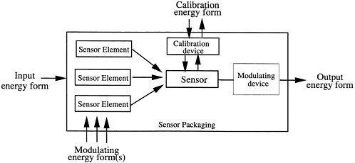

Figure 2.1 Anatomy of a Sensor System

Modern sensors are more than transduction material, which opens new opportunities to introduce new material in sensors. The advances in sensors have not came from the new transduction materials but rather from microelectronic innovations, large scale manufacturing of interconnections and micromachining that allow more complex systems to be formed. (Brindley, 1988)

## Smart Sensor Technology

In the last ten years the importance of advanced sensor technology has been focused on the development of self-contained smart sensors. The basic principle of smart sensors is “*the sensor complexities must be concealed internally and must be transparent to the host system.”* (Council, 1995)

The design of smart sensors is to simply attach to the host structure via a digital interface so that the involvement is brought by the sensor and not by the central signal processing system. Requirements involving a smart sensor is that the system has a dedicated on chip signal processing. This means that the electronic signal processing hardware is dedicated to each sensor and becomes part of the sensor package. Stated above in Figure 1.1, a smart sensor would include interface circuit, signal processing, power source and the sensor. The subcomponents of a smart sensor include the following:

* A primary sensing element
* Excitation control
* Amplification
* Analog filtering
* Data conversion
* Compensation
* Digital information processing
* Digital communications processing
* Power supply

Within a smart sensor the primary sensor element may not be made up of conventional transducer material, but may include nonlinear and hysteretic materials which were previously discarded as being unreliable or unstable for these type of applications. This means it can be applied to sensors that contain their own dedicated microprocessor, so the need for a complex constitutive model or filtering algorithm can be avoided on the central processor. Many silicon manufacturing techniques are now being used to make not only sensor elements but also multi-layered sensors and sensor arrays that are able to provide internal compensation and increase reliability. (Lion, 1969)

## Motion Sensor Technology

Motion sensing also known as motion detection, can be referred to as any kind of sensing system which detects motion from any type of human or object motion. There are two basic types of motion sensors, active sensors and passive sensors.

An active sensor is the most commonly used and reliable type of sensor. They emit a signal (light or sound) wave which reflects the surroundings and then, is received by the sensor which in turn, activates the system. An example would be of an automated sink tap (sensor tap), when a hand motion is detected under the tap, the device signals for the system to run the tap.

Passive sensors are another type of motion sensor, these do not emit a signal like active sensors do, but instead they detect the infra around the sensor. These type of sensors are more suited at detecting temperatures and the movement of a human body. An example would be of a sensor light, which only turns on when there is a movement from a person or animal entering the room, the sensor works by detecting heat from the movement which activates the system that is connected to it.

A number of applications use motion sensing technology including security systems, burglar alarms, radar guns, automated light system etc. The advantages of motion sensor technology is security, saves on energy, saves time, relatively easy to install and has a powerful transmission. There are three types of motion sensing: (Kumar, 2013)

* Local Motion Sensing
  + Infrared motion systems are the most affordable and reliable systems available today, they measure light radiating from objects in view. This can be used to detect motion in an area. The use of this technology is usually used to detect heat which can be programed to only pick up certain levels of heat, allowing it the advantage of ignoring small animals.
* Ultrasonic Motion Sensing
  + This type of motion detection uses sound waves to detect the motion. When movement is detected the wave pattern of sound is altered and an alarm signal is sent to the system. The sound frequencies are not heard by humans and most animals.
* Microwave Motion Sensing
  + This type of sensor system sends out microwaves that bounce off of objects and return back to the sensor. It can read the frequency of the waves that bounce back off of the object. It will signal an alarm when an object moves as the ounce back signals that it receives will be different. Microwave motion sensing is suited to larger areas than infra systems, the range is much further and the radiation that is emitted is not suitable for living organisms. Given these facts, they are also extremely costly so it makes them the least popular detection system available on the market.

Dual sensor technology is massively popular with home owners and businesses, the technology combines the use of infrared and microwave technology systems to provide a complete coverage. By using both the distance coverage range of microwave motion sensing technology and the infrared heat system technology this allows the reduction of false alarms being detected by the dual sensor motion system. (Kumar, 2013)

Currently the technology used in phones include a complex motion sensor technology called an accelerometer, this translates the motion of the object onto the screen. This type of sensor is also used in digital cameras and tablet computers to ensure that images are displayed in an upright position on screen. Motion sensing is also visible in game technology, Microsoft’s Kinect brought the first touch free motion sensing to the market allowing the gamer to freely move without a control system in hand and enables facial, voice and advanced posture recognition. (Bewley, et al., 2014)

# Chapter 3: Kinect Technology

## Introduction

The Kinect is a motion sensing device which was developed originally by Microsoft for the Xbox 360 gaming console. This device is not a hand controlled device, it detects body motion, position and voice recognition. Using the Kinect provides a NUI (Natural User Interface) to allow the interaction of the body for voice, motion and gesture commands. This has developed a new gaming world experience for users, allowing them to be the controller of the game or application rather than using control device, this has led to a new revolution in the gaming world.

## Components of a Kinect

A Kinect is a horizontal device which includes depth sensors, colour camera and microphones, the device is horizontal in shape and has the ability to be tilted in a horizontal direction. The key components of the Kinect are:

* Colour camera
  + The colour camera is responsible for capturing and streaming the coloured video data. The main function is to detect red, blue and green colours from the source. That data is then sent back to the Kinect in succession of still image frames. The Kinect colour stream supports a speed of 30 frames per second (FPS) at a resolution of 640 x 480 pixels and has a maximum resolution of 1280 x 960 pixels up to 12 frames per second. Each frame per second can depend on the resolution that is used for the image frame.
* Infrared emitter (IR) & IR Depth sensor
  + The Kinect depth sensor consist of an IR emitter and an IR depth sensor, both work together for the Kinect to work. The IR emitter is an IR projector that constantly emits infrared light in a “pseudorandom dot” pattern, these dots are not visible to the human eye only by using night vision camera or goggles but the depth data can be captured using an IR depth sensor. The dotted light pattern reflects off the surroundings and objects while the IR depth sensor reads the lights emitted off the objects and converts them into depth information by measuring the distance between the sensor and the object. The Kinect can capture raw 3D view of objects regardless of the lighting conditions in the set up area, this is down to the IR emitter and IR depth sensor that is a monochrome complimentary metal-oxide-semiconductor sensor (CMOS).
* Tilt motor
  + The Kinect uses a tilt motor to change the camera and sensor angle to the correct position of the human skeleton within the area. The motor is able to tilt 27 degrees up or down, this is controlled by the specific APIs within the Kinect and does not require the user to alter the angle.
* Microphone array
  + The microphone array consist of four different microphones that are in a linear order across the bottom face of the Kinect. The purpose of these microphones is to detect and locate the audio wave being produced. An advantage of having an array of microphones is capturing and recognising the voice as well as noise cancellation, enhanced noise suppression and beam forming technology. This enables a highly bidirectional microphone that is able to identify the source of the sound and recognise the voice irrespective of the noise and echo present in the environment.
* LED
  + Between the camera and IR projector is the LED, this is used for indicating the status of the Kinect device. A green colour being emitted through the LED indicates that the Kinect device drivers are loaded correctly and properly.

## Kinect v1 Sensor vs Kinect v2 Sensor

The Kinect v1 sensor for Xbox 360 was introduced with the Xbox 360 gaming console. This was the first motion control system brought in for a gaming console, released in 2010. A newer version v2 was released with the Xbox one in 2013, bringing a new more refined version of the Kinect v1, though the newer version had a defect of being much bigger and need lots more cables and convertors while the Kinect v1 is a more lightweight and easy to install piece of equipment.

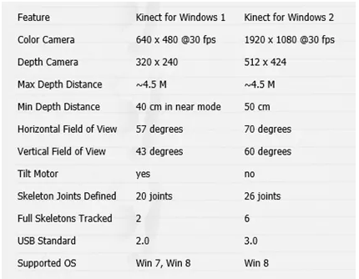

Figure 3.1 Comparison of Kinect v1 vs Kinect v2

The following image shows that the Kinect v2 performs better than the Kinect v1. The increase in the resolution with the v2 reaching full-HD res. The field of view has been increased also where if you move in front of the sensor, it will always detect you, whereas with the Kinect v1 it had a tendency to lose your movement if you moved too much on a side. The issue with Kinect v1 is the way it calculates the depth using IR light pattern projection, this can be a problem if you are going to use multiple Kinect v1’s together as they interfere a lot with each other, while Kinects v2 uses another way to compute depth using time of flight. This means that the Kinect v2 computes the depth of objects it has in front of it throwing some infrared light rays and looking how much time these rays need to bounce on surfaces and come back. This method means that it is much more stable, precise and less prone to interferences. (Skarredghost, 2016)

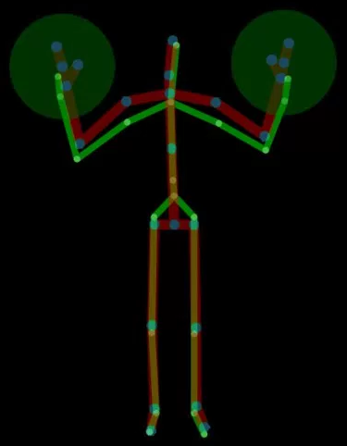

Figure 3.2 A Skeleton detected with Kinect v2 (red and blue) super-imposed to its Kinect v1 version (green). Look how their pose is similar, but v2 one is more natural and precise. (Meisner, 2013)

The Kinect v2 has the added ability to track more people with more joints with faster and greater precision than the previous version. As shown in Figure 1.3 one thing that is missing in Kinect v1 skeleton is the hands and thumbs, this means that there is no way to detect how the user’s hand/s rotate and this can be a serious issue if you want to control an avatar using Kinect v1. (Skarredghost, 2016)

## Time of Flight Camera

Cyrus Bamji, who is a Microsoft partner hardware architect for Microsoft’s Silicon Valley-based Architecture and Silicon Management group, was part of a team that was trying to incorporate a time-of-flight camera into the Xbox One Kinect. This camera emits light signals and then measures how long it takes them to return. This would need to be accurate to 1/10,000,000,000 of a second, with these measurements the camera is able to differentiate light reflecting from objects in a room and the surrounding environment. That provides an accurate depth estimation that enables the shape of those objects to be computed. This would mean that the speed of light capability is a major advancement for the Kinect sensor for the Xbox One. The aim for the Kinect v2 was a need to capture a larger field of view with a greater accuracy and higher resolution than the previous Kinect v1. The infrared sensor will enable object identification requiring little to no light and improvement in hand pose recognition which allows general users and gamers the opportunity to control the console with their hands. (Meisner, 2013)

Challenges that where made a factor when developing the new technology were motion blur in time of flight and having accurate depth measurement in diverse scenes with the new camera’s high resolution and a wider field of view posed a user experience issue, this made it difficult to keep small objects such as a finger from fading into the background. The challenge of motion blur needed to be minimized and with using the time of flight camera it helped to reduce the motion blur significantly from sixty five milliseconds in the original Kinect v1 to fewer than fourteen milliseconds in the Kinect v2. (Meisner, 2013)

A feature that the Kinect sensing device for Xbox one is the infrared sensor. This can identify objects in a completely darkened room. It can also recognize people and track their bodies even without any light visible to the naked eye. It also has the ability to identify a hand pose from four meters away, also pick up and see the fingers of a child and remember your identity even minus room illumination. The wider field of view also featured in the Kinect v2 makes it possible for more users to be viewed at the same time. As many as six users can crowd into one scene, also a tall adult can stand next to a small child and not be squeezed out of the picture. The improvement of hand pose recognition thanks to the infrared camera enables the user to interact with the Xbox One by just using their hands, this means that a controller is not necessary. The infrared camera allows for the hand gestures to be identified in any illumination giving deliverable speed and accuracy. (Meisner, 2013)

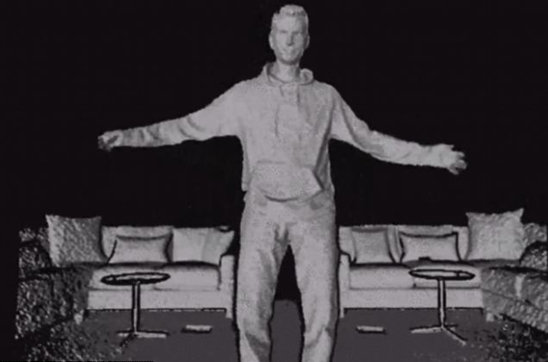

Figure 3.3 Camera view of Kinect v2 showing 3D imaging and the low illumination of light in the environment. (Wilhelm, 2013)

## Applications using Kinect Sensor

A lot of companies try to provide products using software applications to help people learn movements and physical skills in all aspects of life, such as medical care, rehabilitation, learning, education or sports training. With the Kinect being released the technology provided by the Kinect sensor allowed these applications to be developed beyond the scope of gaming even sign language recognition, robotic control, voice and gesture recognition as well as 3D reconstruction and 3D printing. The figure below shows the major application domains that can benefit from using the Kinect sensor device technology. (Hesham Alabbasi, 2015)

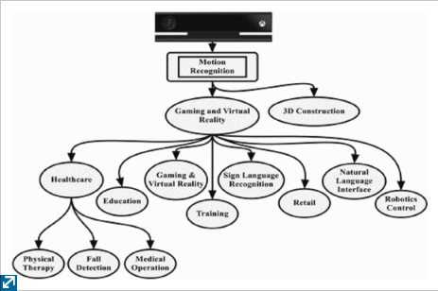

Figure 3.4 Kinect Major Applications

* 1. Motion Capture with the Kinect

Motion capture in the Kinect uses a marker less system which is more convenient and easier to use than other motion capture systems, but it does not give such a high accuracy of motion capture. The Kinect has developed software which is used for all kinds of manipulation of information processed by the Kinect. With the technology of the Kinect Skeletal Tracking software you are able to evaluate the quality of motion capture at different points in space by measuring the angular acceleration of the motion of human joints. If the acceleration value is too high there will be an error because a person cannot bend their joints at high speed. (Liza Egorova, 2015)

## Gesture Control with the Kinect

While the early version of the Kinect v1 can track joints in a body, the new and current version of the Kinect v2 can now recognise open and closed hands using machine learning. The Microsoft Research Cambridge team developed the gesture control with mouse clicks and multi-touch and pinch to zoom interactions. (Gorman, 2013). The Microsoft researchers assessed a number of ways in which technology can start to recognise hand motion with the ultimate end goal of allowing users to interact with technology in a more natural way than ever before. With the computer scientists and engineers behind the projects they believed that by making gesture recognition tools practical enough for mainstream, they could become just as ubiquitous as speech recognition, used to dictate texts and issue commands, or computer vision, which is regularly used to recognise faces in photos.

The broader goal in Microsoft’s research is to provide a more personal computing experience by creating the technology that can adapt to how people move, speak and see rather than asking people to adapt to how computers work. For these ambient computing systems to work well, Microsoft must combine all of the senses, allowing users to easily communicate with gadgets using speech, vision and body language together, just like users do when communicating with each other. (Linn, 2016)

In order for the team to accomplish this gesture control they believe that the technology must track hand motion precisely and accurately using as little computing power as possible allowing users to use their hands naturally and with ease. The complexity in this project is due to the hand being complex. Hands can rotate completely around and they are able to do things like ball up into a fist, which means the fingers disappear so the tool needs to be able to guess as to where the fingers have gone and what they are doing. Also a hand is smaller than the entire body so there is more detailed motion to track. The computer visions team combined new breakthroughs in methods for tracking hand movements with an algorithm dating back to the 1940’s, with this they were able to create a system that can track hands smoothly, quickly and accurately in real time. (Linn, 2016)

For hand gestures to be used in applications using the Kinect, an engagement gesture is to be performed by the user. There are two ways to teach a machine to detect custom gestures using the Kinect sensor is the heuristic method which depends on coding: this means that if all phases of the gesture must be checked programmatically. For example to determine if a hand is above the head, only the head and hand coordinates have to be compared. This method can be used in an interface type application to determine hand poses. To do a more complex gesture the heuristic method requires a very high level of skill in programming and understanding of the human body. The second method is done by using the Visual Gesture Builder, this is part of the Kinect for windows SDK v2.0. This uses algorithms to understand data given as clips recorded with the Kinect sensor. (Demitševa, 2015)

## Developing Gestures with the Kinect

Hand movements can be used as a basis for a curser. Many applications use the wrist joint coordinates to track in order to move the cursor. Finger joint coordinates can be used, but as the fingers can move a lot during the process of hand poses, the wrist can be a more stable joint to keep track of. Joints are tracked by using JointType and TrackingState, to instantiate the joint to be tracked the following code is used, Joint jointRightWrist = body.Joints[JointType.WristRight]; The position of the wrist must be scaled to screen size so that moving the cursor would be more natural. To do this the SystemParameters.PrimaryScreenWidth and System.Parameters.PrimaryScreenHeight are used to get the height and width of the primary monitor in pixels and position values that can determine the distance that the hand can move along the x and y axis. (Demitševa, 2015)

In order to train gestures, it is necessary to record clips with the Kinect Studio which comes with the SDK. The user would then stand in front of the sensor and act out the gestures, the more clips that are recorded of the gestures the more accurate the gesture detection will be. The next step is to start up the Visual Gesture Builder and to make a new solution, you can then determine which joints are going to be used e.g. determine if the lower body joints will be used when building the gesture. You are also able to set if the hand state should be monitored during the build. In the VGB Gesture Wizard a joint mask will represent the gestures, so if a joint is tracked it will display in green otherwise it’ll display in grey, it will be important to determine if it is important to know which side of the body the gesture responds to. An important feature is being able to duplicate and mirror the data, this is useful if motions for the left and right side of the body are equivalent. (Demitševa, 2015)

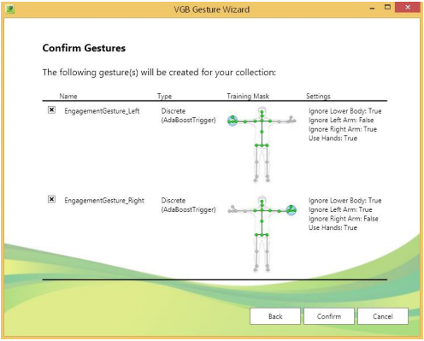

Figure 3.5 Visual Gesture Builder Wizard (Demitševa, 2015)

## Facts based on using a Kinect to develop a free movement painting application

One thing to be aware of when developing an application using a Kinect is the distance and depth that is tracked between the Kinect and the user, this is 50cm which means the user must sit or stand in view of the camera sensor between 1.2 and 3.6 meters. The sensor on the Kinect can monitor twenty joints in the human body and is able to detect up to six users. While the sensors on the Kinect can follow your movement you need to calculate the average speed of hand movements for a default speed value. (Chang, et al., 2017)

The Kinect for Windows is made up of one infra-red and one colour camera. These are sensors that capture the image of the skeleton and the target depth data. (Chang, et al., 2017)

Currently world artists and even other professionals who deal with interacting with different interfaces to produce work on a two dimensional surface, feel that the necessity to produce a digital copy of the artefact as well. To accomplish this they want to move beyond the regular use of a mouse pointer and being constrained within the window icon mouse pointer interface. People want to be able to move more freely from these constraints and move freely and have control that they would have in a real world drawing pad. The Kinect sensor can allow the user the freedom from a physical medium. (Vairamohan, n.d.)

Researchers believe that the Kinect’s motion technology can advance art therapy techniques and believe that artistic expression is a valuable social and emotional outlet that can develop communication skills and creativity as well as provide physical benefits like improved motor control. The Kinect removes a barrier to engagement that kids with a range of disabilities seem to take to. Parents of disabled children have noted that games marketed at the general public like the workout game Your Shape are being used by this special interest demographic. From different forms of studies it has shown there is a demand for the Kinect based software designed for therapeutic use, but currently there are no commercial products like this available. (Mallett, 2013)

# Chapter 4: Motion Tracking

## Introduction

The history of motion analysis is an interesting area due to it’s highly interdisciplinary nature and a wide range of applications. Histories of science normally begin with the ancient Greeks though Aristotle may be considered the first biomechanician. Nearly two thousand years later Leonardo Da Vinci sought to describe with aid of his drawings the mechanics of standing, walking up and down hill, rising from a sitting position and jumping, with Galileo adding in attempts to mathematically analyse physiologic function. Building on from Galilei, Borelli figured out the forces required for equilibrium in various joints of the human body. The first photographer to dissect human and animal motion was Muybridge, this technique was first used scientifically by Marey who correlated ground reaction forces with movement and pioneered modern motion analysis. Now in the 20th century many researchers and (biomedical) engineers contribute to an increasing knowledge of human kinematics and kinetics. (Xsenss, 2014)

## Human Motion Analysis

There are many different disciplines used for motion analysis systems to capture movement and posture of the human body. Basic scientists seek a better understanding of the mechanisms that are used to translate muscular contractions of articulating joints into functional accomplishment e.g. walking. In the line of medical professionals they apply an evolving knowledge base in the interpretation of the walking patterns of impaired ambulators for the planning of treatment protocols e.g. orthotic prescription and surgical intervention and allow the clinician to determine the extent to which an individual’s gait pattern has been affected by an already diagnosed disorder. In sports athletes and their coaches use motion analysis techniques in a quest to improve performance while avoiding injury. (Xsenss, 2014)

The use of motion capture for computer character animation or VR (virtual reality) applications are used to capture the position of the body in a space or as complex as the deformations of the face and muscle mases. The mapping of this can be direct such as a human arm motion controlling a characters arm motion or indirect such as a human hand and finger patterns controlling a characters skin colour or emotional state. This type of copying human motion is not new, to be able to get a convincing motion for the human characters in Snow White, Walt Disney studios traced animation over film footage of live actors playing out the scenes. This is a method called rotoscoping and has been successfully used for human characters, even in the late 70’s when animating characters by computer was available, animators adapted traditional techniques which included rotoscoping. (Xsenss, 2014)

## Motion Capture Systems

Motion capture or motion systems record the movement of an object or person. The system is highly sophisticated and requires a certain number of capture sessions during which the movement of an object is recorded multiple times per second. The data of the movement of that said object is then mapped out into a 3D model that will mirror the exact movement positions as the object that is wired to the motion sensor network. (Kaur, 2012)

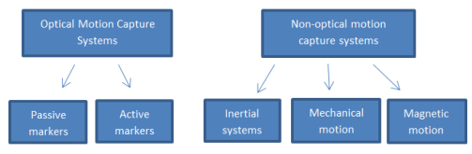

Figure 4.1 Flowchart illustrating the different types of motion sensors. (Kaur, 2012)

Optical motion sensors capture the image data and triangulate the 3d positioning of an object using multiple cameras at varying angles to the object. The markers that are attached to the object make this positioning possible. The motion sensors are attached directly to the surface of the object being captured. Passive markers are coated with a retro-reflective material that can reflect the light source, this technique is important for making sure that only movement is tracked. Software is then used to help in 3D modelling the image. An example of this would video cameras recording an actors movements for a particular film or scene, the captured motion data from different angles allows the software to monitor the movement of the markers that are attached to the actor, this data is then used to program sliders (camera movement system) to help in animating the character. (Kaur, 2012)

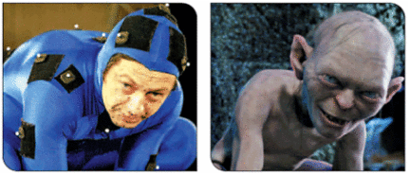

Figure 4.2 Motion Sensors attached to an actor to capture the movement and then put through software to help in animating the character. (Xsenss, 2014)

Commercial optical systems such as Vicon (reflective markers) or Optitrack (active markers) systems are often considered as a standard in human movement analysis. Although these systems provide accurate position information there are limitations due to high costs, occlusion problems and limited measurement volume. Having the use of a specialized laboratory with fixed equipment impedes man applications like monitoring daily life activities, control of prosthetics or assessment of workload in ergonomic studies. The promotion of a large development of non-invasive portable and wearable systems has come from the health system who trend towards early discharge to monitor and train patients in their own environment. This has opened many possibilities to capture motion data for athletes or animation purposes without the need for a studio. (Xsenss, 2014)

## Non-optical Motion Capture Systems

Non-optical motion systems are split into three types of sensors:

* Inertial Sensors
  + Measurement sensors such as accelerometers and gyroscopes are commonly applied for motion tracking. The motion data from these sensors is detected wirelessly by a computer software system and recorded. Tracking movement through the inertial sensors can be difficult as the data recorded can be ambiguous. More accurate readings of human movement can be done through models of human motion. Combining both the accelerometers and gyroscopes to measure movement is controlled by applying an algorithm. The gyroscope measures the orientation of the sensor and the data then reflects the gravitational acceleration. By deducting the gravitational acceleration from the sensor frame, the accelerometer can then calculate the initial position. (Jorg Hoffmann, 2010)

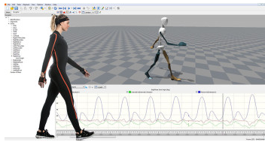

Figure 4.3 Shows Inertial motion trackers which give absolute orientation estimates to calculate the 3D linear accelerations. (Xsenss, 2014)

* Mechanical Motion Capture Sensors
  + This is a structure that is attached to a subject who will then act out a sequence of movements. A mechanical motion system consists of electrogoniometers which is a sensor system made up of potentiometers or transducer technology which is designed to estimate joint angles when positioned close to a joint on the subjects body, this allows for direct measurement of movement so the subject is allowed to move freely in a large environment without being out of view by a central camera system or have the capture system affected by reflective light. An example of a wireless mechanical motion capture sensory system is the Gypsy 5 which was engineered by Meta Motion. (J.C.Norton, 2008)

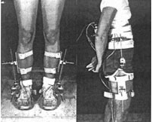

Figure 4.4 Mechanical Motion Capture Sensors. (Xsenss, 2014)

* Magnetic Sensors
  + This type of motion sensor calculates a low frequency magnetic field created by a transmitter. The magnetic current is detected by the orthogonal coils in the transmitter. Two types of magnetic current flow are the direct current (DC) technique and the alternating current (AC) system. With the DC system the magnetic current flows in the form of square pulse waves, sine pulse waves are then generated with an AC current. The involvement in using a magnetic motion system is applying 6-11 sensors around the joint on a subject’s body where each sensor works to produce measurements on the position and rotation of the corresponding joint. The reduction in accuracy of position measurements can occur when multiple actor magnetic systems are performing in one space which results in distortion of results. This type of capture system is best used in controlled environments. The military are known for using magnetic motion capture systems for head tracking. An example of this is for the system to calculate the pilot’s line of sight so when weapons are released with maximum accuracy when hitting the target. This application of magnetic motion sensors is used in the medical industry where these systems have been engineered to help measure the size of organs inside the human body, which is useful during a medical procedure to allow for better accuracy and the outcome of surgery. (Xsenss, 2014)

# Chapter 5: Autism Spectrum

## Introduction

Autism can perhaps be said to be the “most prolifically researched of all child psychiatric disorders” (S., 2004). Since the discovery of autism over sixty years ago, it has had significant research researched and generated two international journals, *“The Journal of Autism and Developmental Disorders, which started life in 1971 as The Journal of Autism and Childhood Schizophrenia, with Leo Kanner and Stella Chess as its foundation editors; and Autism: the International Journal of Research and Practice which first appeared in 1997”.* From the publishment of these journals a further two journals were dedicated to autism “*Focus on Autism and other Developmental Disabilities, first published in 1985, offering practical articles on care, treatment and education for a multidisciplinary readership and The International Autism Research Review started in 1987.”* (Wolff, 2004)

Almost one in a hundred children are born autistic with five times as many boys as girls being diagnosed. While some autistic children may experience delayed development other children will develop normally until their second year of life. Some children may never communicate through speech while others might be classed as genius. Because autism begins in early life, children with autism often need to find an alternate method of learning as they are not always suited to the traditional education methods used by children not on the autism spectrum. The behaviour of each child with autism can vary enormously depending on different factors, but it can mostly come down to the age of the child, their general ability, personality and education. Thanks to autism being a frequent subject of academic and clinical study, there are a number of core features and traits that can be identified. (Frith, 2008-10-23)

## Symptoms

One of most common symptoms of autism is poor social interaction. This can be seen in equal interactions. This symptom may present itself as a poor ability to communicate engage with both adults and other children, this may appear as not having an interest in being social towards the group or single person or displaying a coldness in regards to other people. Occasionally, autistic children can discover alternate methods of self-education. For example, in one study, a child was examined that despite never having been shown how to read, managed to teach himself. (Schweizer, 2014)

A second common symptom relates to communication. This is most commonly noticed with the difficulty around understanding secondary methods of verbal and visual communication. Often, communication between people can be non-verbal, just simple movements or facial expressions, for example a look of alarm when a subject is brought up, or someone displaying their unhappiness by general demeanour. Children who are on the autism spectrum can often have difficulty in communicating and understanding what is being communicated in situations like this. The problem may arise when the child develops speech much later on in their life which limits their vocabulary. Many children can find a difficulty in understanding conversations involving jokes or simple sarcasm.

The third core symptoms involve repeating activities and constricted interests. This can seem slightly ordinary to everyday people, but when seeing children on the autism spectrum who day in and day out line up their brick toys or toy cars in neat patterns or straight rows without them exploring other possibilities of playing with the toys, this can be described as seeming lacking in emotion. Obsessive behaviour like this can be commonly seen in children with autism. (Frith, 2008-10-23)

## Social interaction based on the autism spectrum

Many children who are on the autism spectrum can play differently to other children that surround them. As stated seen above, children from a young age with autism can play with toys in a very different method to children not on the spectrum. Often enjoying repetitive motion by lining up the toys in a single line or neat pattern or just simply playing by themselves and repeat those actions over and over again. They can also so a less than likely want to engage in imagine play like games that can require social communication or collaboration. With this in mind, many children like to line up their toys or choose to play on their own, but often not in such an obsessive manner. Typically children like to learn new skills or play imagination games with other children and tend to ask questions when they are confused. (Manning, 2010)

Children that have autism often lack the skill of imitation, with most children observing how other children play with toys, a child with autism may not notice this or begin to observe that other children are playing with the toys and then will instinctively begin to imitate that behaviour of lining up the toys or blocks. While other children enjoy the sense of imagination and playing pretend, they have by the age of three developed the tools to engage in imagination use with many using toys as a set like a dolls house or a plastic tea set. Those skills are rarely developed in a child with autism, most need help in learning symbolic play skills. (Murdock, 2010)

As noted above, children with autism often lack in communication and social skills, this can be seen when they have little to no desire to communicate or take part in activities with other children. Even though these skills might be poorly developed, it can still be possible for children with autism to have fun and play. With technology and research that has been conducted there are many therapeutic approaches that can focus on building up these skills that many children with autism may lack in.

## Art therapy

Art therapy can be used as a way of helping autistic children access and communicate their emotions. Art is often used by therapists who will work one on one with the child and help in building the skills in a way that can be more comfortable for the child rather than verbal communication.

Art therapy differs from general art classes in that classes are generally conducted in a structured environment. Specific instructions are provided on how to achieve different effects and create forms of art to accomplish the goals intended for the art class. While classes like this can be helpful, they are often very challenging for children who have difficulty showing and interpreting emotion.

There are many benefits to art therapy, many children with autism have an exceptional ability to think visually. This can used to assist with the processing of memories and granting the ability to visualise information and express ideas or emotions with images through drawing or other forms of artistic expression. As autistic children can often exhibit poor verbal and social communication skills, giving them a new form of expression through the medium of art that does not always require communication of this type can drastically improve their lives. Examples of how art therapy can aid a child with autism is:

* Improvement of the ability to distinguish and react to facial expressions
* Improved ability to use imagination and to think figuratively
* Management of sensory problems
* Enhanced fine motor skills (Association, 2012)

## Free movement paint application for children on the autism spectrum

Through seeing in the above research, an application involving free movement art would allow a child on the autism spectrum a chance to learn as well as show emotions based on their movement. The idea would be to allow a child with autism to move their hands to paint or draw while seeing themselves produce any art they accomplish. The use of bright, crayon-type colour paints attracts the attention and allows them to learn and express themselves through their application of colours and movement. (Association, 2012)

A game/toy based learning system is a common approach to both educational and recreational learning. Adding a learning aspect into activities that children enjoy will often have the side effect of helping the child to understand the content and improve their problem solving and active learning skills. It is also proven that using game based activities improve attention, confidence and emotion. It also provides a challenging and interesting environment for the child, this then enhances the child’s motivation to learn and encourages them to be more active in their education, leading to a dramatic improvement in what they can learn. (Chang, et al., 2017)

Painting is a popular way for everyone, not just children to find their artistic value in life as well as understand their emotions they have, which they may not be able to show in everyday life. This can be seen in their colour choice, the paint strokes they can make or simply by the actual end result that they produce. There is also a sense of relaxation that can be felt as part of the emotions displayed in participating in art, the feeling of zoning out from the outside world can be felt as freedom to some people. This being said, it can give a child that is on the autism spectrum a chance to escape the outside world or the feeling of being trapped under pressure or insecurity.

From a young age we are taught in play school using arts and crafts. This gave us the chance to explore all art mediums including paint and allows us to show our emotions through using the poster paints or finger painting.

# Chapter 6: Methodology & Design

## Key Findings

Research undertaken in Sensor technology indicates that the Kinect Sensor provides a movement tracking ability which can be can be utilised in a software development environment, for example Unity and Visual Studio both can integrate with the Kinect. The Kinect provides a NUI (Natural User Interface) to allow the interaction of the body for voice, motion and gesture commands, allowing a user to be the controller of the game or application rather than using control device

Research into Motion Tracking indicated that the use of motion capture for computer character animation or VR (virtual reality) applications are used to capture the position of the body in a space or as complex as the deformations of the face and muscle mases.

The use of a Kinect Sensor and a free movement application can be developed to provide an application in which a user can paint and draw in a 3D space which is then projected.

It has been established that children with autism, who are lacking in social skills, can utilise a creative therapeutic development application which will enhance their sensory skills.

## Research Question

An evaluation of students, who have been diagnosed on the Autism spectrum, to assess if they can benefit from learning in an innovative learning environment. This environment may include a two dimensional painting application or a three dimensional computer aided visual environment?

This research question will be broken down into a series of sub questions which will be answered individually.

## Vision Document

## Project Proposal

The purpose of this study is to analyse how a free movement application can help children on the autism spectrum. It will focus on the requirements of the target user base and how the use of a free movement artistic application can be applied to assist with their education and the improvement of communication skills.

## Scope / Outline

The free movement application maybe a desktop application in which the user can paint and draw in a 3D space which is then projected. The application is primarily aimed at children with autism. Based on the research conducted on autism, many children with autism have difficulty in displaying emotion or communication, through using a fun and colourful application, many studies have confirmed a positive development in that area. This application will be developed using a combination of technologies such as an Xbox one Kinect sensor, Visual Studio and Unity.

## Stakeholder and User Descriptions

The main stake holders for this application are children with autism and parents of children with autism and those involved in the teaching of the skill. In the research conducted on autism it has been established that children in particular that have autism, deal with a lot of difficulty in the communication process and have a delayed development compared to other children. Social interaction is another key area in which children with autism can be under developed in. The benefit of a free movement painting application is the communication with the application and how it helps children showing emotions through their movement and the art that they can produce.

## Product Overview / Features

The product is a free movement painting application aimed at children who are on the autism spectrum. The application is design to allow the user to paint and draw with different colours and stroke weight in a projected room environment. The application will be developed through unity software integrating the Kinect for Xbox one along with a projection system. The main features of this application is the ability to move freely around with the movement of the user’s hands to develop creations of art. The movements are tracked using the Kinect and can be seen by projecting the application and user onto a white screen. The user can then move their hand to alternate through a menu system that will allow them to change the stroke weight, the colour, saving and editing.

## User Requirements

**MOSCOW Method**

|  |
| --- |
| 1 Must Have |
| 2 Should Have |
| 3 Could Have |
| 4 Won’t Have |

**MOSCOW Method Representation**

|  |  |  |
| --- | --- | --- |
| ID Number | Description | MOSCOW Number |
| 001 | A Functioning Kinect Device | 1 |
| 002 | Computer Aided Software, Visual Studio, Unity, Kinect SDK | 1 |
| 003 | Projectors, Monitors, Software to Kinect the device | 1 |
| 004 | User | 1 |
| 005 | Child proof interactive interface | 1 |
| 006 | Gesture Recognition Software | 1 |
| 007 | Track hand movement and triggers | 1 |
| 008 | Incorporate Kinect device data into the unity environment | 1 |
| 009 | Prototype a sample game in unity | 1 |
| 010 | Run user testing, can it interact with non-autistic users as well as human users | 1 |
| 011 | Adult supervision | 2 |
| 012 | Ability to change colours, stroke weight etc. | 2 |
| 013 | Ability to edit art piece | 2 |
| 014 | Let the user move freely in the environment | 2 |
| 015 | Certain space requirements | 2 |
| 016 | Easy hand gesture movements recognised by the learner | 2 |
| 017 | Implement a user interface | 2 |
| 018 | Store sample data | 2 |
| 019 | Certain lighting in the environment | 3 |
| 020 | Multiple users | 3 |
| 021 | 3d emersion environment | 3 |
| 022 | Availability on tablet devices | 4 |
| 023 | Make available across different operating platforms | 4 |

## Solutions

The solutions proposed for this application are the use of the Kinect for Xbox One, Unity software as well as Visual Studio for the C# coding. Other application software that will be needed is the Kinect SDK that is available for download from Microsoft, this allows the drivers to be installed so a Kinect can be used when developing applications for windows. Other technology that would be needed is a projector that will allow the application to projected out onto a screen, multiple projectors will also be required to allow the application to project on multiple walls, this will allow the user to feel immersed in the 3D environment.

## Design- Functional Specification

## User Story

**Story Identifier:** 001

**Story Name:** Movement Recognition

**Description:** As a User, I need to move my hand across the screen so I can paint a line on the canvas.

**Conformation:**

* Can the Kinect pick up the hand coordinates?
* Can I see the line being drawn on the screen?
* Can I change the direction of movement?
* Can I view the lines being drawn on screen?

**Story Identifier:** 002

**Story Name:** Colour Choice

**Description:** As a User, I need to change the colour of the brush so I can use different colours.

**Conformation:**

* Can I use a different hand to alter the paint colours?
* Can I use a simple hand gesture to bring the colour changer on to the screen?

**Story Identifier:** 003

**Story Name:** Alter Brush Size

**Description:** As a User, I need to change the size of the brush stroke so I can paint with different stroke weights

**Conformation:**

* Can the Kinect pick up the hand movement?
* Can I use an alternative hand to change the stroke weight of the brush?

## Risk Analysis

|  |  |
| --- | --- |
| Risk | Preventative Measures |
| Specific hardware may not be available or accessible | Contact supervisor/ lecture and enquire if hardware e.g. projectors, Kinect sensor, webcam, are available |
| Software required for the proposed hardware may not be freely available or updated | Research on software for the proposed application |
| The programming language may not suit across multiple software platforms | Research and test which programming language suits for each software application |
| How can the Kinect be used for development in a 3D environment | Research for extra software tools that can be implemented into the Kinect SDK |
| Can the Kinect work well with Unity | Research Unity and packages that can be implemented into the Kinect |
| Can multiple projectors be implemented with the application to create a 3D CAVE system | Test application with one projector and research more on the 3D CAVE system |
| Will developing a 3D environment suit a child with autism? | Research papers and projects that involve projects associated with autistic children and 3D environments |

Table 6.1 Risk Analysis

## Proposed System Architecture Diagram

Kinect Studio is a utility application that can be used to preview Kinect sensor array data, record and play extended event file (XEF) files, control the timeline position and select 2D or 3D views. Kinect studio APIs enable you to custom tools and record and play back body data using XEF files.

The installation of the SDK deploys the Kinect monitor service which monitors the start-up and shutdown of both the Kinect Service and the Kinect Studio Service (KStudioHostService). The Kinect Service roper operation of the sensor and the processing of the data as it flows from the sensor to one or more client applications. The Kinect Studio Service performs all recording and playback. (Pradeep, 2016)

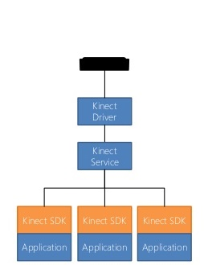

Figure 6.1 Kinect V2 System (Valoriani, 2015)

The diagram below shows the design of the final application using the 3D CAVE environment system. For this application to work the user’s movement must be mapped out using the Kinect and the gesture recognition software, once this has been done, the application is then mapped out in unity using multiple cameras for each projection screen, this is then projected onto the multiple screens using the projection system allowing for movement in a 3D environment.

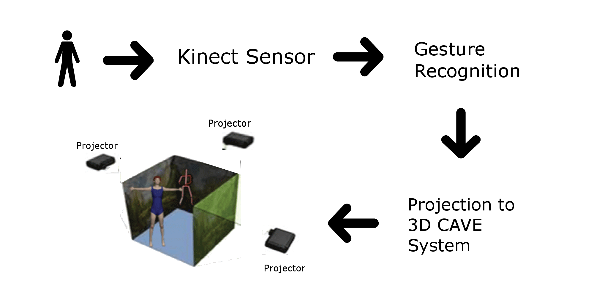

Figure 6.2 Diagram of the final application

## Prototype

|  |  |  |
| --- | --- | --- |
| ID Number | Description | Status |
| 001 | Setup of hardware equipment (Xbox one Kinect, adapter, Windows 10, Unity) | Complete |
| 002 | Download SDK drivers | Complete |
| 003 | Run Visual Gesture Builder - Preview | Complete |
| 004 | Build a 3D game in Unity | Complete |
| 005 | Install Kinect software packages into Unity | Complete |
| 006 | Write code classes to allow for the game in Unity to be used with the Kinect | Complete |

Table 6.2 Proposed Prototype Implementation

# Chapter 7 Implementation

## 7.1 Sprints

A set period of time during which specific work has to be completed and made ready.



## Sprint One

This first sprint explored in detail the setup and programming an application with the Kinect v2. The following will show the requirements of software, sample applications and the implementation of sample applications and any errors or problems that may have been encountered.

|  |  |
| --- | --- |
| Task | Status |
| Download and Install the Kinect SDK | Complete |
| Download and install the Visual Gesture Builder | Complete |
| Download and install Unity | Complete |
| Download and install Visual Studio | Complete |
| Develop a 3D game sample in Unity | Complete |
| Import Kinect properties into Unity | Complete |
| Test and run the developed 3D game in unity | Completed |
| Implement C# code into Visual Studio to work with Unity and the Kinect | Complete |
| Run and test the Unity game only using the Kinect | Complete |

In table 6.7 it shows the tasks associated with the initial setup and development of an application programmed in C# using Unity and the Kinect v2. For the initial setup Kinect v2.0 SDK (Kinect for Windows) had to be downloaded and installed first, this is important as this project involves using the Kinect v2. The Kinect for Windows Software Development Lit (SDK) 2.0 allows developers to create applications that support gesture and voice recognition using Kinect sensor technology on computers running Windows 8 and above.

For the Kinect to be setup there are a few hardware requirements especially for the Xbox one Kinect v2. These involve a Kinect v2 sensor, Kinect Adapter for connection to the PC, USB 3 cable. For the PC the hardware requirements must meet a minimum specification of 64-bit processor, Physical dual-core 3.1 GHz or faster processor, USB 3.0 controller, 4 GB of RAM, Graphics card that supports DirectX 11 and Windows 8 or 8.1, Windows Embedded 8 or Windows 10.

The Kinect SDK Browser is a tool that comes with the Kinect SDK when installed. This offers components, samples C#, samples windows store, SDKs and tools. This is very helpful when developing Kinect applications on windows.

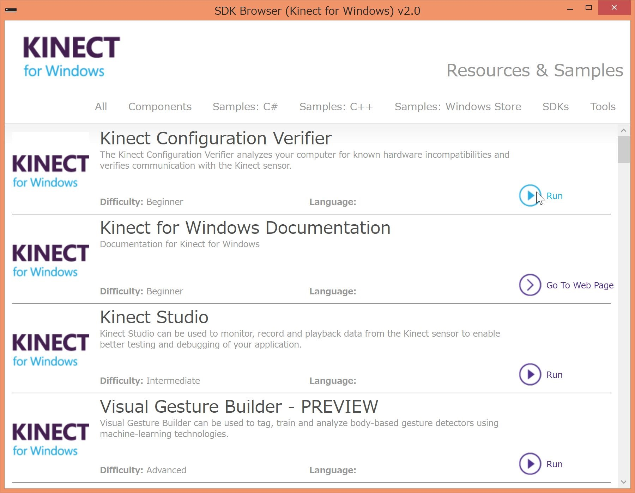

Figure 6.3 The SDK Browser (Kinect for Windows) v2.0

To get a view of how a user would look and the skeleton mapping I decided to run the Visual Gesture Builder, this generates data that applications use to perform gesture detection at run time. This gave an advantage as normally with gesture detection it can involve many lines of code to obtain reliable results, considering all of the different users and spaces that an application might encounter. Using the Visual Gesture Builder.

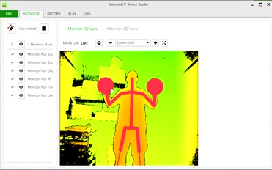

Figure 6.4 Visual Gesture Builder

To build the prototype Unity was installed. This is a multipurpose game engine that supports 2D and 3D graphics and scripting using C#. This is useful as the application will be developed using C#, which is not that different to java. After downloading Unity, the supporting Unity 3D plugins were downloaded. These expose APIs for Kinect for Windows core functionality, visual gesture builder and face to Unity apps. The Unity packages from the download also contained two sample scenes Green Screen and Kinect View.

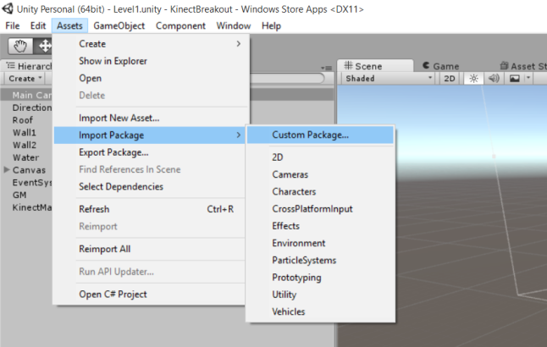

Figure 6.5 Importing Kinect v2.0 Plugin into Unity

Once the plugin was imported into Unity two new folders were added to the project window under the Assets folder these are called Plugins and Standard Assets. This is the baseline configuration for any Kinect v2 project in Unity. To edit and debug scripts for the application in Unity I chose to install Visual Studio, this allowed for me to write the C# code for the prototype. The installation of Visual Studio is quite simple. To use the game with the Kinect I made an invisible GameObject that exchange data from the Kinect and the game.

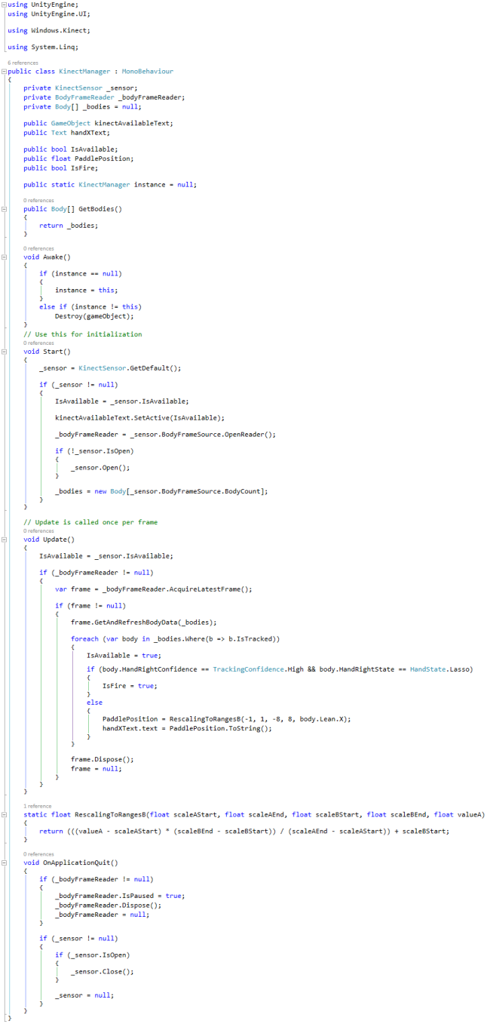

Figure 6.6 GameObject Script

Once the GameObject script has been made, I made changes in the Paddle class to pass the coordinates from the KinectManager GameObject. This allowed for the paddle in the Unity game to be controlled by a user.

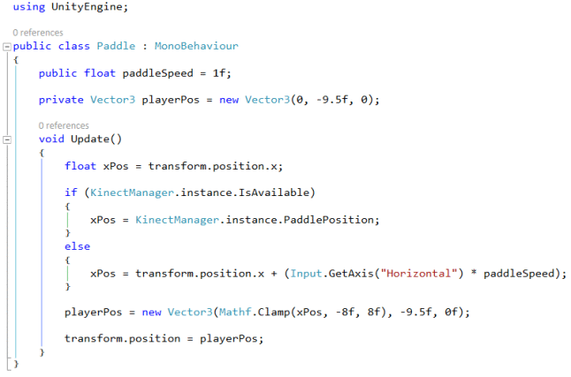

Figure 6.7 Paddle Script with the player’s position coordinates

Finally after testing and debugging the scripts were able to run the application only using Unity and the Kinect. The game is controlled by moving the body slightly to move the paddle from side to side. To release the ball, a simple hand gesture and slight flick of the wrist allows for the ball to be released from the paddle. Depending on the position of the paddle, when the ball is released it will hit the bricks and destroy them. If the ball is not caught by the paddle once it drops back down, a life is lost. When all lives are lost the game will end and restart with a new set of lives.

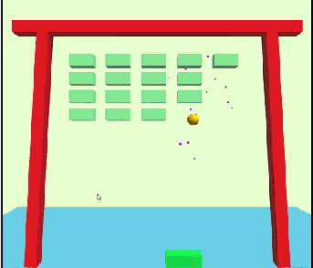

Figure 6.8 Developed Unity game

## Sprint Two

|  |  |
| --- | --- |
| Task | Status |
| Download and run pre-defined sample applications. | Complete |
| Develop and test basic applications. | Complete |
| Build environment in unity. | Complete |
| Exploration of assets and textures in unity. | Complete |
| Exploration of hand and figure gestures. | Complete |
| Develop test application calculating hand movement. | Complete |

The table above displays the tasks associated in the further exploration of Unity and using C# as the programming language. With research in using Unity and Visual Studio, C# was an immediate possibility since it is developed and maintained by Microsoft. Further research was performed into the exploration of the libraries that are available in Visual Studio for the Kinect, this gave an insight into what they offered as well as building and testing examples online.

Once the various scripts and libraries where imported, a C# script was created to get the Kinect sensor data into the scene, the script contains the code copied from the KinectView sample in the file BodySourceManager.cs. This code retrieves the sensor and opens a reader for the body data and also reads the current frames data in the update() method in the script. The update() method is used as part of the game loop, so the Kinect Skeleton data is being used each time the script is called. The script uses a method GetData() to allow the data to be accessed by other scripts.

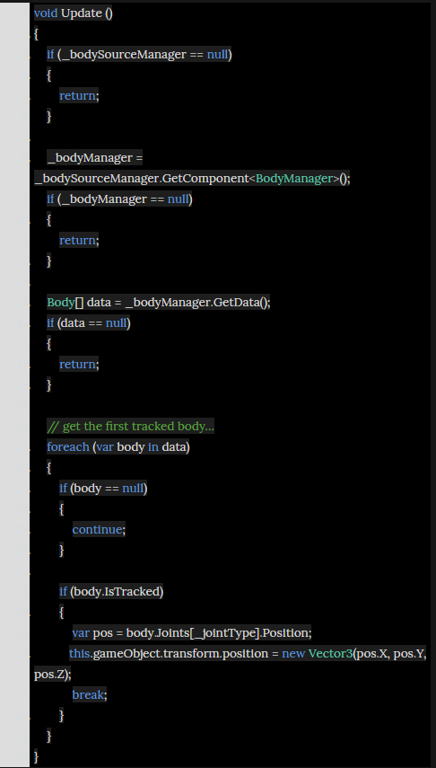

Figure 7.1 BodySourceManager Script

First an empty GameObject called BodySourceManger was created that associates with the BodySourceManager script. Once that was completed I then created another empty GameObject and associated a new script which would get the body data and position of the GameObject depending on the position of one of the joints in the skeleton. The Joint type was made a variable so the positions could be set up of various GameObjects. The idea for this is so that a child object of the GameObject would follow the tracked position, say of the left hand and others can then be added for each of the joints that I would want to be tracked.

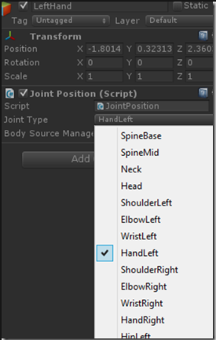

Figure 7.2 Unity Joint Position

Two new Game Objects were added in Unity, one for each hand and the joint types were set to HandLeft and HandRight. One of the Game Objects was set as a cube object and the other Game Object was set to be a particle system. The particle system was altered in Unity so they could look how I wanted them to look.

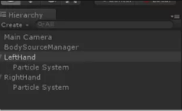

Figure 7.3 GameObjects Assigned Particle Systems

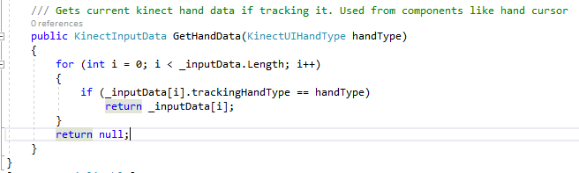

Figure 7.4 KinectInputData Method

The class KinectInputData which is used to check which hand movement is being tracked has getters isTracking, IsHovering, IsPressing and IsDragging, these can used to visualize a cursor hand. The KinectInputData size is set to two, so both hands can be used. The KinectInputData array is set to be two for the right and left hands. To handle the hover, the BaseInputModule’s HandlePointerExitAndExit method is going to be used. This method needs a pointer event data and a GameObject as its parameters. The pointereventdata is getting the hand screen position and the GameObject is set as a raycast as the result of the pointereventdata, the inputdata’s hovering properties are updated, this sends pointer enter exit event to the GameObject.

To process the press a basic solution is used to track the handstate, so if the hand is closed the data is set as being pressed and when the hand opens a submit event is sent to the UI component. The IsDragging getter is used to check if the hand is being dragged, it can be checked by when a component is pressed with the processpress method and setting a temporary screen position, also while processing drag comparing the current hand position axis values with the temporary one, and if the values are bigger than a threshold set IsDragging as true. If dragging use unit’s event handler to send an event to a scrollview like component.

## Sprint Three

|  |  |
| --- | --- |
| Task | Status |
| Develop three quad panes in Unity | Complete |
| Apply cameras for each pane | Complete |
| Develop application to draw lines onto the quads | Complete |
| Add in colour elements | Complete |
| Enable lines drawn to change colour | Complete |

The table above displays the tasks associated in the further development of the painting application using Unity and the Kinect. After integrating the hand position controls from the previous sprint, it further developed the environment in Unity for the application with the integration of various hand detections and components within Unity. C# scripts where developed to allow objects and the setup of a ray cast to pin point the position of the hand movements.

The main C# script the application with be developed around is the BodyManagerScript and DetectJoints Script, these will handle the main areas of the development for hand and body tracking.

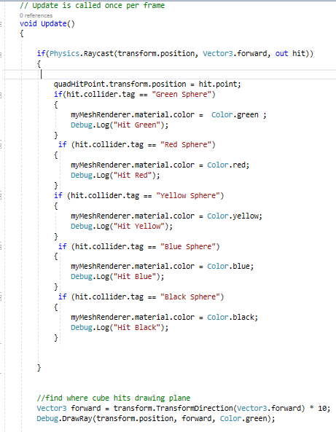

Figure 7.5 Raycast Code

For the first part a Ray object needed to set up, a Ray in unity corresponds to a point in the view, so a point can be from the camera directly using the ScreenPointToRay and the ViewportPointToRay functions. The most common use of a raycast from a camera is to perform it out to the scene. A raycast sends an imaginary line along the ray from its origin until it hits a collider in the scene, so for this to work in this application, I set a raycast to start from the cube object and collide with the canvas, the information is then returned about the object and the point that was hit in a RaycastHit. For this application the Physics Raycast from the cube is used to select each of the material colours and set the trail renderer to the selection of colours that collide with the raycast point. To find where the cube hits the drawing plane a variable called TransformDirection is used to transform a vector from local space to world space, to obtain the direction of the object I use Vector3.forward which will compute the angle between the direction of the cube object and the drawing plane.

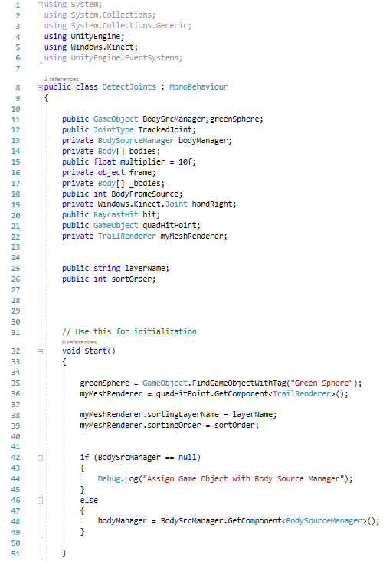

Figure 7.6 DetectJoints Code

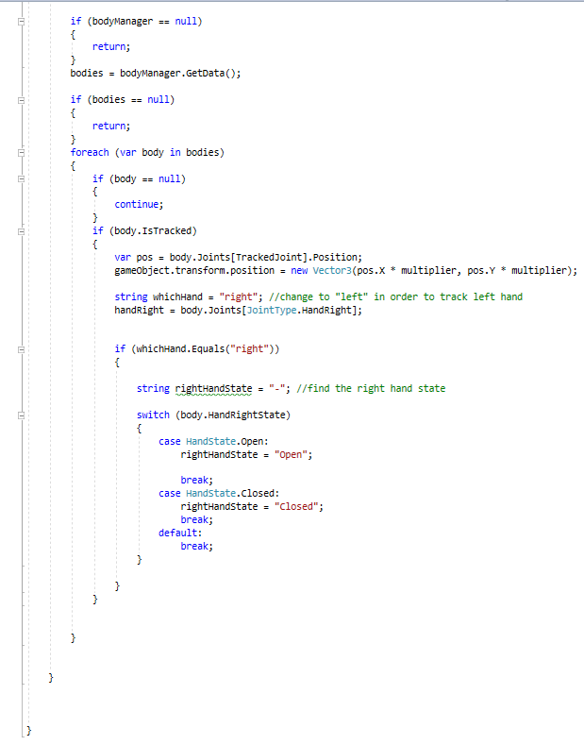

Figure 7.7 DetectJoints Code

Body Source Manager was assigned a game object that was created in the script by adding the variable public GameObject BodySrcManager; and then assigning the GameObject to Object1 in Unity. I then created a JointType enum which enables a selection of which joints I wish to track assigning it this value public JointType TrackedJoint;. A private variable was created to take care of the data being retrieved from the Body Source Manager component, private BodySourceManager bodyManager; this is then assigned once in the void Start() method. Every frame is checked to see if BodySrcManager is still equal to null. If this is true it just returns, else data is obtained.

The Kinect can track up to six bodies so this needs to be assigned an array that will differentiate between the different bodies being tracked. This is done by declaring an array body of type bodies, private Body[] bodies; When tested and run in unity, the object does not move very far, so a multiplier is incorpriated and declared. Public float multiplier = 10f; this variable is then assigned to the position of the object gameObject.transform.position = new Vector3(pos.X * multiplier, pos.Y * multiplier); This then made a huge different in the movement.

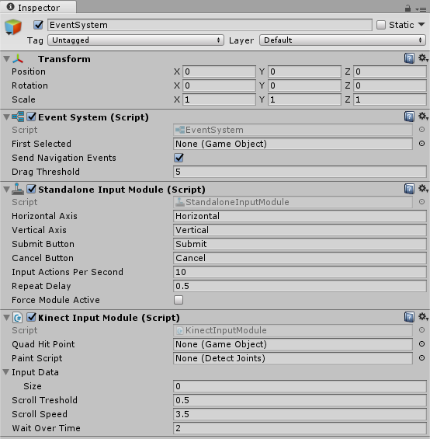

Figure 7.8 Scripts Attached to Unity

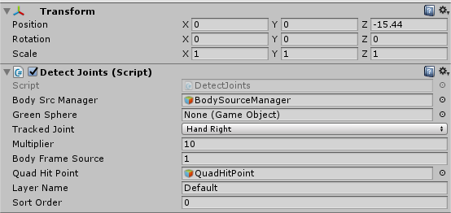

Figure 7.9 Detect Joint Script Attached to Unity

The Detect Joints script was then assigned to the object created in Unity. Hand Right was selected from the drop down menu of TrackedJoint, this is the joint that I’ve decided to track.

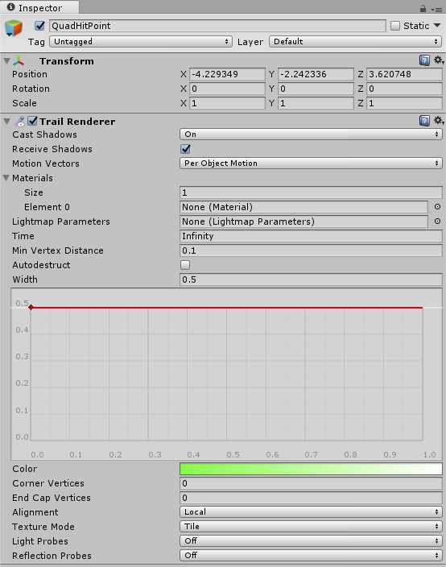

Figure 7.10 Trail Renderer Assigned in Unity

A Trail Renderer was assigned to the Quad Hit Point Object. Using a trial renderer allows for trails to be left behind the game object as it moves around the scene, it uses polygons allowing for a visual effect. Setting the Min Vertex Distance to 0.1 allows for the trail segments to be created more often which creates smoother lines. The width was defined as 0.5 allowing the trial to be quiet thin like a pencil stroke. The texture mode was set to tile to allow the control of the repeat rate.

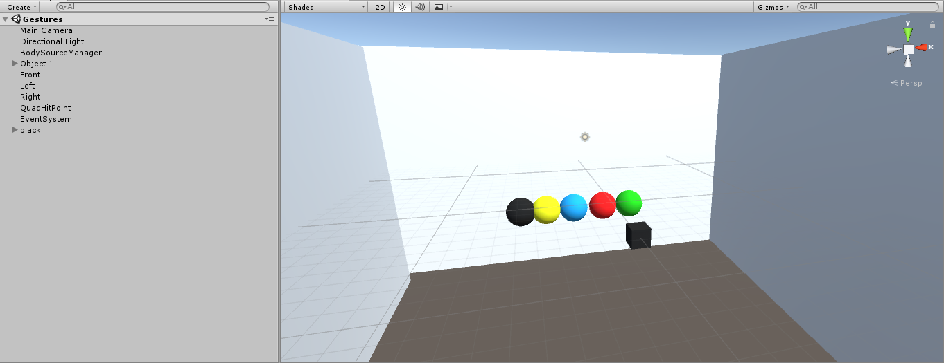

Figure 7.11 Unity Scene Setup

Finally after testing and debugging the scripts, the scene was able to run allow the cube to be controlled by the movement of the right hand. Once the cube was controlled by the movement of the hand, the cube was able to move down to the selection of coloured balls. Once the cube moved over a coloured ball the lines being generated by the trial renderer from the cube allowed the lines to change colour to the colour that was being selected.

## Sprint Four

|  |  |
| --- | --- |
| Task | Status |
| Adjust Trial Renderer | Complete |
| Apply Open And Close Hand Gestures | Complete |
| Implement GUI to scene | Complete |
| Implement Gestures to work with the GUI elements | Complete |
| Develop a second scene to implement colouring book | Complete |
| Design Menu Screen for the main scene | Complete |
| Integrate the use of a projector | Complete |

The table above displays the tasks associated in the further and final development of the painting application using Unity and the Kinect. After integrating the trial renderer, hand movement gestures and allowing the user to change colours from the previous sprint, the application was further developed in using Unity and Visual Studio, adding in the gesture signal of open and close movement of the hand. This gesture hand control was applied and developed in the DetectJoints script along with the implementation of a new trial renderer. Also the addition of a GUI panel for the ability to erase, change size of the trial renderer and changing the colours was implemented into the main painting scene.

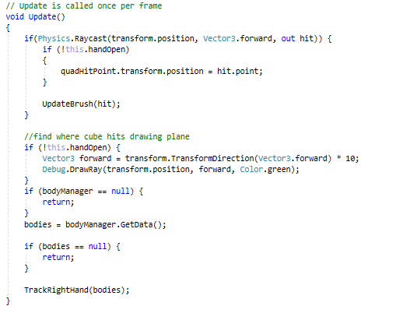

Figure 7.12 Tracking hand state

The above code shows how the hand state of the user can be tracked. If the hand is not open the ray cast will begin following the tracked hand movement and update the method UdateBrush(hit).

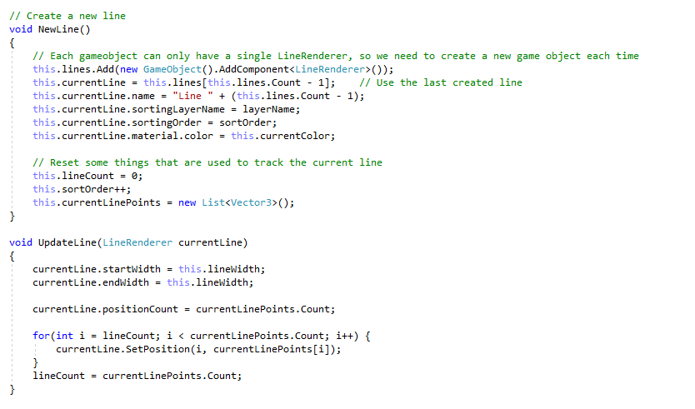

Figure 7.13 Creating a new line

The main difficulty that I faced is it was not possible to segment a TrailRenderer, what this means is that I could not start and stop drawing a line.

I got around this by using the LineRenderer gameObject. I immediatly encountered an issue where a single GameObject could not contain multiple LineRenderers, this issue was solved by keeping a list of GameObjects, each containing a LineRenderer. As lines are permanent and there is no way to erase lines in my application, I only ever need to use the top item in the List.

While I was in the process of doing this, I also extracted some of the blocks of code, such as tracking the movement or the colour sphere hit detection to their own methods in order to increase code readability.

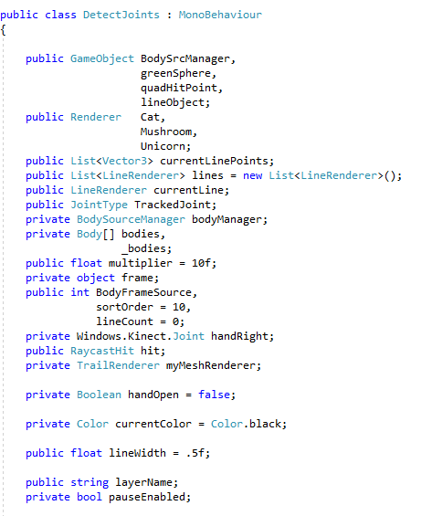

Figure 7.14 Instantiating the Variables Needed

In the detect joints class a number of variables were declared to enable the use of the images for the colouring book called public Renderer, as well as the Game Objects including lineObject that enabled the line renderer to be set up. The list also includes the tracking of the joints and the use of the body source manager script. For the stroke width of the lines being drawn, a float variable called lineWidth was made.

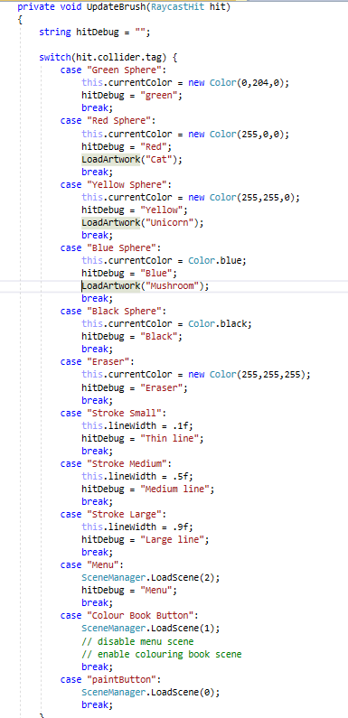

Figure 7.15 UpdateBrush Case Statement

To allow for the alternating of colours a case switch statement was set up that allowed a transition through the elements on the GUI panel. Once the objects were instantiated, they could then be called through the UpdateBrush switch statement. The inclusion of an eraser allowed the lines being drawn to be erased, as well as the different stroke width which changes depending on which size of element is picked by the user. The case statement also includes the ability to change scenes through the scene manager, when the user selects the button on the chosen screen the scene manager is called and a different scene will be produced.

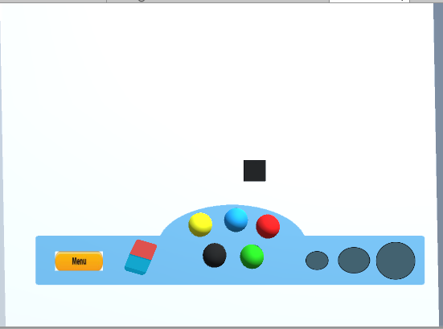

Figure 7.16 Main Painting Game Screen

The image above shows the final screen that the user will see. The black cube acts like a painting brush that is controlled by the movement and gesture of the user’s hand. The GUI pane includes a Menu button which allows the user to stop using the painting application and move back to the Menu screen. The eraser allows the user to erase and drawn line that they have made, the coloured balls is the colours that can be used in the application and the multiple different sized circles are the stroke width that can altered and changed when selected.

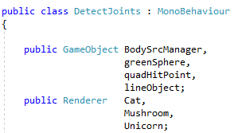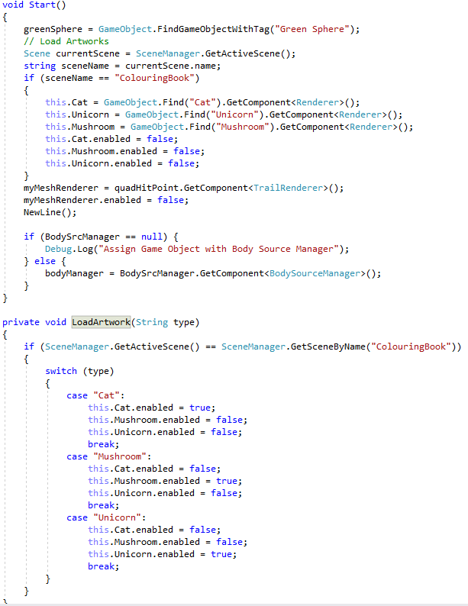

Figure 7.17 Main Painting Game Screen

For the colouring book scene to be created, first a public Renderer was initialized to hold the images. In the start method it looks to see if the current scene loaded is the ColouringBook scene, if it is it will then load the three images and call the LoadArtwork method. When an image is selected the other images will remain hidden till the user changes to a different image. This is achieved by moving through the top three colouring in an open hand state.

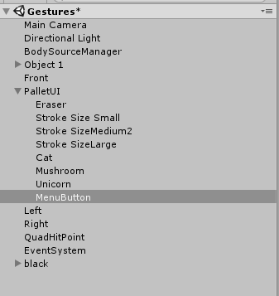

Figure 7.18 Main Painting Game Screen

In Unity a canvas was set up that allowed for the GUI elements that were made to be positioned on the screen, these included a menu button, an image of a cat, mushroom and unicorn, an eraser and the three types of stroke widths.

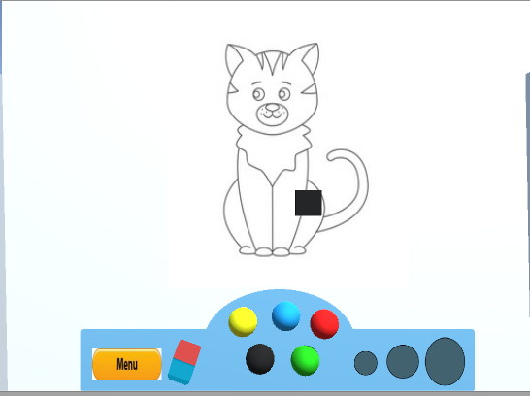

Figure 7.19 Main Colouring Book Screen

The Scene Colouring Book has the same GUI as the main painting scene, the elements of the GUI work the same as the painting scene, though three images will appear when the user moves there hand with a closed hand state over the colours red, blue and yellow. Each colour holds one of the three images that are being loaded onto the screen. Once the image is loaded onto the screen the user can then open there hand and start painting over the image.



Figure 7.20 Main Menu Scene

The image above shows the main menu screen that will be displayed on start of the application. Each of the buttons will allow the user to use both the painting scene and the colouring book scene.

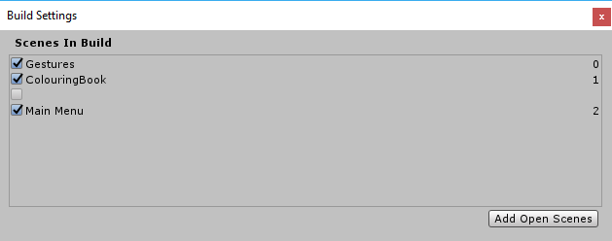

Figure 7.21 Scene Build Settings

In order for each of the scenes to load when selected by the different buttons, Unity has build settings which allows for the scenes to initialised and then used to be called in the switch case statement in the detect joints script.

# Chapter 8 Conclusions & Potential Future Implementations

Over the course of this project I aimed to answer the research question: An evaluation of students, who have been diagnosed on the Autism spectrum, to assess if they can benefit from learning in an innovative learning environment. This environment may include a two dimensional painting application or a three dimensional computer aided visual environment?

While productively designing the application I was able to develop a program that used the utilities of the Kinect sensor to track a user’s hand movements and gestures to produce art work. By the end of this thesis I can conclude that the program facilitated the user’s requirements when producing art work including an addition of images used as a colouring book.

Future work can be implemented to further produce this application, which due to time constraints could not be included this time. These implementations include, the ability to include a wider range of colours by means of a colour wheel. Allowing the addition of a save method that allows the user to save any art work by means of a database. Including a database to hold a larger quantity of images for the colouring book. The inclusion of a larger production system including multiple Kinect sensors and projectors which would allow for an immersive non-virtual CAVE system environment. The potential addition of other requirements for this application are endless.

Potential future implementations for this project can include the ability to use sound to increase the overall sensory experience for the users.

# References

Association, A. T., 2012. *Art Therapy and autism spectrum disorder integrating creative interventions,* s.l.: Art Therapy Association.

Bewley, A., Guizilini, V., Ramos, F. & Upcroft, B., 2014. *Online self-supervised multi-instance segmentation of dynamic objects,* Hong Kong, China: IEEE.

Brindley, K., 1988. *Sensors and transducers,* the University of Michigan: Heinemann.

Chang, Y.-H., Hwang, J.-H. & Fang, R.-J., 2017. *A joyful Kinect-based learning system,* Sapporo, Japan: IEEE.

Council, N. R., 1995. *Expanding the Vision of Sensor Materials,* Washington, DC: The National Academies Press.

Demitševa, S., 2015. *GESTURE BASED COMPUTER CONTROLLING USING KINECT CAMERA.* [Online]   
Available at: https://www.tuit.ut.ee/sites/default/files/tuit/atprog-courses-bakalaureuset55-loti.05.029-sandra-demitsheva-text-20150525.pdf  
[Accessed 22 Febuary 2018].

Frith, U., 2008-10-23. *Autism : A Very Short Introduction.* 1st ed. London: Oxford University Press, UK.

Gorman, C., 2013. *Microsoft Kinect Learns to Read Hand Gestures, Minority Report-Style Interface Now Possible.* [Online]   
Available at: https://spectrum.ieee.org/automaton/robotics/robotics-software/microsoft-kinect-hand-gesture-control  
[Accessed 16 03 18].

Hesham Alabbasi, A. G. F. M. A. M., 2015. *Human motion tracking & evaluation using Kinect V2 senso,* Iasi, Romania: IEEE.

J.C.Norton, 2008. *MOTION CAPTURE TO BUILD A FOUNDATION FOR A COMPUTER-CONTROLLED,* USA: ProQuest LLC.

Jorg Hoffmann, B. B. B. K., 2010. *Automatic Calibration of a Motion Capture System based on Inertial Sensors for Tele-Manipulation,* Madeira, Portugal,: In proceedings of 7th International Conference on Informatics in Control, Automation and Robotics (ICINCO), .

Kaur, K., 2012. *Motion Capture Sensor Systems.* [Online]   
Available at: https://www.azosensors.com/article.aspx?ArticleID=43  
[Accessed 18 11 2017].

Kumar, S., 2013. *Motion Sensing Technology.* [Online]   
Available at: https://www.slideshare.net/gsantosh031/my-seminar111

Linn, A., 2016. *Talking with your hands: How Microsoft researchers are moving beyond keyboard and mouse.* [Online]   
Available at: https://blogs.microsoft.com/ai/talking-hands-microsoft-researchers-moving-beyond-keyboard-mouse/#sm.0000meltgw42ef7bto31aans43fol  
[Accessed 16 March 2018].

Lion, K., 1969. *Transducers: Problems and Prospects,* Masssachusetts: IEEE.

Liza Egorova, A. L., 2015. *Determination of workspace for motion capture using Kinect,* Riga, Latvia: IEEE.

Mallett, W., 2013. *Kinect-Based Art System Improves Disabled Children's Motor Skills.* [Online]   
Available at: https://creators.vice.com/en_uk/article/vvz9ax/kinect-based-art-system-improves-disabled-childrens-motor-skills  
[Accessed 16 March 2018].

Manning, M., 2010. *The role of high-level play as a predictor social functioning in autism,* s.l.: J Autism Dev Disord.

Meisner, J., 2013. *The Official Microsoft Blog.* [Online]   
Available at: https://blogs.technet.microsoft.com/microsoft_blog/2013/10/02/collaboration-expertise-produce-enhanced-sensing-in-xbox-one/  
[Accessed 12 11 17].

Murdock, L., 2006. *Teaching reciprocal imitation skills to young children with autism using a naturalistic behavioral approach: effects on language, pretend play, and joint attention.,* s.l.: J Autism Dev Discord.

Murdock, L., 2010. *Picture Me Playing: Increasing Pretend Play Dialogue of Children with Autism Spectrum Disorders.,* s.l.: I Autism Dev Discord.

Pradeep, 2016. *The official Windows 10 Driver for the Kinect v2 now available.* [Online]   
Available at: https://mspoweruser.com/official-windows-10-driver-kinect-v2-now-available/  
[Accessed 19 11 2017].

S., W., 2004. *The history of autism,* UK: Eur Child Adolesc Psychiatry..

Schweizer, C., 2014. *’ The Arts in Psychotherapy.* 5th ed. s.l.:s.n.

Skarredghost, 2016. *The Ghost Howls.* [Online]   
Available at: https://skarredghost.com/2016/12/02/the-difference-between-kinect-v2-and-v1/  
[Accessed 12 11 2017].

Vairamohan, R., n.d. *KinectDraw: A Kinect based digital tool to visualize 2D figures and edit them in real time.* [Online]   
Available at: http://www.vrohit.com/wp-content/uploads/2014/01/final-project.pdf

Valoriani, M., 2015. *Programming with kinect v2.* [Online]   
Available at: https://www.slideshare.net/MatteoValoriani/programming-with-kinect-v2  
[Accessed 19 11 2017].

Wilhelm, A., 2013. *Techcrunch.* [Online]   
Available at: https://tctechcrunch2011.files.wordpress.com/2013/10/2013-10-02_13h07_34.jpg  
[Accessed 12 11 17].

Wilson, J. S., 2004. *Sensor Technology Handbook,* Oxford: Elsevier Science.

Wolff, S., 2004. *The history of autism,* Edinburgh: European Child & Adolescent Psychiatry.

Xsenss, 2014. *The fascination for motion capture - Xsens 3D motion tracking.* [Online]   
Available at: https://www.xsens.com/fascination-motion-capture/  
[Accessed 18 11 2018].