**Web Technologies CA**

**JavaScript 2d Game**

**Research**

There is a game called Bunny Hunt with has a mouse click event which kills the bunnies when you click them.

<http://www.themaninblue.com/experiment/BunnyHunt/>

Also done some research on PacMan which this example was done in JavaScript.

<http://www.digitalinsane.com/archives/2008/08/30/pacman/>

**Previous Game Idea’s**

1Player against a UI

Player shoots at chickens that fire out of a cannon.

Player has one shot per chicken, if player misses his shot the chicken spawns by the player. If the screen fills with chickens it'll be Game Over and the AI wins.

Cannons fire the chickens, with the cannons moving to a new area on the screen after each shot.

Player aims with a mouse and clicks to fire.

The cannons fire at random angle from a random distance of the player. (Physics formula to do this)

Images/background will all be created using sprite. (Kenny.nl or Open Game Art).

**UI Screen Ideas:**

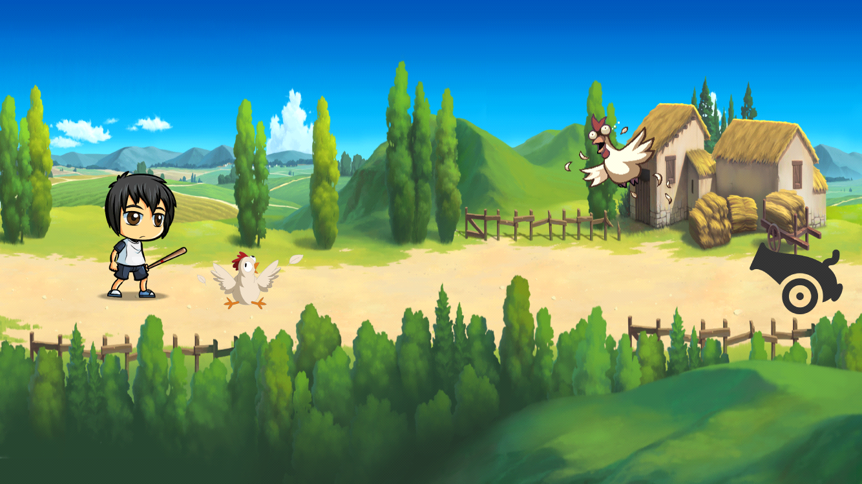

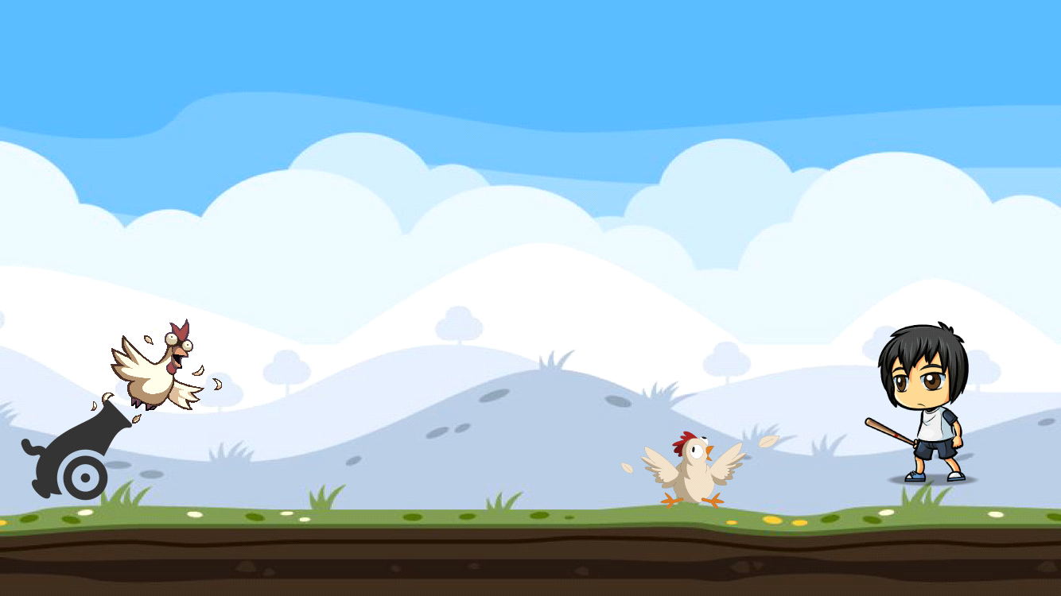

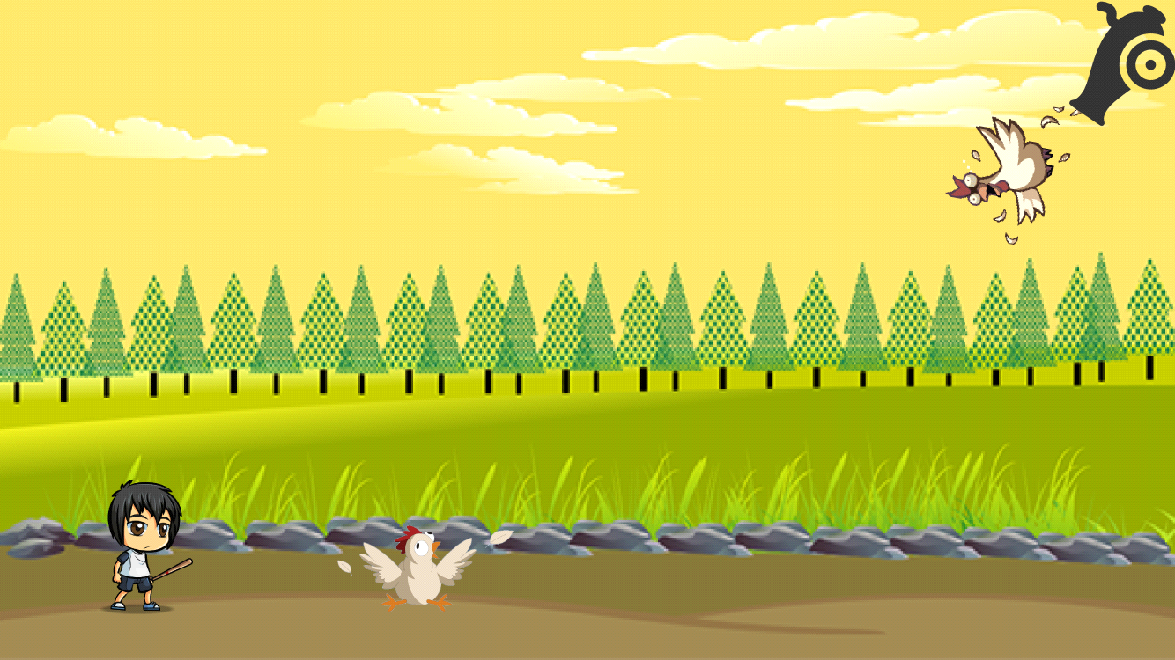

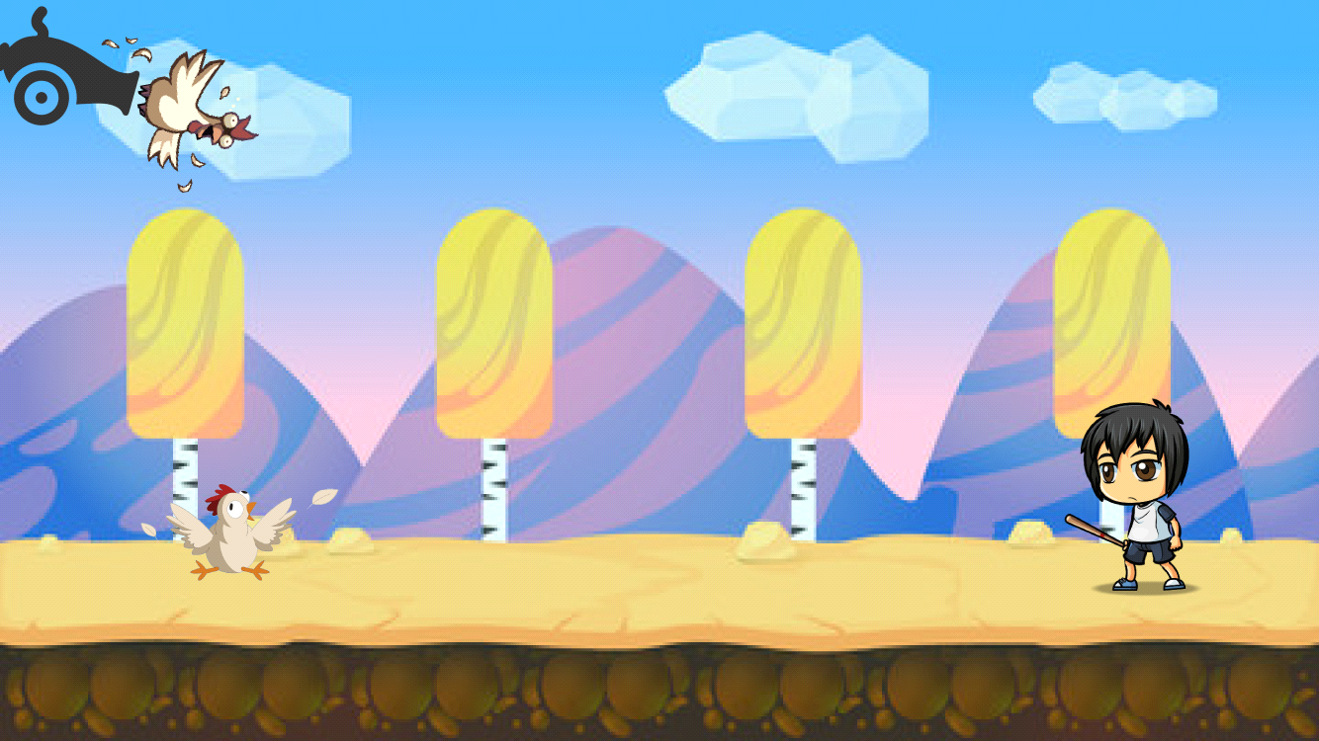

**Zombie shooter Game**

**Components:**

* Zombie Killer
* Top down game
* 2 player game zombie killers
* AI zombies

**Player Conditions:**

Player begins with a gun that fires bullets. The number of bullets that the player can shoot will have a limit of 5. The player’s aim is to kill all zombies that appear on the screen. When a player misses a zombie and that zombie reaches the players side of the screen, the player’s life counter decreases by one. The player will have a certain number of lives either 10 or 20, the player can be instantly killed when a zombie comes in contact with the player. There will be a score counter that will increase by the amount of zombies that are killed.

**Player Controls**

The player will be able to move up, down, left and right by the arrow key’s on the keyboard.

**Zombie**

The zombies will randomly spawn on the other side of the game then will proceed to walk towards the player. The aim of the zombies is to kill the player or to decrease the player’s health counter each by either reaching the player or by reaching the player’s side of the game.

**Game Level’s**

Score Total 5

The first level will see the zombies maintain a slow and steady speed.

Score Total 10

The second level will see the zombies speed increase

Score Total 20

The third level will see the zombies speed increase and the spawn rate of the zombies increase as well.

**Possibilities for the game**

A second player can be added so the game can have two players. The second player’s controls will be the WASD keys on the keyboard.

Alternative weapons that the player can use or that the zombies may drop when killed.

**Audio**

In the game there will be audio applied to the zombies being spawned on the screen, this maybe groaning sounds or other zombie noises.

The player will have sound for each time the gun shots, this maybe the sound of type of gun.

When the player loses and die there will be sound to indicate that it is game over.

If the player is able to move up a level there will be a slight audio indicating a level has just begun.

References

"Backgrounds For Topdown Games". *OpenGameArt.org*. N.p., 2016. Web. 7 Dec. 2016.

"Cite A Website - Cite This For Me". *Chupamobile.com*. N.p., 2016. Web. 7 Dec. 2016.

"Cite A Website - Cite This For Me". *Craftpix.net*. N.p., 2016. Web. 7 Dec. 2016.

"Cite A Website - Cite This For Me". *Andrewphillippi.files.wordpress.com*. N.p., 2016. Web. 7 Dec. 2016.

"Cite A Website - Cite This For Me". *Rpg-maker.fr*. N.p., 2016. Web. 7 Dec. 2016.

"CSS Font-Family Property". *W3schools.com*. N.p., 2016. Web. 7 Dec. 2016.

"Free 2D Character Sprites - Google Search". *Google.ie*. N.p., 2016. Web. 7 Dec. 2016.

"Free Game Assets". *Game Art 2D*. N.p., 2016. Web. 7 Dec. 2016.

"HTML5 Canvas Image Tutorial". *Html5canvastutorials.com*. N.p., 2016. Web. 7 Dec. 2016.

"HTML5 Canvas Text Color Tutorial". *Html5canvastutorials.com*. N.p., 2016. Web. 7 Dec. 2016.

"Image()". *Mozilla Developer Network*. N.p., 2016. Web. 7 Dec. 2016.

"Javascript Array Splice() Method". *W3schools.com*. N.p., 2016. Web. 7 Dec. 2016.

"Javascript Game Development - Keyboard Input · Nokarma.Org". *Nokarma.org*. N.p., 2016. Web. 7 Dec. 2016.

"Javascript Random() Method". *W3schools.com*. N.p., 2016. Web. 7 Dec. 2016.

"Keyboardevent". *Mozilla Developer Network*. N.p., 2016. Web. 7 Dec. 2016.

"Lost Garden". *Lostgarden.com*. N.p., 2016. Web. 7 Dec. 2016.

Malone, William. "Create A Game Character With HTML5 And Javascript - Part 2". *Williammalone.com*. N.p., 2016. Web. 7 Dec. 2016.

"Photo By Lee Brady". *Photobucket*. N.p., 2016. Web. 7 Dec. 2016.

time, HTML5. "HTML5 JS Play Same Sound Multiple Times At The Same Time". *Stackoverflow.com*. N.p., 2016. Web. 7 Dec. 2016.