2017 Land Trust Salaries and Benefits Survey

Katie Chang

November 2017

First conducted in 2000, the Land Trust Salaries and Benefits Survey is the only comprehensive source of staff compensation data exclusively for the land trust community. For general information, please see <http://www.lta.org/salarysurvey>.

# Survey Respondents

The 2017 survey gathered data from 271 organizations from 47 states and the District of Columbia with at least one full-time paid staff member. We estimate that the number of responses represents about 47 percent of staffed land trusts.

# Questions to Consider

* What factors determine how much an executive director is paid?
* What is the pay gap between male and female executive directors?
* Does it change with years of experience, operating budget, and number of full-time staff?
* For non-ED positions, how do salaries compare across job categories and experience levels?
* Do organizations that pay less compensate by offering more generous benefits? Or do larger organizations tend to offer both higher salaries and better benefits?

Let's start by reading the raw data CSV file to see what we've got and start some clean-up.

## Data Clean-up

The online survey did not enforce input validation so we'll need to remove extraneous dollar signs and commas from numeric fields such as Budget, EDsalary, YearsExp, and YearsExpOtherOrgs.

Because this was a fairly long survey, it was not uncommon for respondents to leave some questions blank. To avoid dropping entire responses due to a few NA values, I'll wait until after we start pulling out subsets of columns to drop NA rows.

Since we'll be using the budget and ED salary columns frequently, I'll remove a few obvious outliers, such as respondents that entered the budget year or any budget less than 1000. It's not feasible for an organization that has at least one full-time paid staff to have a budget that low. Similarly, any ED salary should be greater than 0.

## Summary of Key Metrics

This summary shows the range of respondents in our dataset.

|  |  |  |  |  |
| --- | --- | --- | --- | --- |
|  | Mean | Median | Min | Max |
| Budget | 1359214 | 618284.5 | 50000 | 18200000 |
| # of FT Staff | 8.690476 | 5 | 1 | 99 |
| ED Salary | 97219.88 | 84623.5 | 22880 | 335000 |
| ED Years at Current Organization | 8.714563 | 5 | 0 | 35 |
| ED Years at Other Conservation Organizations | 2.114339 | 0 | 0 | 32 |

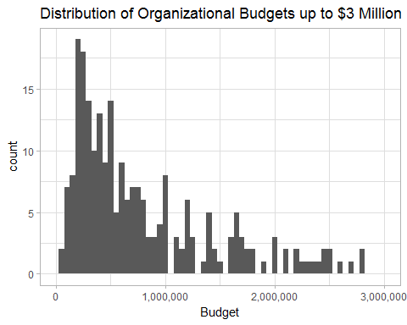

## Executive Director Salaries

Do organizations with larger budgets pay their executive directors higher salaries? The answer appears to be yes.

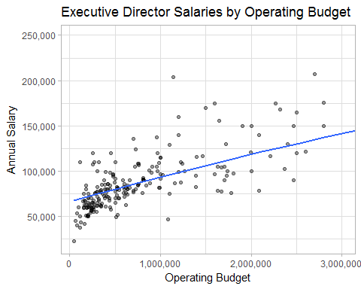

Organizations with more staff also pay their executive directors higher salaries.

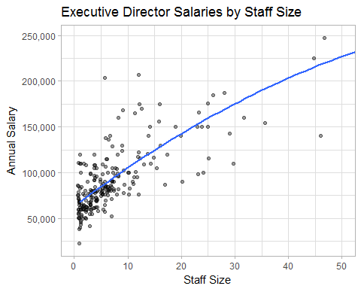

But notice how these graphs change when you take the executive director's gender into consideration. Women are paid less to lead organizations with the same operating budget.

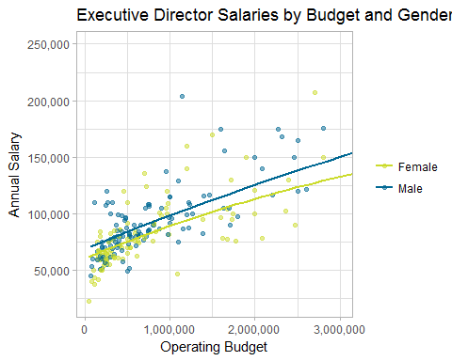

Women are also paid less to lead organizations with the same number of staff:

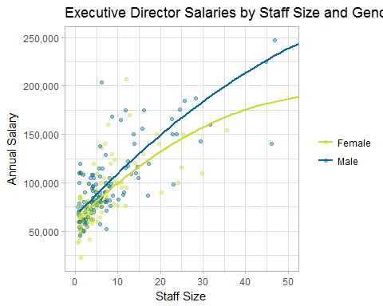

For organizations with budgets over $5 million or more than 30 staff, there are noticeably fewer led by women:

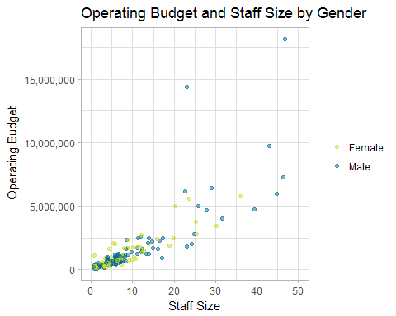

Maybe male executive directors are paid more because they have longer tenures--i.e., they stay with the organization for more years. Let's compare years at the current organization to salary.

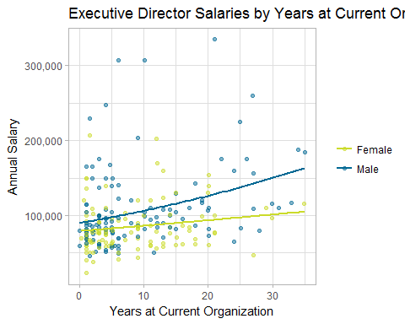

The survey also asked about years of experience at other conservation organizations, so we can also try plotting total years of experience: years at the current organization and at other conservation organizations. Unfortunately the graph is nearly identical to the one above.

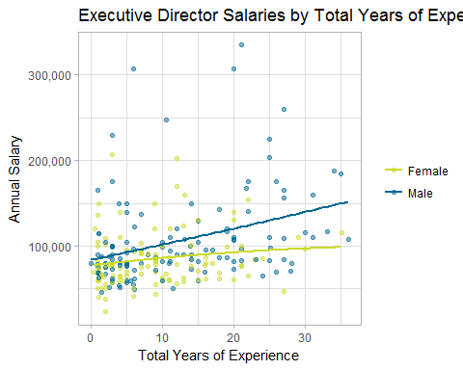

What is the pay gap between male and female executive directors' salaries?

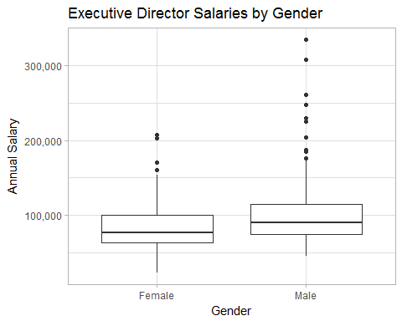

## gender mean median stddev  
## 1 Female 84946.52 77334 32780.79  
## 2 Male 105830.91 90000 52684.33

### Predictive Model

By building a linear regression model to predict an executive director's salary, we can gain some insight into which variables carry the most weight and their effect on salary. After some trial and error, these four variables yield the best predictive model:

*1.* Operating budget

*2.* ED gender (female = 0, male = 1)

*3.* Years of experience at current organization

*4.* Total number of full-time staff

##   
## Call:  
## lm(formula = salary ~ budget + gend + years_exp + FTstaff, data = edsalaries_mf)  
##   
## Residuals:  
## Min 1Q Median 3Q Max   
## -61935 -14755 -4687 10063 150078   
##   
## Coefficients:  
## Estimate Std. Error t value Pr(>|t|)   
## (Intercept) 6.159e+04 3.166e+03 19.452 < 2e-16 ***  
## budget 5.490e-03 1.500e-03 3.660 0.000312 ***  
## gend 1.017e+04 3.521e+03 2.889 0.004225 **   
## years_exp 6.414e+02 2.183e+02 2.938 0.003634 **   
## FTstaff 1.886e+03 2.859e+02 6.597 2.81e-10 ***  
## ---  
## Signif. codes: 0 '***' 0.001 '**' 0.01 '*' 0.05 '.' 0.1 ' ' 1  
##   
## Residual standard error: 26700 on 232 degrees of freedom  
## Multiple R-squared: 0.6664, Adjusted R-squared: 0.6607   
## F-statistic: 115.9 on 4 and 232 DF, p-value: < 2.2e-16

Looking at the gender coefficient, on average, male executive directors are paid $10,170 more than a female director with the same number of years of experience, budget and number of staff.

For both males and females, on average, executive director salary corresponds to:

* An increase of $1886 for each additional staff person;
* An increase of $641 for each additional year of experience; and
* An increase of $549 for each additional $100,000 of operating budget.

# Other Staff

The survey also asked about salaries for 10 job categories with three levels each. Experience levels represent the years of experience required for the position and are defined as follows:

* Entry-Level: Fewer than two years of experience
* Mid-Level: 2 to 7 years of experience
* Senior-Level: More than 7 years of experience

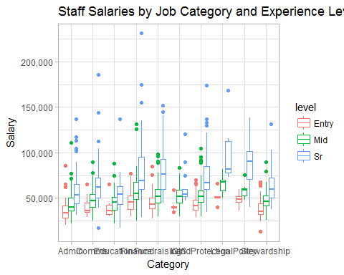

Generally, finance and fundraising positions tend to pay higher salaries across all 3 experience levels. Senior-level legal positions are by far the highest-paid, with an average salary of more than $100,000.

Average Salaries by Job Category and Experience Level

|  |  |  |  |
| --- | --- | --- | --- |
| category | Entry | Mid | Sr |
| Admin | 36918.41 | 44369.70 | 59185.80 |
| Comms | 39602.79 | 48005.25 | 66663.45 |
| Education | 39775.00 | 46878.10 | 58035.82 |
| Finance | 48061.75 | 59811.14 | 80247.64 |
| Fundraising | 46125.26 | 54409.81 | 80190.95 |
| GIS | 41491.33 | 53902.84 | 61769.50 |
| LandProtection | 43562.19 | 54002.62 | 74123.77 |
| Legal | 51595.00 | 65699.70 | 100541.86 |
| Policy | 48642.17 | 58041.00 | 86155.44 |
| Stewardship | 38609.90 | 47682.66 | 62267.41 |

## Comparison of Salaries to Benefits

It's often suggested that organizations which pay lower salaries offer better benefits to compensate. The counter argument is that larger organizations can afford to offer both higher salaries and better benefits.

### Staff Salary Index

We'll use the salaries across all non-ED categories and levels to compute an "index of salaries" for each organization. We start by calculating the difference between the average salary and reported salary for each job category and level. If a particular organization's reported salary is above the average, the value is positive and if it is below average, the value is negative. The index is the sum of these differences.

### Benefits Index

For purposes of this analysis, we'll use the following indicators to compute an "index" of benefits, with a Yes = 1 and No or blank = 0:

* Paid maternity leave
* Paid paternity leave
* Paid family leave
* Paid sabbatical leave
* Flextime
* Telecommuting
* Teleworking
* Employee health insurance
* Employee dental insurance
* Employee long-term disability
* Employee short-term disability
* Employee life insurance
* Retirement benefits

Since we asked about vacation leave for first-year and fifth-year staff separately, we'll assign a value of zero, 0.5 or 1 based on the following criteria:

*First year of employment*

* 10 or more days = 1
* Fewer than 10 but more than 5 = 0.5
* Fewer than 5 = 0

*Fifth year of employment*

* 15 or more days = 1
* Fewer than 15 but more than or equal to 10 = 0.5
* Fewer than 10 = 0

The maximum possible score for the benefit index is 15, with the average and median at 6.5.

## Min. 1st Qu. Median Mean 3rd Qu. Max.   
## 0.00 4.75 6.50 6.54 9.00 15.00

Comparing the benefits index to operating budget, the levels of benefits offered increases with budgets up to $1 million but level off for budgets between $1 million and $2 million.

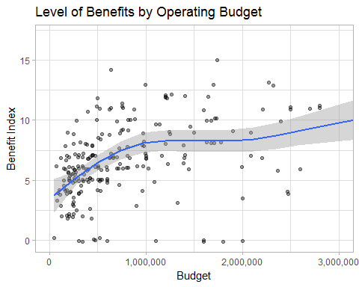

Similarly, benefits improve for organizations with up to 10 full-time staff but stay level or drop slightly when there are more than 10 staff.

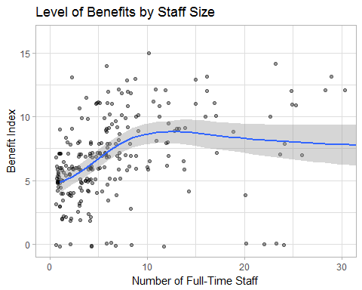

With the exception of a few outliers, the staff salary index remains fairly constant regardless of the number of benefits offered. This means that there is no general trend toward lower salaries being offset by better benefits.

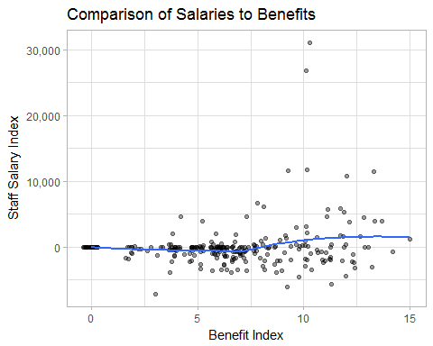

Looking at a comparison of budget to the salary index suggests that across non-ED job categories, staff at larger organizations are paid comparable salaries as their peers at smaller organizations. This stands in contrast to executive directors whose salaries increased with both budget and staff size.

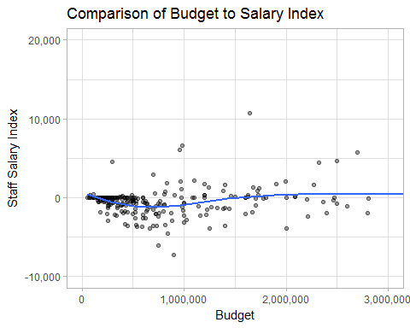

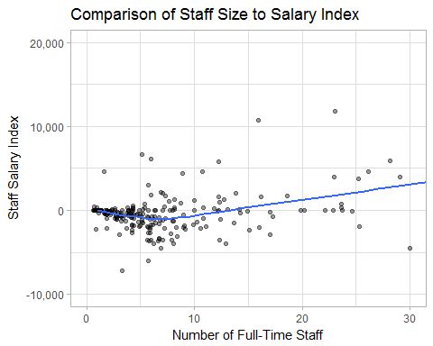

With our benefits index, let's take one last look at executive director compensation as a combination of both salary and benefits.

The graph below suggests that for a given level of benefits, female directors are paid consistently less than their male counterparts.

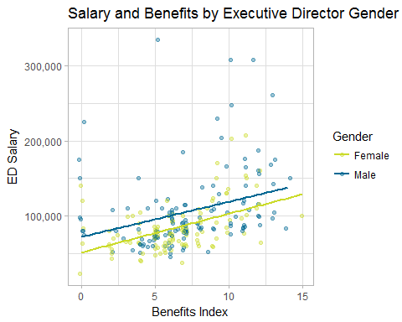

It's often suggested that female executive directors accept lower pay in exchange for more flexible work schedules. We can look specifically at these policies rather than the benefits package as a whole.

We'll create a "Flex Index" which summarizes whether the organization offers flextime, teleworking or telecommuting options. The index ranges from zero (none offered) to 3 (all offered).

The bar graph below shows that for all levels of workplace flexibility, women are still paid less than men at organizations with the same policies. It's interesting to note that the gap is largest for organizations with the least flexibility (index = 0).

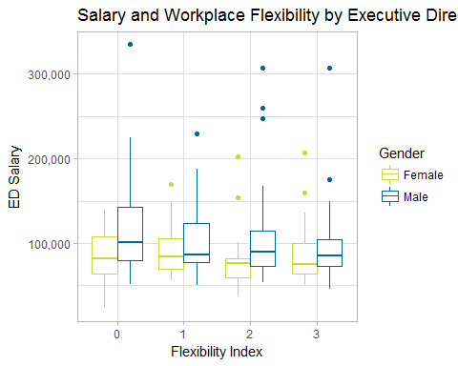

## Conclusions

Key findings of this project analysis include:

* On average, male executive directors are paid $10,170 more than a female director with the same number of years of experience, budget and number of staff. This disparity persists regardless of whether the organization offers better benefits or more workplace flexibility.
* The second-largest factor in executive director compensation is staff size, with an average increase of $1886 for each additional full-time staff person.
* Benefits steadily improve as an organization's budget reaches $1 million or 10 full-time staff but largely level off above this point.
* There does not appear to be any evidence for the anecdotal claim that organizations paying lower salaries offset this by offering better benefits. Generous benefits packages are offered by organizations paying both higher and lower than average staff salaries.
* In contrast to executive directors whose salaries increased with both budget and staff size, staff at larger organizations are paid comparable salaries as their peers at smaller organizations.

### Recommendations

* Distribute these findings internally at the Alliance and with external audiences as appropriate to build awareness of the gender disparity in executive director salaries.
* Conduct this analysis with data from the next salary survey in 2020.

### Further Analysis

Potential avenues for further analysis using the 2017 data could include:

* incorporating the states of operation data to consider an organization's location (state or region) or scope (number of states);
* cross-referencing Census data on acres of land protected as a measure of organizational effectiveness;
* extending the gender pay gap analysis to other staff positions by asking for number of male and female staff in future editions of the survey.