Research Report
- Title
Structural Insights into Minnesota’s Research Ecosystem: A Comparative Network Study of Federally Funded Grants with a Special Focus on AI
- Abstract
The rapid growth of artificial intelligence (AI) and generative AI tools in particular is reshaping research, science and technology, yet there is a lack of evidence about how AI-related research is integrating and interaction within their regional scientific ecosystems. This pilot study analyzes NSF and NIH funded grants from 2024-2025 to characterize the structure of Minnesota’s funded research network and compares it to a subset of the grants that include AI techniques, tools or technology. The study uses publicly available grant award data and creates a graph database and knowledge graph in Neo4j. The relationships between funding agencies, grants, principal investigators, organizations, and research themes are examined through network analysis measures such as PageRank, betweenness centrality, modularity, and community structure. These measures are compared between the full graph and AI subgraph and then again between the AI subgraph and non-AI subgraph to determine any distinguishing characteristics the AI-related research has. AI-related projects are identified through a vocabulary from OECD and the Stanford AI Index, while grants are categorized by disciplines from the Frascati Manual.
Result show that Minnesota’s federally funded research ecosystem is highly centralized, with the University of Minnesota anchoring connectivity and funding awards. The AI subnetwork forms a smaller, but distinct structure: it has higher rates of isolated projects, but contains larger cohesive clusters made up from smaller institutions acting as bridges in collaboration.
By combining a state-level funding lens with science-of-science and network analysis methods, this study contributes to understanding the patterns and characteristics of AI-related research in a regional network, how it connects entities in the ecosystem, and provides insights on gaps or important connections. The findings and interactive knowledge graph visualization tool are intended to inform strategy, funding decisions, and responsible, proactive AI innovation planning in Minnesota.
- Keywords
Science of Science, Knowledge Graph, Research Funding, Collaboration Networks, AI, Regional Innovation
- Introduction/Background
Grant-based funding has large implications for a domain’s ability to conduct scientific research and drive innovation. The research funding landscape across the United States includes federal funding, state funding, private foundations and non-profit organizations, corporate and industry funding, and philanthropic funding, among others. Funding’s impacts, as well as scientific development itself (science of science), have been studied extensively and offer us a more clear view into what factors facilitate scientific progress by examining different patterns that exist in the creation and dissemination of knowledge. Lots of tools and methods exist to analyze these factors; network analysis, in particular, provides useful information on the relationship-driven aspects of science, such as researcher centrality and importance, and collaboration and information flow. There exist a number of databases and analyses at the national level with science and funding as a focus. However, the literature points out that a scientific network in a smaller, sub-regional ecosystem may be quite distinct. Considering the unique selection of Minnesota’s funding options, position in health-focused innovation, and serving as the home of an educational research giant, there remains a need to examine Minnesota’s research ecosystem and funding systems at a state level.
As the field of artificial intelligence (AI) and recent introduction of landscape-changing technologies such as generative AI barrel forward, it is essential that research about AI as a field in itself and as a method applied to various disciplines propels along with it. This includes its impacts on society, the environment, and governance at the regional level. Due to the rapid development and utility of these methods and tools, states and regional stakeholders are being forced to make decisions without a robust body of research from which to inform those decisions, and they may lack the scientific evidence needed to make informed policy decisions and appropriately plan for resource allocation, infrastructure and energy demands, water usage regulation, workforce preparation and more. This study thus hypothesizes this being the case in Minnesota as well and both seek to quantify this gap as part of its analysis and add to the literature about the existing state of funded AI research within the state.
The purpose of this study is to serve as a pilot study analyzing Minnesota’s research grants funded by a subsection of the available funding institutions: the federally funded National Science Foundation (NSF) and the National Institute of Health (NIH)- two of the state’s largest research funders. The dataset therefore characterizes the structure of Minnesota’s NSF and NIH-funding research ecosystem, with a specific focus on a subset of grants related to artificial intelligence. It constructs a network-based model of this ecosystem to analyze the structural, institutional, and thematic characteristics uncovered by network analysis techniques of AI-related research within the larger system. Through this comparison, the study aims to utilize network analysis to identify concentration, fragmentation, collaboration patterns, and thematic or interdisciplinary characteristics of funded AI-related research as it exists from 2024-2025. The results of this study are intended to 1. Serve as a state-level stepping stone for understanding funded research, 2. contribute towards filling the gap of research about AI-related by conducting an analysis of the ‘science of science’ of AI-related research in Minnesota, and 3., to inform decision-making regarding research funding, strategy, and policy adjacent to this discipline and its expansion into different fields of science.
- Research Questions
- RQ1. What are the structural characteristics (collaboration, community structure, lead innovators, and thematic composition) of Minnesota’s NSF- and NIH-funded research ecosystem as revealed through a graph-based network model?
- RQ2. What structural characteristics (interdisciplinarity, funded innovation concentrations, connected or siloed researchers) define Minnesota’s AI-related funded research within the NSF/NIH funding ecosystem?
  - How do the structural patterns of AI research differ from those of the broader funded research ecosystem?
  - How might these patterns inform statewide planning for AI research and innovation?
- RQ3. What research themes are most and least represented within Minnesota’s AI-related NIH/NSF grant funded projects, and does this indicate potential gaps in areas such as sustainability, planning, or public-sector AI readiness?
- Scope of the Project
The scope of the study includes investigating grant and research activity funded by two federal funding institutions, the National Science Foundation (NSF) and the National Institute of Health (NIH), and the grants administered by these organizations to principal investigators and their organizations in Minnesota from 2024-2025.
The study looks more widely at all themes covered in grant-funded projects, what communities exist, and examines funding patterns. It then focuses on grant-funded projects that include the use of artificial intelligence to understand how these same patterns may align or differ within the scope of AI-related research.
The main purpose of the wider scope of grant-funded research is to understand Minnesota’s research funding landscape, to offer insights into major innovation hubs or communities, and identify how funding shapes these communities. The secondary purpose of the project is gain and compare the same insights on the funding ecosystem with a focus on AI-related research.
Network analysis-based metrics will be conducted on the full network and then use subgraphs to examine:
  - The full network compared to the AI-related subnetwork.
  - The AI-related subnetwork to the non AI-related subnetwork.

- Literature Review
7.1 Introduction to Research Funding Ecosystems and their Challenges
Research funding has been shown to shape research agendas, collaboration patterns, and regional innovation, yet the literature consistently highlights how difficult it is to evaluate these effects at scale. Several studies highlight the difficulty of evaluating the effects of research funding, citing the multitude of sources, types, scopes, and overlapping nature of these funding sources [1]. Addressing this, some researchers narrow the problem scope to be able to examine important aspects of research funding patterns, such as equitable allocation of grant funding by a single grant-funder from a particular time period [2]. Recent work offers definitions and processes to be able to tackle the problem, and downstream tools with various impact metrics to explore the impact of science funding on science itself, finding that these tools aid in the needs of its target users and that the ecosystem-wide datasets and analysis framework aid in visualization and science of science research [1, 3].
7.2 Network Science & Graph Theory in Research and Innovation Studies
Network science has developed through different progressions of theory and computation. There is a large body of work existing on top of that, which is specific to scientific collaboration networks. Much of this research is split into innovation or collaboration networks, using research publications and citations as integral measures. It began with classical graph theory and evolved into relational models of influence, community, and collaboration. Several metrics and methodologies form the basis for analyzing scientific collaboration networks: centrality, PageRank, shortest path and connectivity, and community detection.
The first theoretical work is centrality, theorized first by Bavelas in 1948 as a conceptual description of communication and centrality in human networks [4]. Graph theory and centrality are introduced, centrality being described as the center point in a star, the most central position, falling on the geodesics “between the largest possible number of other points and, since it is located at the minimum distance from all other points, it is maximally close to them” [5]. This developed into work by Freeman and Linton in 1979 focusing on social networks and formalizing measures of degree, closeness, and betweenness.
The second main idea is measuring influence, or link-based ranking. This was developed by Brin and Page in the late nineties and was introduced with the concept of Google, using PageRank as the search engine’s main feature, being a quality ranking for each related page, using links to improve search results. It calculates a ‘citation importance’, scoring higher if it is pointed to by many other pages, or if pages that point to it, have a higher rank. Hit counts are computed, ran through lookup tables, and then transformed into a rank. They later compare and contrasts web pages with academic publications. PageRank uses external information to rank the web pages using their backlinks, which can be understood as a type of peer review [6]. The concept of PageRank is still heavily used in network analysis, and goes beyond degree centrality, in that it serves as the basis for detecting influence, cluster identification, and structural importance.
Another important aspect of network analysis is that of shortest path and connectivity. Two foundational papers in this domain are by Kruskal Jr., et al. and Dijkstra, E.W. from 1956 and 1959. Kruskal Jr.’s paper build on the ‘travelling salesman’ problem; “If a finite connected graph has a positive real number attached to each edge […], and if these lengths are all distinct, then among the spanning trees of the graph there is only one, the sum of whose edges is a minimum; that is, the shortest spanning tree of the graph is unique” [7]. The Dijkstra paper offers improved solutions to two problems in graph connections: 1. Constructing the tree of minimum length between two n nodes, and 2. Finding the path of minimum total length between two nodes. This improved solution reduces the amount of work to be done by showing that data storage can be reduced to branches in particular sets, which is always less than n [8].
Finally, a section of graph theory and network analysis that is particularly relevant to this study, is that of community detection. A well-cited article that covers community detection in social and biological networks is by Girvan, M., & Newman, M.E.J. It builds on previous statistical properties of network systems, and highlights a ‘community structure’, which are nodes that exist in tight groups, with looser connections between these groups [9]. It proposes a method of detecting these communities using centrality indices to define boundaries of a community, including that of a collaboration network of scientists, where previous work focused on hierarchical clustering [9]. Additional key findings here are that communities correlate with scientific discipline, and that these subcommunities seem to follow the interests of a dominant member [9]. Another finding relevant to our AI-related subnetwork is that communities seemed to be grouped by research topic or methodology and technical approach. The use of community detection is emphasized through the research as aiding scientists to understand and exploit networks more effectively [9]. Work from the 2000’s builds on Newman’s work by simplifying the algorithm involved in community detection, improving its time complexity, introducing benchmark graphs for testing, and offering comprehensive meta studies on the topic improving protocols of the fundamentals and comparison of existing algorithms [1, 10, 11].
These fundamental metrics in graph analysis are well-established through the literature on their application to community structure and scientific collaborations. These well-established existing theories and methods shape the approach to be used in this study to measure connectivity, community detection, influence, and centrality of researchers and organizations within our larger ecosystem, and the AI subgraph.
7.3. Graph Databases in Research Evaluation & Science of Science
Literature on the ‘Science of Science’ is comprehensive and vast, serving as a deep research domain which studies the “interactions between scientific agents and provides insights into the conditions from which scientific discovery is produced” [3]. Several studies describe the existence of patterns that characterize scientific emergence though studying collaborative networks and discoveries using citation networks. The authors comment on the patterns of scientific impact that are relevant to the AI space as it exists currently. It describes that “the highest impact science is grounded in conventional combinations of prior work, but feature unusual combinations” [3]. They share the idea that identifying drivers of science and creating predictive models to understand its evolution are invaluable for the “design of policies that can improve the scientific enterprise” [3].
They describe some of the previously mentioned metrics, such as ‘betweenness’ as an indicator of interdisciplinarity and institution-level ranking. One article summarizes the purpose of studying social dynamics of scholarly communities as driving the evolution of disciplines and topics, [… and, therefore] the future trends in science can be captured by predicting the collective behavior of scientists” [3]. A model by Sun et al. describes the dynamics of discipline evolution- the key idea being that new scientific fields emerge from the splitting and merging of these groups. Finally, most of this scholarly work includes quantification methods of scientific collaboration as being betweenness centrality, degree centrality, eigenvector centrality, and the clustering coefficient of the primary investigator in a collaboration network [3].
As our primary research questions involve the study of a scientific network, stemming from funding organizations, the forementioned studies build the case of framing our study within the science of science literature and its recommendations of a graph model for analyzing this problem. It also informs the importance of a researcher-focus to understand how AI may develop through Minnesota’s scientific network and provides us with quantification methods of measuring these collaborations.
7.4. Prior Work on Research Funding Analysis
The literature on research funding collectively shows that funding impacts innovation and collaboration within science. The article “Unveiling the Impact and Dual Innovation of Funded Research” focuses on research supported by the National Health Institute (NIH) and National Science Foundation (NSF) [2]. They use a variety of measures to quantify impact, including tweets, patents, citations, and papers, finding that funded research results in higher levels of novelty innovation, and emphasizes the need for understanding further the dynamics and outcomes of funded research, as it has huge implications for scientific advancement, dissemination of knowledge, and progress as a society, reiterating that funding agencies, such as the NIH and NSF play important roles in channeling resources to boost innovation and discovery. The researchers find a significant positive effect of NIH and NSF funding on research, using ordinary least squares regression analyses. Additional studies corroborate these findings and additionally add insights about how leading universities play into the group dynamic, including funding distribution. This study contributes to the literature by showing that leading universities form cohesive groups and act as bridges between their group and otherwise disconnected researchers, and that the degree of this grows over time with the inequality of funding distribution [12]. The study declares itself the first to quantify the effects of research funding on the interactions of team research. These studies call for further research on the effects of funding on research communities and scientific innovation. Our study position itself well here, by also using NIH and NSF as funders and adding to the literature on the impact of funding and also a large institution’s effects on community and clustering.
7.5. Classification of Topic in Research Abstracts
In order to classify or tag discipline or AI-inclusion in the grant-funded studies in this study, the literature is consulted for best methods. There is much work written on the classification of text, particularly in theme extraction or classification, and methods have grown tremendously in recent years with advances in AI. There exists within this topic, a sub-field aimed directly at the classification of scientific abstracts with many different techniques discussed, such as deep learning, Bayesian approaches, SVMs, and others [13]. One concern shared among several authors is that of emerging fields, and the lack of context to appropriately label these. Another is that of multidisciplinary projects that need multiple labels [13]. A recent theme among articles is LLM-based solutions to classify articles based on their abstracts, integrating metadata and background information through an LLM, and then aggregating these into clusters for classification [13].
Beyond classification methods, a standardization of terms exists throughout the research as well, which is important in establishing validity within any new research. The Frascati Manual by OECD from 2015 is an integral standardization structure to the field of R&D. This study contributes by providing a formal definition of research concepts as well. Here, AI projects are classified as “computer and informational science”, a subcategory of “Natural Sciences” [14].
Research exists that seeks to specifically classify NSF and NIH funding classification, but lacked a more recent AI inclusion. Subsequential work filled this gap, particularly related to AI content in Government-funded research and development projects. This is a key study in that it presents a list of key terms to identify AI-related projects, mined from 13 cross-national databases aimed at assessing government spending on AI projects [15]. It identifies the NIH and NSF as the two U.S. agencies that account for most scientific spending in the U.S. This builds on Stanford’s AI Index which measured AI R&D activities through proxy measures. Our study uses this index to tag AI-related projects in an NIH and NSF grant dataset.
7.6. Regional Innovation Systems & Geographic Clustering
To understand regional innovation systems and geographic clustering patterns, literature on this topic is reviewed. Literature addressing regional innovation acknowledges the importance of geography on regional innovation systems by looking at discoveries made by regional scientists [14, 16]. This is expanded on by work by Asheim and Gertler, which emphasizes regional innovation systems and the role they play in creating and moving new knowledge and also on the relationship between national institutional frameworks and regional innovation [16]. Some explanations for the increase in knowledge shared regionally in that researchers share commonalities such as language, codes of communication, and shared conventions and norms, labor market structures, developed infrastructure for technology transfer, and policy similarity, among others. resulting in clusters and cross-fertilization of research institutions [16].
7.7. Gaps in Current Literature
Through reviewing the literature, the research questions at hand are well situated within the ‘science of science’ and as a network analysis problem. There is a tremendous amount of literature analyzing citation networks, and then as a subfield, collaboration networks, but much fewer analyzing funding-based scientific networks, despite the literature citing funding networks’ strong relationship to scientific innovation and development.
There is also a large body of work which focuses on national patterns, and several systems, projects, and existing databases that cover federal networks, but there is a lack of regional or state level analyses, despite the well-established research that demonstrates geographic proximity as key to innovation and development in a scientific network.
Given Minnesota’s unique ecosystem of huge educational systems, several major healthcare institutions, and unique geographical features, there is a need for a state-level analysis of research funding and funded collaboration projects that can be used by state policy makers, researchers, educators, and funding agencies for careful decision-making, with a special emphasis on how AI is integrating into the scientific landscape.
There is a gap in the availability of Interactive tools at a state-level that combines funding, institutions, researcher, grant information, research themes, and graph metrics to aid in understanding these networks, despite evidence of these tools having improved users’ understanding of these complex funding networks.
Finally, no existing research compares the structural properties of a state’s overall scientific funding network with those of its AI-related subnetwork. This comparative perspective, examining differences in centrality, influence, connectivity, and community structure, offers new insights into how AI is emerging within Minnesota’s broader research ecosystem.
- Methodology
8.1 Research Design
The research design is quantitative in nature. Its design is grounded in computational network analysis, and the dataset is numerical and relational. The analysis is conducted with quantifiable structural metrics, such as PageRank, betweenness, network density, modularity, and community detection. These metrics are used to describe the funded grant network and its communities and then compare them with the AI subgraph. This approach is appropriate because network and graph science relies on numerical computation, mathematical graph measures, and statistical comparisons. Qualitative measurements are not examined. Quantitative patterns, such as fragmentation, centralization, and PI or organizational concentration that come from the network itself are examined.

8.2 Conceptual and Theoretical Framework
The study is grounded in the Science of Science literature, which applies network analysis to understand how science and its systems interact to innovate or produce knowledge. Its literature shows that research ecosystems can be modeled as networks whose parts can create structural patterns that can be measured []. Funded research grants can be modeled as a network with relationships between the funding agency, receiving organizations, principal investigators, grant, and topic themes. As a network structure, graph metrics like centrality, clustering, modularity, and fragmentation can be measured to reveal collaboration patterns between researchers, institutions, identify strong producers, and quantify resource and knowledge flow within this regional science ecosystem.
The following network science metrics are examined:
  - PageRank: Measures influence of a PI or organization within the network.
  - Betweenness centrality: Can indicate connecting entities and interdisciplinary bridges.
  - Modularity/community detection: Detects theme-based or organizational clustering
  - Fragmentation: Identifies structural siloing effect.
Science of Science literature uses these measures to reveal institutional or investigator dominance, interdisciplinary intersections, gaps in capacity or reach, and can indicate a new or emerging domain.
Other key research frameworks acted as guiding frameworks in key areas of the study. Key AI terms were defined using the OECD AI related terms from 2021. However, due to the rapid advances in generative AI technology in the last few years, the list was amended and key terms from the Stanford AI 2025 report were added as well. These were defined in Python script and mapped to research abstracts to generate an AI-related flag. The term list is documented in the appendix materials: combined_ai_terms
The Frascati manual was used as a basis to classify research topics into standardized and internationally recognized broad research and development categories. Their categories and 46 subcategories were defined and mapped to NSF or NIH department or organization fields.

8.3 Data Sources Used
NSF grants were accessed from their public search tool: Advanced Search - NSF Award Search and exported as a csv with filters applied for ‘Minnesota’ and for the date range 01/01/2024 – 10/01/2025, which was the most recent point of access at the time of data collection.
NIH grants were accessed from their public search tool: Research Portfolio Online Reporting Tools Home | RePORT (RePORT) and exported as a csv with filters applied for ‘Minnesota’ and for the date range 01/01/2024 – 10/01/2025, which was the most recent point of access at the time of data collection.
A link to these combined datasets are available in the appendix materials: NSF_NIH_combined_funding_data.

8.4 Data Collection Methods
Data preprocessing was done for each of the datasets in both Excel and Python to standardize capitalization and naming conventions across organizations and principal investigators. It was also validated to ensure reasonable date ranges and text length for several fields. Several columns deemed irrelevant to the analysis were removed from each of the datasets. Finally, both datasets were combined, maintaining the following columns: AwardNumber, Title, NSFOrganization, Program(s), PrincipalInvestigator, Co-PIName(s), Organization, OrganizationCity, StartDate, EndDate, AwardInstrument, AwardedAmountToDate, Abstract, FundingAgency, Topics.
Notes on data handling: NSF data is organized by campus level organizations when there is a larger governing system, such as Minnesota State University system and the University of Minnesota system. However, NIH does not include campus level information, and organizations are all categorized by their larger governing system. In order to not lose the important granularity of campus level information from NSF grants, this was left as ‘Organization’, and a higher grouping was created ‘InstitutionSystem’ with a ‘PART_OF’ relationship in order to be able to construct accurate relationships between grants from both funding agencies.
Neo4j Desktop was used as a graph database and modeling tool. Analyses were done within Neo4j as well, conducted through cypher queries.
Streamlit and Python were used as web applications tools, connecting to the Database through the cloud, using Neo4j Aura.
The combined and cleaned dataset was modeled in Neo4j as a heterogeneous property graph, using six primary node types and labels:
  - Grant: NSF/NIH award number
  - PrincipalInvestigator: PI/researcher names associated with grant projects
  - Organization: receiving organization or institution
  - InstitutionSystem: larger system of an organization, such as Minnesota State Colleges and Universities or the University of Minnesota.
  - FundingAgency: NSF or NIH
  - ResearchTheme: NSF or NIH program code and mapped Frascati research area category
Relationships were created connecting grants to PI, organization, funding agency, and research theme:
- LED_BY: Grant to PrincipalInvestigator
- HELD_AT: Grant to Organization
- PART_OF: Organization to larger InstitutionSystem
- FUNDED_BY: Grant to Funding Agency
- ADDRESSES: Grant to ResearchTheme
This model reflects the structure of research funding systems in the science-of-science literature, where grants serve as the anchor for relationships.
Property keys were added to grants include: Abstract, ai_flag, ai_type, Amount, AwardNumber, city, StartDate, EndDate, id, name, nodes, and Title. The ai_flag includes a True/False Boolean indicator to flag the inclusion of one of OECD’s AI terms in the abstract, and ai_type attempts to classify whether the AI-relatedness of the project used AI as a method itself, or used as an tool applied to a problem.
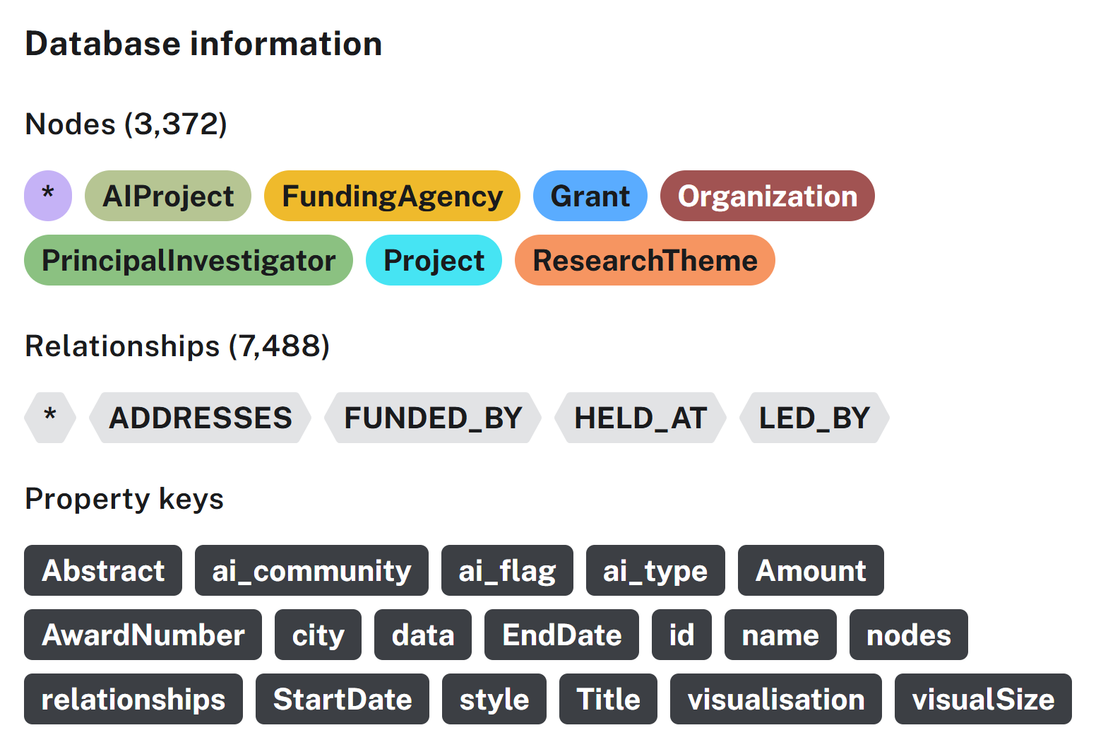
Figure 1: A Neo4j database summary of nodes, relationships and property keys, stored.

8.5 Data Analysis Techniques
8.5.1 AI-related Flag Mapping
To tag a grant as having some type of AI inclusion, an index of AI-related terms was compiled. The OECD AI Glossery terms were first consulted, and then noticing and referencing literature on the tendency of AI-related terms to be incomplete, due to the rapidly evolving nature of the field, another more modern list was sought and added to OECD’s base terms- Standford AI Index. The combined vocabulary is documented in the appendix- 1. Combined_AI_terms.
For each grant, the title, abstract, program code, and keywords were searched and tagged if any key terms from the Combined_AI_terms list were included. An LLM was used to automate this process, increasing consistent and replicable identification of AI-related grants.
Theme Extraction
To standardize and create research project themes that were consistent across funding institutions, the Frascati manual was consulted as an internationally-accepted research classification scheme. NSF and NIH program codes were included in the original export, and these were mapped to approximate Frascati research categories. This was done to understand the extent of the interdisciplinary nature and use of AI research, and also to get an understanding of what categories of research are most heavily funded. Frascati categories are included in the appendix- 1. Frascati_Research_Categories
Network Analysis Algorithms
This study uses network science and science of science analytical methods to examine structural patterns in Minnesota’s NSF and NIH-funded research ecosystem. Node level metrics such as degree, betweenness, and clustering coefficient are calculated, leaning on foundational research from Page et al. (1999) and Newman (2010). Community detection was calculated with the Louvain algorithm from Blondel et al., 2008) to measure clustering. Research from Fortunato et al. (2018) on the Science of Science methodology is used to understand how these methods can create insights into community fragmentation, centralization, interdisciplinarity, and discipline or AI-related level structures within the research or scientific system.
Graph projections were created in Neo4j for each of the three groups.
        - 'funding_full_theme'
        - ‘funding_ai_theme’
        - 'funding_nonai_theme'
Then network analysis metrics were run on these three graph projections and results were documented in the tables 1.3, 1.4, and 1.5. The study computes and compares the following metrics to understand community structure, centralization, fragmentation, institutional dominance, and thematic gaps:
- Nodes
- Edges
- Average degree
- Density
- Modularity
- % Singleton nodes
- % in largest community
- PageRank
- Betweenness
The ability to calculate these metrics exist within Neo4j as functions. Example code is included in the appendix- 1.4 Network_Analysis_Cypher_Code_Sample.
8.5.2 AI Subgraph Comparison
In comparison tables 1.4 and 1.5, differences were calculated and documented for comparative analysis between the full group and AI subgroup, and between the AI subgroup and Non-AI subgroup. Several of these metrics are sensitive to size of the network (number of nodes) and their measures were transformed using a porportion or other standardization for accurate comparison between the two groups with differing sizes.
8.5.3 Graph Visualization and Exploration Tool
An interactive knowledge graph product (a public graph visualization layer) is included as a product of this study. This tool allows decision-makers and researchers to understand this ecosystem in a more comprehensive way than traditional analytics and visualization tools. This is offered, along with our analysis comparison tables, as a deliverable that improves the presentation of results, understanding, and explore the study’s findings.

8.5.4 Validity and Reliability
During the data preprocessing step, data was validated for common potential errors for each field in the combined dataset. General descriptive statistics were calculated to check for reasonability of the dataset.
Extracting themes proved to be tricky. There is much research on extracting themes from scientific abstracts, but time was a limitation in this study. Perhaps the golden standard would be the OECD methodology for extracting research themes from abstracts, and this method was deeply reviewed and considered, but this was moved to a future goal due to time restrictions. Using this extraction framework would increase validity of the ‘theme’ and interdisciplinarity metrics of the study. Different methods of theme generation were tried, but due to time restrictions, a mapping document was created to map NSF and NIH programs, for which the code acronym was available) to Frascati themes of research. This mapping was automated using an LLM and then all categories were visually inspected and verified by the researcher. The use of globally accepted and validated research key word frameworks were intentionally designed to improve validity in generalizing to a more standardized set of themes related to research. This mapping document and its decisions are documented in the appendix documents: nih_nsf_Frascati_Mapping_With_Theme.
- Evaluation of Results
Network Analysis Results
Metrics for several different measures are calculated for each of the three comparative groups: Full graph, AI subgraph, and non-AI subgraph. Table 1.3 shows each metric for each of the three groups.
For our analysis, we are interested in overall examination of the full graph, and 1. comparing the full graph to the AI subgraph to see how funded AI research compares to the full funded research ecosystem, and 2. Comparing funded AI-related research structures to that of funded not AI-related research to see if there are any structural differences between these two distinct groups.
The full graph structure is visualized in Figure 1. The graph depicts the entire research funding ecosystem from 2024 and 2025 funded by NIH and NSF in the Neo4j database. Blue nodes represent grants, green represent the PIs, yellow nodes represent funding agencies NSF and NIH, magenta represents receiving organizations. This color map is described in Figure 3.
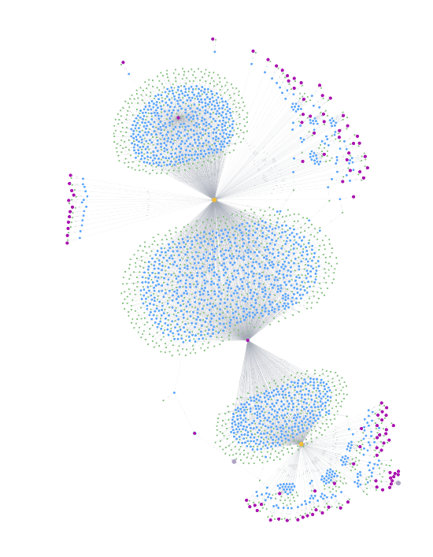
Figure 2a: Full Research Funding Ecosystem Graph


Figure 2b: Full Research Funding Ecosystem Graph with Research Theme Clusters
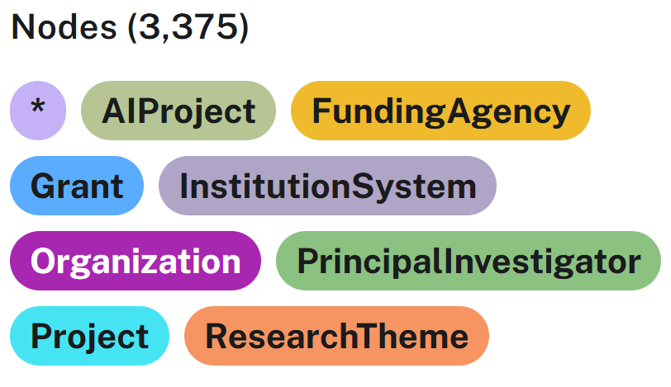
Figure 3: Node color mapping schema
The structure shows a hub-and-spoke pattern, where a small number of funders and receiving organizations from dense clusters, relating to a large number of grants and their principal investigators. These hubs (large research institutions) anchor the ecosystem and account for the majority of the network’s connectivity. Smaller hubs can be visualized at the peripheral by clusters of smaller number of grants. The smaller clusters and satellite structures nodes represent a number of other organizations, including independent research organizations, tribal organizations, community and specialized programs, and private funded companies.
What can be visualized here is the high number of grants administered to the University of Minnesota- Twin Cities between both funding institutions. Additionally, NIH funds a large amount of grants for Mayo Clinic and research organizations, while NSF is funding grants for private college and universities, as well as a number of Minnesota State colleges and Universities and University of Minnesota campuses beyond the Twin Cities.
Overall, the graph shows a highly centralized network, where the two federal funding institutions’ resources flow to mostly a few large core organizations, and smaller, more loosely connected research communities. This visualization offers a macro-level view of the organization of federal funding institutions, receiving organization, investigators, and grants are organized across Minnesota’s NSF & NIH grant-funded research ecosystem.
When examining the research funding ecosystem that includes AI-related projects as seen in Figure 4., we see an almost identical structure, with the most obvious change being the number of nodes included.

Figure 4. AI-related Grant Subgraph
9.1.2 Metric Comparison
Table 1.4 shows the metrics relevant to our first comparison group, between the full graph and AI-related subgraph along with difference reporting. Table 1.5 shows the metrics relevant to our second comparison group, that of funded AI-related research and funded not AI related research, with calculated difference reporting.

Table 1.3 Raw structural metrics for full, AI, and non-AI graphs
Structural Metric | Full Graph – All NSF/NIH Grants | AI Subgraph | Non-AI Subgraph | Interpretation Notes
Graph Level Metric
Node count (N) | 3375 | 797 | 2747 | Scale of activity
Edge count (E) | 15008 | 1500 | 5988 | Collaboration volume
Modularity (Louvain) | 0.46 | 0.40 | 0.296 | Fragmentation (for direct comparison)
Num. communities | 35 | 104 | 726 | Clustering
Largest community | 1393 | 209 | 355 | Size-sensitive
% Singleton grants | 0 | 28.0% | 28.8% | Isolation indication
Average clustering coefficient | 0 |  |  | Local cohesion
Top PageRank organization | University of MN: 208.19 | Bethel University: 0.27 | Myogenica Inc.: 0.48 | Influence hubs
Top betweenness organization | "University Of Minnesota-twin Cities": 2790963 | "Carleton College": 113.5 | "University Of Minnesota-twin Cities": 2275 | Bridge entities

Table 1.3 shows a baseline landscape of the whole graph network.

Table 1.4 Normalized Comparison Metrics: AI vs. the Full Graph
Structural Metric | Full Graph – All NSF/NIH Grants (Normalized) | AI Subgraph (Normalized) | Difference | Interpretation Notes
Graph Level Metric
Nodes (proportion) | 1.00 | 0.236 | -76.4% | AI-related grants make up 24% of the full ecosystem
Edges (proportion) | 1.00 | 0.100 | -90% | AI represents 10% of collaboration links
Modularity (direct) | 0.46 | 0.40 | -0.06 | AI share is slightly less fragmented than the full graph
% Singleton nodes | 0% | 28% | +28% | AI has substantial isolated activity
% in largest community | 0.413 | 0.262 | -0.151 | AI is less centralized and more distributed
PageRank (top 5 rank) | University of Minnesota | Bethel is the highest in AI | Different ranking | Influence shifts in AI network
Betweenness (percentile) | University of Minnesota > 99th percentil | Carlson is unusually central | Structural role shifts | Bridges differ from the full ecosystem
Table 1.4 isolates AI-specific structural behavior and compares it with the full graph. It uses proportions and percentiles to control for the difference in size.

Table 1.5 Normalized Comparison Metrics: AI vs. Non-AI Graph
Structural Metric | AI Subgraph (Normalized) | Non-AI Subgraph (Normalized) | Difference | Interpretation Notes
Graph Level Metric
Nodes (proportion) | 0.236 | 0.814 | -65% | Non-AI has more grants
Edges (proportion) | .100 | 0.399 | -29.9% | AI has fewer collaborative links
Modularity (direct) | 0.40 | 0.296 | -0.104 | AI is less fragmented
% Singleton nodes | 28% | 28% | +0.8% | Both subgraphs show strong isolation
% in largest community | 0.262 | 0.129 | -0.133 | AI forms larger cohesive clusters
PageRank (top 5 rank) | Bethel | Myogenica | Different influence hubs | AI and non-AI have distinct hubs
Betweenness (percentile) | Carlton | University of Minnesota | Role reversal | AI bridges differ from non-AI
Table 1.5 compares the AI subgraph to the non-AI subgraph and calculates differences. This helps aid in understanding the unique network characteristics about grants and research with AI-related elements.

9.1.3 Discussion and Interpretation of Results
AI-related research is a smaller, but structurally distinct subset of the full ecosystem. It is notably less centralized than the full graph, with high isolation, but larger cohesive clusters when compared to grants that don’t include AI-related topics in their projects. This suggests clusters of tightly connected AI activity with many siloed projects. Influence and bridging show a noticeable difference for the AI subgraph; smaller institutions, such as Bethel and Carlton College are structurally central, which is surprising considering the enormous domination of the University of Minnesota and Mayo Clinic in the full ecosystem.
This analysis of Minnesota’s NSF and NIH-funded research ecosystem reveals a highly centralized structure, notably, with the University of Minnesota- Twin Cities ranking as the organization with the highest influence (PageRank), as a bridge between other funded research, researchers, and organizations (betweenness), and also in sheer size, with the highest number of grant nodes in the network. In network analysis, this demonstrates that this ecosystem is strongly anchored in terms of collaboration and resource and knowledge flow by a single receiving organization, in the case of NSF and NIH research funding. It shows that many other receiving organizations are less connected, and work in smaller clusters, often correlated with their discipline, or as isolated nodes. When examining research themes, medical and health science as themes make up a huge portion of Minnesota’s funded research, with environmental engineering, sustainability, and energy-related computing much less represented in funded grants from these two institutions.
AI-related funded research shows to hold a distinct structural pattern than both the broader ecosystem, and comparatively with the subsection of the full eco system that does not include AI-related elements in the grant-funded project. The AI subgraph is less connected, with a higher proportion of singleton projects and more small clusters. However, through the analysis we can see that smaller institutions play a notable role in bridging other researchers, organizations, and also disciplines. This suggests that Minnesota’s NSF and NIH funded AI-related research is more spread out across institutions and disciplines. There is much AI-related activity in the mathematical, biomedical, and engineering disciplines.
The results produced in this study show that network analysis can add more to the study of AI research beyond traditional descriptive statistics. By understanding network position and disciplinary alignment, these structural results highlight collaboration, innovation, and funding patterns not typically visible without network analysis metrics. This study focuses on two federally funded research grants, but its insights could help identify strengths in the ecosystem, gaps, and aids in the study of AI integration throughout the regional scientific community at large. It serves to add information from which policy makers, funders, and researchers can be grounding their decisions for targeting investments, and thus meaningfully strengthening Minnesota’s capacity for responsible and impactful AI innovation.

9.1.4 Future Work
There is enormous potential for expansion on this project in terms of scope and also design details. The results of this study leave the following as suggestions for expansion of this study in future studies:
- Expanding the dataset:
  - Adding funding agencies: A realistic research ecosystem has a number of different funding institutions, including additional federal funding agencies, state agencies, philanthropies, etc. Including these diverse funding sources would give a clearer picture on the wholistic state of funded research in Minnesota and also the state of funded AI-related research. As a pilot study, only two federal funding agencies were used. Some potential consequences of this include a lack of representation of other disciplines or topics, such as agriculture, defense, etc.
  - Expanding the date range: Grants from 2024-2025 were examined in this study, which is justifiable in that recent generative AI research is likely to be concentrated in this time frame, and is relevant in terms of recency. However, analysis of prior years could lead to insights on how the research funding landscape has transformed throughout time. A longitudinal analysis could be helpful and give a more full picture of the structure of this ecosystem.
- Robustness of tagging and theme extraction:
  - There are strong existing techniques for theme generation or extraction and it is a topic widely studied, especially recently using LLMs. The OECD method of AI identification, in particular, could be applied to this dataset to increase the quality and validity of these categories.
- A public-facing exploration tool could be created to inform decision-making. The existence of a state-level tool would be beneficial in helping to visually understand the results of this study, and possible future studies.
This study serves as a pilot study to demonstrate structural approach and a slice of what can be examined at a state level. Its expansion in terms of entities, time period, and topics would allow for greater generalization, and would likely reveal richer connectivity and more robust communities.
- Ethical Considerations
Ethical considerations include the possibility of AI or domain misclassification, as the grants were classified based on explicit inclusion of at least one of the combined AI terms. This could lead to misleading conclusions about the state of AI-related research. If this is used to inform policy decisions, there is potential for harm here. This is mitigated by including all datasets within the report for reproducibility. The study is also defined as a pilot study, with future exploration and more detailed analysis mentioned as highly desirable. Privacy due to the inclusion of PI names could be a concern as well, although these are obtained through an originally public dataset. A priority for this study is transparency and fairness, and authors are hoping to model that in the process and data documentation.
AI Disclosure: Generative AI tools (ChatGPT) was ethically used throughout the project for the previously cited automation of theme mapping and AI-relatedness tagging, and within the report itself for the following specific purposes: brainstorming, ensuring the inclusion of the full breadth of literature on reference topics, phrasing support for a small number of sentences of text, cypher query generation, and reference formatting generation. All AI-produced inclusions were for the purpose of efficiency and were thoroughly inspected by the researcher for accuracy.

- References
[1] J. Wang, P. Shapira, and X. Li. 2019. Measuring the effect of research funding on scientific collaboration networks. Journal of Informetrics 13, 2, 695–709. https://doi.org/10.1016/j.joi.2019.02.007
[2] D. Li, L. Agha, E. Mollick, and O. Ozguz. 2019. Funding shapes the structure of science. arXiv:1908.02749. https://doi.org/10.48550/arXiv.1908.02749
[3] S. Fortunato, C. T. Bergstrom, K. Börner, J. A. Evans, D. Helbing, S. Milojević, A. M. Petersen, F. Radicchi, R. Sinatra, B. Uzzi, A. Vespignani, L. Waltman, D. Wang, and A.-L. Barabási. 2018. Science of science. Science 359, eaao0185. https://doi.org/10.1126/science.aao0185
[4] D. J. Watts and S. H. Strogatz. 1998. Collective dynamics of ‘small-world’ networks. Nature 393, 440–442. https://doi.org/10.1038/30918
[5] E. W. Dijkstra. 1959. A note on two problems in connexion with graphs. Numerische Mathematik 1, 269–271. https://doi.org/10.1007/BF01386390
[6] S. Brin and L. Page. 1998. The anatomy of a large-scale hypertextual Web search engine. Computer Networks and ISDN Systems 30, 1–7, 107–117. https://doi.org/10.1016/S0169-7552(98)00110-X
[7] J. B. Kruskal. 1956. On the shortest spanning subtree of a graph and the traveling salesman problem. Proceedings of the American Mathematical Society 7, 48–50.
[8] L. Page, S. Brin, R. Motwani, and T. Winograd. 1999. The PageRank citation ranking: Bringing order to the web. Stanford InfoLab Technical Report. https://research.google.com/archive/pagerank.html
[9] M. Girvan and M. E. J. Newman. 2002. Community structure in social and biological networks. PNAS 99, 12, 7821–7826. https://doi.org/10.1073/pnas.122653799
[10] V. D. Blondel, J.-L. Guillaume, R. Lambiotte, and E. Lefebvre. 2008. Fast unfolding of communities in large networks. Journal of Statistical Mechanics 2008, P10008. https://doi.org/10.1088/1742-5468/2008/10/P10008
[11] V. A. Traag, L. Waltman, and N. J. van Eck. 2019. From Louvain to Leiden: Guaranteeing well-connected communities. Scientific Reports 9, 5233. https://doi.org/10.1038/s41598-019-41695-z
[12] J. Wang, R. Veugelers, and P. Stephan. 2017. Inequalities in the distribution of NIH research project grant funding. PNAS 114, 37, 193–201. https://doi.org/10.1073/pnas.1619111114
[13] L. Zhang, X. Zhao, and Z. Chen. 2021. What is research funding, how does it influence research, and how is it recorded? Scientometrics 126, 2, 1399–1423. https://doi.org/10.1007/s11192-020-03782-4
[14] OECD. 2015. Frascati Manual 2015. https://doi.org/10.1787/9789264239012-en
[15] European Commission Joint Research Centre. Measuring the AI content of government-funded R&D projects. Technical report.
[16] M. E. Porter. 1998. Clusters and the new economics of competition. Harvard Business Review 76, 6, 77–90.

