Classic Comfort Food Dinners That Feel Like a Warm Hug
Consider this recipe collection a comfort food checklist, with chicken enchiladas, Japanese ground beef curry and toor dal all ready to satisfy and soothe.
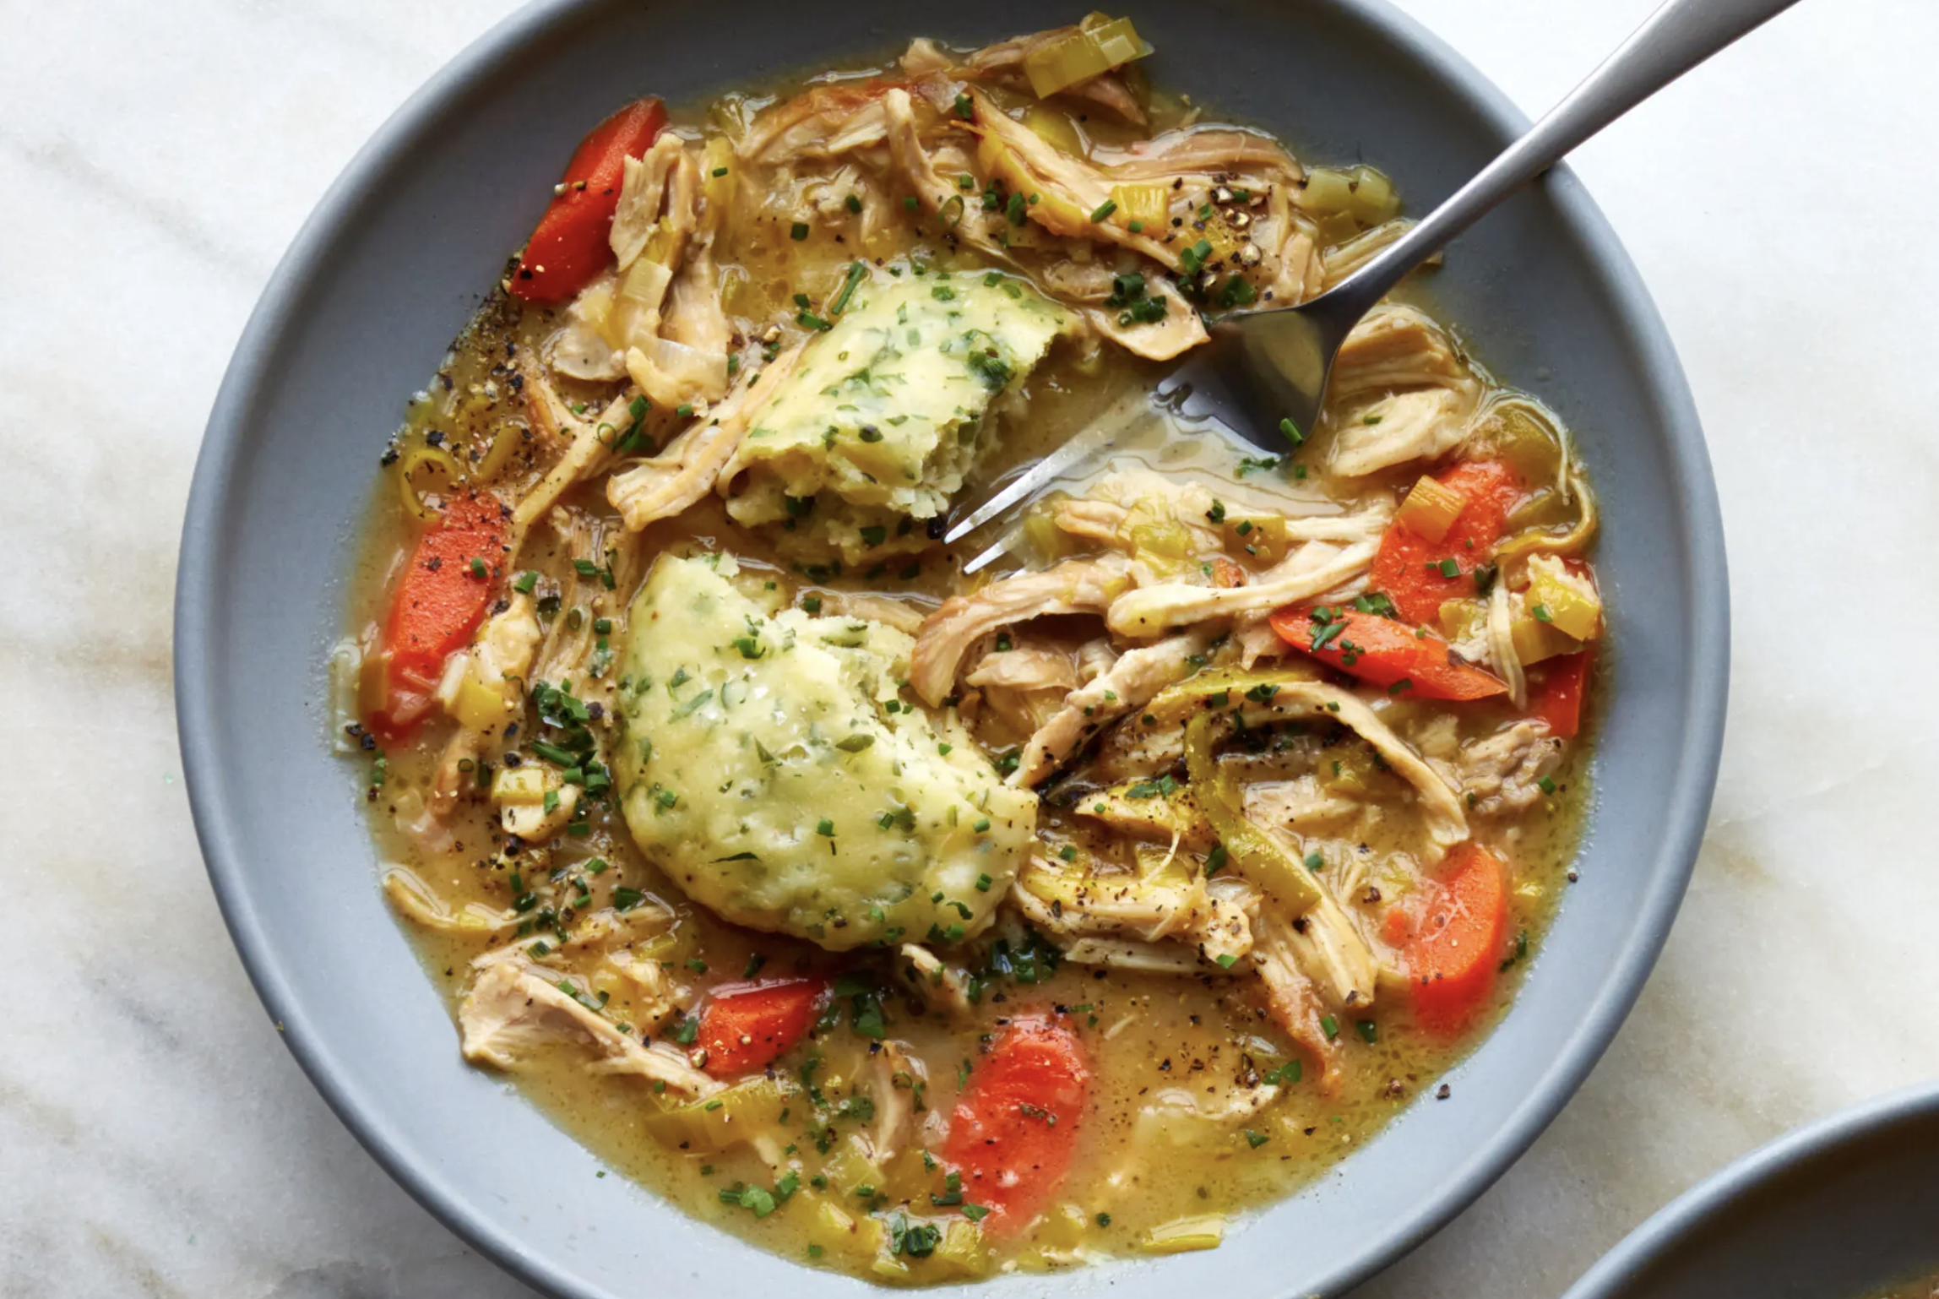

This Alison Roman recipe is what to eat when you’re craving the soothing flavors of chicken soup but want something with a bit more stick-to-your-bones heft. If the “dumplings” part sounds fiddly, don’t worry, it’s not: They’re made from a simple stirred-together dough that’s spooned on top of your hearty chicken stew to plump up and steam.

