Which Claude Tier Should Drive a Kernel-Writing Agent? A Controlled Comparison on the FlashInfer FP8 Mixture-of-Experts Kernel
Team 3: Michael Parker, Nandhu Shankar, Katherine Lingenfelter, Ian Farmer
CIS 4930/6930 ML for Computer Systems, Fall 2026
Code and data: github.com/katielinge/Nvidia-AI-Kernel
Abstract
Which Claude tier should drive a kernel-writing agent, and does it beat non-ML tuning at the same budget? We ran Haiku 5.5, Sonnet 5.5 and Opus 5.5 three times each in an identical 15-attempt write–benchmark–feedback loop on the FlashInfer contest's FP8 Mixture-of-Experts kernel, on an 8 GB laptop GPU. Opus reached a median 20.2× speedup over the PyTorch reference and Sonnet 17.5×, against 11.5× for a Triton-autotuned kernel given the same 15 timed candidates. Haiku never wrote Triton code (1.44×). A knock-out ablation traces Sonnet's lead mainly to a rewrite of the second matrix multiply that no tile search can reach: without its three design choices, its kernel falls from 16.8× to 8.8×. All 21 best kernels passed 26 unseen workloads, though the lead over autotune shrank to 1.34× (Sonnet) and 1.65× (Opus). Sonnet gave most of Opus's speed at a third of the cost.

1 Introduction
Mixture-of-Experts (MoE) layers send each token to a few of many expert networks, so the matrix multiplies behind them are small, irregular and data-dependent. With FP8 weights and 128 × 128 block scales, as in DeepSeek-V3 [5], a fast GPU kernel for this layer takes expert knowledge of tiling, memory traffic and tensor-core formats. The MLSys 2026 FlashInfer contest [1, 7] made this operation a target for AI agents, and LLM agents now write competitive kernels. A team that wants to use one faces the decision this project studies: which model tier to put in the loop, what it costs, and whether it beats conventional, non-ML tuning given the same budget.
We ran a controlled comparison. Claude Haiku 5.5, Sonnet 5.5 and Opus 5.5 each drove the same agent loop, with the same prompts, seed kernel, feedback and 15-attempt budget, three times, on the contest's FP8 MoE definition. We compared them with non-ML baselines built on one conventional hand-written Triton [6] kernel: untuned, tuned by random search, and tuned by Triton's autotuner, the last two with the same 15 timed candidates as an agent run. Everything ran on one 8 GB RTX 5060 laptop GPU. Our claims:
- Rung 1. Sonnet and Opus beat the best non-ML baseline at the same budget: a median 17.5× and 20.2× speedup over the PyTorch reference, against 11.5× for Triton autotune, which is 1.52× and 1.75× better. Haiku (1.44×) loses to every baseline.
- Rung 2. …because they change how the matrix multiplies are computed. Switching Sonnet's three design choices back to the baseline's takes its kernel from 16.8× to 8.8×. The largest single factor is its GEMM2 rewrite (−21% when removed), which lies outside any tile search; choosing tile sizes per token count, the factor autotune also exploits, is second (Table 3). FP8 tensor-core multiplies, used by every Sonnet and Opus kernel, add only 6% when given to the baseline.
- Rung 3. The ranking holds on 26 workloads no kernel was developed on, except that Sonnet's and Opus's lead shrinks there (1.34× and 1.65×) and every method's speedup collapses at 10,000+ tokens.
- Rung 4. Sonnet's kernel costs $0.98 of API-equivalent model usage and repays it, against autotune, after about 220,000 kernel calls at $2 per GPU-hour.

2 Background and baselines

2.1 The operation
The target is the contest definition moe_fp8_block_scale_ds_routing_topk8_ng8_kg4_e32_h7168_i2048. Each token's 256 routing logits go through a sigmoid plus a bias; the experts form 8 groups, the 4 groups with the highest top-2 scores are kept, and the top 8 experts inside them are chosen. This GPU holds 32 of the 256 experts. For each token–expert pair, GEMM1 multiplies the token (hidden size 7,168) by a 4,096 × 7,168 weight matrix, SwiGLU halves the result to 2,048 values, and GEMM2 projects back to 7,168. Tokens and weights are FP8 (e4m3) with one scale per 128 values (tokens) or per 128 × 128 block (weights); the bf16 output is the routing-weighted sum over experts. The 19 contest workloads range from 1 to 14,107 tokens, and 15 of them have 80 or fewer.

2.2 What exists without ML, and how we tuned it
- PyTorch reference. The contest's own implementation; every speedup is measured against it (patched to fit in memory, Section 4).
- Hand-written Triton kernel, untuned. A standard grouped-GEMM design: routing in PyTorch, token–expert pairs sorted by expert, then per local expert one Triton kernel for GEMM1 + SwiGLU (FP8 converted exactly to bf16, block scales applied per 128-wide slice, fp32 accumulation) and one for GEMM2 plus a scatter-add into the output (fp32 operands, tf32x3 precision). Weights stay in FP8 in memory. One default configuration.
- Random search. Draws tile height, width and depth, warp count and pipeline depth for both kernels, plus the GEMM2 precision (tf32x3, tf32 or full fp32): about 315,000 combinations. Draws that do not fit in the GPU's 101 KB of shared memory are caught by a compile check and redrawn without counting, as Triton's autotuner does (10 of 55 draws). It keeps the fastest of 15 timed candidates.
- Triton autotune. Triton's autotuner chooses among 15 standard configurations at run time, separately for each power-of-two bucket of tokens per expert.
- Autotune + FP8 dot (ablation). The same, with GEMM1 multiplying FP8 values directly on the FP8 tensor cores, the one design choice every Sonnet and Opus kernel made.
Tuning effort and ceiling. Both searches get an agent run's budget: 15 timed candidates, measured with the same benchmark. We have no oracle: exhaustive search would take about 315,000 candidates, and the contest's expert baseline (FlashInfer's TensorRT-LLM MoE kernel) targets the B200 and could not run on our GPU.

3 Approach
The agent loop. The model gets a system prompt (target GPU and its 8 GB memory, Triton as the language, the exact correctness rule, an instruction to keep weights in FP8) and a task message (the reference implementation and a seed kernel, which is the reference itself). It answers with one complete kernel file. Each attempt is benchmarked on all 19 workloads, and the next message reports the outcome: the error text for a crash; for a wrong answer, the failing workload, its largest absolute and relative error and the fraction of outputs within tolerance; for a correct kernel, its speedup on every workload. The model always sees its last attempt with its result and its best kernel so far, and nothing older. A run has 15 attempts, and its result is its best correct kernel.
Models. claude-haiku-5-5, claude-sonnet-5-5 and claude-opus-5-5, called through the Claude Code command-line tool on a subscription. Tools were switched off, user customizations were not loaded, and each call ran in an empty folder with our system prompt, so the model saw only our messages. Sampling used default settings and is not seeded. Cost is Claude Code's estimate of the same tokens at API prices ("API-equivalent"); nothing was billed.
Inputs, labels and budget. Nothing is trained. The learned component is the LLM; its only inputs are the definition, the reference code and benchmark feedback, and there are no labels. The budget is 15 attempts per run, matched to the baselines' 15 timed candidates.

4 Setup
Hardware and software. NVIDIA RTX 5060 Laptop GPU (8 GB, compute capability 12.0, 101 KB shared memory per block), Windows 11, Python 3.12, PyTorch 2.14.1 (CUDA 13.0), triton-windows 3.9.0, FlashInfer-Bench 0.1.2.
Two changes to fit this GPU. The contest reference dequantizes all 32 experts' weights to float32 at once (about 17 GB at peak). We patched it to do one expert at a time; on 6 input sizes its output is bit-identical to the original, at a 1.74 GB peak. FlashInfer-Bench's runners pass GPU tensors between processes, which Windows does not support, so we call its own evaluator (input generation, correctness check and timing) in one process, one trial at a time.
Correctness and timing. An output element fails only if its absolute error exceeds 0.01 and its relative error exceeds 0.01; 95% of elements must pass, on every workload (FlashInfer-Bench's low-bit evaluator). In the loop, each attempt is timed with 3 trials × 20 iterations against cached reference timings. Every reported number re-measures a run's best kernel with 3 warm-ups and 5 trials × 100 iterations. Identical code measures 1.00–1.03×, so differences under about 3% are noise.
Runs and held-out data. Three runs per method; Claude runs were interleaved (Haiku, Sonnet, Opus for run 1, then run 2, then run 3) so time of day and laptop temperature affect all tiers alike. Section 7 adds 26 held-out workloads.

5 Is it better?
Table 1. Speedup over the PyTorch reference, mean of 19 workloads, median of 3 runs (lowest–highest). "vs. autotune" divides by autotune's median. Cost is API-equivalent, not billed.
Method | Timed candidates per run | Final speedup, median (min–max) | vs. autotune | API-equiv. cost per run
Haiku 5.5 | 15 | 1.44× (1.43–1.45) | 0.13 | $0.03
Hand-written Triton, untuned | 1 | 8.02× (8.02–8.05) | 0.70 | $0
Random search | 15 | 11.18× (9.88–11.33) | 0.97 | $0
Triton autotune | 15 | 11.51× (11.48–11.84) | 1.00 | $0
Autotune + FP8 dot (ablation) | 15 | 12.19× (12.01–12.35) | 1.06 | $0
Sonnet 5.5 | 15 | 17.54× (14.73–18.00) | 1.52 | $0.98
Opus 5.5 | 15 | 20.17× (18.46–28.53) | 1.75 | $3.07

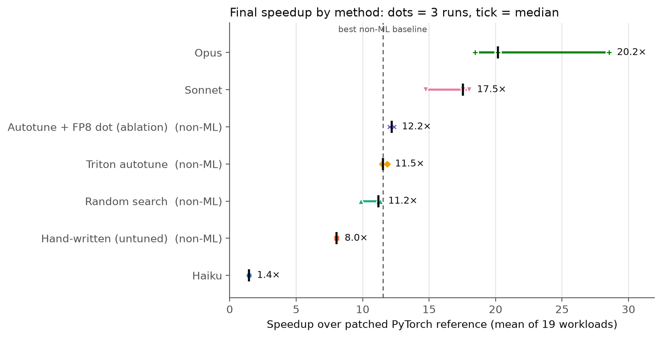
Figure 1. Final speedup by method. Each dot is one run; the tick is the median; the dashed line is the best non-ML baseline.
Every Sonnet and Opus run (lowest 14.7×) beat every run of every non-ML baseline (highest 12.4×). Against the best non-ML bar, Triton autotune at 11.5×, Sonnet is 1.52× faster and Opus 1.75×. Haiku, at 1.44×, is slower than even the untuned hand-written kernel.
Search did not substitute for design. Random search (11.2×) did no better than autotune and spent about 30 times as much benchmark time (66 versus 2.3 minutes per run). Adding FP8 multiplies moved autotune only to 12.2×.
Reliability. 91% of Sonnet's 45 attempts were correct, 73% of Opus's and 51% of Haiku's. Opus's first correct kernel was already 17–18× in all three runs, and feedback then added 10% to 77%. Sonnet leaned on feedback more: run 1 doubled from 9.1× to 18.6×.
Spread. Opus varied most (18.5–28.5×): its median is barely above Sonnet's best run, so a single run would have misled us. The loop's own measurements overstate results slightly, because the loop keeps whichever attempt happened to time fastest; we therefore report re-measured numbers (Opus run 2: 29.95× in the loop, 28.53× re-measured).

6 Why it works
Table 2. Design choices in each run's best kernel (3 per tier), from reading the code.
Best kernels | Written in Triton | FP8 dot in GEMM1 | One launch for all experts | Routing in Triton
Haiku 5.5 | 0 of 3 | 0 of 3 | 0 of 3 | 0 of 3
Sonnet 5.5 | 3 of 3 | 3 of 3 | 1 of 3 | 0 of 3
Opus 5.5 | 3 of 3 | 3 of 3 | 3 of 3 | 1 of 3
Non-ML baselines | all | ablation only | none | none

Every Sonnet and Opus kernel multiplies FP8 values directly on the tensor cores, and no baseline does. The FP8 ablation tested whether that explains the gap: adding it to the autotuned baseline gives 12.2×, only 6% more. FP8 is not the explanation.
Knock-out ablation. Sonnet run 1 isolates the cause. Its kernel has the same structure as the hand-written baseline (routing in PyTorch, one launch per expert, the same two kernels) and differs in three choices: FP8 multiplies in GEMM1; GEMM2 done as two bf16 tensor-core multiplies of an fp32 operand split into high and low halves, where the baseline uses fp32 operands with tf32x3; and a tile height picked from each expert's token count (16, 32, 64, or 128 for large experts). We switched each back to the baseline's choice.
Table 3. Knock-out ablation of Sonnet run 1's best kernel. "on" = Sonnet's choice, "off" = the baseline's. 19 contest workloads, 3 trials × 20 iterations.
Variant of Sonnet run 1's kernel | FP8 dot | GEMM2 split | Adaptive tiles | Speedup | vs. original
Unchanged (all three choices on) | on | on | on | 16.82× | 1.00
FP8 dot off | off | on | on | 16.30× | 0.97
GEMM2 split off (fp32 + tf32x3) | on | off | on | 13.26× | 0.79
Adaptive tiles off (height 32) | on | on | off | 14.69× | 0.87
FP8 dot and GEMM2 split off | off | off | on | 12.28× | 0.73
All three off (= baseline design) | off | off | off | 8.81× | 0.52

Table 3 gives the result, with every variant measured the same way (19 contest workloads, 3 trials × 20 iterations). The unchanged kernel measures 16.82×. Switching off the FP8 dot alone gives 16.30× (−3%), the adaptive tiles alone 14.69× (−13%), and the GEMM2 split alone 13.26× (−21%), the largest single factor. With all three off, the kernel is the baseline design and measures 8.81×, close to the hand-written baseline under the same benchmark (7.9–8.3×). The effects compound: all three together cost more than the product of their separate costs, because tile sizes matter more once the multiplies are slower. The ablation also explains the baselines. Tile choice per token count is exactly what autotune does, and Sonnet's kernel with only its adaptive tiles left (12.28×) lands next to autotune (11.5×). What no search could find is the GEMM2 rewrite: computing the fp32 intermediate as a high and a low bf16 half with two bf16 tensor-core multiplies keeps near-fp32 accuracy at a fraction of the cost of tf32x3, and it is worth 1.27× on its own. That is a change to how the multiply is computed, outside the baselines' search space.
A second mechanism: launch overhead. At attempt 10 of Opus run 2, the model wrote that small batches were dominated by launch overhead from about 50 small PyTorch operations, and moved routing and sorting into two Triton kernels, leaving the matrix-multiply kernels unchanged. The loop measured 19.4× before and 29.6× after. Per workload, run 2 is 2.4–2.8× faster than the other Opus runs at 1 token, and the gap fades to about 1.0× at 900+ tokens, where the multiplies dominate: the model's diagnosis was right.
Why Haiku failed. None of Haiku's 45 kernels contains a Triton kernel. It rewrote the PyTorch reference to avoid building the expanded scale tensors, then alternated between this correct fp32 version and a bf16 version that failed the tolerance, correct and incorrect in strict alternation in all 15 attempts of all three runs. Because the loop shows only the last attempt and the best kernel, Haiku never saw that bf16 had failed two attempts earlier. A log of failed ideas in the prompt is the obvious fix; we did not test it.

7 Where it fails, and transfer
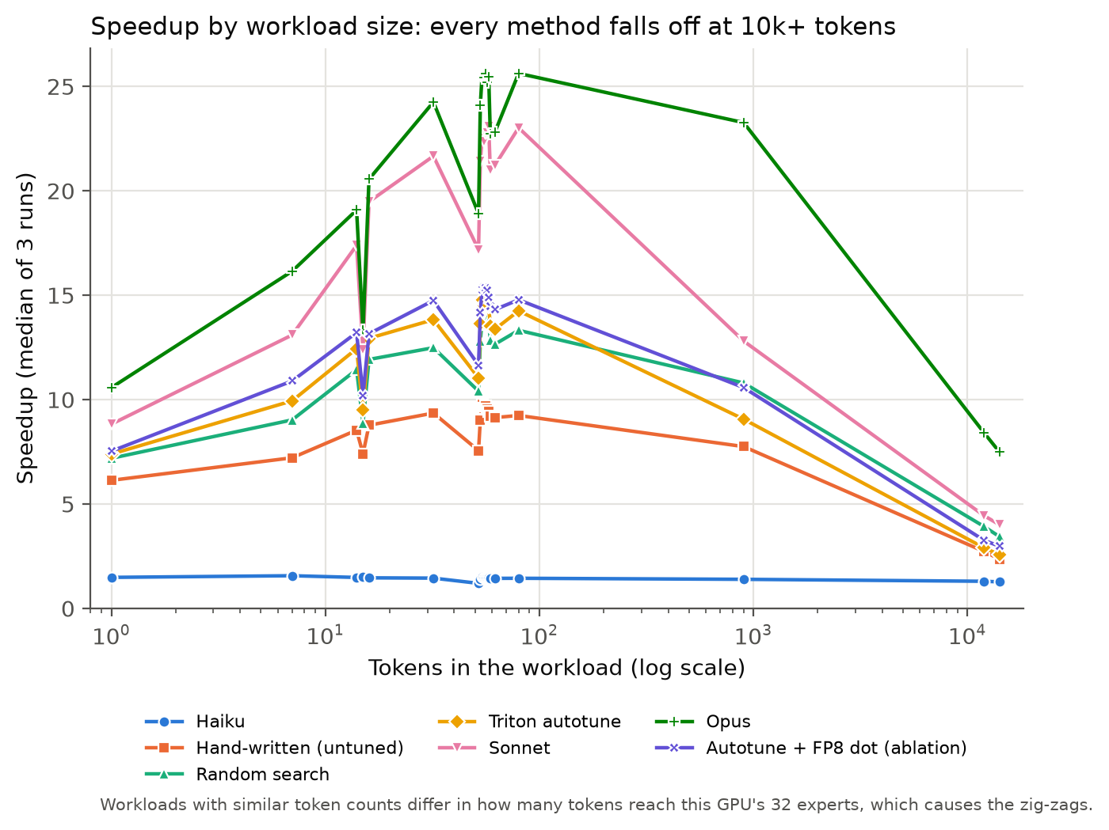
Figure 2. Speedup by workload size (median of 3 runs). Workloads with similar token counts differ in how many tokens reach this GPU's 32 experts.
By size. Every Triton kernel peaks between about 16 and 900 tokens and collapses at 11,948 and 14,107 tokens (Haiku stays flat at 1.2–1.6×); these are the worst workloads for 15 of the 18 runs (all but Haiku's). At that size the multiplies dominate and the gap to the reference narrows. Opus degrades least: its lead over autotune grows from 1.43× at 1 token to 2.91× at 14,107, while Sonnet's stays between 1.2× and 1.6×. Because 15 of the 19 workloads have 80 tokens or fewer, the headline mean mostly measures small batches.
Transfer. We ran every best kernel, unchanged, on 26 new workloads: the 19 real routing traces served by a different set of 32 experts, and 7 token counts not in the contest set (3 to 4,096) with random routing. All 21 kernels passed all 26. The ranking held (Table 4, Figure 3), but Sonnet's and Opus's lead over autotune shrank from 1.52× and 1.75× to 1.34× and 1.65×, while the baselines changed by 1–3%: a sign that the agents' kernels are partly fitted to the contest workloads. Opus held up best at large sizes (19.0× and 11.8× at 2,048 and 4,096 tokens, against 6.1× and 4.4× for autotune). Haiku was slower than the reference at 3 tokens (0.71×).
Table 4. Median speedup on the contest workloads (5 × 100 benchmark) and on 26 unseen workloads (3 × 20 benchmark). The baselines act as a control for the change in benchmark setting.
Method | Contest workloads (19) | Unseen workloads (26) | Change | vs. autotune, unseen
Haiku 5.5 | 1.44× | 1.30× | −10% | 0.11
Hand-written, untuned | 8.02× | 7.92× | −1% | 0.70
Random search | 11.18× | 11.12× | −1% | 0.98
Triton autotune | 11.51× | 11.38× | −1% | 1.00
Autotune + FP8 dot | 12.19× | 11.87× | −3% | 1.04
Sonnet 5.5 | 17.54× | 15.21× | −13% | 1.34
Opus 5.5 | 20.17× | 18.83× | −7% | 1.65

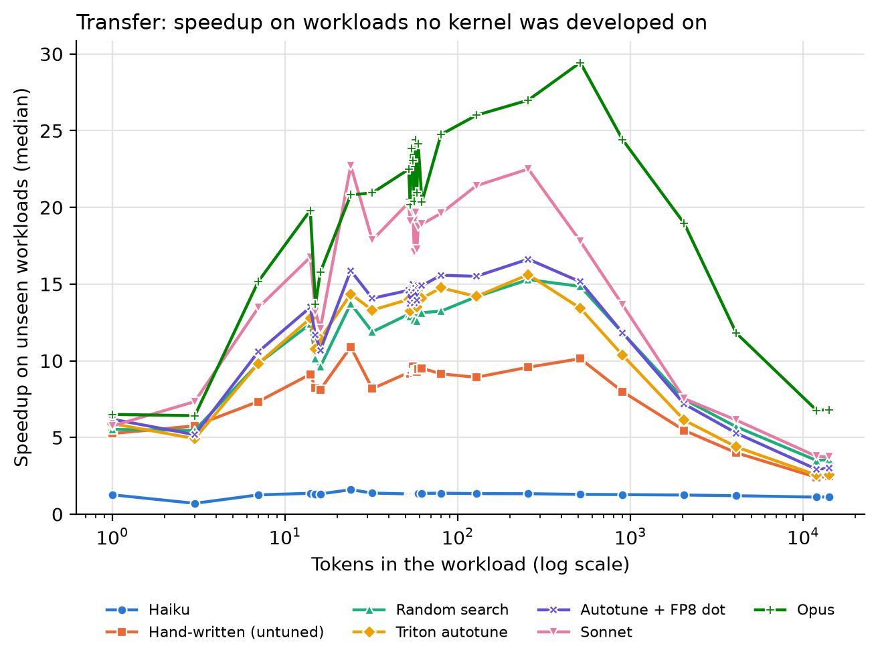
Figure 3. Speedup on the 26 unseen workloads by token count (median of 3 runs).
What the test covers. Kernels were checked on 45 workloads (1 to 14,107 tokens, several expert shards) in the definition's fixed shapes and dtypes. We did not test other hidden sizes, other expert counts, an empty batch, or a second GPU. The test is only as strong as its tolerance: one of Haiku's wrong kernels, with a largest error of 4,096, matched 91.6% of outputs on one workload and would have passed a 90% rule.

8 Cost and deployment
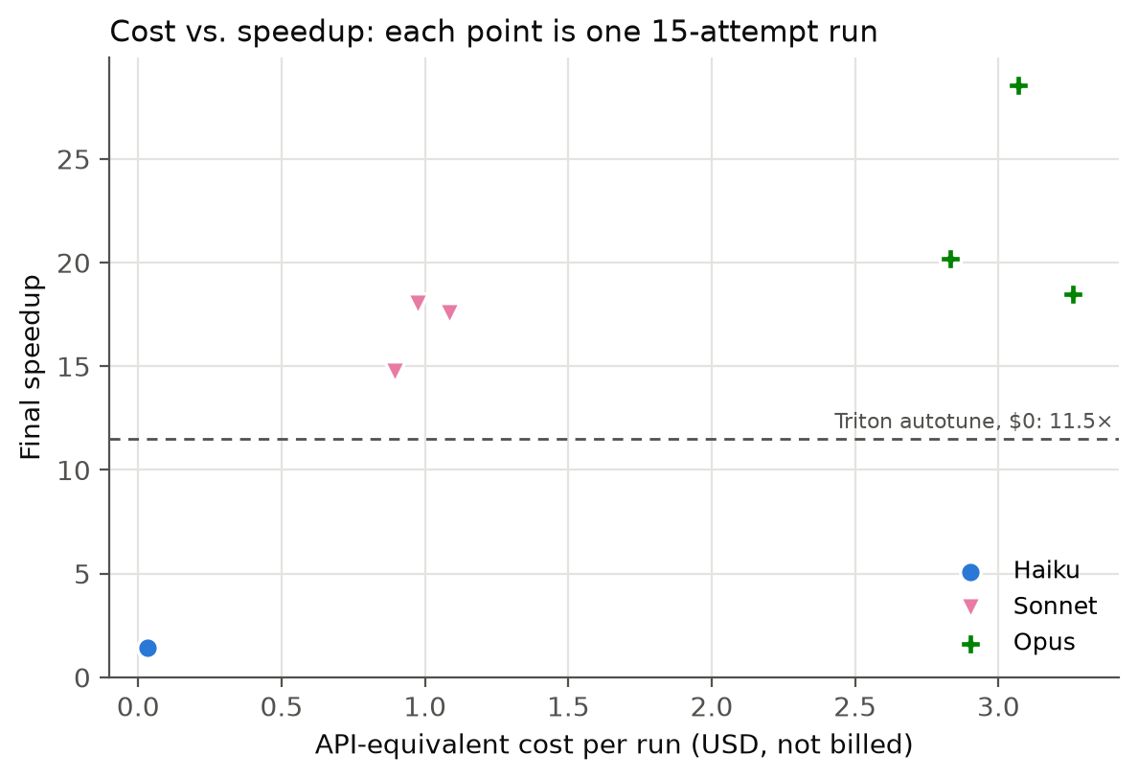
Figure 4. API-equivalent cost against final speedup; each point is one 15-attempt run.
Cost. A run cost $0.03 (Haiku), $0.98 (Sonnet) or $3.07 (Opus) in API-equivalent usage, plus 2.8, 6.1 and 14.7 minutes of model time and 10–22 minutes of benchmarking (medians). All nine agent runs together cost $12.22 and used 0.89 million input and 0.63 million output tokens. Opus bought 15% more median speed than Sonnet for about three times the cost, with more variance; Sonnet is the efficient choice.
Break-even. Averaged over the 19 workloads, Sonnet's kernel saves 8.1 ms per call against autotune and Opus's 13.2 ms. With N* = one-time cost ÷ (time saved per call × GPU price), at $2 per GPU-hour Sonnet repays its $0.98 after about 220,000 calls and Opus its $3.07 after about 420,000 (twice as many at $1). A serving deployment calls this kernel once per MoE layer per forward pass, so it reaches that quickly; for a one-off job, autotune is the better deal.
Where it would run, and what happens when it is wrong. The agent belongs where an autotuner sits today: offline, once per kernel and GPU, before deployment. Its output is source code a person can review, accepted only if it passes the correctness gate. If the agent fails or produces a slower kernel, the autotuned kernel stays, so the worst case is today's performance. The real risk is a kernel that passes the test set but is wrong on inputs it does not cover, so the test set must cover the deployment's batch sizes.

9 Related work, limitations and conclusion
Related work. KernelBench [3] showed that frontier models rarely beat PyTorch on the first try, and that iterative refinement with execution feedback helps a lot; TritonBench [4] found that code LLMs struggle to write efficient Triton. FlashInfer-Bench [1], which supplies our benchmark, found that earlier frontier models lagged human experts on compute-bound GEMM and struggled to use newer tensor-core instructions. In our runs, every Sonnet and Opus kernel used the FP8 tensor cores, and Haiku did not write Triton at all. Our contribution is a controlled comparison of model tiers with cost, matched non-ML baselines and an ablation of why the winners win.
Limitations.
- One consumer GPU (8 GB, compute capability 12.0), not the contest's B200, and one operation.
- The denominator is a slow, memory-patched PyTorch reference, so absolute speedups are large and not comparable with the contest leaderboard; comparisons between methods are the result.
- Three runs per method, with unseeded sampling; Opus's spread shows that this is few.
- The hand-written baseline kernel was drafted with AI assistance in a chat assistant, outside the agent loop; it is non-ML in how it is tuned, not in who wrote it (Appendix A).
- We used knock-out ablations instead of Nsight Compute profiler counters, which our proposal planned.
- Novelty: FlashInfer's and DeepSeek's FP8 MoE kernels are public, so the models may have seen similar code in training. We cannot rule this out.
- Changes from the proposal: an RTX 5060 instead of an H100 (no H100 was available to us), the 5.5 model versions instead of Haiku 4.5, Sonnet 5 and Opus 5, no open-source models, and ablations instead of profiling.
Conclusion. For this kernel, an agent driven by Sonnet or Opus beat a tuned non-ML baseline at the same budget by 1.5–1.75×, mainly by changing how the matrix multiplies are computed, which no setting search can reach. Sonnet gave most of the gain at a third of Opus's cost and is the tier we would use; Opus is worth it when large batches matter. Haiku should not drive a kernel-writing agent.

References
[1] S. Xing, Y. Zhai, A. Jiang, Y. Dong, Y. Wu, Z. Ye, C. Ruan, Y. Huang, Y. Zhang, L. Yin, A. Bayyapu, L. Ceze and T. Chen. FlashInfer-Bench: Building the Virtuous Cycle for AI-driven LLM Systems. MLSys 2026. arXiv:2601.00227.
[2] Z. Ye, L. Chen, R. Lai, W. Lin, Y. Zhang, S. Wang, T. Chen, B. Kasikci, V. Grover, A. Krishnamurthy and L. Ceze. FlashInfer: Efficient and Customizable Attention Engine for LLM Inference Serving. MLSys 2025. arXiv:2501.01005.
[3] A. Ouyang, S. Guo, S. Arora, A. L. Zhang, W. Hu, C. Ré and A. Mirhoseini. KernelBench: Can LLMs Write Efficient GPU Kernels? ICML 2025. arXiv:2502.10517.
[4] J. Li, S. Li, Z. Gao, Q. Shi, Y. Li, Z. Wang, J. Huang, H. Wang, J. Wang, X. Han, Z. Liu and M. Sun. TritonBench: Benchmarking Large Language Model Capabilities for Generating Triton Operators. Findings of ACL 2025. arXiv:2502.14752.
[5] DeepSeek-AI. DeepSeek-V3 Technical Report. arXiv:2412.19437, 2024.
[6] P. Tillet, H. T. Kung and D. Cox. Triton: An Intermediate Language and Compiler for Tiled Neural Network Computations. MAPL 2019.
[7] FlashInfer AI Kernel Generation Contest @ MLSys 2026. http://mlsys26.flashinfer.ai/

Appendix A AI use disclosure
- The subject of the study is AI: Claude Haiku 5.5, Sonnet 5.5 and Opus 5.5 wrote every kernel in the agent runs, inside our agent loop.
- The experiment code (agent loop, in-process benchmark runner, memory-patched reference, baseline search, transfer test, ablations and analysis scripts) was written with the help of Claude (Anthropic) in a chat assistant, and directed, run and checked by the team.
- The hand-written baseline kernel was also drafted with Claude in a chat assistant, outside the agent loop: one design, written once, never shown benchmark feedback.
- AI assistance was used in drafting this report and the presentation. All results come from runs on our own hardware and are saved in the repository.

Appendix B Progress over the attempt budget
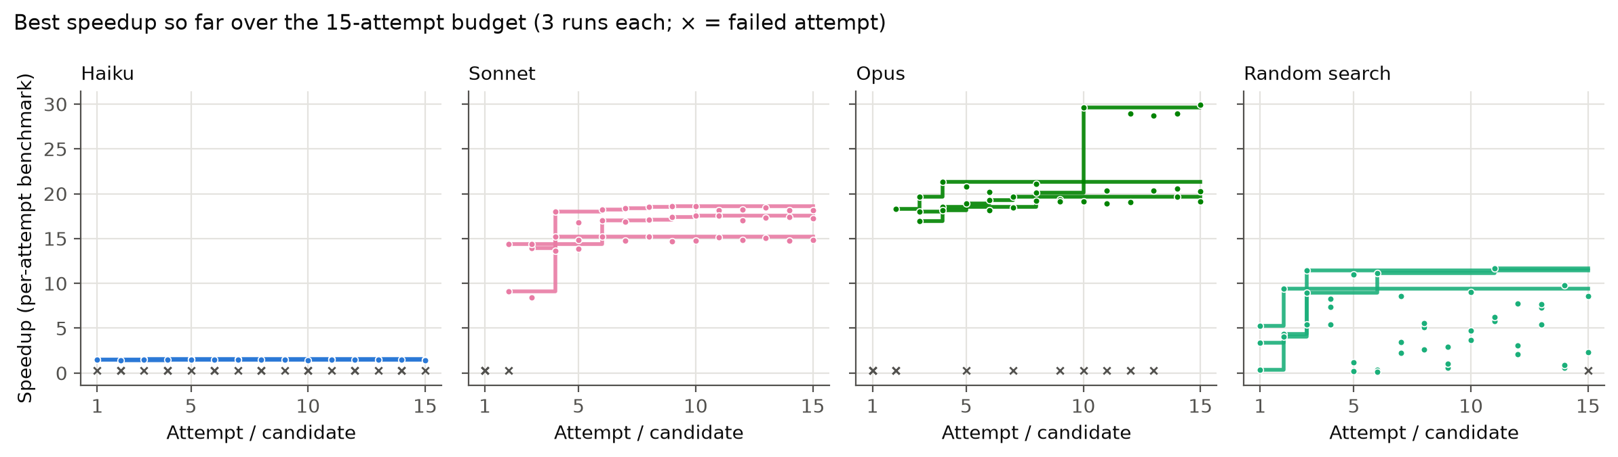
Figure 5. Best speedup so far over the 15-attempt budget (per-attempt benchmark), 3 runs each; × marks a failed attempt. Random search shown for comparison.

Appendix C Reproducing the results
The repository README gives the full setup. Rebuilding the main results table from the saved runs needs only Python 3.11+ and one command:
python agent_loop/run_experiments.py --table-only
Rerunning the experiment from scratch (about 10 to 12 hours on our laptop):
python agent_loop/run_experiments.py
python agent_loop/transfer_test.py
python agent_loop/ablation_knockout.py
python agent_loop/analyze_results.py

