Palmly

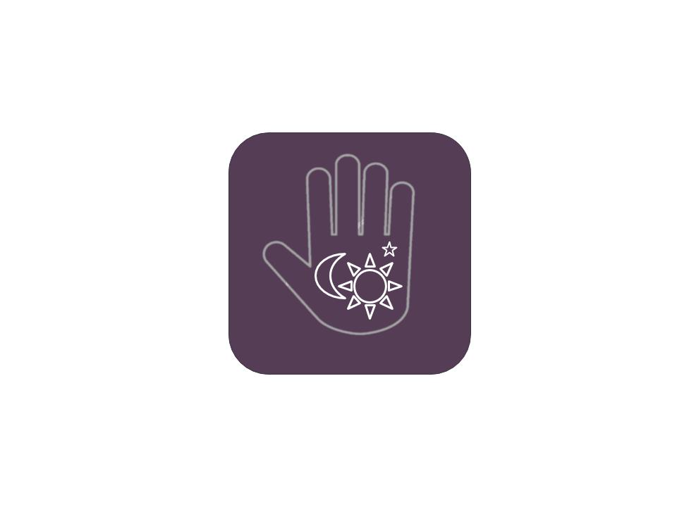

Katie Nguyen

Sofia Ruiz

Moriah Tolliver

Spring 2020

Project Proposal **3**

# Project Proposal

In recent years, it has become increasingly popular in online communities to refer to non-traditional ideas regarding spirituality and lifestyle. A great example of this is Co-Star, an application that uses AI to give lifestyle tips based on astrological signs. The application has approximately 463 thousand downloads monthly[1] and a 4.9 out of 5-star rating amongst 83.6 thousand Apple users.[2] Palmly wants to offer users a similar experience of using AI to learn more about themselves but with a new method of self-discovery: palm reading. Palmly is a mobile application that allows a user to take a picture of their palm and, using deep learning, give the user a classification of their three major palm lines: life, head, and heart. Each user will receive specifics on what their lines says about their past, what the reading means about their present, and what choices they can make to positively affect their future.

Unlike other palm reading apps that require users to draw lines on the picture of their palm, with Palmly, users will simply select or take a photo, and be taken to a new page that displays their reading. On this page, the user will see the interpretation of each major palm line as well as three tabs that further explain each line. Each of these tabs will display the percentage that the user’s palm aligns with each classification. This allows the user to learn more about palm reading, and decide which attributes from their reading they identify with most. There will also be a personality section in each tab informing the user what each line says about their behavior and emotions. These tabs also have a lifestyle section that gives the user tips on what could benefit someone with their observed personality traits. The end user of Palmly will be those who enjoy using applications like Co-Star and lifestyle apps like Headspace. This target group mostly consists of females belonging to the Millennial generation and Generation Z. The application will also appeal to anyone who is interested in astrology, horoscopes, or personality tests. The application will be for iOS, so the user will need an iPhone or iPad to download the application.

Palmly will allow the developers to build on their interaction design skills as they aim to create a user experience that is easy and enjoyable to use. They will also be employing their skills with Python as they implement the TensorFlow MobileNet API. Palmly will also give the developers more experience with iOS development as they work with XCode and Swift, and strive to comply with the Apple Store’s Review Guidelines. Overall, this project will provide the team with a holistic app development experience from ideation to beta testing to redesign and final release.

Status Report

February 24, 2020

|  |
| --- |
| Accomplishments |

* Trained Life, Head and Heart networks with MobileNet
* Developed first draft design in Figma
* Revised first draft of design
* Completed backend connection from MobileNet to temporary front end for Head Network

|  |
| --- |
| This Week’s Plans |

* Connect all three networks to temporary front end
* Complete back-end development of image capture and reading for each line
* Complete front-end development of UI components:

|  |  |
| --- | --- |
| * + Header   + Tab Bar   + Breakdown Card | * Personality Card * Lifestyle Slide * Reading Page |

* Decide source of personality and lifestyle tips (either API, internal database, or hardcoded)

|  |
| --- |
| Next Week’s Plans |

* Assemble components to create Breakdown, Personality, and Lifestyle pages
* Connect front and backend of Reading and Breakdown pages
* Begin integrating backend for Personality and Lifestyle pages

|  |
| --- |
| Risks / Help Needed |

* Certain test images getting 100% assurance from MobileNet. Most likely due to muddling of test and training data. Will acquire new test images to verify the cause of the issue. If test images are not the cause, will retune parameters and retrain networks.

Status Report

March 30, 2020

|  |
| --- |
| Accomplishments |

* Completed front-end development of UI pages and their components:

|  |  |
| --- | --- |
| * + Personality   + Breakdown | * + Reading   + Lifestyle |

* Decided on static set of information for Lifestyle and Personality Page
* Began collection and curation of information for pages above

|  |
| --- |
| This Week’s Plans |

* Continue figuring out how to connect all three networks to front end
* Continue collection of information for Lifestyle and Personality Pages
* Determine database design for Lifestyle and Personality data
* Complete front-end development of UI components:

|  |  |
| --- | --- |
| * + Header | * + Tab Bar |

|  |
| --- |
| Next Week’s Plans |

* Continue integrating all three neural networks
* Finalize database design for Personality and Lifestyle pages
* Connect database to front end

|  |
| --- |
| Risks / Help Needed |

* The team has successfully integrated one neural network to a temporary front-end. However, integrating all three networks into one application has proven difficult. The risk here is not being able to integrate all three networks in a feasible way for a mobile application.

Status Report

April 6, 2020

|  |
| --- |
| Accomplishments |

* Completed front-end development of UI pages and their components
* Began collection and curation of information for pages above
* Connected all three neural networks to temporary front end

|  |
| --- |
| This Week’s Plans |

* Finish collection of information for Lifestyle and Personality Pages
* Connect front end to database for Lifestyle and Personality data
* Connect front end to network outputs

|  |
| --- |
| Next Week’s Plans |

* User-interface testing
* Performance testing

|  |
| --- |
| Risks / Help Needed |

N/A

1. <https://www.crunchbase.com/organization/co-star>
2. <https://apps.apple.com/us/app/co-star-personalized-astrology/id1264782561#see-all/reviews>