Katie Schilling -- Juan Collar -- PHYS 25000 -- Homework #5 -- Mathematica

Part 1: Gammas vs. Neutrons

In this exercise, I will analyze data from interactions in a liquid scintillator in the form of a plot of pulse amplitude per area. Two particles are present, gammas and neutrons. After the 15 a.u. pulse area, it is obvious the distinction between gammas and neutrons. In the 0 to 15 a.u. region, with the naked eye, it is impossible to distinguish between gammas and neutrons (Shown in Figure 1).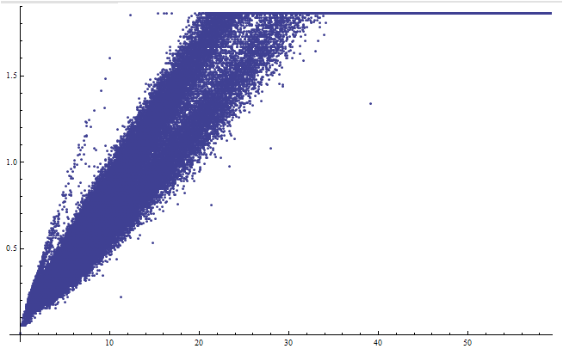

Figure 1: Pulse amplitude per area in arbitrary units

Gammas and neutrons have different pulse shapes, varying in pulse area and amplitude. To discriminate between the two, I generated a third column of the pulse amplitude divided by the pulse area in the supplied input. I then made a list density plot with the amplitude / area as my density (Shown in Figure 2). From this graph, you can clearly see two distinct regions, which can be discriminated by gamma vs neutron. Clearly, a conservative cut should be made between the two regions.

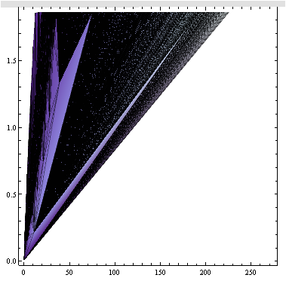

Figure 2: List density plot of pulse amplitude per area with density amplitude / area.

I also used the original graph to experiment with the density histogram by looking at the neighbors of the determined points (Shown in Figure 3). Each neighbor is .07 steps in x and .002 steps in y away from the determined point. Clearly, the cut should be conservative between the two regions and through the region of white in the bottom lefthand corner of the graph that separates the two particles.

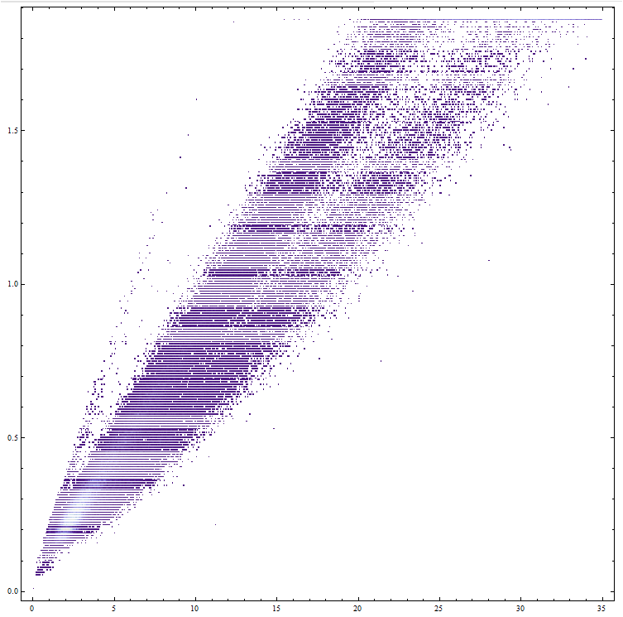

Figure 3: Density histogram with square bins (scaled axes)

The cuts suggested by the list density plot and the density histogram are quite similar, demonstrating such a conservative cut is optimal.