In this exercise, I will find the maximum heat increment for “ramping up” a detector suspended in a gel-based detector matrix that will maintain a standard deviation in temperature, T, smaller than one degree Celsius during a 12 hour ramp up. If the ramp up is too fast, the heat difference from the wall of the gel matrix to the detector will be too high and the detector will not function properly. If the ramp up is too slow, we will be there all day and **miss 3:30pm science cookies**. The horror!

Given initial conditions of T(t) = T(0) = 0 and boundaries of constant temperature (same as bath), I solved the heat equation in Mathematica and plotted a heat map of the chamber and its standard deviation (Shown in Figure 4).

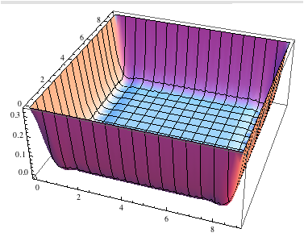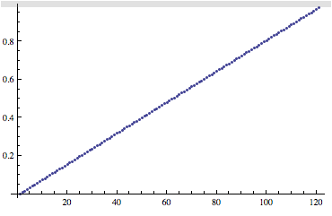

Figure 4: 3D Heat Map of chamber (left) and standard deviation over time (right) given r = .166

Increasing values of r increase the standard deviation above 1. For example, r = .267 gives a standard deviation plot shown below, which clearly exceeds 1 degree. The 3D graph of the temperature is largely unchanged.

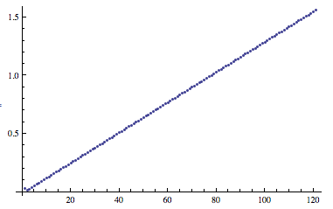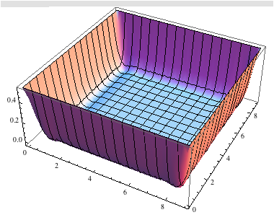

Decreasing r decreases the standard deviation. After varying r, I recommend a ramp increment of r= .166.