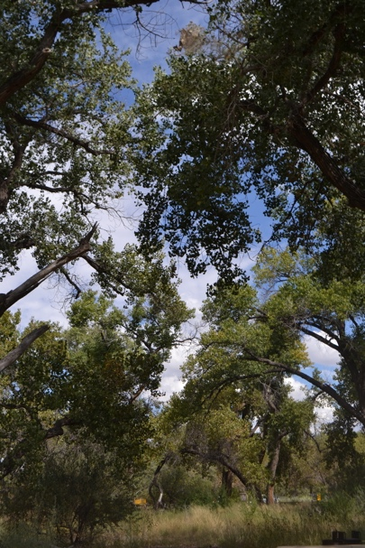*Populus deltoides* ssp. *wislizenii*, Rio Grande Cottonwood

The Rio Grande cottonwood tree is a popular tree species native to New Mexico that can grow up to 100 feet tall. Since this species only grows near the river, it is highly associated with water and arid-land ecosystems. Its survival highly depends on monsoon flooding with its proximity to the Bosque. Thus, this species is affected by climate change and urban landscaping. Additionally, it plays an important role in riparian ecological role as it provides food and shelter for the surrounding organisms.

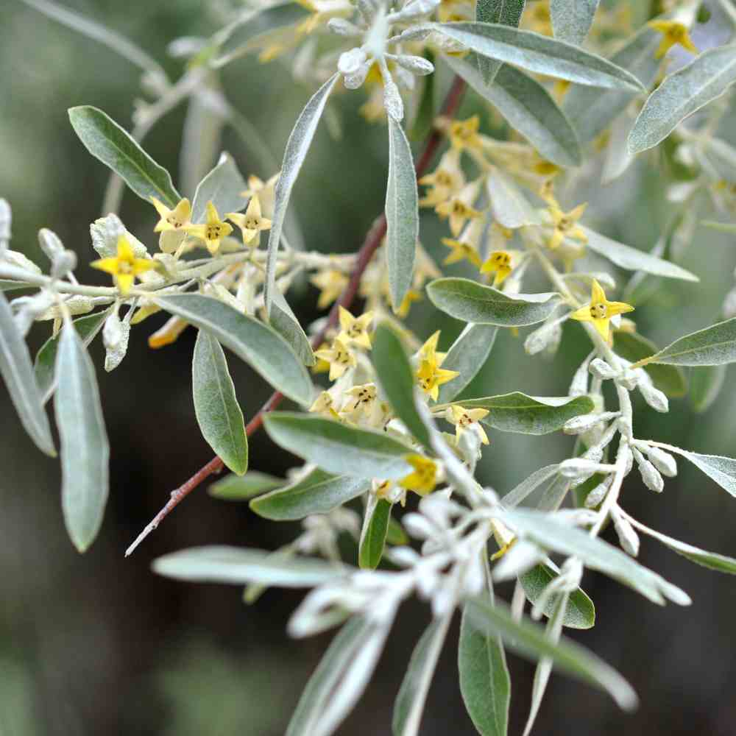

*Elaeagnus angustifolia*, Russian olive

The Russian olive is an invasive species in the American Southwest as it originated in southern Europe & western Asia. It is a particular problem in New Mexico as this species prefer riparian zones and moist environments. It is a resilient, fast-growing tree identifiable by its slivered leaves and yellow flowers. The Russian olive consistently competes with other riparian vegetation and in addition to reducing natural fauna.

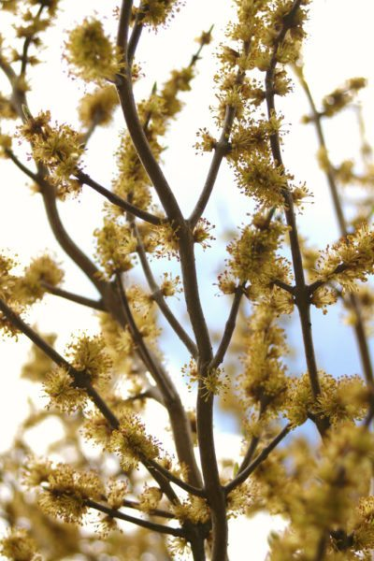

*Forestiera pubescens* var. *pubescens*, New Mexico Olive

The New Mexican olive, otherwise known as the desert olive, is a tree species native to New Mexico as it thrives in hot and sunny regions. Despite its preference for hot climates, it is often found in abundance near rivers and streams in riparian ecosystems. This tree is an essential part of our ecosystem as its fruits provide nutrients to riparian fauna. This species is very hardy and does not face any potential threats as it has no particular soil preferences and thrives in a multitude of biomes.

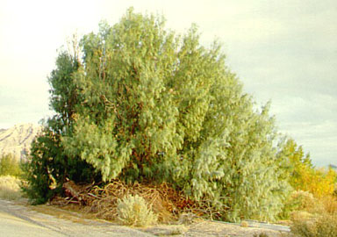*Tamarix chinensis*, Saltcedar

The saltcedar is an invasive species all across the United States known for its small, flat leaves that resemble needles. Saltcedars are a particular threat to riparian areas as they alter soil composition, stream flow, and decrease microbial activity. In New Mexico, the impacts on stream flow are particularly harmful and the invasive aspect of this species is worsened by its spreading mechanisms, that mainly rely on annual river flooding.

Info sources:

<https://www.fs.usda.gov/Internet/FSE_DOCUMENTS/stelprdb5410126.pdf>

<https://www.gardeningknowhow.com/ornamental/shrubs/forestiera-desert-olive/growing-new-mexico-olive-trees.htm>

<https://www.fs.usda.gov/Internet/FSE_DOCUMENTS/stelprdb5410127.pdf>

Picture sources:

<https://www.inaturalist.org/guide_taxa/354910>

<https://www.nature-and-garden.com/gardening/russian-olive-invasive-control.html>

<https://www.texasinvasives.org/plant_database/detail.php?symbol=TAAP>