Supplementary file 2: figures and tables of additional analyses

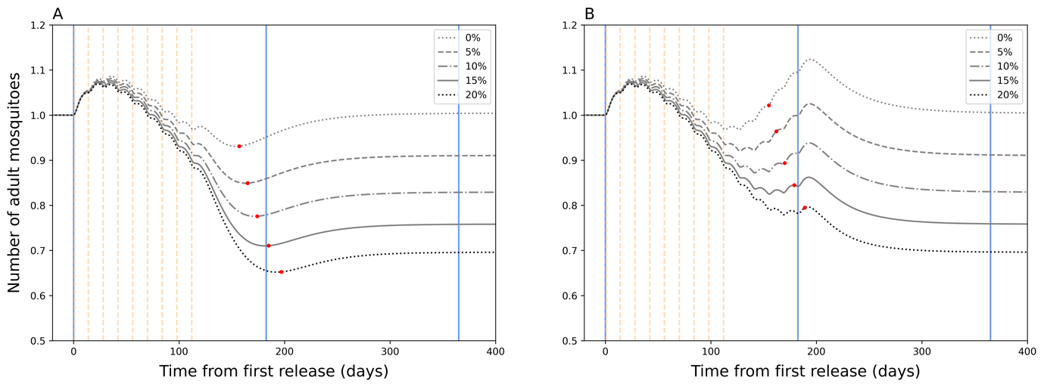

**Supplementary Figure 1. Wolbachia infection fitness cost sensitivity analysis.** The total adult mosquito population size over time during *Wolbachia* replacement after a (A) nine and (B) fourteen release (dotted vertical lines) round programme for a range of Wolbachia fitness costs (0% – 20%, in 5% increments). Red dots indicate the date at which target coverage (>= 95% *Wolbachia* coverage) is first achieved. The blue lines show the time points from first release at 0 days, 6 months, and 1 year from left to right.

**Supplementary Figure 2.** **Comparing efficacy calculations for 1gSLT and Male *Wolbachia* release.** A) 1gSLT has a literature efficacy of 45% fitted at 5 weeks (30) but delayed effects lead to the maximum efficacy reaching 51.67%. B) Male *Wolbachia* release has a literature efficacy of 60% fitted at 5 weeks (31) but delayed effects lead the maximum efficacy reaching 63.28%.

**Supplementary Figure 3. Adulticide recovery sensitivity analysis.** Adulticide (thermal fog application of deltacide) reportedly has an efficacy of 94% with full recovery within 7 days (34), however, this rapid and complete recovery could not be simulated in the model population. Therefore, a coverage value was applied which allows the adulticide to retain its high efficacy and the population to recover within reasonable time; this figure shows 80% population recovery within various timeframes (1 – 5 weeks) and 80% population recovery within 3 weeks was assumed in the model.

**Supplementary Figure 4.** **Seasonal precipitation and population dynamics.** The adult *Aedes aegypti* population mirrors the precipitation dynamics with a 41-day lag from peak precipitation to maximum adult population and a 2.74-fold increase from minimum to maximum population (with $s$ constant of 2.09 the population average becomes 458 which be comparable to non-seasonal model equilibrium of 457.5 for further analyses).

**Supplementary Figure 5. Temperature sensitivity analysis.** (A) With the addition of temperature in the density-dependent function which determines larval development rate, the adult *Aedes aegypti* population mirrors (B) precipitation dynamics with a 43-day lag from peak precipitation to maximum adult population and a 1.41-fold increase from minimum to maximum population.

**Supplementary Figure 6.** **Model Wolbachia coverage dynamics compared to Yogyakarta RCT.** The *Wolbachia* coverage dynamics of twelve treatment areas (grey) (14) are compared to nine (blue) and fourteen (black) releases. The dashed and sold red lines indicate 90% and 95% coverage points, respectively, while the vertical dashed lines indicate *Wolbachia* releases.

**Supplementary Table 1. Suppression efficacy.** Description of suppression technique efficacy values and their literature sources.

|  |  |  |  |  |
| --- | --- | --- | --- | --- |
| **Suppression Technique** | **Efficacy** | | **Literature Source** | **Notes** |
| At 5 weeks | At 10 weeks |
| 1gSLT | 45% | 70% | Carvalho *et al.* (2015) (30) | 1gSLT males released from slowly moving vehicle, total 5 months intervention, population measured in release area before and after. Extracted from Figure 2, panel D, from the 5- and 10-week timepoints of release in area A only. |
| SIT* | – | – | – | – |
| Male *Wolbachia* release | 60% | 95% | Ching (2021) (31) | Male *Wolbachia* released weekly on ground floor of hi-rise blocks, total 17½ months intervention, population measured in release area before and after. Extracted from Figure 2, panel G, for 5-week timepoint and long-term efficacy. |
| Environmental Management | 47.4% flat rate | | Andersson *et al.* (2015) (32) | Community education on dengue transmission cycle promoted reducing larval habitat, total 16 months intervention, pupae population measured in control vs. intervention villages. Extracted from Table 3, the effect of intervention on the pupae per person index relative to control. |
| Larvicides | 44% flat rate | | Hustedt *et al.* (2021) (33) | Use of guppies in household water containers, total 12 months intervention, pupae population measured in control vs. intervention household clusters. Extracted from Table 4, abundance ratio of immature *Aedes* index after treatment with guppies. |
| Adulticides | 94% weekly | | Mani *et al.* (2005) (34) | Peridomestic fogging, applied once, mosquito resting density measured for the following 14 days. Extracted from Table 3, reduction in *Aedes aegypti* resting density after treatment with peridomestic fogging. |

* There are currently no published trials for suppression using SIT

|  |  |  |  |  |  |  |  |  |  |
| --- | --- | --- | --- | --- | --- | --- | --- | --- | --- |
|  |  |  |  | Placement 2 | | | | | |
|  |  |  |  |  |  |  |  |  |  |
|  |  |  | Singly applied | $$\frac{dO}{dt}=…$$ $$-f_{K}α_{O}O$$ | $$\frac{dL}{dt}=…$$ $$+f_{K}α_{O}O$$ | $$\frac{dL}{dt}=…$$ $$+f_{K}α_{O}O$$ | $$\frac{dP}{dt}=…$$ $$+{f_{K}α}_{L}\frac{L}{1+({γL)}^{β}}$$ | $$\frac{dP}{dt}=…$$ $$+α_{L}\frac{L}{1+({γf_{K}L)}^{β}}$$ | $$\frac{dP}{dt}=…$$ $$-f_{K}α_{P}P$$ |
| Placement 1 |  | $$\frac{dO}{dt}=…-f_{K}α_{O}O$$ | 52  *(2.54)* | – | – | – | – | – | – |
|  | $$\frac{dL}{dt}=…+f_{K}α_{O}O$$ | 146  *(2.73)* | 139  *(1.1)* | – | – | – | – | – |
|  | $$\frac{dL}{dt}=…-f_{K}α_{L}L$$ | 55  *(2.15)* | 58  *(5.05)* | 139  *(1.18)* | – | – | – | – |
|  | $$\frac{dP}{dt}=…+{f_{K}α}_{L}\frac{L}{1+({γL)}^{β}}$$ | 152  *(7.55)* | 158  *(2.87)* | 151  *(21.16)* | 156  *(3.17)* | – | – | – |
|  | $$\frac{dP}{dt}=…+α_{L}\frac{L}{1+({γf_{K}L)}^{β}}$$ | 41  *(2.74)* | 46  *(6.74)* | 5  *(1.1)* | 46  *(5.56)* | 151  *(2.74)* | – | – |
|  | $$\frac{dP}{dt}=…-f_{K}α_{P}P$$ | 43  *(5.14)* | 47  *(12.25)* | 33  *(1.92)* | 47  *(10)* | 146  *(1.44)* | 42  *(13.95)* | – |
|  | $$\frac{dM}{dt}=…+f_{K}α_{P}P$$& $$\frac{dF}{dt}=…+f_{K}α_{P}P$$ | 153  *(7.55)* | 160  *(2.89)* | 151  *(21.12)* | 158  *(3.18)* | 153  *(65.78)* | 153  *(2.74)* | 158  *(1.44)* |

**Supplementary Table 2. Seasonality sensitivity analysis.** Exploring placement of the seasonality function, comparing the number of days delay between peak mosquito population and peak precipitation and the proportion population increase from minimum to maximum (in brackets). The selected placement is highlighted yellow