Assessment-2
Write SQL query to solve the problem given below
Question:
Create a database named NobelPrize.
CREATE DATABASE NobelPrize;

Question:
Use the NobelPrize database.
USE NobelPrize;

Question:
Create a table named Nobel_win with columns year, subject, winner, country and category.
CREATE TABLE Nobel_win (
year INT,
subject VARCHAR(50),
winner VARCHAR(100),
country VARCHAR(50),
category VARCHAR(50)
);

Question:
Insert records into Nobel_win table.
INSERT INTO Nobel_win VALUES
(1970, 'Physics', 'Hannes Alfven', 'Sweden', 'Scientist'),
(1970, 'Chemistry', 'Luis Federico Leloir', 'Argentina', 'Scientist'),
(1970, 'Economics', 'Paul Samuelson', 'USA', 'Economist'),
(1971, 'Physics', 'Dennis Gabor', 'Hungary', 'Scientist'),
(1965, 'Chemistry', 'Robert Burns Woodward', 'USA', 'Scientist'),
(1975, 'Chemistry', 'John Cornforth', 'Australia', 'Scientist'),
(1968, 'Chemistry', 'Louis Leloir', 'Argentina', 'Scientist'),
(1972, 'Peace', 'Louis Neel', 'France', 'Leader');

Question:
Write SQL query to find the Nobel Prize winners of the year 1970. Return year, subject and winner.
SELECT year, subject, winner
FROM Nobel_win
WHERE year = 1970;
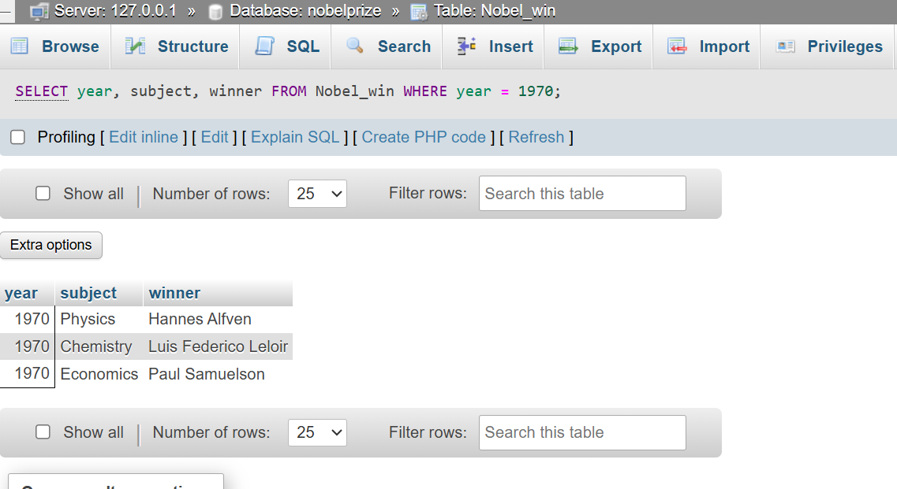

Question:
Write SQL query to find the Nobel Prize winners in Chemistry between the years 1965 and 1975. Return year, subject, winner and country.
SELECT year, subject, winner, country
FROM Nobel_win
WHERE subject = 'Chemistry'
AND year BETWEEN 1965 AND 1975;
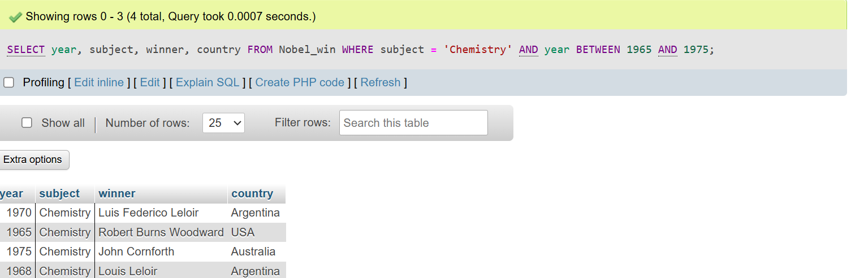

Question:
Write SQL query to retrieve the details of the winners whose first name matches with the string ‘Louis’. Return year, subject, winner and country.
SELECT year, subject, winner, country
FROM Nobel_win
WHERE winner LIKE 'Louis%';
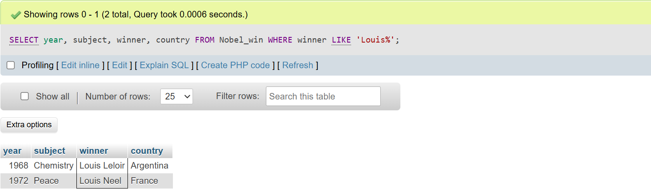

Question:
Write SQL query to find Nobel Prize winners for the subject that does not begin with the letter ‘P’. Order the result by year descending and winner ascending.
SELECT *
FROM Nobel_win
WHERE subject NOT LIKE 'P%'
ORDER BY year DESC, winner ASC;
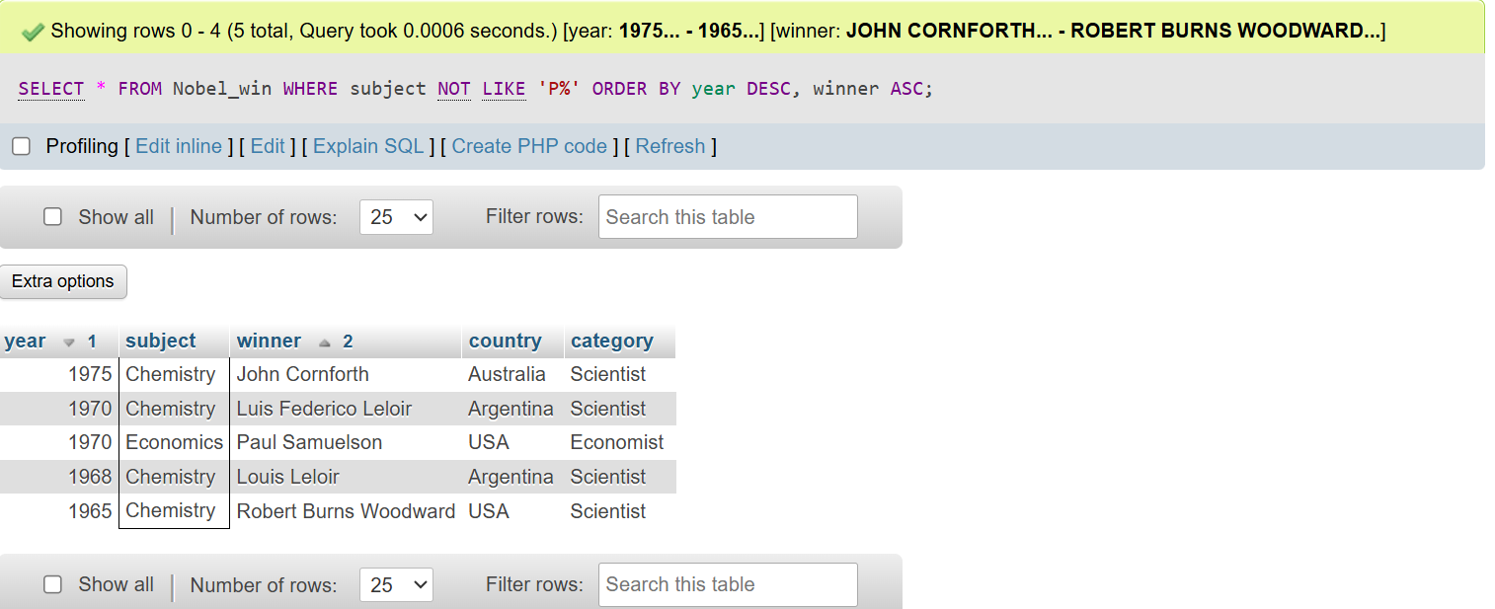

Question:
Write SQL query to find the details of 1970 Nobel Prize winners. Order the result by subject ascending except for Chemistry and Economics which will come at the end of the result set. Return year, subject, winner, country and category.
SELECT year, subject, winner, country, category
FROM Nobel_win
WHERE year = 1970
ORDER BY
CASE
WHEN subject = 'Chemistry' THEN 1
WHEN subject = 'Economics' THEN 2
ELSE 0
END,
subject ASC;


