Jenkins

It is a java application. it is platform independent.

According to this you can use in windows/MAC.

It is used for CI and Contionous Delivery..

---DEVELOPER(works on his machine) -----> Shared repositroy

(GIT/TFS) --

Jenkins will take the commit and trigger a build.

Any error then you will get notify when trigger completes.(Due to some changes some broke happend that to be reported)

If there it iws success- post build actions.

Jenkins will trigger some test cases and it will send to the report back to us.

Download jenkins and place the war file in any location of the system.

place the war file in some (C:\programsfiles\skatika)and run through command prompt.

Java –jar Jenkins.war

Password will generate in the command and copy the password and save it somewhere.

Now login with http:/localhost/8080

And give the password for the first time and it will ask suggested plugins or install plugins we need to give suggested plugins.

You can check the folder name like .jenkins in this we have all logs, configuration files, Jenkins plugins.

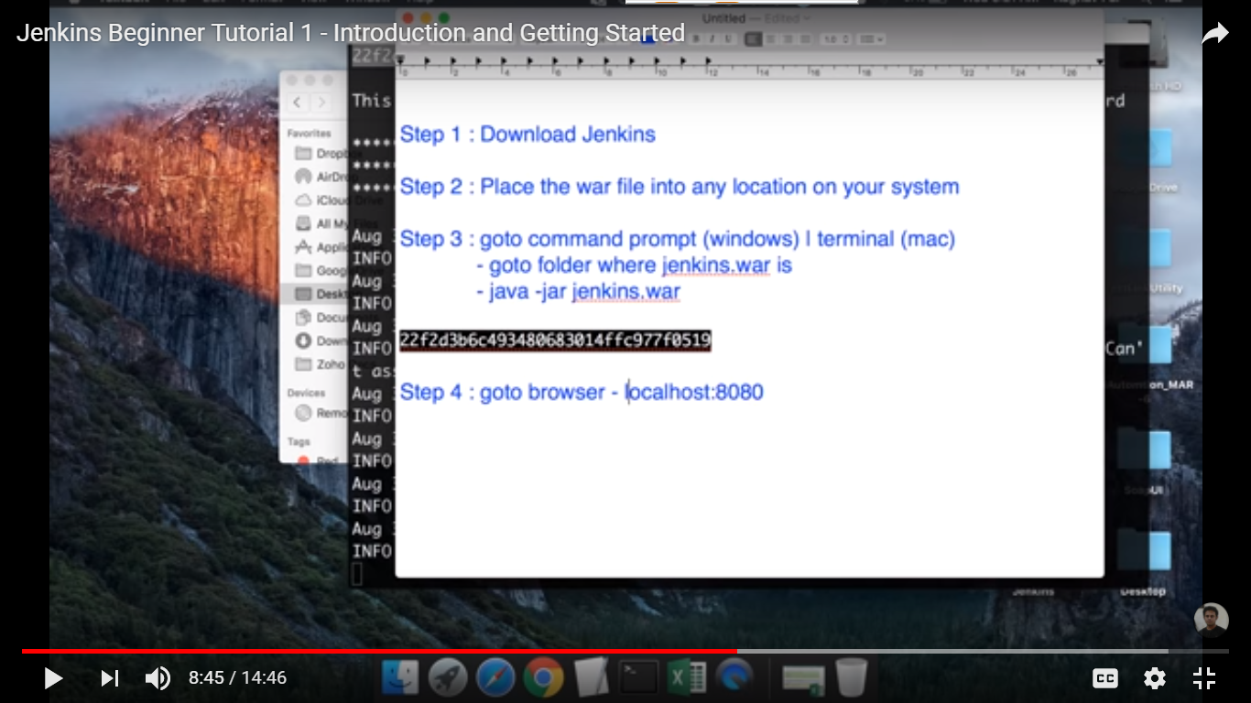

2nd Session : -

Why we should deploy Jenkins in Tomcat server ?

Jenkins will come under with own server..

We can install Jenkins on TOMCAT… if we can continue in Jenkins standlone we can do it.

Servlet containers( TOMCAT)

\*\* TOMCAT 5 or above

\*\* JAVA 7 or above should be available on your system.

Step 1: Download TOMCAT zip file

Step2 :

TO start Jenkins stand alone with different port.

Java –jar Jenkins.war - -httpPort = 9090

Basic Configuration for Jenkins

1. Go to Jenkins-> Manage Jenkins -> Configure System
2. Get a undetstanding of comman and some basic configurations.

How to change the HOME DIRECTORY :

How to change the users.

1. Go to Jenkins-> Manage Jenkins- >Manage users -> create user-> give username, password and save it
2. Logout the existing user and login with the user which you create just now.

How to configure the users :

Go to the user and drop down coloumn and click configure and then do settings.

How to create and manage user roles.

Role strategy plugin ->Download -> Restart Jenkins.

Manage Jenkins -> Configure Global Security -> Authorization -> Role based strategy(only visible after your installation)

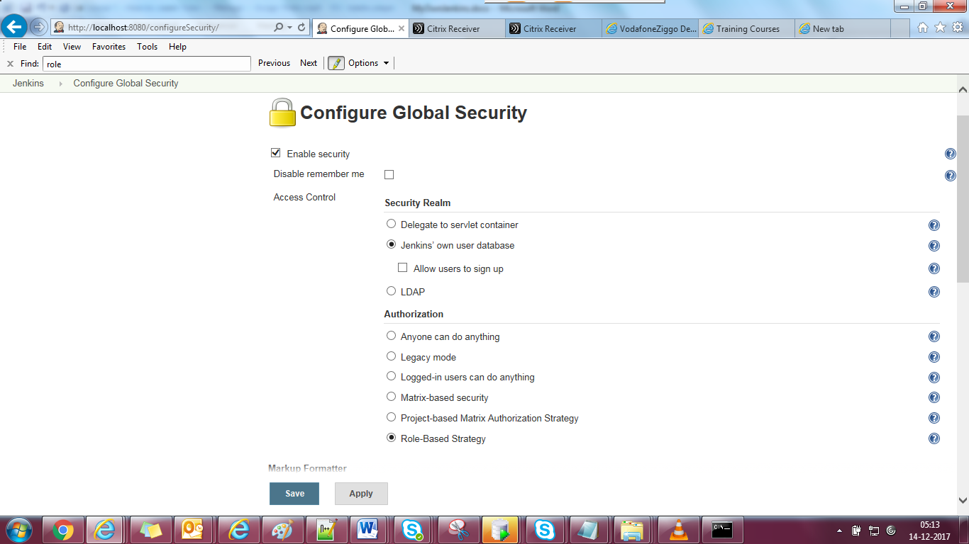

Manage Jenkins -> Configure System ->

Get an understanding of common and basic commands.

Get System Message -> Give anything which is meaningful under Configure system