Aug 29th 2023

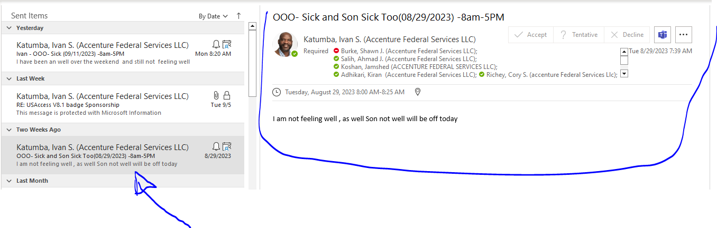

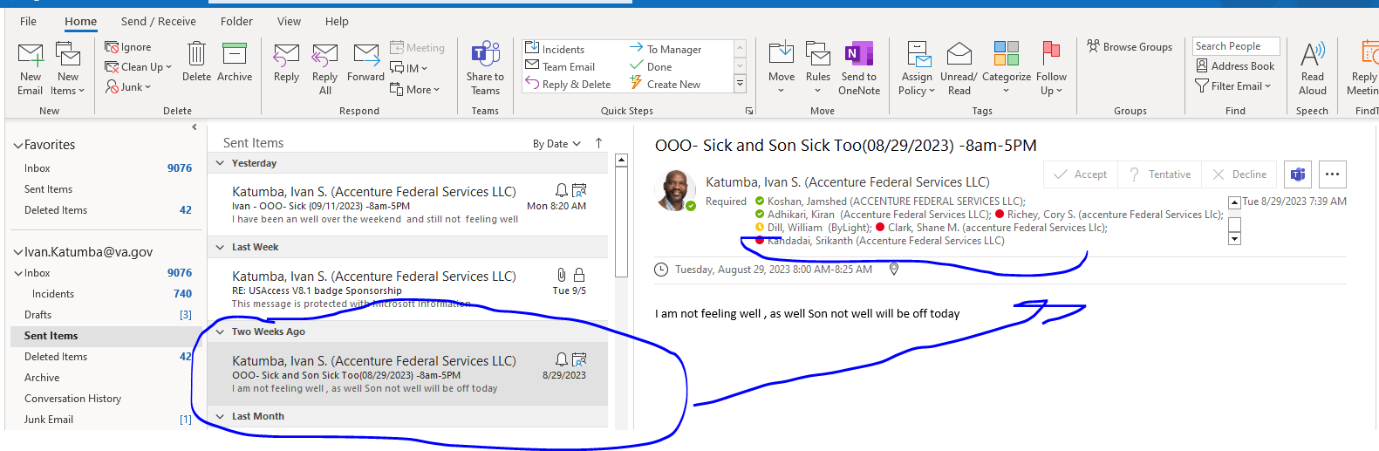

August 31st ------ was not Available

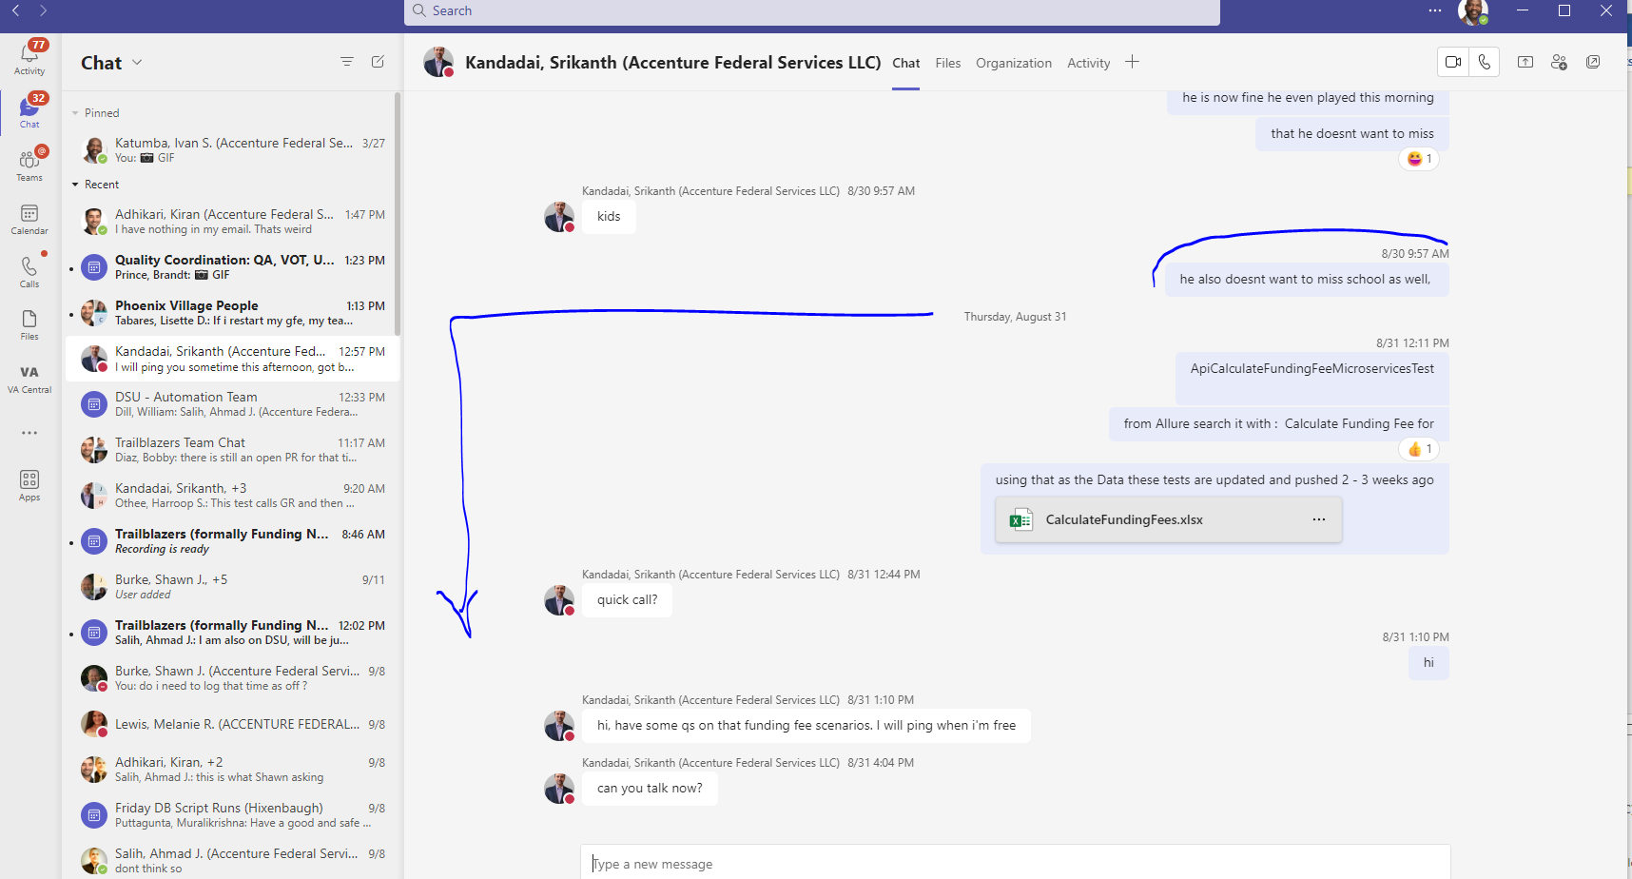

September 1st 2023

Attache sms to sent to shawn + screen shoot from provider

September 5th----------

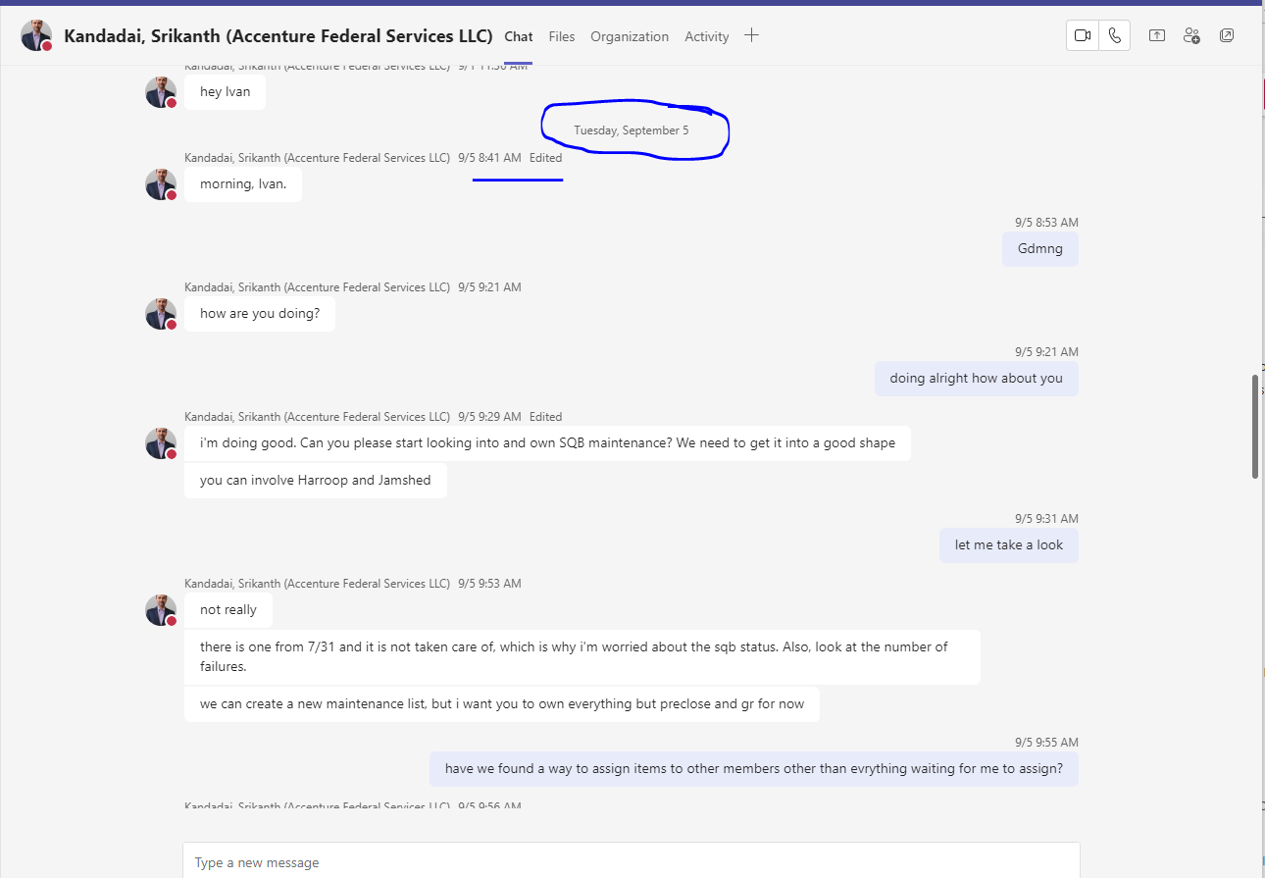

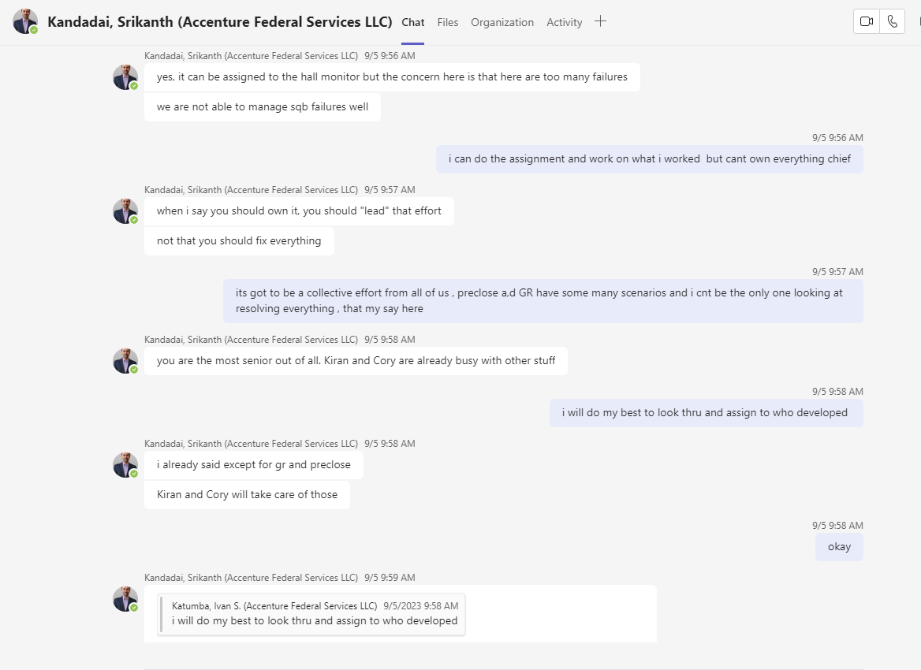

Maintenance List : [[LGY-1354484] AUTOMATION: Repair 07/31/2023 SQB Microservice broken and failed - VA DTE Jira](https://jira.devops.va.gov/browse/LGY-1354484)

About the Fixes

