Coupling biochar properties and sorption behavior of perfluorooctanoic acid (PFOA) for 23 biochars produced from organic waste

Krahn KM1*, Skjennum KA1,2, Sørmo E2,3, Wolf R3, Hartnik T4, Arp HPH3,5, Zimmerman AR6, Zhang Y7 and Cornelissen G2,3

*1Lindum AS, 3036 Drammen, Norway*

*2Faculty of Environmental Sciences and Natural Resource Management, Norwegian University of Life Sciences (NMBU), 1430 Ås, Norway*

*3Norwegian Geotechnical Institute (NG), 0484 Oslo, Norway   
4Norwegian Institute of Bioeconomy Research (NIBIO), 1430 Ås, Norway   
5Norwegian University of Science and Technology (NTNU), 7024 Trondheim, Norway,   
6University of Florida, Gainesville, FL, USA  
7College of Environmental Sciences and Engineering, Hunan University, Lushan Gate, Lushan South Road, Yuelu District, Changsha 100084, China*

[*katinka.krahn@lindum.no](mailto:*katinka.krahn@lindum.no)

***ABSTRACT***

The use of sewage sludge to produce biochar-based sorbents for per- and polyfluoroalkyl substances (PFAS) removal from water and soil may be an economically and environmentally sustainable waste management option. This study compared the sorption of perfluorinated octanoic acid (PFOA) by 23 sewage sludge biochars (SSBCs) and wood waste-based biochars (WWBCs), dry pyrolyzed at temperatures from 500-800 °C in batch sorption tests. Sorption was represented using both the Freundlich and Polyani-Dubinin-Manes (PDM) nonlinear isotherm models. The biochars were thoroughly characterized for pore volume, surface area, elemental content, mineral composition, and zeta potential. Statistical analyses using these parameters and the modelled distribution coefficients for PFOA were conducted to highlight the most important biochar properties that govern sorption affinity and capacity of PFOA on biochar. PFOA-sorption to the SSBCs at 700-800 °C outperformed the WWBCs and reference sorbent, and exhibited log-linear biochar-water distribution coefficients (log *Kd*), two to three orders of magnitude higher than previously reported log *Kd*sfor commercial activated carbons (e.g., 6.72 ± 0.22 at 1 µg/L for PFOA on biochar from dewatered sewage sludge at 800 °C). The strong sorption of PFOA was mainly attributed to the SSBCs’ relatively high pore volumes in the pore size range that can accommodate this relatively large molecule (1.36 nm length). These findings could enable sustainable value chains for waste-based biochar sorbents in soil remediation and water filtration solutions.

Keywords: PFOA, biochar, sewage sludge, organic waste, sorption

Themes: Production, characterization, and technologies (Biochar properties and characterization) & Materials and non-soil-based applications (Biochar based filters for liquids and gases)

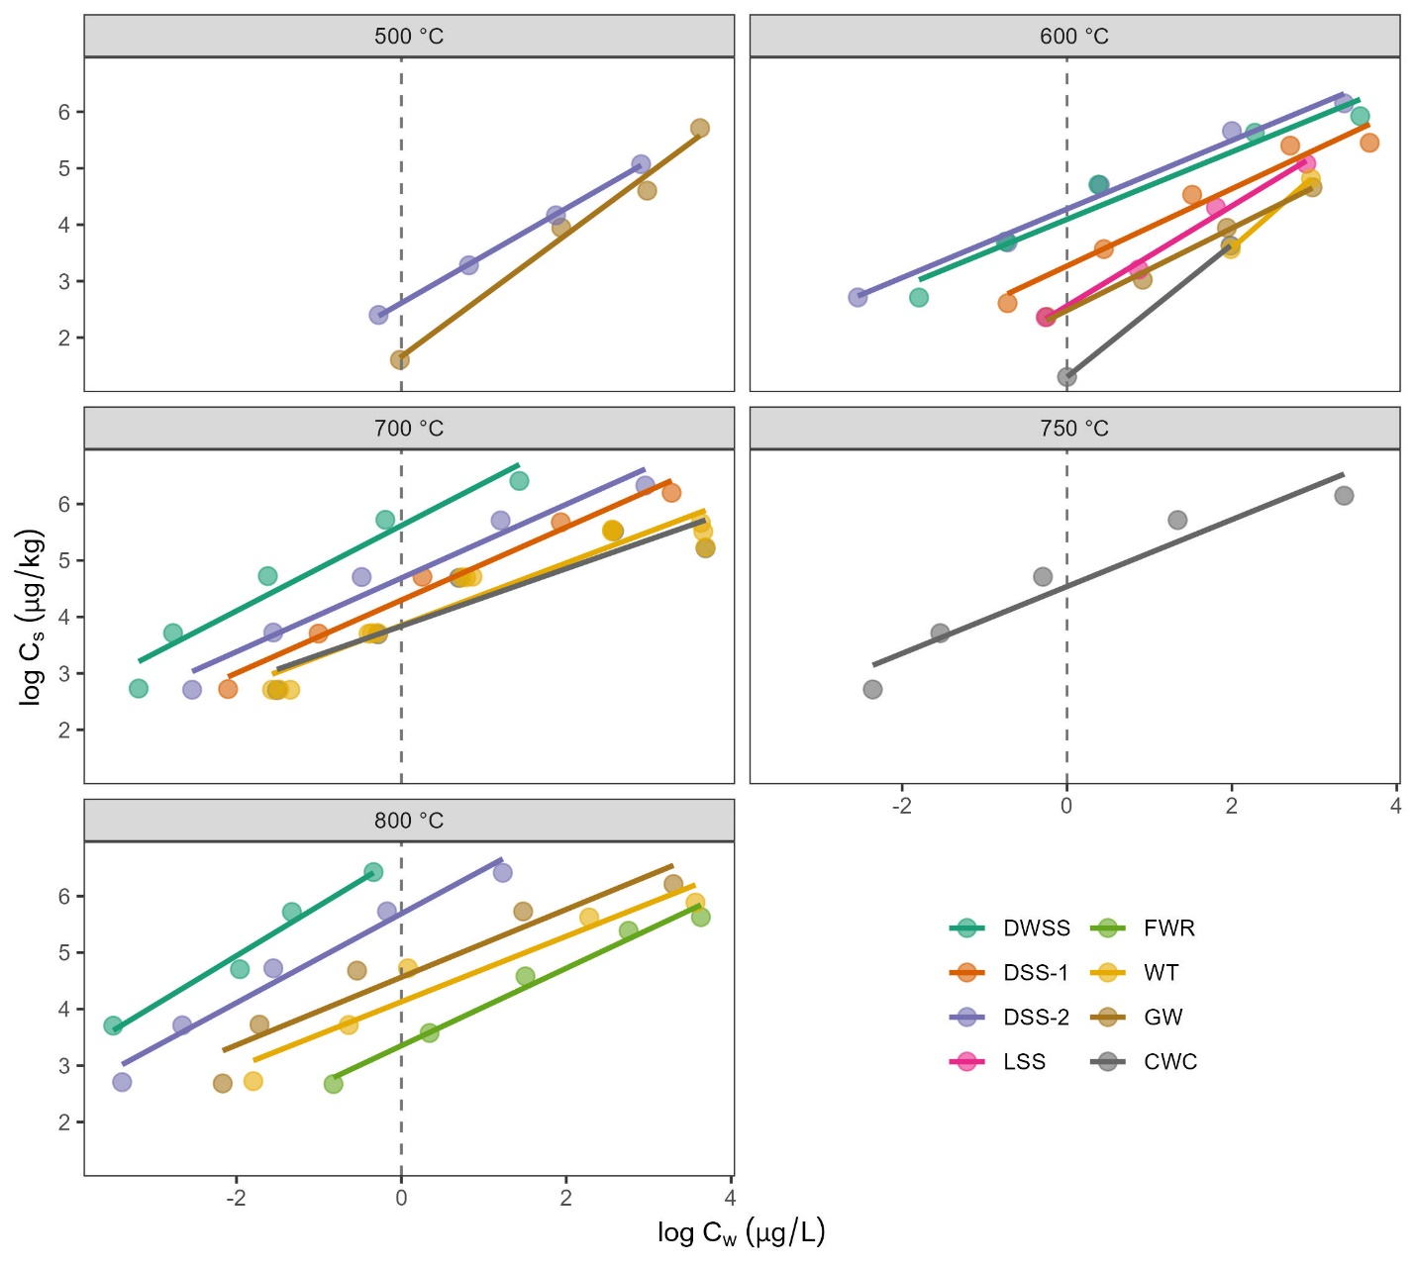

Figure 1 Sorption isotherms of PFOA on biochars from the digested sewage sludges (DSS-1 and DSS-2), dewatered sewage sludge (DWSS), limed sewage sludge (LSS), food waste reject (FWR), waste timber (WT), garden waste (GW), and wood chips (CWC) categorized by pyrolysis temperature (˚C).



Figure 2 Cumulative surface area (SA) and pore volume (PV) for pore diameters ranging between 0.4 and 1.5 nm (a and b), and pores > 1.5 nm (c and d) using DFT theory for two sewage sludge biochars (SSBC-1 and SSBC-2) and one reference wood-based sorbent (WCBC) pyrolyzed at 700 ˚C. The dashed vertical lines represent the maximum diameter of the PFCAs tested (PFPeA, PFHxA, PFHpA, PFOA, PFNA, and PFDA).

**Biography**

Katinka Muri Krahn is an environmental chemist with a Master in Environmental and Natural Resources with focus on contaminated soil and water remediation. After finishing her studies in May 2022, she has spent the past year as a researcher for Lindum AS, an industrial waste handling company and landfill. Her main research areas are treatment and recycling of contaminated organic waste by pyrolysis, mass balance of organic pollutants (PFAS, PAH, PCB and dioxins) during pyrolysis, and sorption chemistry using carbonaceous sorbents, with focus on biochar.

**Contact Information:**

Lindum AS

Katinka Muri Krahn

Lerpeveien 155

3036 Drammen

Norway

Tel: + 47 454 40 247

Email: [katinka.krahn@lindum.no](mailto:katinka.krahn@lindum.no)

LinkedIn: <https://www.linkedin.com/in/katinka-muri-krahn-36a946102/>

Presentation Category: Oral Presentation