Excel Dashboard Features

**Overall Dashboard View:** A comprehensive glance at the entire Olympics dashboard with interactive elements.

After changing theme :

About me:

Process:

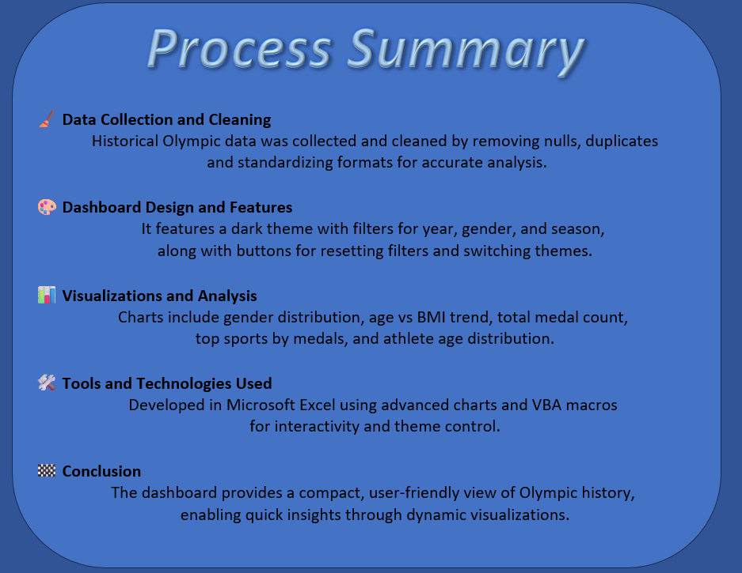

**LinkedIn Engagement**

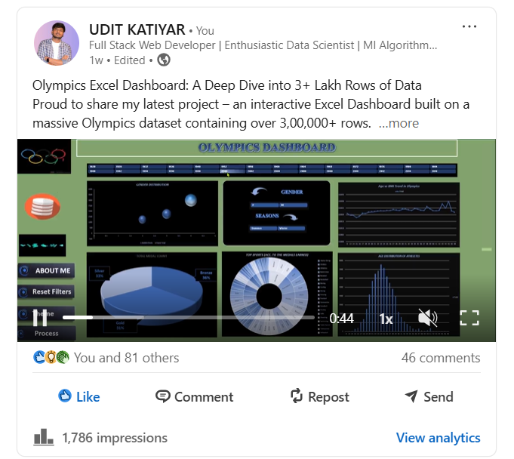

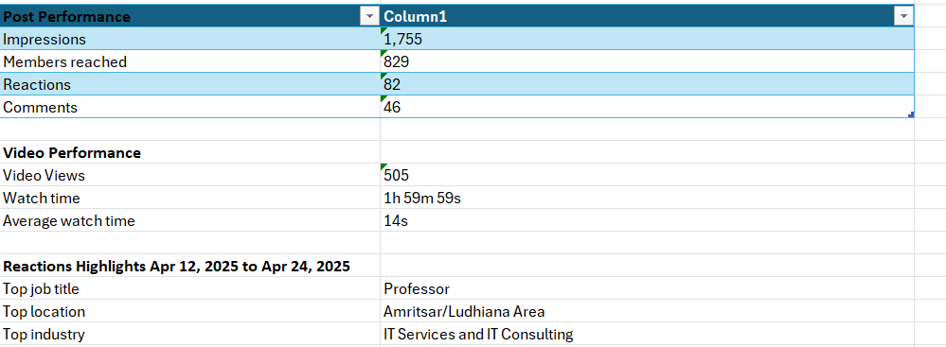

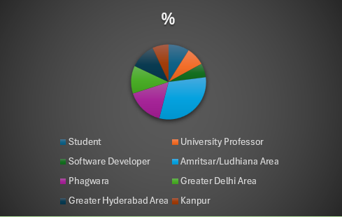

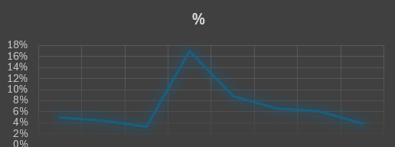

Some Special Comments:

**Head Of computer Science Domain:**



**IEEE Senior Member & Dean of ECE at NIET’s:**



**Faculty from LPU Comments:**

