PWD: this command shows present working directory

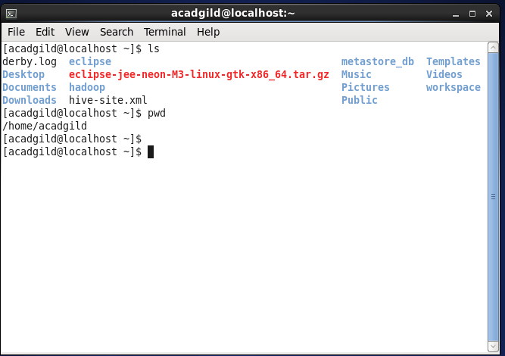

Vi: it is a visual editor

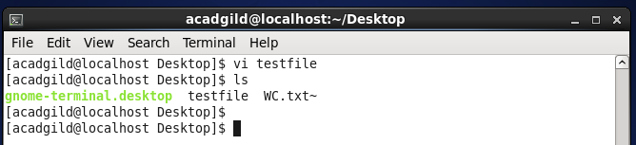

Touch: it is used to create a new empty file

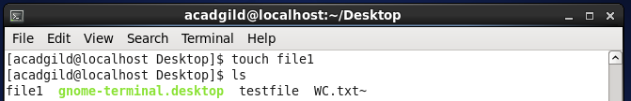

mkdir: this command is used to create a new directory

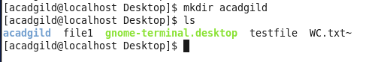

rm: This command is used to remove files and directories

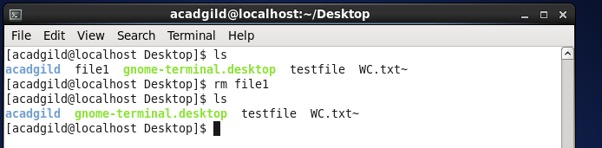

ls : this command is used to list files

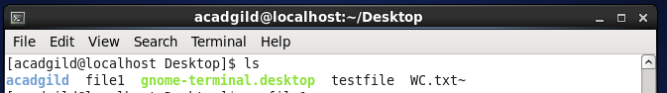

Echo: it is used to display line of text on standard output or a file

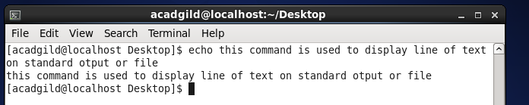

Cat: command is used to create file, view content of file

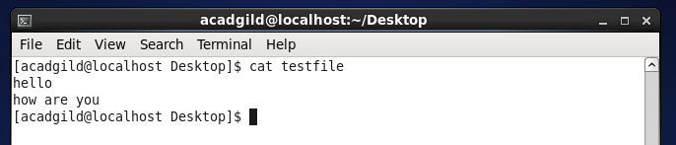

Who: displays list of users currently logged into the system

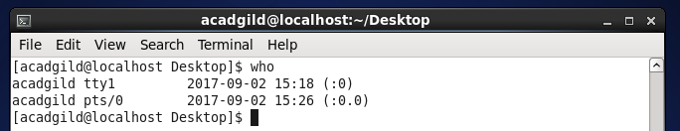

cd : This command is used to change directory

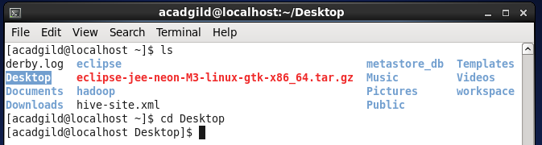

Date : displays current date and time

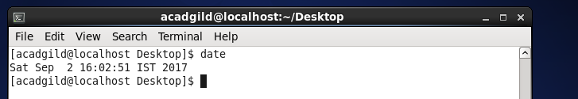

Cal : it is used to display calendar

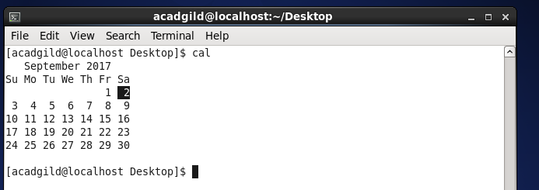

mv: It is used to move files/directory

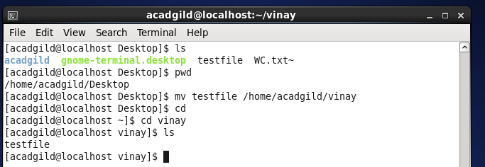

cp : to copy file to another location

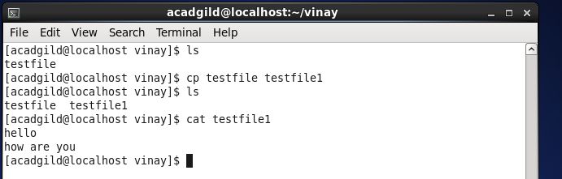

Which : is used to find location of program

