Moved max-temp.txt file from local system to HDFS

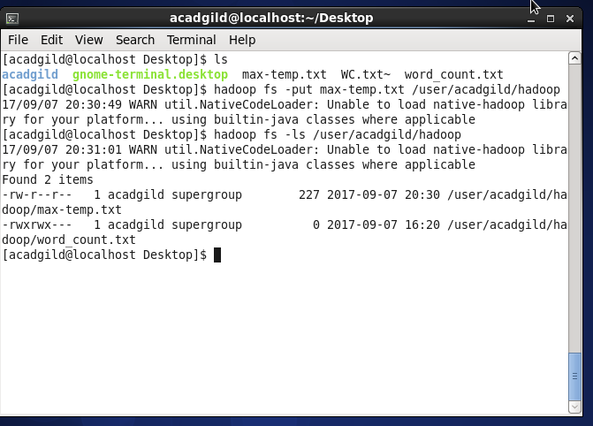

Used chmod command to change file permissions as per problem statement

