CS 550 | Fall 2023

**Project 5**

## “Texture Mapping"

By

**Pushpak Katkhede**

Email – [katkhedp@oregonstate.edu](mailto:katkhedp@oregonstate.edu)

**OUSID – 934453040**

Instructor – Prof Mike Bailey

* **Description 🡪**

**Video Link:** [**Click Here**](https://media.oregonstate.edu/media/t/1_z9ioq4gd)

* **Texture Loading**
* Texture Files: Stored each texture file, such as "venus.bmp" and "earth.bmp," within the file system.
* Texture Object Creation: Employed the BmpToTexture function to process each texture and generate corresponding texture objects. The texture objects were associated with texture names using the glGenTextures and glBindTexture functions.
* **Display Lists**
* Unit Sphere Display List: Created a display list (SphereDL) representing OSU sphere with a radius of 1.0.
* Planetary Display Lists: Generated separate display lists for each planet, such as MarsDL. Each display list contained the scaled planetary geometry and the corresponding texture bound using glBindTexture.
* **Light Source**

Dynamic Lighting: Introduced a moving point light source within the scene to illustrate the effects of dynamic lighting on the textures. The light's movement was designed to showcase the functionality of the GL_MODULATE mode.

* **Keyboard Controls**
* Planet Switching: Implemented keyboard controls ('v', 'e', 'm', 'j', 's', 'u', 'n') to switch between different planets.
* Texture Modes: Enabled keyboard interaction to toggle between displaying:
  + A lit white sphere without texture (proper scale)
  + The texture image in GL_REPLACE mode
  + The texture image in GL_MODULATED mode
* Texture Mode Switching: Utilized a designated key (e.g., 't') to cycle through these three texture modes.
* **Key and Function 🡪**

1. 't': Toggle Texture
2. 'l': Toggle Light
3. 'c': Toggle Modification
4. 'v': Venus
5. 'e': Earth
6. 'm': Mars
7. 'j': Jupiter
8. 's': Saturn
9. 'u': Uranus
10. 'n': Neptune
11. 'o' or 'O': Orthographic Projection
12. 'p' or 'P': Perspective Projection
13. 'q', 'Q', or ESCAPE: Quit

* **Screenshots 🡪**

**Osu sphere**

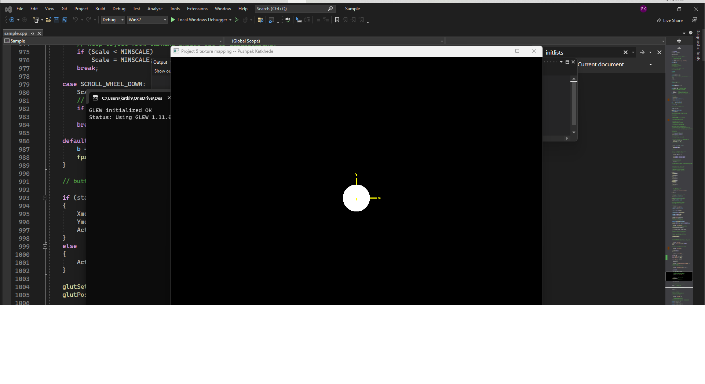

**GL_REPLACE vs GL_MODULATE**



