Q-1 Examples 2-3, 2-4, and 2-5 :

hdfs dfs -copyFromLocal /home/student13/sample.txt /home/13student13/sample.txt

hadoop jar /home/student13/hadoop-streaming-2.9.0.jar -input /home/13student13/sample.txt -output /home/13student13/output12 -file /home/student13/max_temperature_map.py -mapper /home/student13/max_temperature_map.py -file /home/student13/max_temperature_reduce.py -reducer /home/student13/max_temperature_reduce.py

hdfs dfs -ls /home/13student13/output12/

hdfs dfs -cat /home/13student13/output12/part-00000
RESULT :
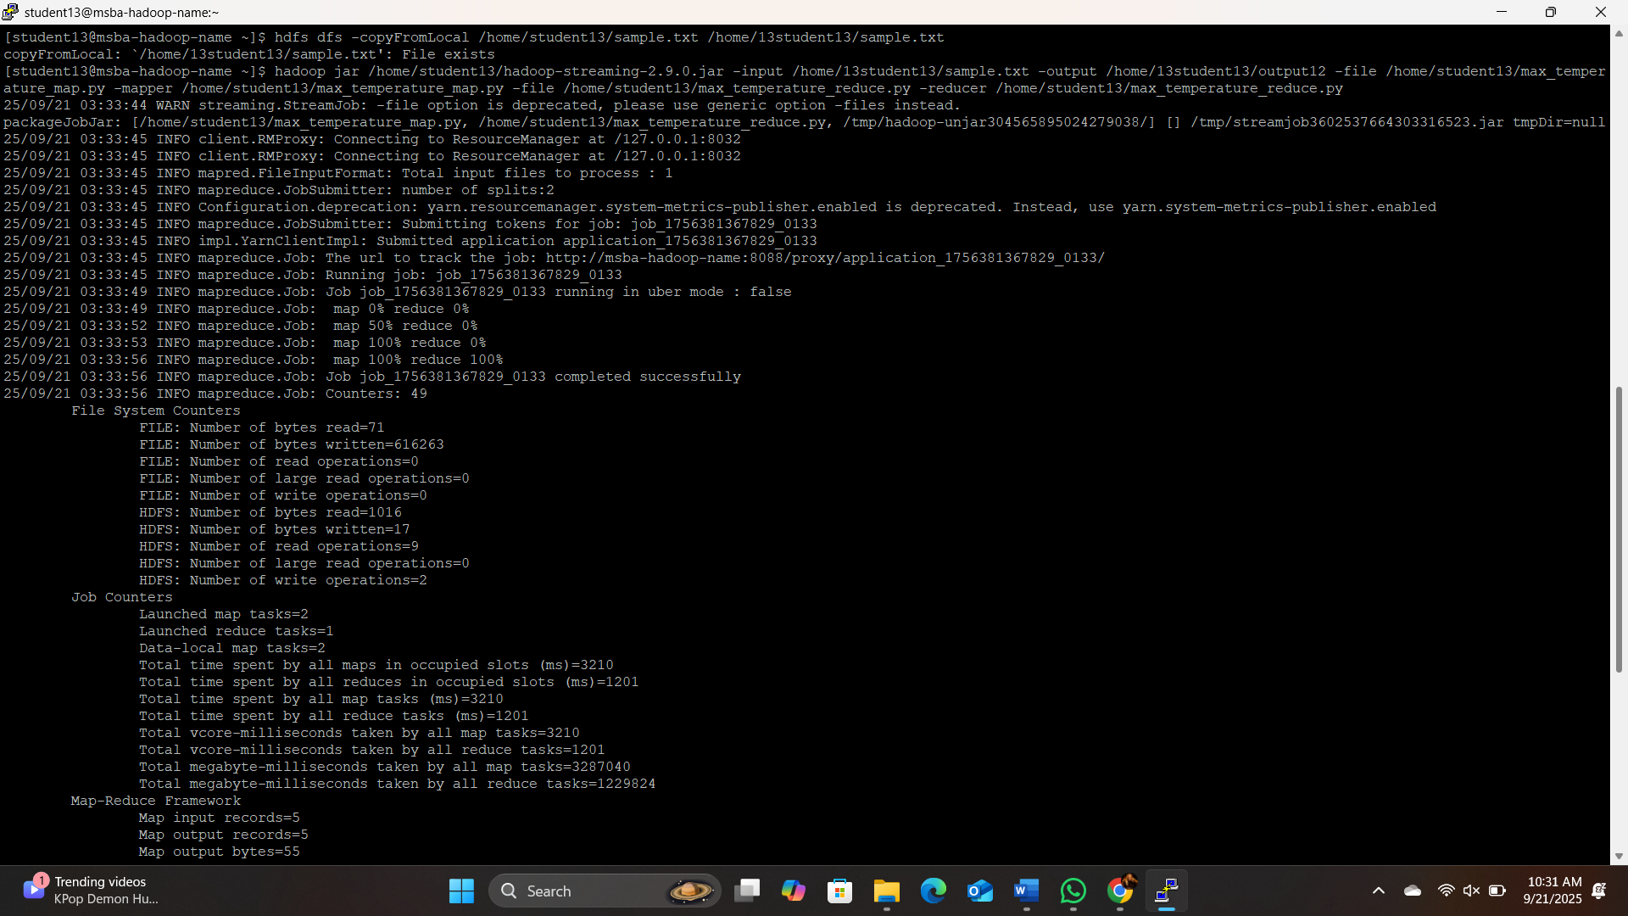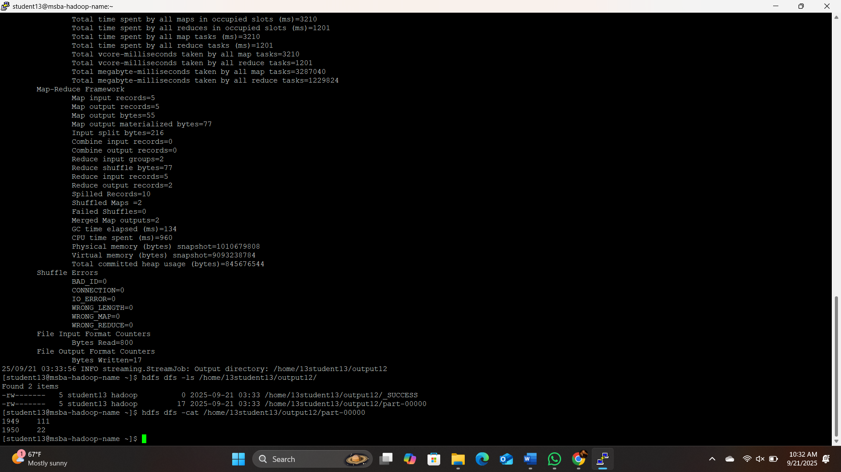

Q-2 - EXAMPLE 3-3:
Step 1:
Copied “quangle.txt” from server hard drive to HDFS
hdfs dfs -copyFromLocal /home/student13/quangle.txt /home/13student13/

Step 2:
Creating Jar file for FileSystemDoubleCat
javac -classpath /home/student13/hadoop-common-2.6.1.jar:/home/student13/Hadoop-mapreduce-client-core-2.6.1.jar:/home/student13/commons-cli-2.0.jar -d . FileSystemDoubleCat.java
jar cvf FileSystemDoubleCat.jar FileSystemDoubleCat.class
Step 3:
Run FileSystemDoubleCat
hadoop jar /home/student13/FileSystemDoubleCat.jar FileSystemDoubleCat /home/13student13/quangle.txt/ /home/13student13/output-double-cat/

RESULT:
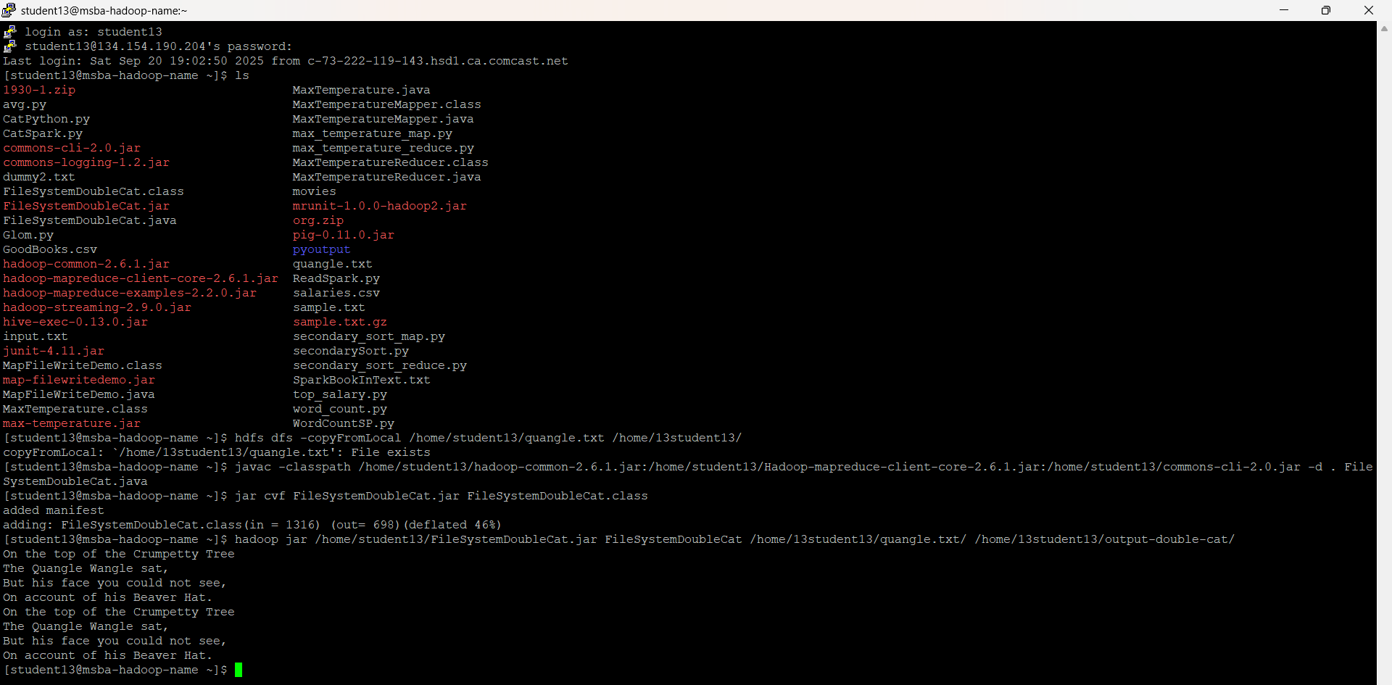
Q3 –
Command for compiling Java file:
javac -classpath /home/student13/hadoop-common-2.6.1.jar:/home/student13/hadoop-mapreduce-client-core-2.6.1.jar:/home/student13/commons-cli-2.0.jar:/home/student13/commons-logging-1.2.jar -d . /home/student13/MapFileWriteDemo.java

Create a Jar file:
jar -cvf map-filewritedemo.jar MapFileWriteDemo.class

Create Output directory : (Storing output in different directory)
hdfs dfs -mkdir /home/13student13/output-GKAS-1
Run a Jar file on Hadoop:
hadoop jar map-filewritedemo.jar MapFileWriteDemo /home/13student13/output-GKAS-1/numbers.map
Build map file:
hdfs dfs -ls /home/13student13/ output-GKAS-1/numbers.map
Content of the map file:
hdfs dfs -text /home/13student13/output-GKAS-1/numbers.map/data | head

Index output:
hdfs dfs -text /home/13student13/output-GKAS-1/numbers.map/index

RESULT :

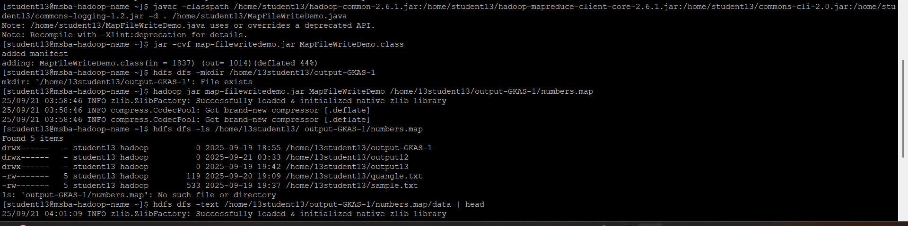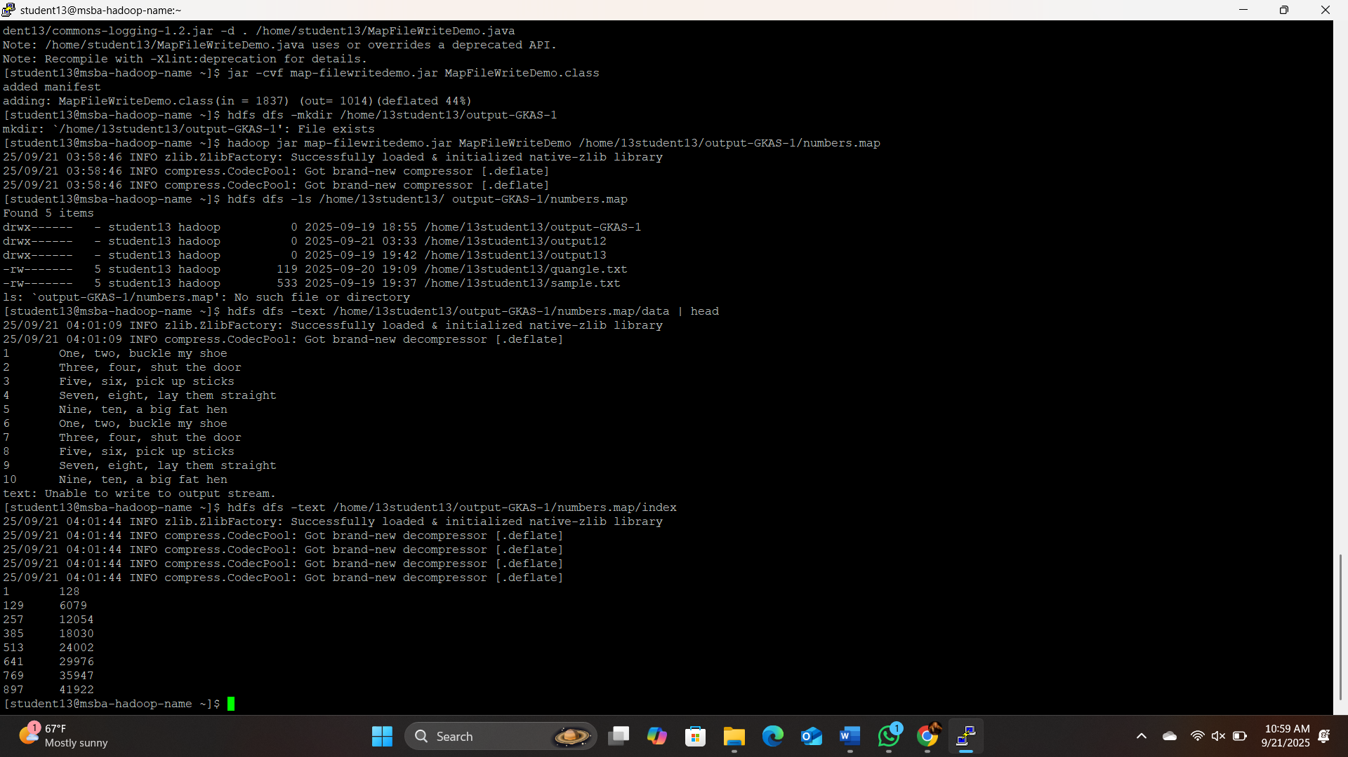

4th
spark-submit /home/student13/sparkgk/WordCountSP.py

hdfs dfs -ls /home/13student13/output20

hdfs dfs -cat /home/13student13/output20/part-* | head -20

RESULT :
