I would recommend the following book as a reference for Java:
Java: A Beginner's Guide, six edition
http://www.amazon.com/Java-Beginners-Guide-Sixth-Edition/dp/0071809252
Again, the required textbook is:
Hadoop: The Definitive Guide, third edition
http://shop.oreilly.com/product/0636920021773.do

Download textbook source code and data files:
https://github.com/tomwhite/hadoop-book/

Reference book: Learning Spark: Lightning-Fast Big Data Analysis, 1st edition, O’Reilly
https://www.amazon.com/Learning-Spark-Lightning-Fast-Data-Analysis/dp/1449358624

We need to download and install the following three tools for BAN632-Big Data. Please note a Mac may not work; you had better use a PC for these tools and for this class.
1) PuTTY, a client for the SSH and Telnet. It can be downloaded here (the first one putty.exe):
http://www.chiark.greenend.org.uk/~sgtatham/putty/download.html
2) WinSCP, an SFTP client for Windows. It can be downloaded here (click Installation package)
https://winscp.net/eng/download.php
3) 7-Zip, a file archiver to compress and decompress files. It can be downloaded here:
http://www.7-zip.org/
We will also learn how to use Hadoop on Amazon Web Service. ﻿﻿﻿﻿﻿﻿﻿Please followed ﻿﻿﻿the attached instructions to make your Amazon account ready. You may also search on Amazon website for student credits so that you may be able to use the service for free.
- Create an Amazon Web Service Account
We will use Amazon S3, which is a data storage service and is free for 12 months for its 5GB standard storage capacity. Please find more details here:
https://aws.amazon.com/free/?sc_channel=PS&sc_campaign=acquisition_US&sc_publisher=google&sc_medium=cloud_computing_hv_b&sc_content=aws_core_e_control_wia&sc_detail=amazon%20web%20services&sc_category=cloud_computing&sc_segment=wia_q4_2015_control_85549480482&sc_matchtype=e&sc_country=US&s_kwcid=AL!4422!3!85549480482!e!!g!!amazon%20web%20services&ef_id=U6pR8AAAAcDv9Q1I:20160323185419:s
Please create an Amazon Web Service Account by clicking the link “Sign up for an AWS account” on the webpage above. Note that you need to choose US East (Northern Virginia) as the region if you are asked to.
We also need to use Amazon Elastic MapReduce (Amazon EMR), which is a Hadoop system provided by Amazon. More details can be found here:
https://aws.amazon.com/elasticmapreduce/
Amazon EMR service is not free. For an m3.xlarge system that we will use, the cost will be 0.336/hour of usage ($0.266 per Hour for EC2 and $0.070 per Hour for EMR). I expect that you will use this system 10 hours per week for the first 3-5 weeks. Thus, the total cost will be 0.336*10*5=16.8 dollars. Detailed pricing information can be found here:
https://aws.amazon.com/elasticmapreduce/pricing/

- Create a Key Pair
AWS uses public-key cryptography to secure the login information for your instance. Thus, we need to create a key pair.
To create a key pair
- Sign in to AWS using the URL that you created in the previous section.
- From the AWS dashboard, choose EC2 to open the Amazon EC2 console.
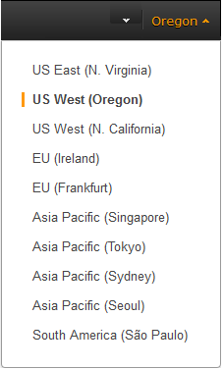
- From the navigation bar, select US East (Northern Virginia) as the region for the key pair.

- In the navigation pane, under NETWORK & SECURITY, click Key Pairs.
Tip
The navigation pane is on the left side of the console. If you do not see the pane, it might be minimized; click the arrow to expand the pane. You may have to scroll down to see the Key Pairslink.
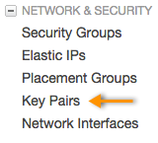
- Click Create Key Pair.
- Enter ITM6273 for the new key pair in the Key pair name field of the Create Key Pair dialog box, and then click Create.
- The private key file is automatically downloaded by your browser. The base file name is the name you specified as the name of your key pair, and the file name extension is .pem. Save the private key file in a safe place.
Important
This is the only chance for you to save the private key file. You'll need to provide the name of your key pair when you launch an instance and the corresponding private key each time you connect to the instance.

- Convert the .pem File to a .ppk File.
- Download PuTTYgen from: http://www.chiark.greenend.org.uk/~sgtatham/putty/download.html
- Start PuTTYgen by double clicking it.
- Under Type of key to generate, select RSA.
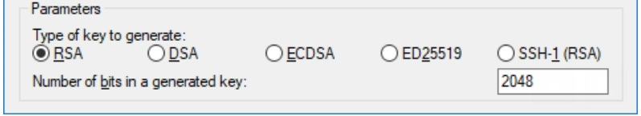
- Click Load. By default, PuTTYgen displays only files with the extension .ppk. To locate your .pem file, select the option to display files of all types.
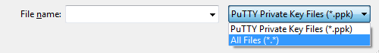
- Select the private key file that you created in the previous procedure and click Open. Click OK to dismiss the confirmation dialog box.
- Click Save private key. PuTTYgen displays a warning about saving the key without a passphrase. Click Yes.
- Specify the same name for the key that you used for the key pair. PuTTY automatically adds the .ppk file extension.
- Save this .ppk file and bring it to the first class.

